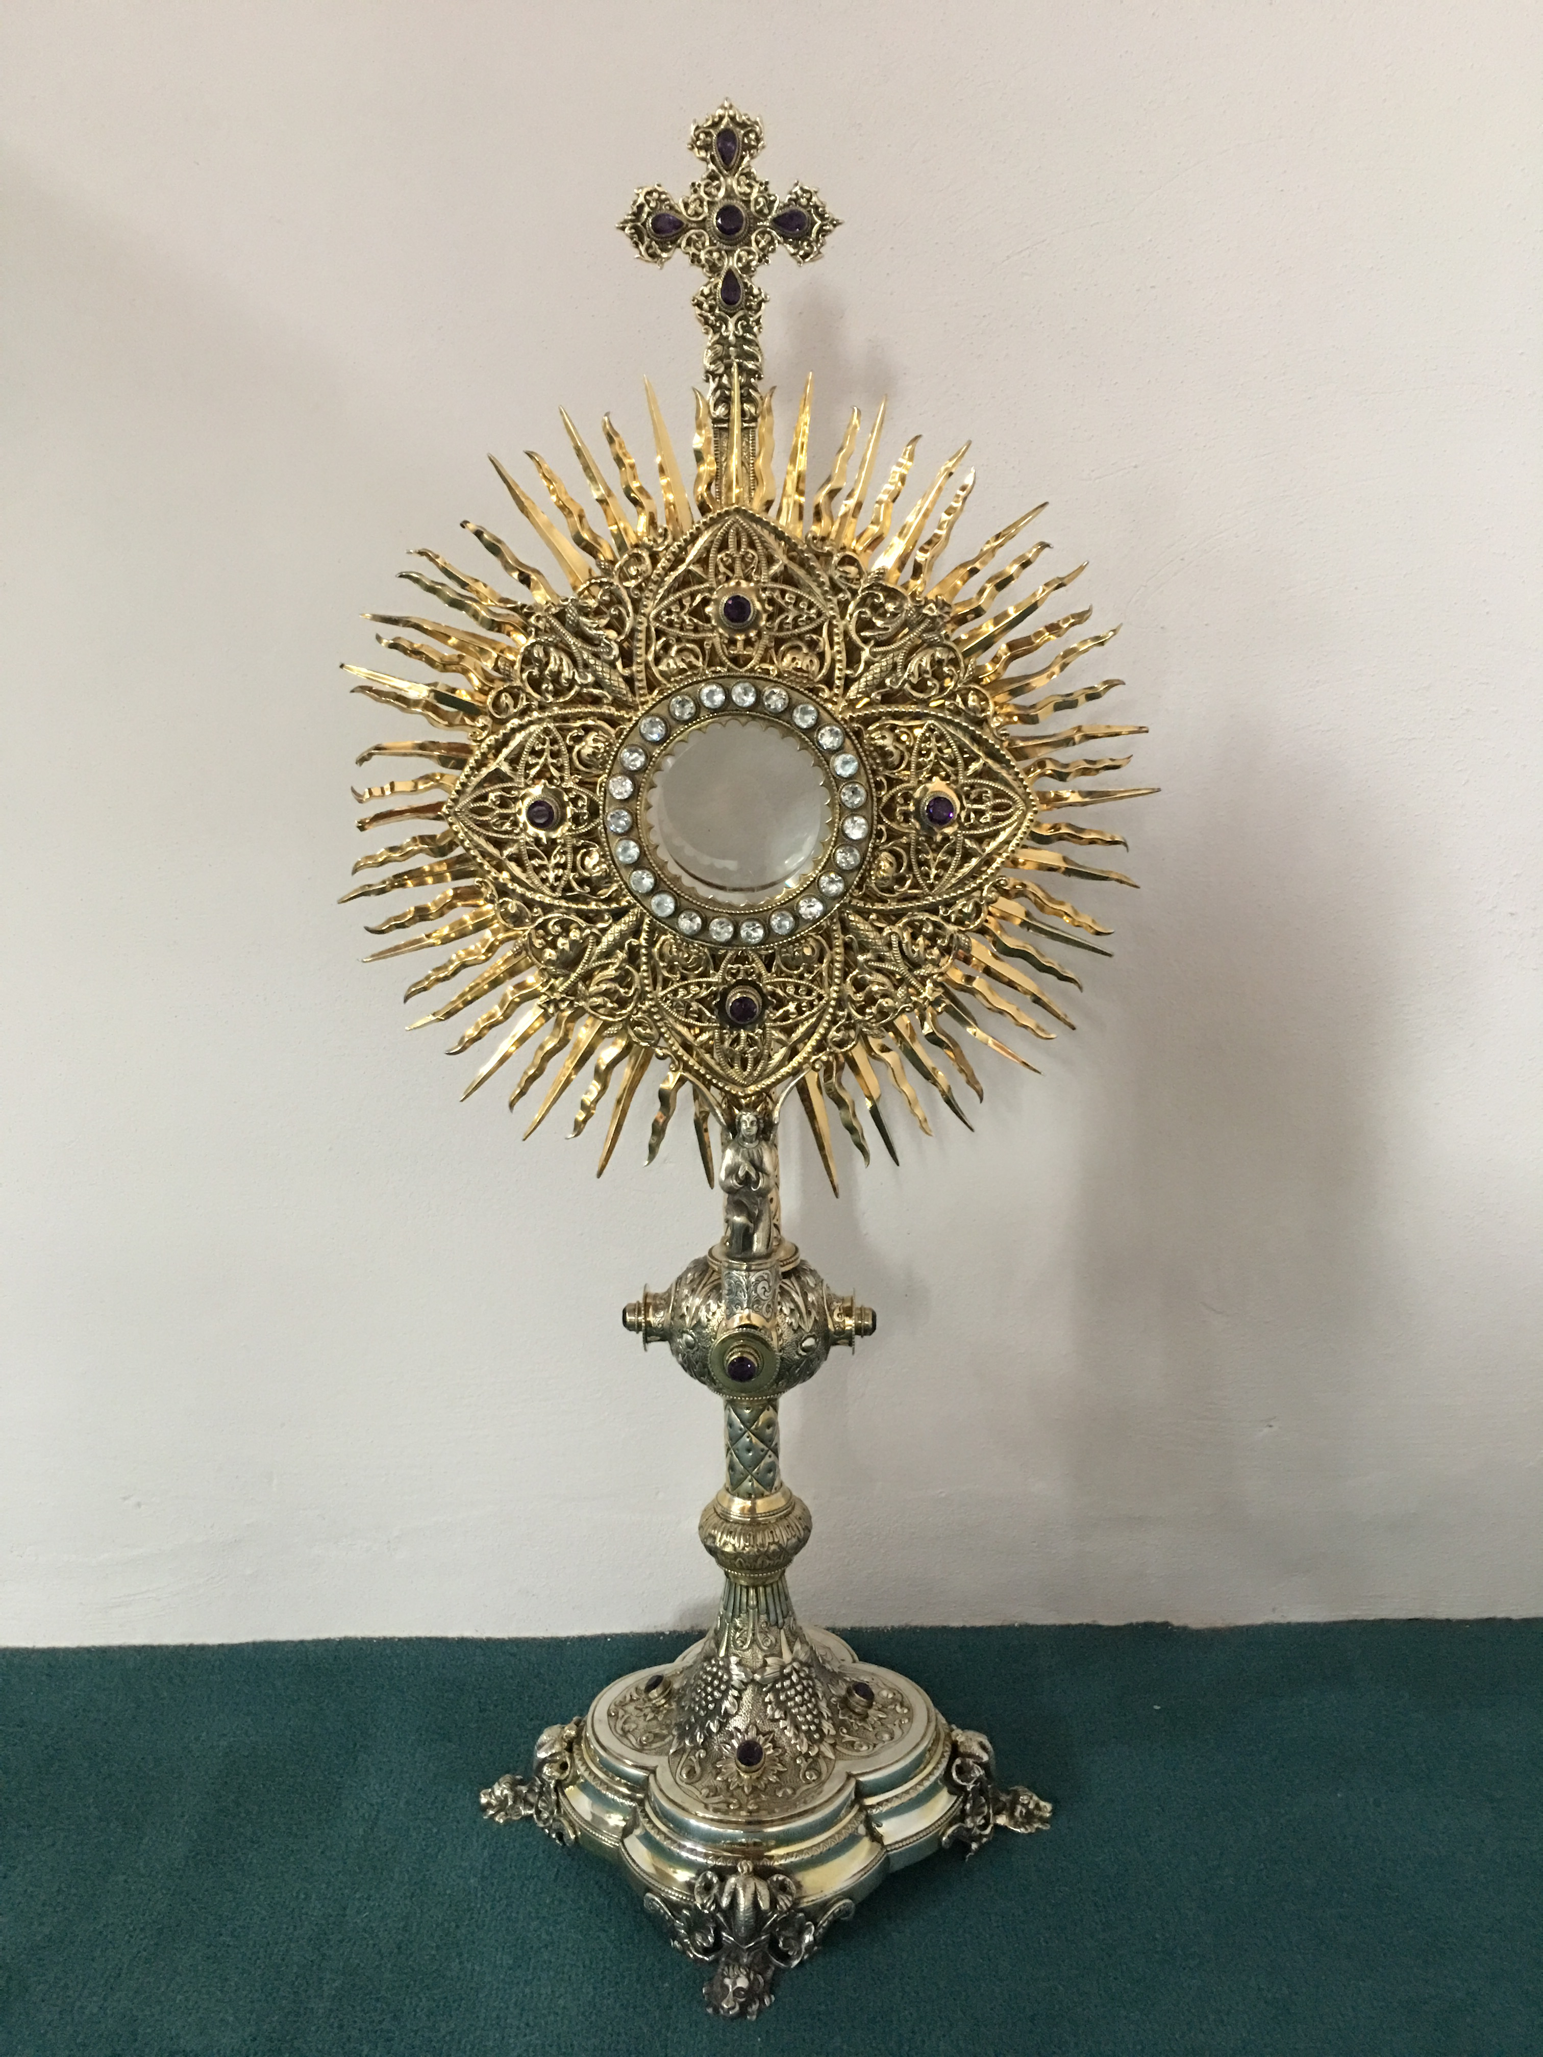
EUCHARISTIC ADORATION
The Parish of Hannahstown News
St Peter’s Church - Every Friday from 2 pm – 8.30 pm. Every evening Adoration & Prayer in St Peter’s Church 6.30 pm – 7.30 pm.
St Joseph’s Church Fr. Patrick will notify parishioners when Adoration will resume in St Joseph’s Church.
https://churchmedia.tv/st-josephs-church https://churchmedia.tv/st-peters-church-2
ANNIVERSARIES – William Cooley, John & Joseph Doone,
Diarmuid Frazer, John Frazer, Sadie Frazer, John Kennedy, Mary & Fergus Mulholland, Ruth McAuley, Paddy McGarrity, Catherine Smyth RIP.

WEEKLY COLLECTIONS
2403/2024 Weekly Collection £990.00
Thank you to everyone for their generosity to the Parish.

PRE-BAPTISM COURSES – Attendance at a Pre-Baptism course is required for all parents presenting a first baby for Baptism.
To book a Baptism, please visit the parish office with the new baby’s long birth certificate.
We also welcome Mia McParland into our parish who was recently baptised in St Joseph’s Church.
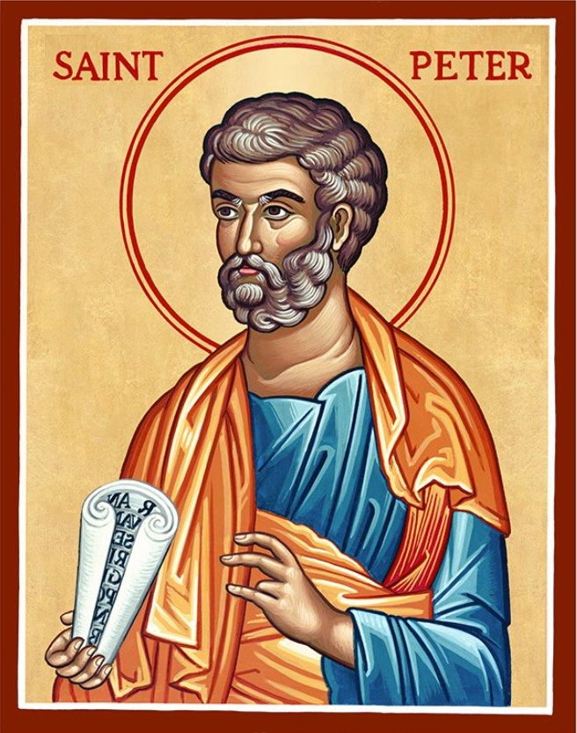
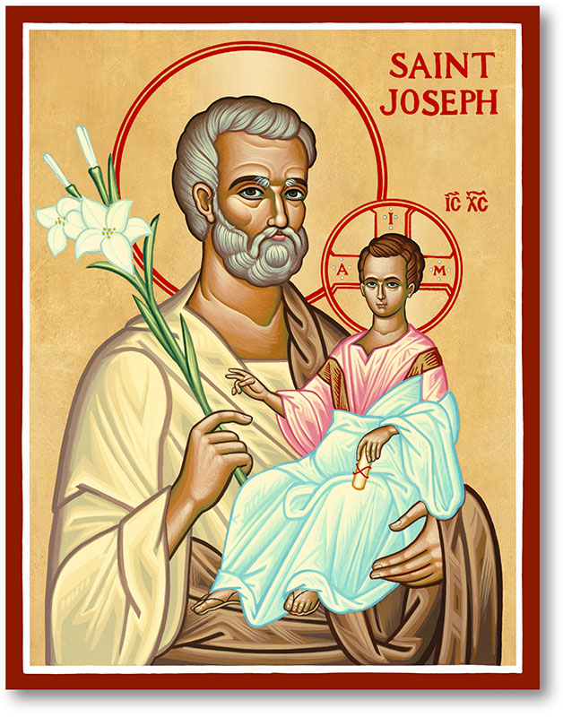
The Parish of Hannahstown
Saint Joseph’s and Saint Peter’s

31st March 2024
Easter Sunday of the
Resurrection of Our Lord

THE DAWN OF EASTER BREAKS FORTH
Every time we ask forgiveness of one another for our sins against other Christians, and every time we find the courage to grant and receive such forgiveness, we experience the Resurrection!
Every time we put behind us our long-standing prejudices and find the courage to build new fraternal relationships, we confess that Christ is truly risen!
Every time we reflect on the future of the Church in the light of her vocation to unity, the dawn of Easter breaks forth!
Fr Patrick Devlin hopes that during this Easter season, you will experience the mercy, compassion and inner peace that the Risen Lord promises.
We wish all our parishioners, their families and friends a very Happy Easter.
_______________________________________________________
Mas Times this week
Monday 09:15 am Saint Joseph’s
Monday Funeral Cover Saint Joseph’s 10am
Tuesday 09:15 am Saint Joseph’s
Wednesday 09.15 am Saint Joseph’s
Wednesday Funeral Cover St Michael’s 10 am
Thursday 09:15 am Saint Peter’s
Thursday Funeral Cover Saint Agnes’
Friday 09:15 am Saint Joseph’s
Saturday 6:00 pm Saint Joseph’s
Sunday 10:00 am Saint Peter’s Sunday 11:30 am Saint Joseph’s

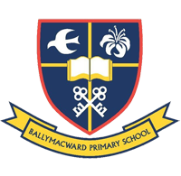
easters Sunday Mas times as usualOur Parish School Ballymacward Primary School,
THE PARISH OF HANNAHSTOWN SCHOOLS
22 Rock Road, Stoneyford, Lisburn, Co Antrim, BT28 3SUTel: (028) 92648130, Principal: Mr Hugh Kennedy
Email: info@ballmacwardps.lisburn.ni.sch.uk

Pre-School Playgroup - Supervisor: Ms Sarah Scott. Tel: (028) 9264 8515
18th April 2024 Service of Light St Peter’s at 9.15 am Mass

5th May 2024 First Holy Communion St Peter’s at 10.00 am

19th May 2024 Confirmation St Peter’s at 10.00 am
HANNAHSTOWN COMMUNITY HALL
Monday – Coffee Morning after 9.15 am Mass, everyone welcome.
Please contact Anthony Adams for enquiries at 02890 309795
Mon – Fri 10 am – 1 pm

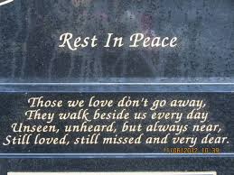
CEMETERY SUNDAY IN BELFAST CEMETERIES
LIVING CHURCH / Family of Parishes
Milltown (Service) Sunday 12th May @ 3 pm
City (Service) Sunday 19th May @ 3 pm
HANNAHSTOWN PARISH
St Joseph’s Cemetery (Mass) Sunday 26th May @ 3 pm

Tullyrusk Cemetery (Mass) Sunday 16th June @ 1.30 pm
St Peter’s
The Rock Cemetery (Mass) Sunday 9th June @ 1.30 pm
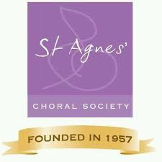
ST AGNES CHORAL SOCIETY - Have an electric night out at “Young Frankenstein” by St Agnes' Choral Society. One of Belfast’s biggest and best musical societies is back on stage with "Young Frankenstein" - the hilarious Mel Brooks Musical Comedy. St Agnes' Choral Society will be performing this monstrous hit at The MAC, Belfast from Tuesday 23rd to Saturday 27th April. "Walk this way" and get your tickets at themaclive.com
LIVING CHURCH / WEST BELFAST PASTORAL COMMUNITY

NATIONAL EUCHARISTIC ADORATION PILGRIMAGE TO KNOCK ON SUNDAY 14TH APRIL 2024 – Calling ALL ADORERS of the Blessed Sacrament in Down & Connor Diocese. For further information please contact Patrick on 07963 581 543. Full Bus details on www.eucharisticadoration.ie

DIAMOND WEDDING ANNIVERSARY – The parish would like to take this opportunity to wish Charlie & Geraldine Connolly a very Happy Diamond Wedding Anniversary.
60 years is a wonderful milestone for any couple, 60 years of sharing your faith and your love with one another. We wish you many more years of love & good health together.

