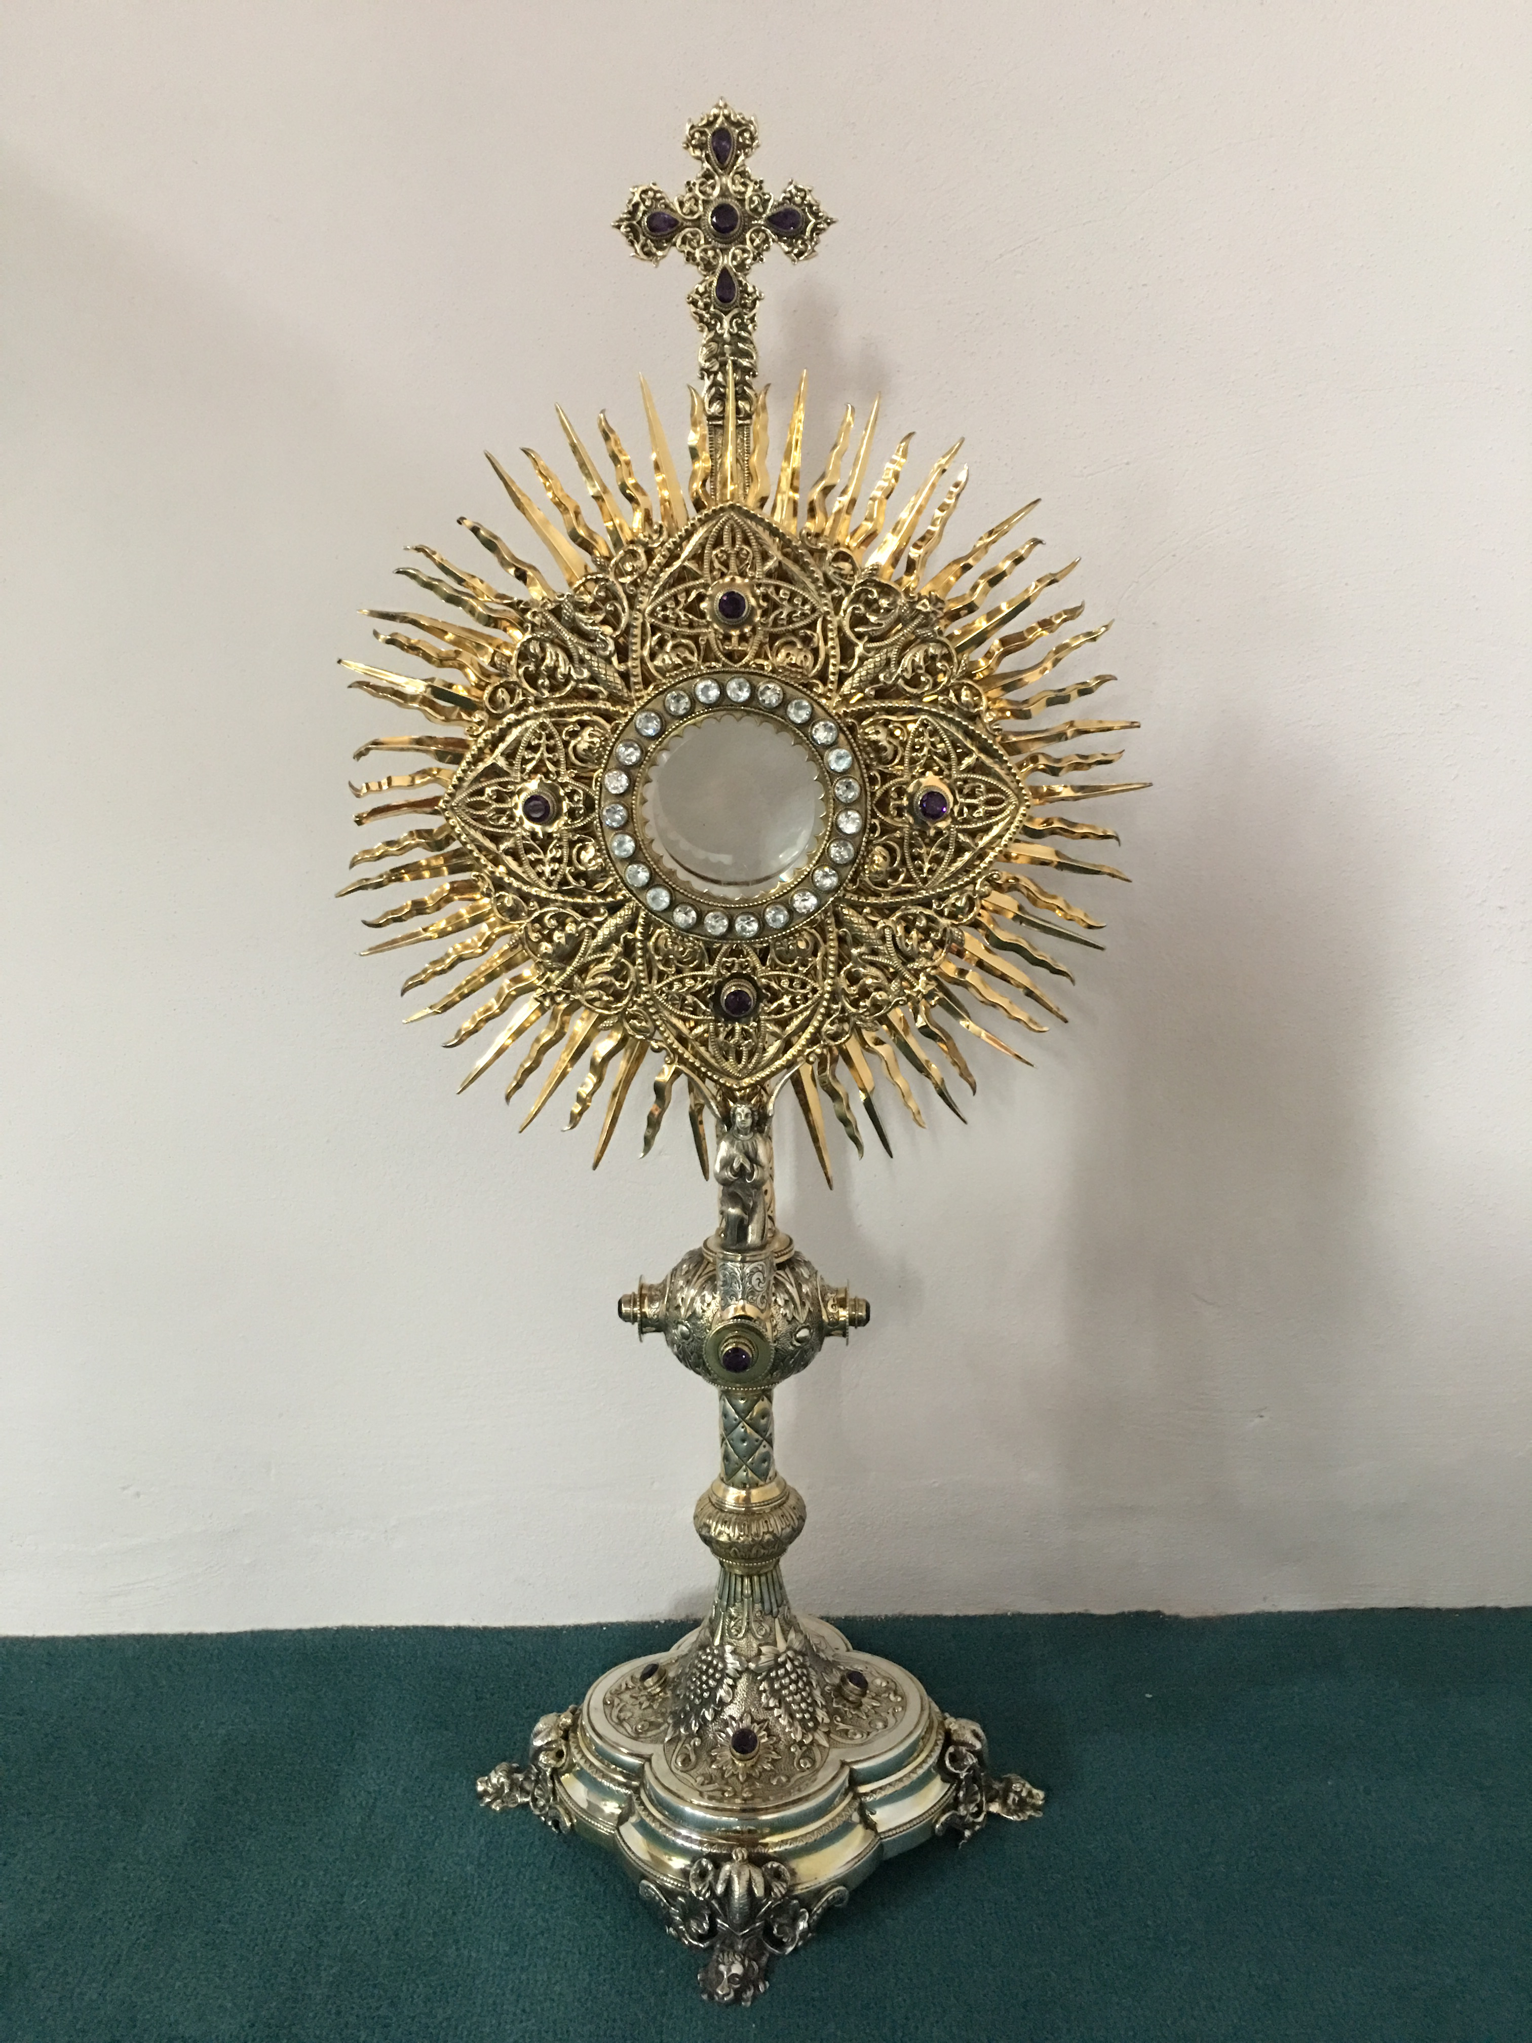
EUCHARISTIC ADORATION
The Parish of Hannahstown News
St Peter’s Church - Every Friday from 2 pm – 8.30 pm. Every evening Adoration & Prayer in St Peter’s Church 6.30 pm – 7.30 pm.
St Joseph’s Church Wednesdays during Lent from 9.45 am – 1.45 pm. You can join us in the Church or via the webcam. https://churchmedia.tv/st-josephs-church https://churchmedia.tv/st-peters-church-2
ANNIVERSARIES – Mairead & Barney Brannigan, Kathleen Brankin, Michael Hall, Sr. Sarah Jordan, Miles Ritchie Keenan (1st Anniversary), Gerard & Harry McGowan & Pat McMahonRIP.

WEEKLY COLLECTIONS
31/04/2024 Weekly Collection £1112.49
Easter Offering will be printed next week, still coming in.
Thank you to everyone for their generosity to the Parish.
BAPTISMS Last weekend we welcomed Finn Louchlainn McMahon into our parish community.
PRE-BAPTISM COURSES – Attendance at a Pre-Baptism course is required for all parents presenting a first baby for Baptism.
To book a Baptism, please visit the parish office with the new baby’s long birth certificate.
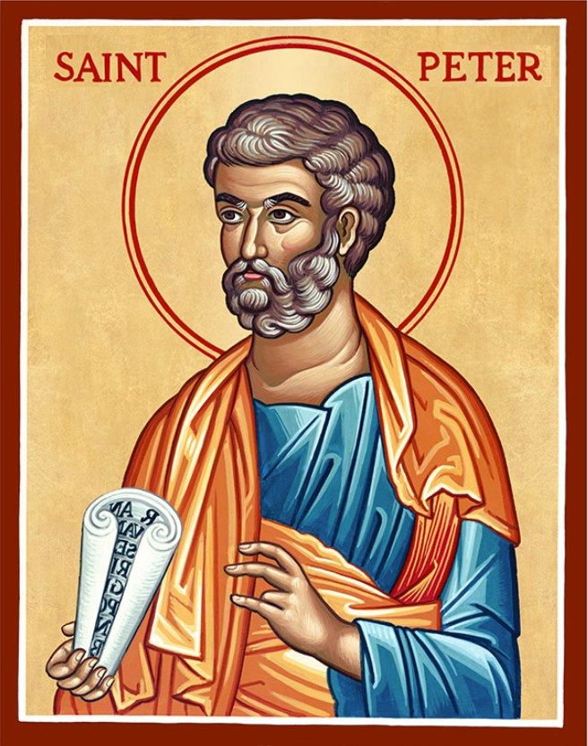
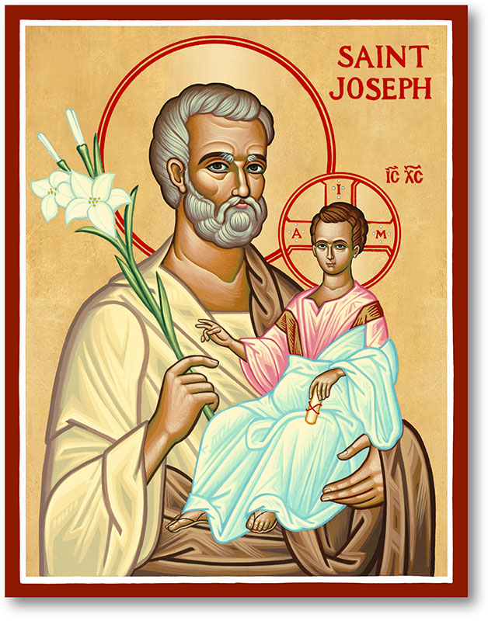
The Parish of Hannahstown
Saint Joseph’s and Saint Peter’s

7th April 2024
Second Sunday of Easter

Vicariate / Family of Parishes Emergency Sick Calls: 07549209775
Readings: Sunday Cycle B Weekdays Psalter Week
Monday 09:15 am (Prayer for Vocations) Saint Joseph’s
Tuesday Fr. Patrick’s day off.
Wednesday 09.15 am (Parish Novena to Our Lady) Saint Joseph’s
Thursday 09:15 am (Parish Novena to Our Lady) Saint Peter’s
Friday 09:15 am (Sacred Heart Prayer) Saint Joseph’s
Saturday 6:00 pm (Saint Michael the Archangel Prayer) Saint Joseph’s
Sunday 10:00 am (Prayer for Pope’s Intentions) Saint Peter’s
Sunday 11:30 am (Saint Joseph Prayer) BSL Signed Mass Saint Joseph’s
Very Reverend Patrick Devlin Parish Priest,
Chaplain to the Deaf Community, Down and Connor Diocese
Chaplain to Antrim Area Hospital Thursday & Friday (Emergency calls)
(Fr. Patrick’s mobile…. For Spiritual and pastoral needs only, thank you) Tel: 07910 833699
Parish Secretary: Mrs Grainne McArevey Tel: 028 90614567
Parish Email: hannahstown@downandconnor.org
Parish Website: https://www.parishofhannahstown.com

DIVINE MERCY SUNDAY
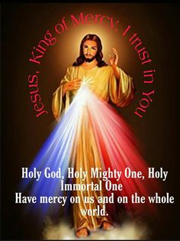
Eternal God, in whom mercy is endless and the treasury of compassion inexhaustible, look kindly upon us and increase your mercy in us, that in difficult moments we might not despair nor become despondent, but with great confidence submit ourselves to your holy will, which is Love and Mercy itself.
Amen

Our Parish School Ballymacward Primary School,
THE PARISH OF HANNAHSTOWN SCHOOLS
22 Rock Road, Stoneyford, Lisburn, Co Antrim, BT28 3SUTel: (028) 92648130, Principal: Mr Hugh Kennedy
Email: info@ballmacwardps.lisburn.ni.sch.uk

Pre-School Playgroup - Supervisor: Ms Sarah Scott. Tel: (028) 9264 8515
HANNAHSTOWN COMMUNITY HALL
Please contact Anthony Adams for any enquiries on 90 309795
Mon – Fri 10 am – 1 pm.
Monday – Coffee Morning after 9.15 am Mass, everyone welcome.

LIVING CHURCH / Family of Parishes

Spiritual and Pastoral Commitments: March 2024 - June 2024 Update
LIVING CHURCH / Family of Parishes
18th April 2024 Service of Light for Confirmation Saint Peter’s at 9:15 Mass
5th of May 2024, Parish School First Holy Communion, Saint Peter’s 10:00 am.
19th May 2024, Parish School Confirmations, Saint Peter’s 10:00 am
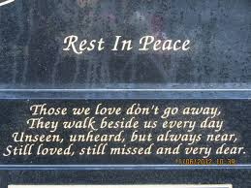
CEMETERY SUNDAY IN BELFAST CEMETERIES
Milltown (Service) Sunday 12th May @ 3 pm
City (Service) Sunday 19th May @ 3 pm
Hannahstown Parish……..
St Joseph’s (Mass) Sunday 26th May @ 3 pm
Tullyrusk (Mass) Sunday 16th June @ 1.30 pm
St Peter’s (Mass) Sunday 9th June @ 1.30 pm

