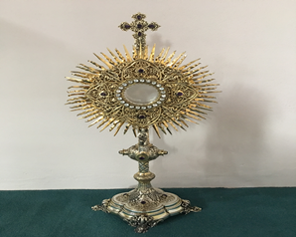
EUCHARISTIC ADORATION in St Peter’s Church - Every Friday from 2 pm – 8.30 pm.
THE PARISH OF HANNAHSTOWN
Every evening within St Peter’s Church, Adoration & Prayer from 6.30 pm – 7.30 pm
https://churchmedia.tv/st-josephs-church https://churchmedia.tv/st-peters-church-2


RECENTLY DECEASED – Isobel Mulryne RIP
MONTH’S MIND – Nora McCarthy RIP
1st ANNIVERSARIES – Frank Matthews RIP
ANNIVERSARIES – Kathleen McKeown
& Lily McMullan RIP


WEEKLY COLLECTIONS
23/6/25 Weekly Collection £ 721.52

Thank you to everyone for their generosity to the Parish.

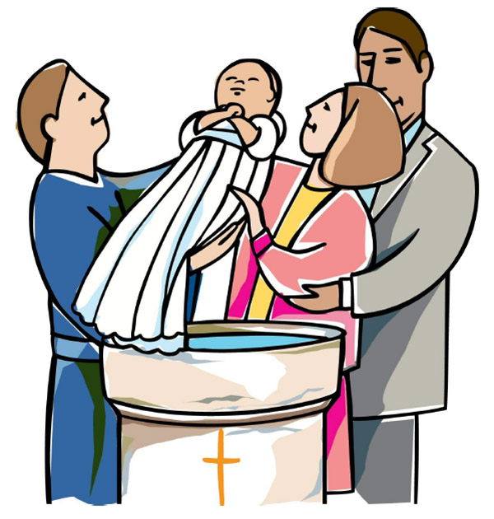
BAPTISMS
To arrange Baptisms, please present the long birth certificate to the parish office.
Baptisms will be arranged upon request.

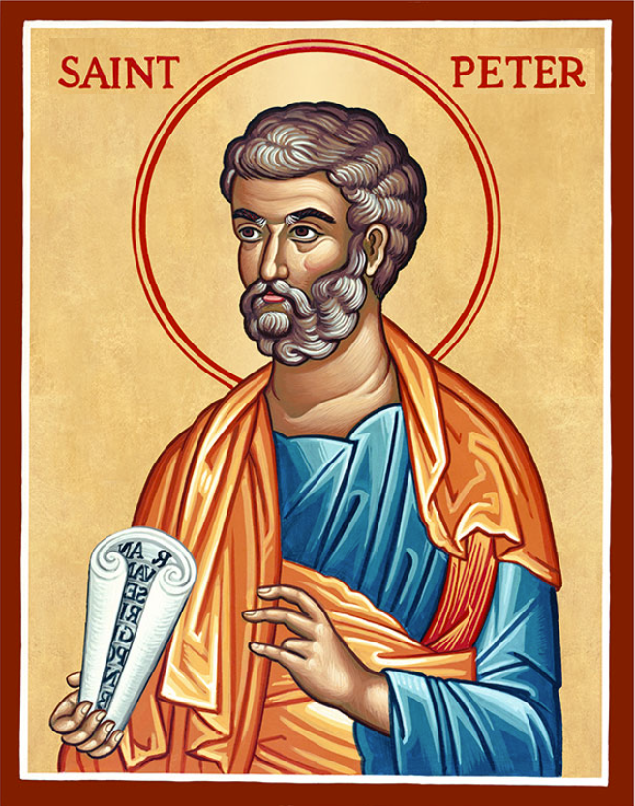
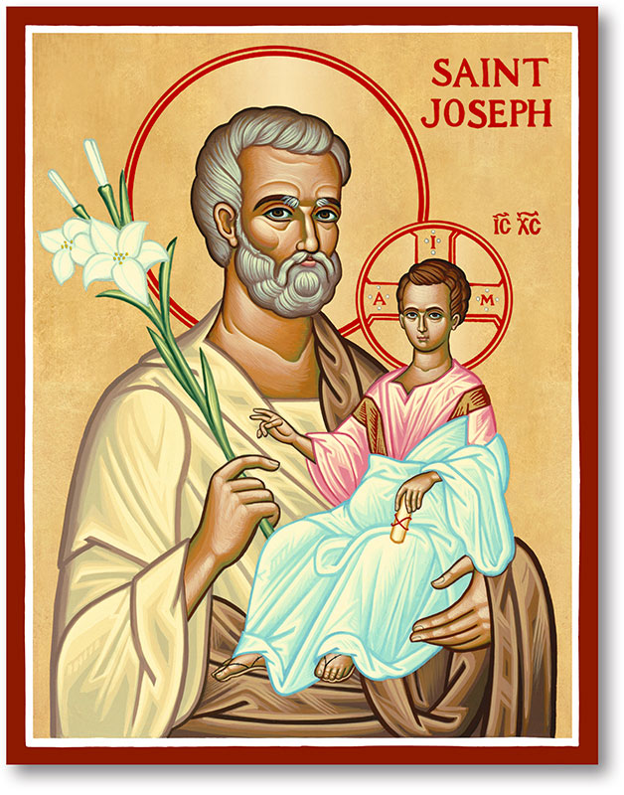
The Parish of Hannahstown
Saint Joseph’s and Saint Peter’s

29th June 2025
St Peter & St Paul, Apostles
Family of Parishes Emergency Sick Calls: 07549209775
Monday 09.15 am (Prayer for Vocations) St Joseph’s
Tuesday Fr. Patrick’s day off.
Wednesday 9.15 am (Parish novena to Our Lady) St Joseph’s
Thursday No Mass
Friday No Mass
Saturday 6:00 pm (St Michael the Archangel Prayer) St Joseph’s
Sunday 10:00 am (Prayer for Pope’s intentions) St Peter’s
Sunday 11:30 am (Saint Joseph Prayer) ( BSL Signed ) St Joseph’s
Very Reverend Patrick Devlin, Parish Priest,
Chaplain to the Deaf Community, Down and Connor Diocese
Chaplain to Antrim Area Hospital, Thursday & Friday (Emergency calls)
Fr. Patrick, for Spiritual and Pastoral needs only, thank you Tel: 07910 833699
Parish Secretary: Mrs Grainne McArevey Tel: 028 90614567
Parish Email: hannahstown@downandconnor.org Parish Website: https://www.parishofhannahstown.com

What is remarkable about Peter and Paul is not just their personal conversions and faith journeys, but also their unity in diversity. They were two different individuals with distinct backgrounds, personalities, and approaches to ministry. Peter was the one who walked with Jesus during His earthly ministry, while Paul came later as a convert and a passionate advocate for the Gospel. Yet, despite their differences, they recognised their common mission and the need to work together for the sake of the Church. Their collaboration was not always smooth. They had disagreements and even public disputes, but they ultimately sought reconciliation and unity. Both Peter and Paul understood that their shared commitment to Christ and the proclamation of His message superseded personal differences. They recognised that unity in the Church was essential to its mission and witness in the world. As we reflect on the lives of Peter and Paul, we are reminded of the importance of unity within the Church today. The Church, like any human institution, is made up of diverse individuals with unique backgrounds, perspectives, and gifts. It is in embracing this diversity and recognising the common mission that we can truly be effective witnesses of Christ’s love and mercy.
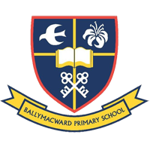
Ballymacward Primary School,
HANNAHSTOWN PARISH SCHOOL / COMMUNITY PLAYGROUP
22 Rock Road, Stoneyford, Lisburn, Co Antrim, BT28 3SUTel: (028) 92648130, Principal: Mr Hugh Kennedy
Email: info@ballmacwardps.lisburn.ni.sch.uk
Ballymacward Community Pre-School Playgroup - Supervisor: Ms Sarah Scott. Tel: (028) 9264 8515
HANNAHSTOWN PARISH/FAMILY OF PARISHES

ALL-IRELAND RALLY FOR LIFE - All-Ireland Rally for Life takes place in Dublin on Saturday, 5th July. Make a stand to protect Ireland's unborn babies. A coach will be travelling from Belfast City Centre. To book your seat, contact 07592280522.

Mass for Life - St Saviour’s Church, Dublin, noon, followed by Rosary procession to the Rally for Life.
Also, a visit to view the two bells of St Patrick, the Ardagh chalice and other treasures of the Church. Evening Mass at 5.30 pm (for 2nd Jubilee Year daily indulgence)
The bus leaves Belfast city centre at 9 a.m., also picking up in Sprucefield and Banbridge.
Tickets £25, children free. To book, contact Orla at 07545 452362

FIRST SATURDAY DEVOTIONS - First Saturday Devotions will take place in St. Matthias’s Church, Glen Road, on 5th July;
HANNAHSTOWN PARISH/FAMILY OF PARISHES
3.00 p.m. Adoration of the Blessed Sacrament, Confessions and Act of Consecration, Rosary and Divine Mercy Chaplet, 4.00 p.m. Holy Sacrifice of the Mass
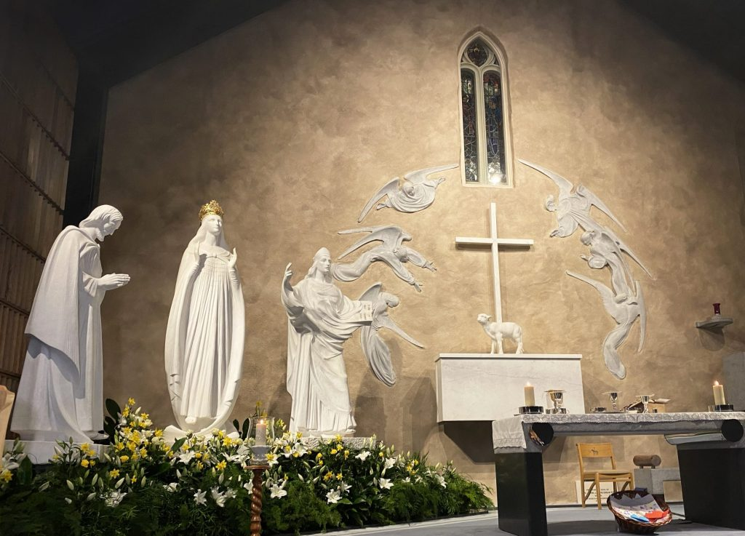
HANNAHSTOWN PARISH/FAMILY OF PARISHES
PARISH PILGRIMAGE TO KNOCK SHRINE – Tuesday 15th July – Wednesday 16th July staying at The Knock House Hotel. There are 6 places available. Please give your name to Fr. Patrick or ring the parish office to reserve a place. The cost of the trip is £170 pp, this includes bed, breakfast, lunch and one evening meal (and of course your transport).

THANK YOU FROM IRENE PHILLIPS – Irene would like to thank everyone who contributed in any way to the celebration of her 90th Birthday. For all the gifts, cards, prayers and most of all the charitable donations received. “I am very grateful, together we raised £2,405.67, which was donated to two charities; Sightsavers and Smile Train. Once again, a big thank you”. Irene
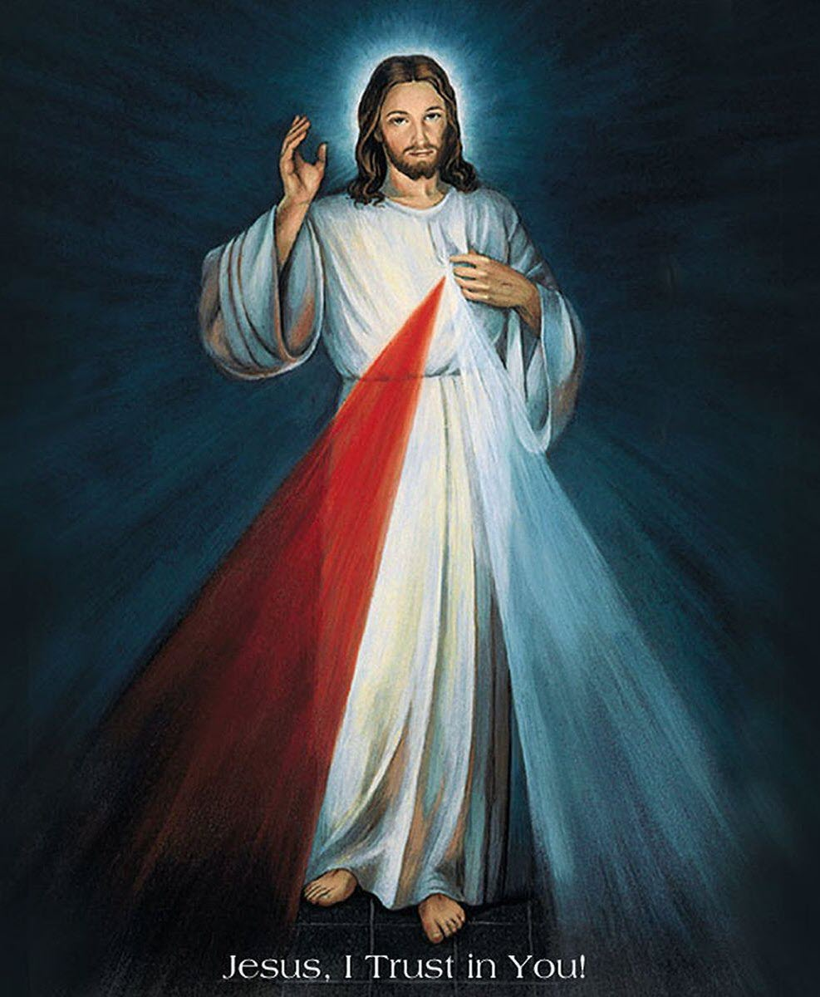
DIVINE MERCY CHAPLET – Saint Faustina wrote extensively about the Divine Mercy Chaplet, emphasising its power and the graces associated with praying it.
Our parish is planning to have one hour every week with Exposition of the Blessed Sacrament on a Friday at 3 pm. During this hour, we will have Adoration & pray the Divine Mercy Chaplet in St Joseph’s Church. We will inform you when this will commence.

