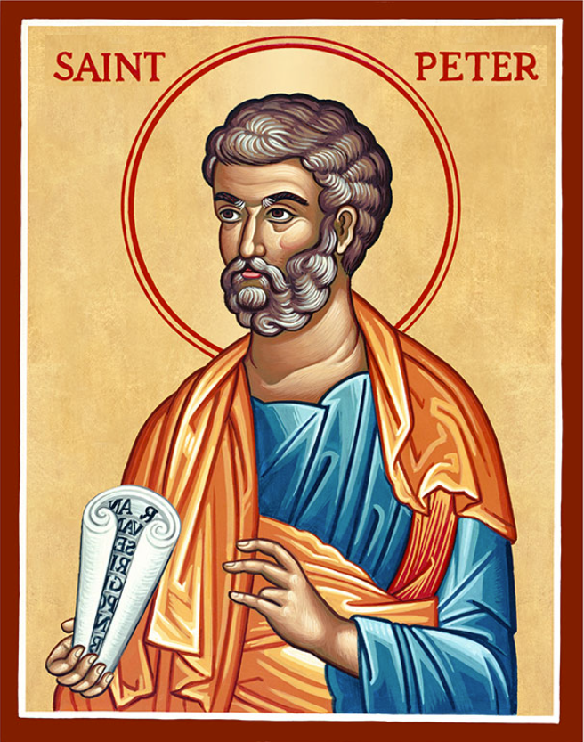

The Parish of Hannahstown
Saint Joseph’s and Saint Peter’s

Very Rev. Patrick Devlin
Parish Priest
Chaplain to the Deaf Community
(Down and Connor Diocese)
23 Hannahstown Hill, Belfast, BT17 0LT
E-mail: hannahstown@downandconnor.org
Tel: 07910833699

8th November 2025

Dear Parishioners

I write to update you on the status of the Cemetery Appeal of 2020 and the two projects which were part of that appeal.

Background

Five years ago the parish launched an appeal to fund two projects: the resurfacing of all the paths in our cemetery, and the building of a stone wall fronting St Joseph’s Cemetery. The projected costs at that time were £62,500. The parish is greatly appreciative of the generosity of parishioners who raised £22,500 in total. As there was a shortfall between the projected costs of the works and the monies raised, the parish had to assess how best to use the £22,500 and as you may know the monies were used to resurface the paths of the cemetery. Those works alone cost £35,400 meaning that the parish paid for the shortfall from within its own reserves. With funds fully spent, the original cemetery appeal has been concluded.

The Future

The parish remains committed to caring for our cemeteries and I am currently seeking agreement on a new plan for our cemeteries. A number of views have been expressed, such as:

· Install an aesthetically pleasing fence fronting St Joseph’s cemetery;

· Build a stone wall fronting St Joseph’s cemetery;

· Re-assess priorities of the parish overall to take account of other works and pastoral programmes.

As parish priest I must ensure good stewardship of parish resources and so, in considering the future plans for our cemeteries and the parish generally, I propose to consult with the Parish Council– the Finance Committee, the Cemetery Committee – and ask for their prayerful reflection as to future plans for the upkeep of the cemeteries. I also ask for your prayerful support and practical advice as we step into the future together.

Yours in Christ,

Very Rev Patrick Devlin

