
EUCHARISTIC ADORATION
THE PARISH OF HANNAHSTOWN
St Peter’s Church - Friday’s 2 pm – 8.30 pm.
Daily Adoration, Rosary & The Divine Mercy Chaplet St Peter’s Church 6.30 pm – 7.30 pm every evening. https://churchmedia.tv/st-peters-church-2
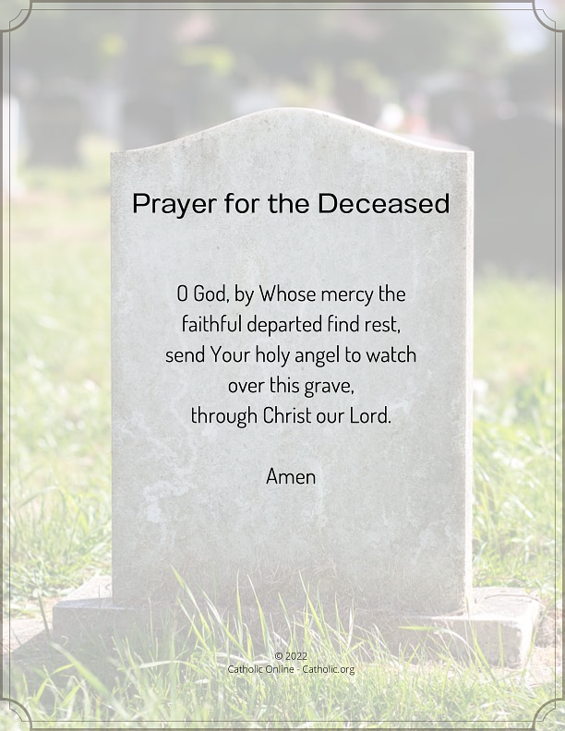
RECENTLY DECEASED – Liam Skelly RIP
ANNIVERSARIES – Patsy & Micky Jordan, Timothy McElroy, Valerie McGarrity, Marianne Sinclair, Hannah Totten RIP
Please remember to visit Fr. Patrick in the Sacristy before Mass starts if it is intended for your loved one.


WEEKLY COLLECTIONS
27/10/25 Weekly Collection £954.60
Thank you to everyone for their generosity to the Parish.

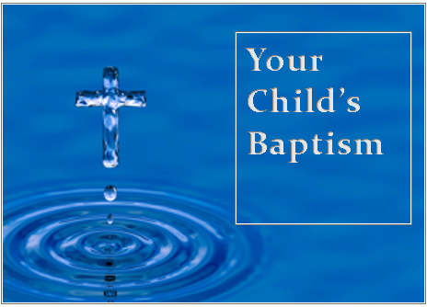
BAPTISMS
To arrange Baptisms, please present the long birth certificate to the parish office.
We welcome Baby Oisin Savage into our parish family, who was recently baptised in St Joseph’s Church.

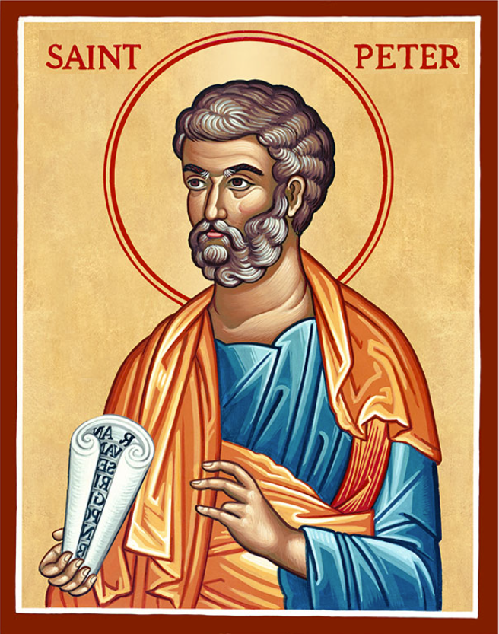
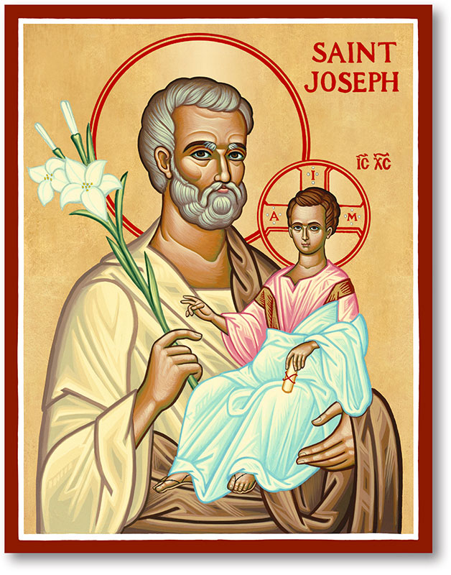
The Parish of Hannahstown
Saint Joseph’s and Saint Peter’s

2nd November 2025
29th Sunday in Ordinary Time
Family of Parishes Emergency Sick Calls: 07549209775
Monday 9.15 am Prayer for Vocations Saint Joseph’s
Monday 11.00am Funeral Liam Skelly Saint Josep’s
Tuesday Fr Patrick’s Day away.
Wednesday 9.15 am Parish Novena to Our Lady Saint Joseph’s
Thursday 9.15 am Parish novena to Our Lady Saint Peter’s
Friday 9.15 am Sacred Heart and St Michael’s Prayer Saint Joseph’s
Saturday 6:00 pm Prayer of Hope, Jubilee 2025, Saint Joseph’s
Sunday 10:00 am Prayer of Hope, Jubilee 2025 Saint Peter’s
Sunday 11:30 am Prayer of Hope, Jubilee 2025 Saint Joseph’s
Very Reverend Patrick Devlin, Parish Priest,
Chaplain to the Deaf Community, Down and Connor Diocese
Chaplain to Antrim Area Hospital Thursday & Friday (Emergency calls)
Fr. Patrick, for Spiritual and Pastoral needs only, thank you Tel: 07910 833699
Parish Secretary: Mrs Grainne McArevey Tel: 028 90614567

THE COMMEMORATION OF ALL THE FAITHFUL DEPARTED (ALL SOULS)

On 2 November, it is especially important to recall the Church’s teaching that there is indeed a Purgatory in which the souls of the saved but imperfect are awaiting the fulfilment of their purification and healing, and that these souls can be greatly helped by the prayers, sacrifices and Masses offered by the living. This is an aspect of the Catholic patrimony that must not be forgotten or de-emphasised. Justice demands that our brothers and sisters in the faith who have died find in us faithful friends who acknowledge that it is indeed a good and pious thing to pray for the dead.

KNOCK ALL NIGHT VIGIL – Departs from Clonard Monastery at 1.45 pm on Sunday 7th December, Returns Monday 8th December. Price is £75.00 and this includes dinner & breakfast. For further informtion call Brendan 02890 665211 or pay a £20 deposit to Shearers Butchers beside Andersonstown Leisure Centre.
HANNAHSTOWN PARISH / FAMILY OF PARISHES / PATHWAYS

The annual Masses for the Deceased Teachers of Down and Connor will be celebrated on:
Tuesday 11th November 2025 at 7.30pm in Good Shepherd Church, Ormeau Road, Belfast AND
Thursday 13th November 2025 at 7.30pm in All Saints’ Church, Broughshane Road, Ballymena. Please forward by Friday 7th November 2025 the name and school of any teacher who died during the past twelve months to: Rev Colin Grant, Director of the Down and Connor Catholic Schools’ Support Service, 120 Cliftonville Road, Belfast BT14 6LA
Tele: 028 9049 1886 or Email: dctrusteeservice@downandconnor.org
(Light refreshments will be served afterwards in Holy Rosary Parish Centre and All Saints’ Parish Centre)

Missio Ireland - On behalf of Pope Leo, thank you for supporting Mission Sunday. Your kindness means that overseas missionaries can continue to share the love of God with some of the world’s most marginalised and vulnerable people. Please donate at www.missio.ie or call Missio Ireland on (01) 497 2035.
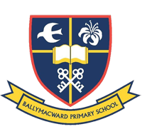
THE PARISH OF HANNAHSTOWN SCHOOL
COMMUNITY PRE-SCHOOL PLAYGROUP
Our Parish School Ballymacward Primary School,
22 Rock Road, Stoneyford, Lisburn, Co Antrim, BT28 3SUTel: (028) 92648130, Principal: Mr Hugh Kennedy
Email: info@ballmacwardps.lisburn.ni.sch.uk
Pre-School Community Playgroup – Supervisor: Ms Sarah Scott. 02892648515
HANNAHSTOWN COMMUNITY HALL

Please contact Anthony Adams for any enquiries on 90 309795.

Mon – Fri 10 am – 1 pm.

Mondays – Coffee Morning after 9.15 am Mass.



Wednesdays – Seniors Group after 9.15 am Mass.

HANNAHSTOWN ASSOCIATION AGM Our Annual General Meeting will be held on Monday 10th November at 6 pm in the Community Hall. We look forward to seeing you. (upstairs room).

