
EUCHARISTIC ADORATION
THE PARISH OF HANNAHSTOWN
St Peter’s Church - Friday’s 2 pm – 8.30 pm.
Adoration, Rosary & The Divine Mercy Chaplet in St Peter’s Church 6.30 pm – 7.30 pm every evening.
https://churchmedia.tv/st-peters-church-2
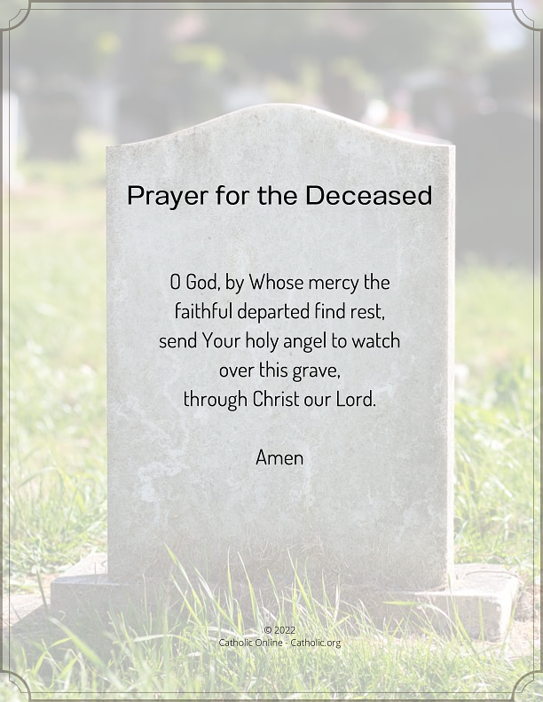
RECENTLY DECEASED – Maeve McPeake RIP
& Gerry Mulholland RIP
MONTH’S MIND – Ena Jordan RIP
ANNIVERSARIES – Jim McDonagh, John McNeice, Kieran Walker & Peggy Walker RIP
Please remember to visit Fr. Patrick in the Sacristy before Mass starts if it is Intended for your loved one.

WEEKLY COLLECTIONS
14/03/25 Weekly Collection £965.19
14/03/25 Building Collection £299.19
Thank you to everyone for their generosity to the Parish.
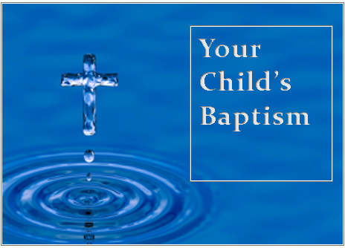
BAPTISMS
To arrange Baptisms please present the long birth certificate to the parish office.
We welcome Eireann Rose Cosgrove to our parish family.

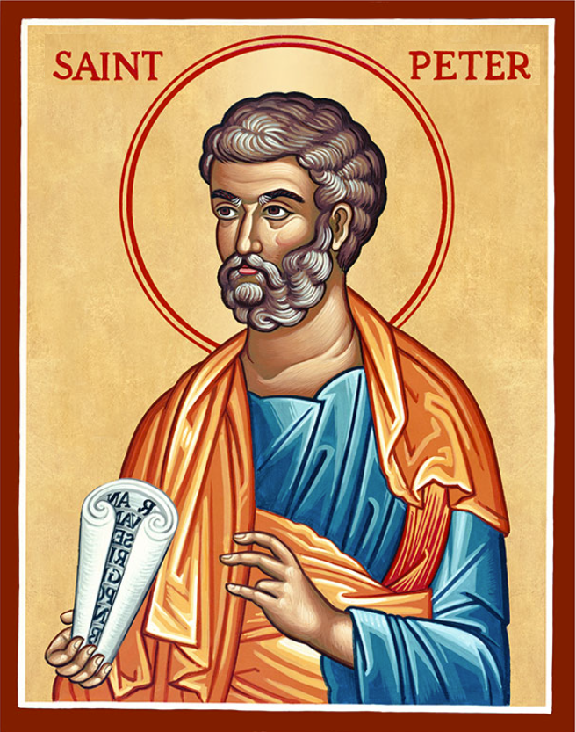
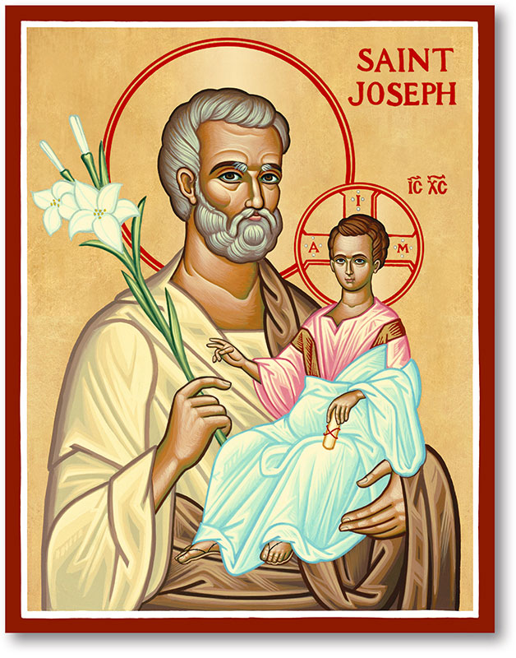
The Parish of Hannahstown
Saint Joseph’s and Saint Peter’s

21st September 2025
25th Sunday in Ordinary Time
Family of Parishes Emergency Sick Calls: 07549209775
Monday 10 am Prayer for Vocations Saint Joseph’s Tuesday Fr. Patrick’s Day off
Wednesday 9.15 am Parish Novena to Our Lady Saint Joseph’s
Thursday 9.15 am Parish novena to Our Lady Saint Peter’s
Friday 9.15 am Sacred Heart and St Michael’s Prayer Saint Joseph’s
Saturday 6:00 pm Prayer of Hope, Jubilee 2025 Saint Joseph’s
Sunday 10:00 am Prayer of Hope, Jubilee 2025 Saint Peter’s
Sunday 11:30 am Prayer of Hope, Jubilee 2025 BSL Signed Saint Joseph’s
Very Reverend Patrick Devlin Parish Priest,
Chaplain to the Deaf Community, Down and Connor Diocese
Chaplain to Antrim Area Hospital Thursday & Friday (Emergency calls)
Fr. Patrick, for Spiritual and Pastoral needs only, thank you Tel: 07910 833699
Parish Secretary: Mrs Grainne McArevey Tel: 028 90614567
Parish Email: hannahstown@downandconnor.org Parish Website: https://www.parishofhannahstown.com
TWENTY-FIFTH SUNDAY IN ORDINARY TIME

Today’s gospel calls us to account for our management of all that we are and all that we have. The manager has been charged with squandering his master’s property. He is going to be fired. He will lose his job, income, reputation, and status. At some level he will lose his life as he now knows it.
Whether we’ve lived it, heard it from a friend or colleague, or read it in the news, it’s a familiar story. Somebody has been bad. They’ve been caught. Now they’re going to get what they deserve. That’s how the world works. That’s what we expect. But that’s not how the kingdom of God works. So we ought not be too quick to come to a final or definitive interpretation of this parable.
We cannot with ease or confidence declare who, if any one in particular, each character represents: God, Jesus, or us. The parable offers ambiguity and tension not a neat resolution and that feels a lot like real life. What if the accounting is not about finding wrongdoing but new life? What if its about grace rather than punishment? The accounting of our management isn’t about numbers, wrongdoing, or punishment but about helping us see and orient our lives in a new direction. It opens us to new possibilities. It points us to our eternal home.
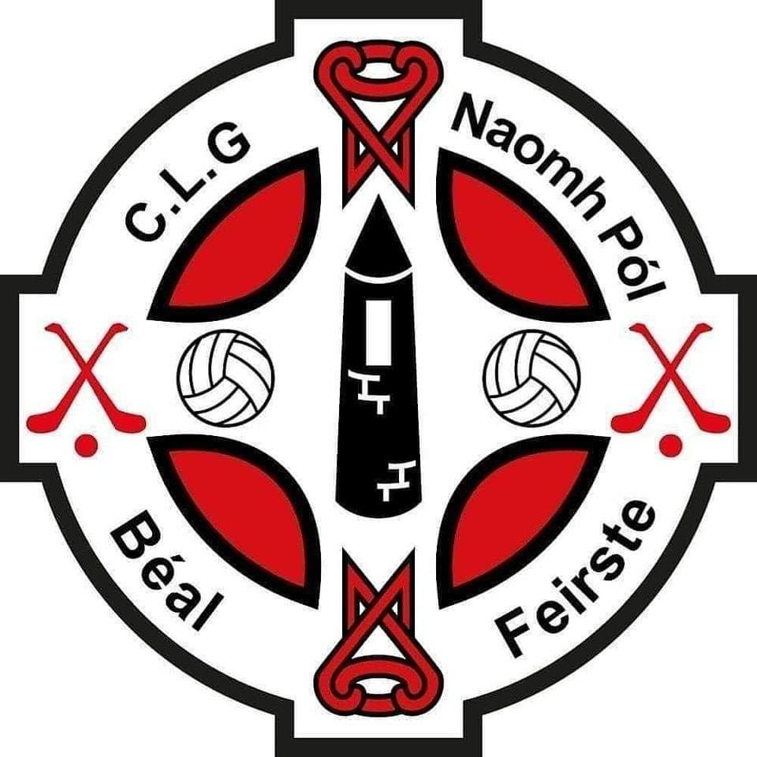
Free Irish classes at Naomh Pól. starting 23rd & 24th September- Bunrang (beginners) and Ciorcál Comhrá (conversation) every Tuesday, Meánrang (intermediate) every Wednesday. Tea, coffee & buscuits at 7.00pm, classes start at 7.15pm. Contact Glen Phillips on 07906 179605.for more details. Fáilte roimh chách!
HANNAHSTOWN PARISH / FAMILY OF PARISHES / PATHWAYS
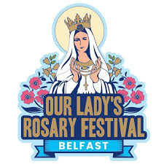
ROSARY FESTIVAL - The Legion of Mary and the Knights of Saint Columbanus present Our Lady’s Rosary Festival from Saturday 4 October to Sunday 12 October 2025 with 9 events in different venues. The Festival ends with the 22nd Annual Rosary Procession from St. John’s Church to St Peter’s Cathedral commencing at 2:30pm on Sunday 12 October. All details can be found at belfastrosaryfestival.com

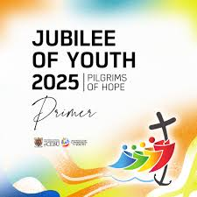
NOTICE FROM BISHOP ✠ Alan McGuckian SJ

Jubilee of Youth – Diocese of Down and Connor
📍 Clonard Monastery - 🕖 Friday, 26th September at 7.15pm
Key Highlights:
- Celebration as part of the Holy Year Jubilee.
- A special evening to uplift young people in faith and hope.
- Encouraging youth to grow as disciples and leaders.
Special Announcement:
- Launch of a new initiative for youth and young adult ministry.
- A step toward building a vibrant faith community among young people.
Call to Action:
- Priests, deacons, and pastoral leaders:
  - Invite young people from your parishes.
  - Encourage them to bring friends.
  - Promote this as a joyful encounter with God’s love.
Why It Matters:
- Your support helps young people feel valued in the Church.
- They play a vital role in its renewal.
With gratitude and blessings,
During this Season of Creation, “an ecumenical time to pray and act for our common home”, the Presbyterian Church is holding a one-day conference on caring for creation which will take place on Saturday 27th September 2025, from 10am to 4pm at Assembly Buildings, Belfast. All are welcome to attend. The keynote speaker will be Rev Dr Chris Wright, Global Ambassador and Ministry Director of the Langham Partnership. There will be breakout sessions on faith, environment, food, farming and local church initiatives. Information available at the following link or by emailing: info@presbyterianireland.org

Our Parish School Ballymacward Primary School,
THE PARISH OF HANNAHSTOWN SCHOOL
COMMUNITY PRE-SCHOOL PLAYGROUP
22 Rock Road, Stoneyford, Lisburn, Co Antrim, BT28 3SUTel: (028) 92648130, Principal: Mr Hugh Kennedy
Email: info@ballmacwardps.lisburn.ni.sch.uk

Pre-School Community Playgroup – Supervisor: Ms Sarah Scott. 02892648515

Please contact Anthony Adams for any enquiries on 90 309795.
HANNAHSTOWN COMMUNITY HALL
Mon – Fri 10 am – 1 pm.

Monday – Coffee Morning
after 9.15 am Mass.
Please come along to our popular coffee morning. An opportunity to meet with fellow parishioners for some company and good craic.


Wednesday Morning
Seniors Group
after 9.15 am Mass
Please come along, bring a friend or a neighbour, bring your knitting or just yourself, no judgments, just a chance to share some friendhsips and good conversations.

