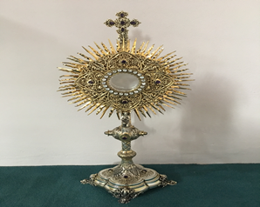
EUCHARISTIC ADORATION in St Peter’s Church - Every Friday from 2 pm – 8.30 pm.
THE PARISH OF HANNAHSTOWN
Every evening with in St Peter’s Church Adoration & Prayer from 6.30 pm – 7.30 pm
https://churchmedia.tv/st-josephs-church https://churchmedia.tv/st-peters-church-2

ANNIVERSARIES – Malachy McCague 1st Anniversary,
Patrick & Aisling Cushnahan, Phil Maguire
& Eamon McGarrity,RIP


WEEKLY COLLECTIONS
8/6/25 Weekly Collection £1,036.91
8/6/25 Building Fund Collection £ 412.09
Cemetery Sunday Collection £4,296.98

Thank you to everyone for their generosity to the Parish, especially at our Cemetery Sunday collection. This money goes a long way to help cover the costs of Cemetery Sunday and towards maintainenace our beautiful grounds.


BAPTISMS
To arrange Baptisms please present the long birth certificate to the parish office. Baptisms will be arranged upon request.

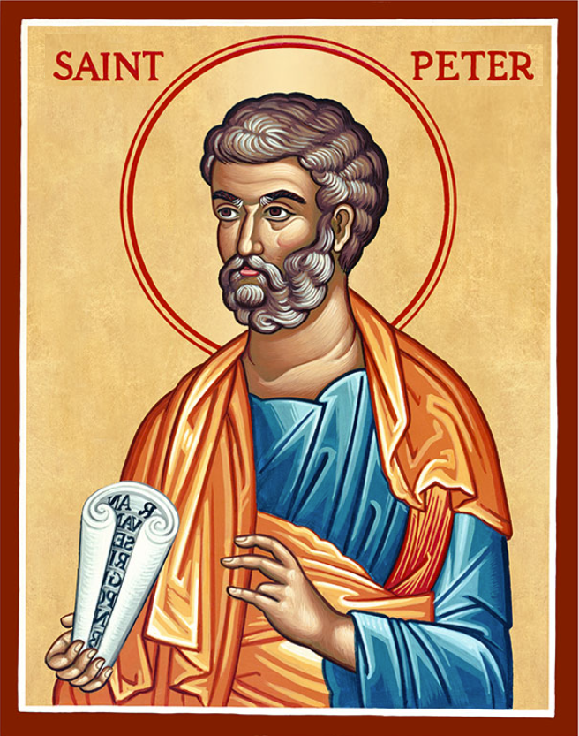
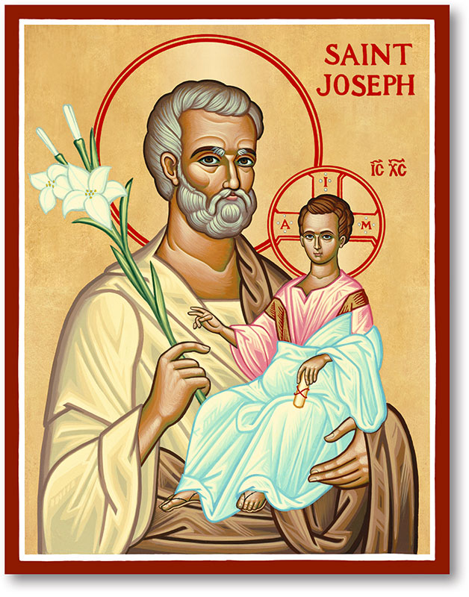
The Parish of Hannahstown
Saint Joseph’s and Saint Peter’s

15th June 2025
THE MOST HOLY TRINITY
Family of Parishes Emergency Sick Calls: 07549209775
Monday 09.15 am (Prayer for Vocations) Saint Joseph’s
Tuesday Fr. Patrick’s day off.
Wednesday 9.15 am (Parish novena to Our Lady) St Joseph’s
Thursday 9.15 am (Parish novena to Our Lady) St Peter’s
Friday 9.15 am (Sacred Heart Prayer) Saint Joseph’s
Saturday 6:00 pm (St Michael the Archangel Prayer) Saint Joseph’s
Sunday 10:00 am (Prayer for Pope’s intentions) Saint Peter’s
Sunday 11:30 am (Saint Joseph Prayer) ( BSL Signed ) Saint Joseph’s
Very Reverend Patrick Devlin, Parish Priest,
Chaplain to the Deaf Community, Down and Connor Diocese
Chaplain to Antrim Area Hospital, Thursday & Friday (Emergency calls)
Fr. Patrick, for Spiritual and Pastoral needs only, thank you Tel: 07910 833699
Parish Secretary: Mrs Grainne McArevey Tel: 028 90614567
Parish Email: hannahstown@downandconnor.org Parish Website: https://www.parishofhannahstown.com

THE MOST HOLY TRINITY

The Father, Son and Holy Spirit are persons. And as persons, they want to be known. And they want to be known primarily through a life of deep and intimate prayer. Praying to one person, of course, is praying to all, since they are one God. But we are, nonetheless, called to a relationship of love with the Father, the Son and the Holy Spirit.
Prayer often begins by saying prayers, by meditating upon Scripture, and be listening. But true prayer is something much deeper. True prayer is contemplative prayer that ultimately leads to divine union. Only God can initiate this form of prayer in our lives, and only God, through this deep form of prayr, can communicate himself to us as he is. Reflect, today, upon the Most Holy Trinity. As you do, say a prayer to God asking for a deeper and more intimate knowledge of him. As, him to communicate to you his divine love and to open your mind and heart to a deeper understanding of who he is.
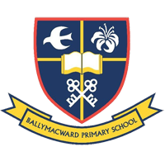
No matter what suffering there is in the world and in our lives there is also beauty. Our Parish School Ballymacward Primary School,
HANNAHSTOWN PARISH SCHOOL / COMMUNITY PLAYGROUP
22 Rock Road, Stoneyford, Lisburn, Co Antrim, BT28 3SUTel: (028) 92648130, Principal: Mr Hugh Kennedy
Email: info@ballmacwardps.lisburn.ni.sch.uk
Ballymacward Community Pre-School Playgroup - Supervisor: Ms Sarah Scott. Tel: (028) 9264 8515
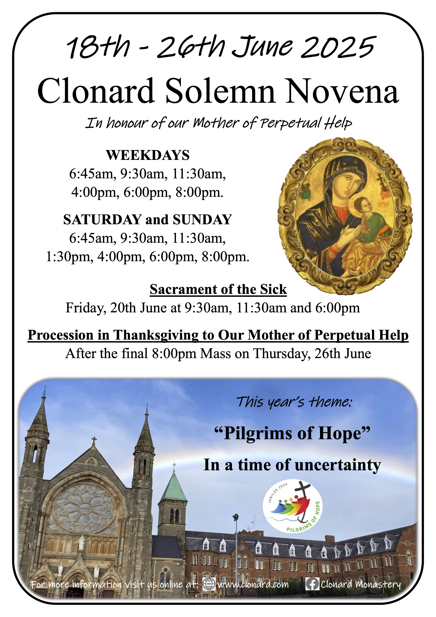
HANNAHSTOWN PARISH/FAMILY OF PARISHES

DAY OF REFLECTION - The Day of Reflection is on 21st June each year. This special day provides an opportunity for reflection and to remember that so many suffered from all corners of society in our conflict. We invite you to a service at St Anne's Cathedral from 11.30am-12.30pm on Saturday 21st June where the Day will be marked by victims as well as religious, civic and political representatives. This event is free and open to all.
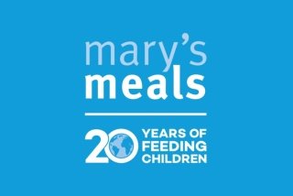
MARY’S MEALS - A representative from the charity Mary’s Meals will speak at all Masses next weekend (21st/22nd June) about their life-changing work of feeding children in some of the world’s poorest countries with a daily meal at school. There will be a bucket collection and card machine available after mass if you wish to support financially. Mary’s Meals would also appreciate your prayers in support of their work. Prayer cards will be available to take home. Further details about our work and how you can get involved can be found at www.marysmeals.org.uk or contact Caoimhe McCann on 07394564065
HANNAHSTOWN PARISH/FAMILY OF PARISHES
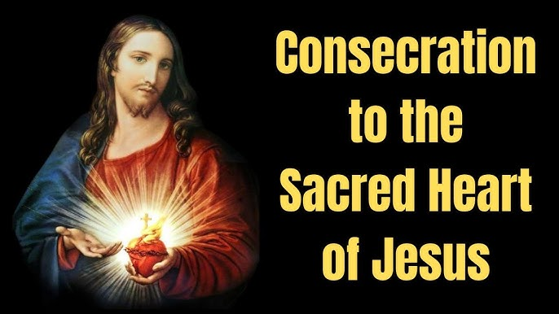
Consecration of Ireland to the Sacred Heart – Sunday 22 June 2025 - On Corpus Christi Sunday, 22nd June, Archbishop Eamon Martin will consecrate Ireland to the Sacred Heart. Bus to Knock from Belfast also picking up in Sprucefield and Banbridge. £30, children free. For further information and to book please contact Orla 07545452362

ALL-IRELAND RALLY FOR LIFE - takes place in Dublin on Saturday 5th July. Make a stand to protect Ireland's unborn babies. Coaches will be travelling from towns across Northern Ireland. To book your seat contact 02890278484/ 07592280522 or email info@preciouslife.com

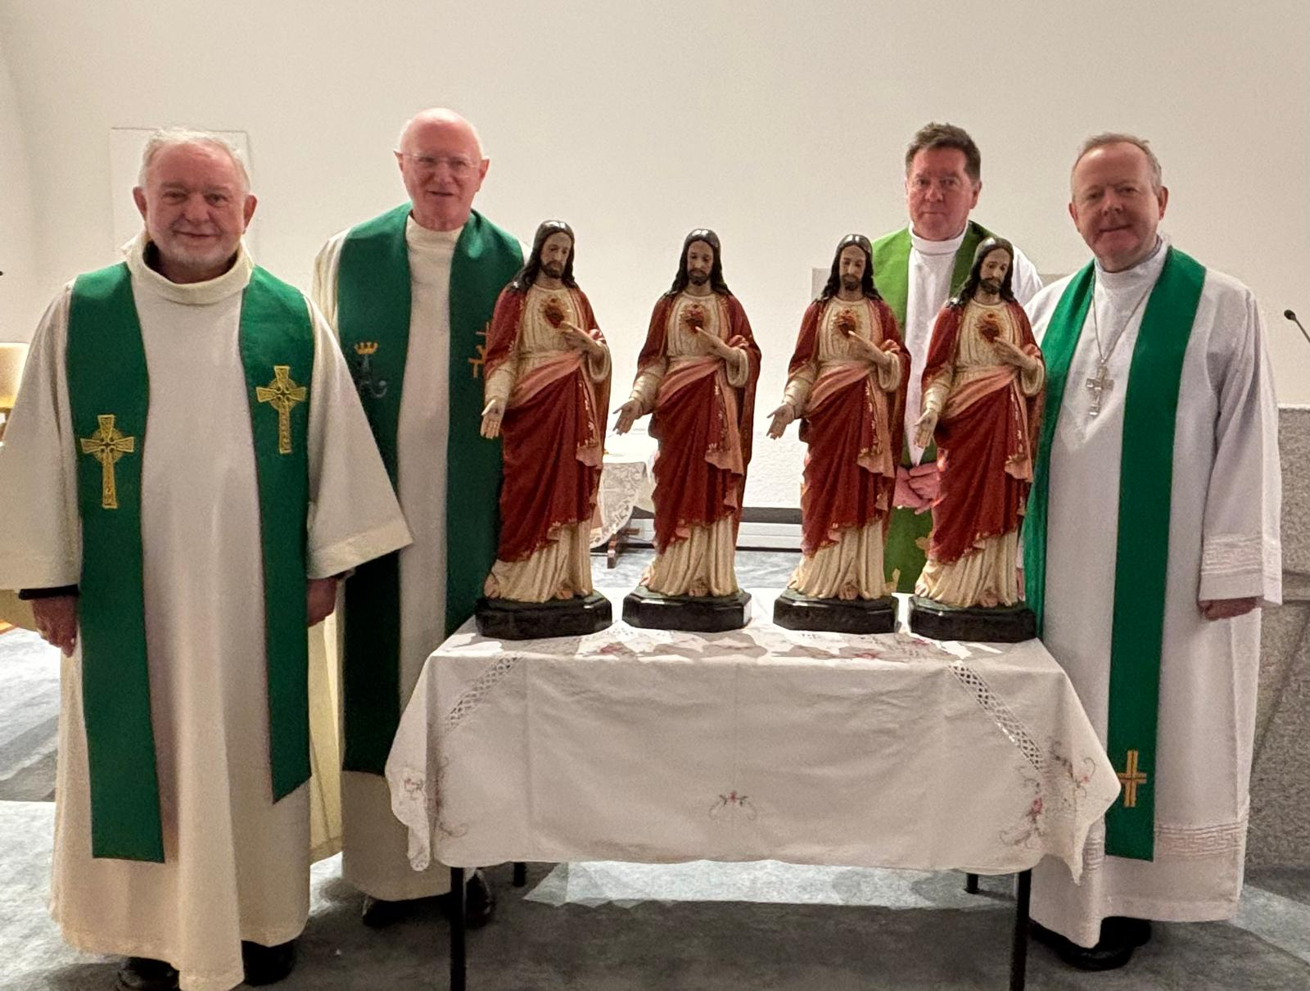
THE PILGRIM SACRED HEART STATUE - The Sacred Heart Crusade commenced with the papal blessing of four pilgrim Sacred Heart Statues on the 8th January 2025 in Rome. The Statue will arrive in St Oliver Plunkett parish on the afternoon of Sunday 15th June. On Sunday evening at 7pm there will be adoration of the Sacred Heart in the Church. On Monday 16th June, we will dedicate our Mass to the Sacred Heart with children from the primary school and music at 10am. Everyone is welcome.

