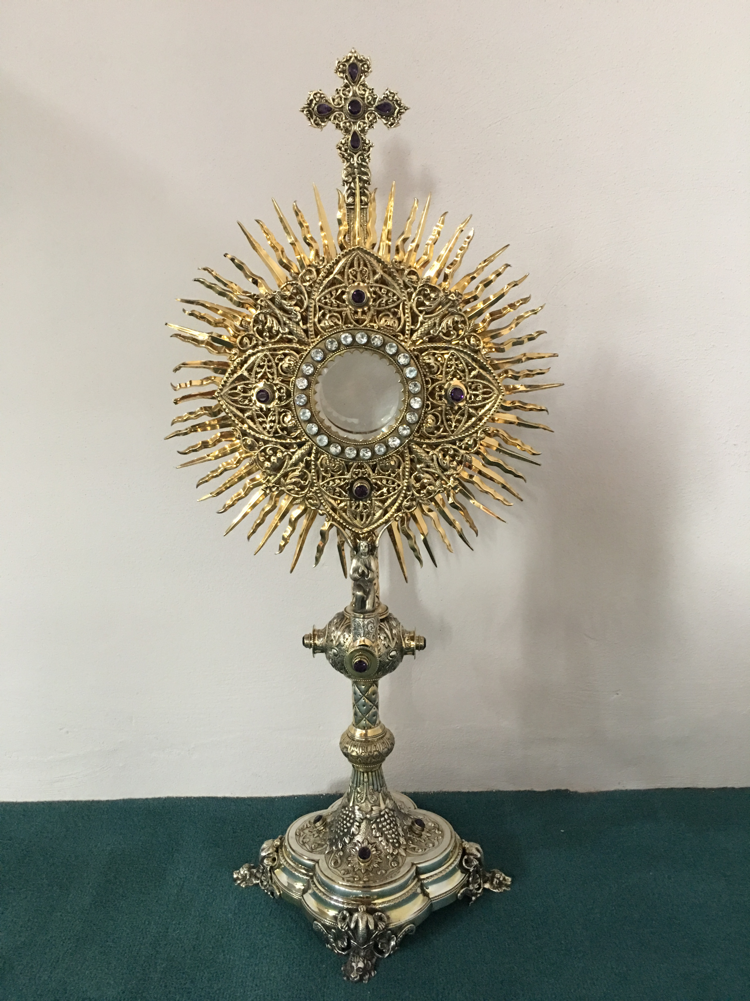
EUCHARISTIC ADORATION
The Parish of Hannahstown News
St Peter’s Church - Every Friday from 2 pm – 8.30 pm. Every evening Adoration & Prayer in St Peter’s Church 6.30 pm – 7.30 pm.
St Joseph’s Church Wednesdays during Lent from 9.45 am – 1.45 pm. You can join us in the Church or via the webcam. https://churchmedia.tv/st-josephs-church https://churchmedia.tv/st-peters-church-2
ANNIVERSARIES – James Feely, Sean Keegan, Paddy & Annie McKenna & the McKenna Family, Barney O’Kane & Marie Prior RIP.
MONTH’S MIND – Annie Kelly RIP
WEEKLY COLLECTIONS
11/03/2024 Weekly Collection £847.95
11/03/2024 Building Fund Collection £417.05
Thank you to everyone for their generosity to the Parish.
BAPTISMS Last weekend we welcomed Fódhla McKeating into our parish community.
PRE-BAPTISM COURSES – Attendance at a Pre-Baptism course is required for all parents presenting a first baby for Baptism.
To book a Baptism, please visit the parish office with the new baby’s long birth certificate.
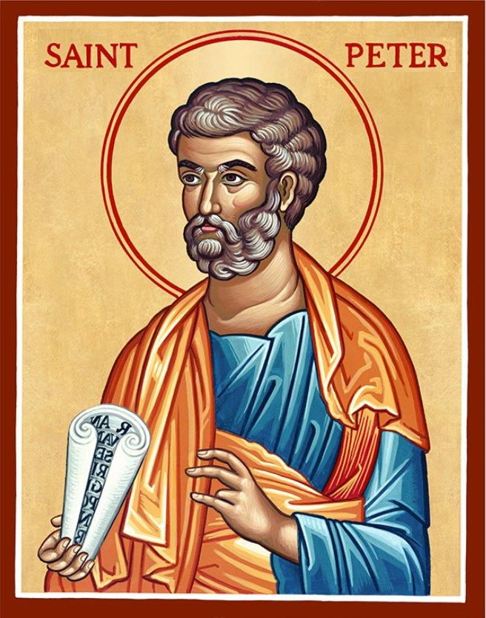
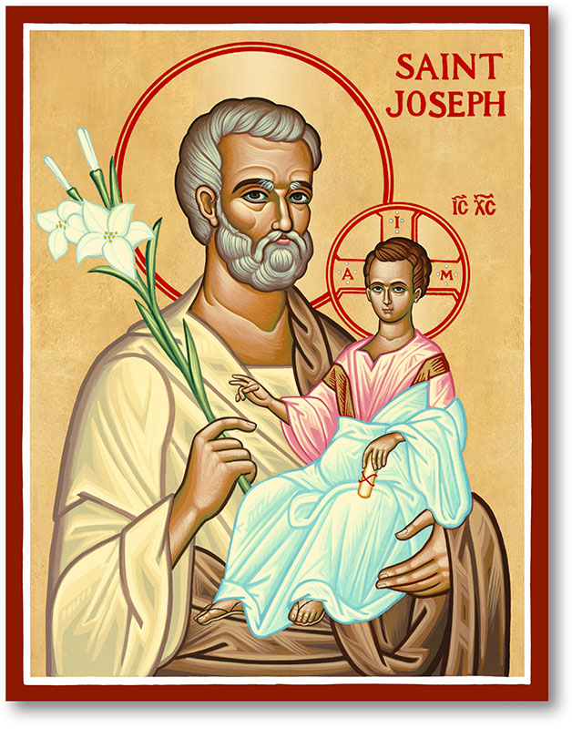
The Parish of Hannahstown
Saint Joseph’s and Saint Peter’s

17th March 2024
Fifth Sunday of Lent

Vicariate / Family of Parishes Emergency Sick Calls: 07549209775
Readings: Sunday Cycle B Weekdays Psalter Week
Monday 09:15 am (Prayer for Vocations) Saint Joseph’s
Tuesday 09:15 am For Feast of Saint Joseph’s Saint Joseph’s
Wednesday 09.15 am (Parish Novena to Our Lady) Saint Joseph’s
Thursday 09:15 am (Parish Novena to Our Lady) Saint Peter’s
Friday 09:15 am (Sacred Heart Prayer) Saint Joseph’s
Saturday 6:00 pm (Saint Michael the Archangel Prayer) Saint Joseph’ Sunday 10:00 am (Prayer for Pope’s Intentions) Saint Peter’s
Sunday 11:30 am (Saint Joseph Prayer) BSL Signed Mass Saint Joseph’s
Very Reverend Patrick Devlin Parish Priest,
Chaplain to the Deaf Community, Down and Connor Diocese
Chaplain to Antrim Area Hospital Thursday & Friday (Emergency calls)
(Fr. Patrick’s mobile…. For Spiritual and pastoral needs only, thank you) Tel: 07910 833699
Parish Secretary: Mrs Grainne McArevey Tel: 028 90614567
Parish Email: hannahstown@downandconnor.org
Parish Website: https://www.parishofhannahstown.com
FIFTH SUNDAY OF LENT & ST PATRICK’S DAY
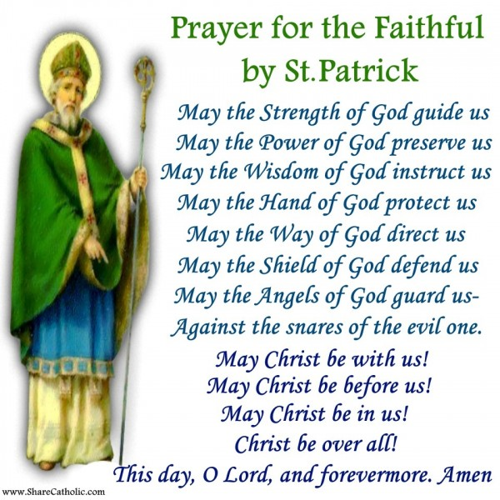

Invitation from Rev John to St Patrick’s 17th March celebrations
At St John Stoneyford 630pm
Service and food afterwards
Our Parish School Ballymacward Primary School,
THE PARISH OF HANNAHSTOWN SCHOOLS
22 Rock Road, Stoneyford, Lisburn, Co Antrim, BT28 3SUTel: (028) 92648130, Principal: Mr Hugh Kennedy
Email: info@ballmacwardps.lisburn.ni.sch.uk

Pre-School Playgroup - Supervisor: Ms Sarah Scott. Tel: (028) 9264 8515
HANNAHSTOWN COMMUNITY HALL
Please contact Anthony Adams for any enquiries on 90 309795
Mon – Fri 10 am – 1 pm.
Monday – Coffee Morning after 9.15 am Mass, everyone welcome.

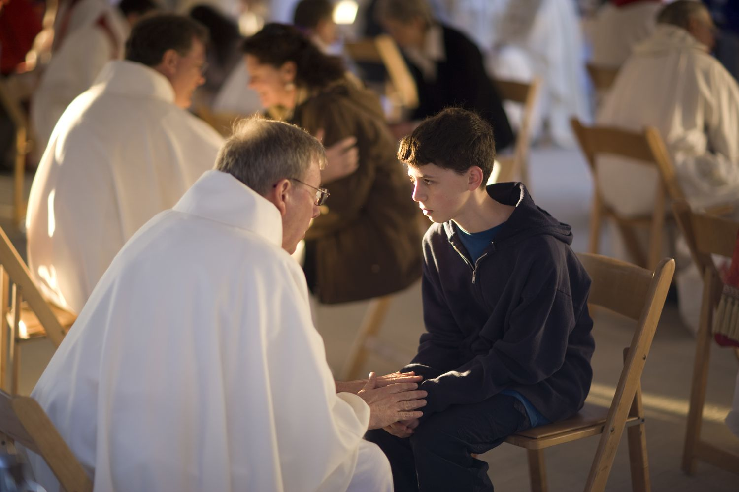
LIVING CHURCH / Family of Parishes
Reconciliation Services –
The following are dates for Lenten Parish Penitential Services, all starting @ 7 pm
St Teresa's: Thursday 21st March
Hannahstown Parish:
St Joseph’s: Sunday 24th March
St Agnes': Monday 25th March
St Oliver Plunkett's: Tuesday 26th March
St Michael's: Wednesday 27th March

Good Friday Falls/Shankill Annual Prayer Walk - will take place on Good Friday 29th March beginning at 4.45 pm in front of Clonard Church, stopping midway at Shankill Methodist for a brief prayer, and returning to Clonard by 6.00 pm. All are welcome as we commit ourselves once again to the ministry of reconciliation, in the footsteps of Jesus of Nazareth, who gave his life for everyone on this day.
Spiritual and Pastoral Commitments: March 2024 - June 2024 Update
LIVING CHURCH / Family of Parishes
Extra Mass Tuesday 09:15 am For Feast of Saint Joseph’s Saint Joseph’s
24th of March 2024, 5:00 pm-6:00 pm Saint Joseph’s Penitential Service
24th of March 2024, Palm Sunday Carrying the Cross, Saint Peter’s at 9:45 am and Saint Joseph’s at 11:00 am.
28th of March 2024, The Last Supper, Washing of the Feet, Saint Joseph’s 7:00 pm.
29th of March 2024, The Passion of Christ, Saint Joseph’s 3:00 pm.
29th of March 2024, Good Friday, Stations of the Cross, Saint Peter’s 7:00 pm
Easter
30th March 2024, Easter Vigil Mass, Saint Joseph’s 6.00 pm Mass
31st March 2024, Easter Sunday, Saint Peter’s 10:00 am Mass
31st of March 2024, Easter Sunday, Saint Joseph’s 11:30 am Mass with Baptism.
18th April 2024 Service of Light for Confirmation Saint Peter’s at 9:15 Mass
5th of May 2024, Parish School First Holy Communion, Saint Peter’s 10:00 am.
19th May 2024, Parish School Confirmations, Saint Peter’s 10:00 am
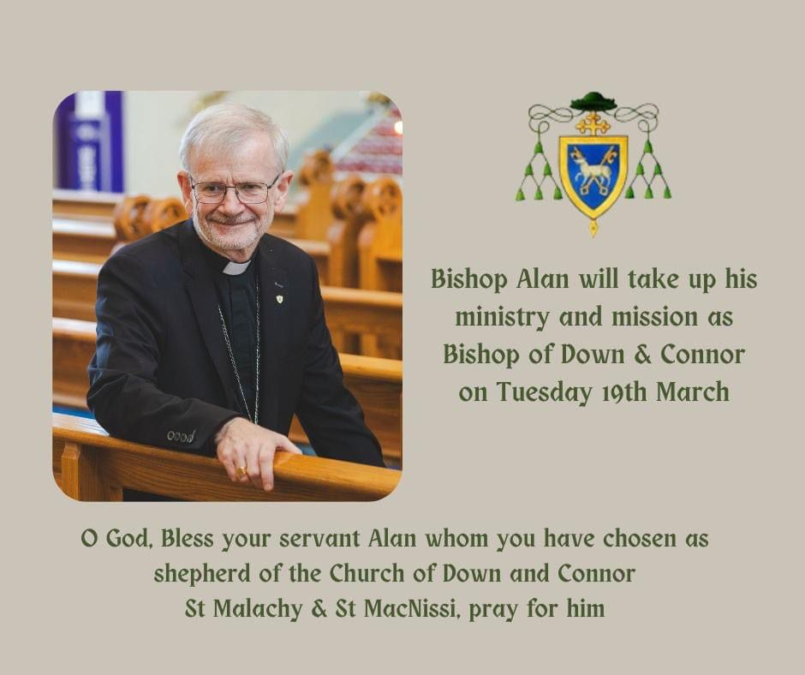

CEMETERY SUNDAY IN BELFAST CEMETERIES
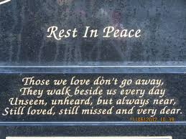
Milltown (Service) Sunday 12th May @ 3 pm
City (Service) Sunday 19th May @ 3 pm
Hannahstown Parish……..
St Joseph’s (Mass) Sunday 26th May @ 3 pm
Tullyrusk (Mass) Sunday 16th June @ 1.30 pm
St Peter’s (Mass) Sunday 9th June @ 1.30 pm

