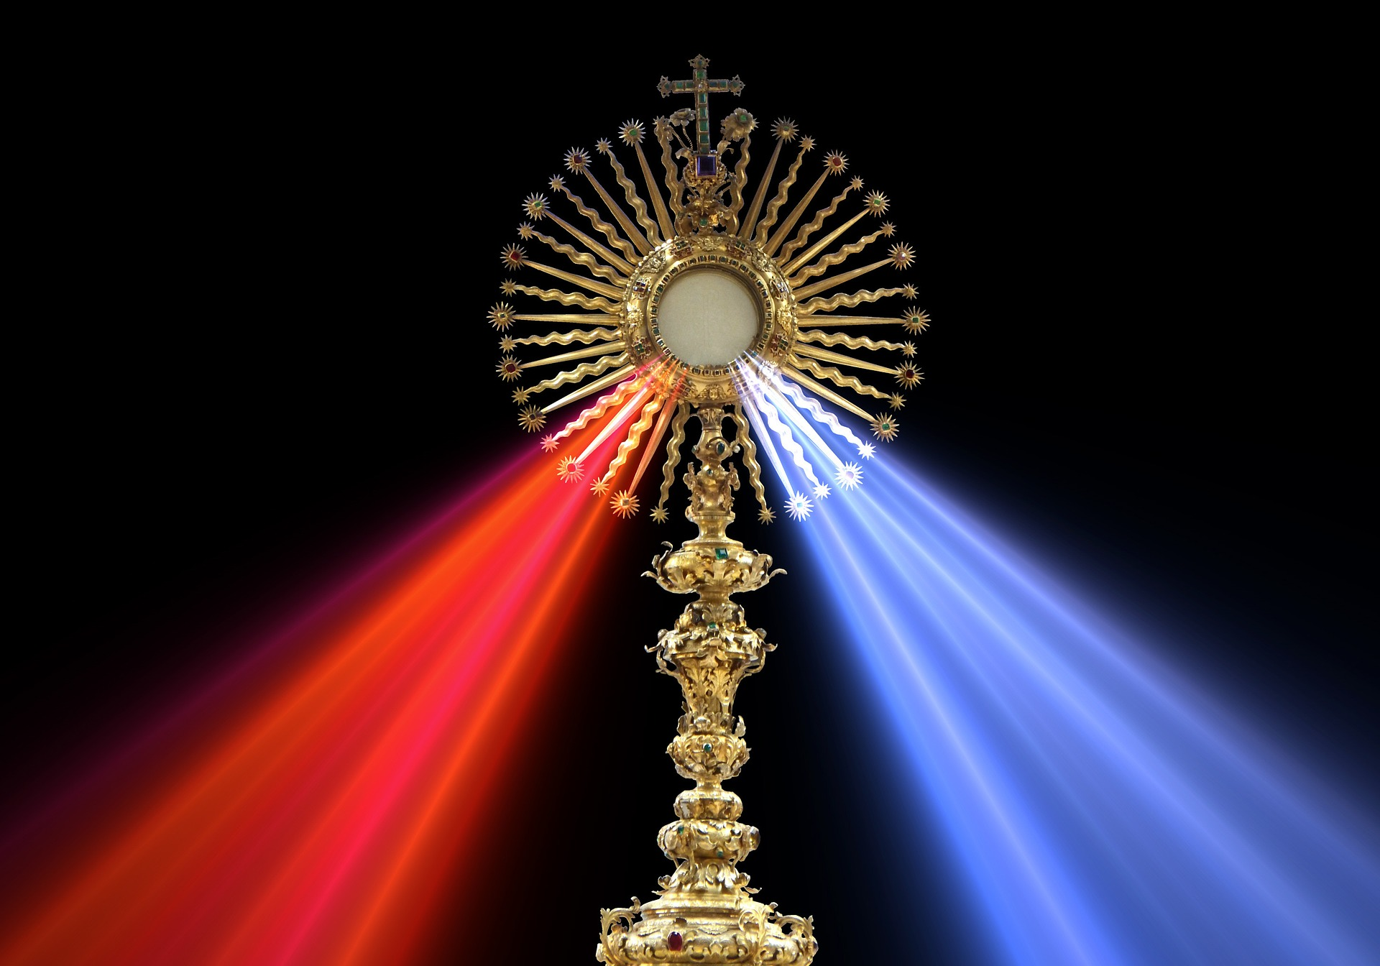
EUCHARISTIC ADORATION
THE PARISH OF HANNAHSTOWN
St Peter’s Church - Friday’s 2 pm – 8.30 pm.
Daily Adoration, Rosary & The Divine Mercy Chaplet St Peter’s Church 6.30 pm – 7.30 pm every evening. https://churchmedia.tv/st-peters-church-2

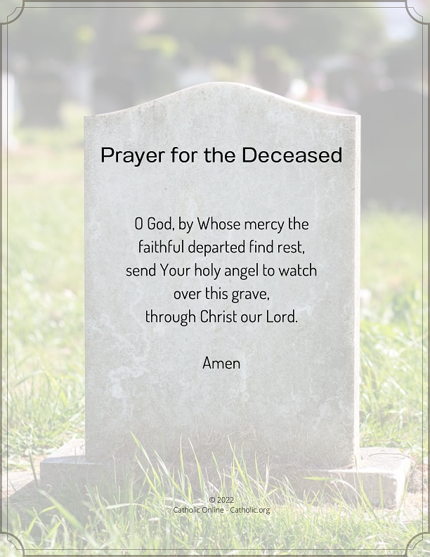
MONTH’S MIND Marie Allen RIP
ANNIVERSARIES – Christina Dowds, Charles Finnegan, Deborah Feeley, Thomas & Rose Kane, Agnes Maguire, Noel McKiernan, Paddy Stott, Jim & Bridie Quinn RIP
Please remember to visit Fr. Patrick in the Sacristy before Mass starts if it is intended for your loved one.


WEEKLY COLLECTIONS
19/10/25 Weekly Collection £750.57
19/10/25 Missions Collection £457.31
Thank you to everyone for their generosity to the Parish.

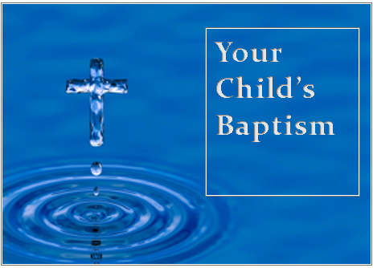
BAPTISMS
To arrange Baptisms, please present the long birth certificate to the parish office.
We welcome Baby Erin into our parish family, who was recently baptised in St Joseph’s Church.
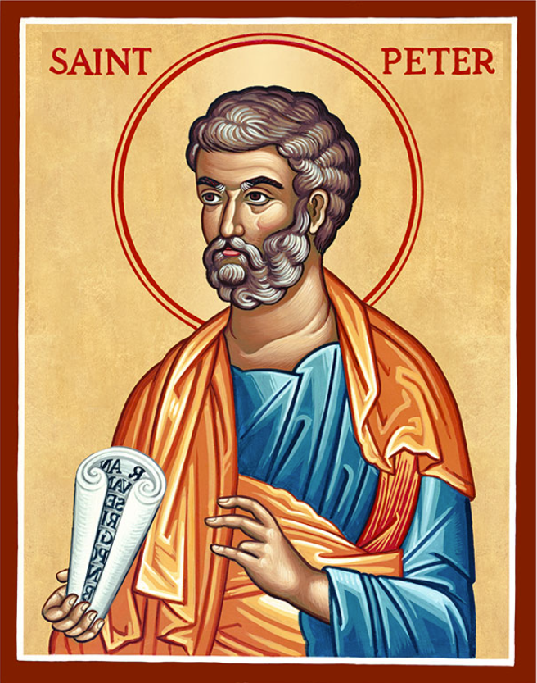
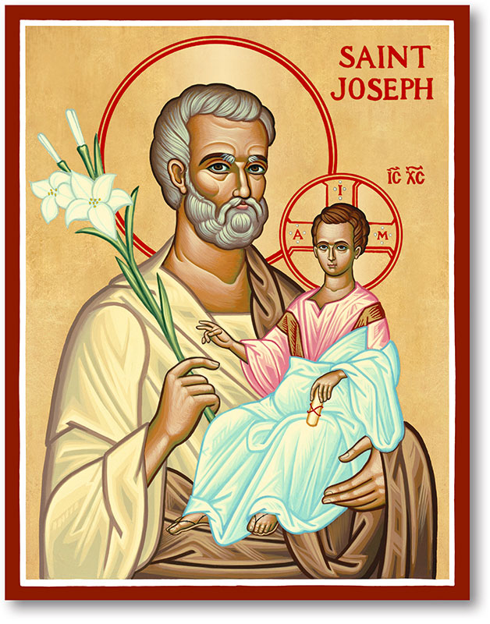
The Parish of Hannahstown
Saint Joseph’s and Saint Peter’s

26th October 2025
29th Sunday in Ordinary Time
Family of Parishes Emergency Sick Calls: 07549209775
Monday 9.15 am Prayer for Vocations Saint Joseph’s
Tuesday Fr Patrick’s Day away.
Wednesday 9.15 am Parish Novena to Our Lady Saint Joseph’s
Thursday 9.15 am Parish novena to Our Lady Saint Peter’s
Friday 9.15 am Sacred Heart and St Michael’s Prayer Saint Joseph’s
Family of Parishes
All Saints Holy Day of Obligation 1st November (Vigils)
Saint Oliver Plunket 730pm
Saint Teresa’s Parish Holy Spirit Church 5pm
Saint Agnes 7pm
Saturday Day Masses
Saint Michael’s 10am
Holy Trinity 10am
Saint Oliver Plunket 10am
Saint Agnes 1pm
Saint Teresa’s Church & Saint Matthais 10am
Hannahstown Parish Saint Joseph’s 1130am

Saturday 6:00 pm Prayer of Hope, Jubilee 2025, Saint Joseph’s
Sunday 10:00 am Prayer of Hope, Jubilee 2025 Saint Peter’s
Sunday 11:30 am Prayer of Hope, Jubilee 2025
Saint Joseph’s
Very Reverend Patrick Devlin, Parish Priest,
Chaplain to the Deaf Community, Down and Connor Diocese
Chaplain to Antrim Area Hospital Thursday & Friday (Emergency calls)
Fr. Patrick, for Spiritual and Pastoral needs only, thank you Tel: 07910 833699
Parish Secretary: Mrs Grainne McArevey Tel: 028 90614567
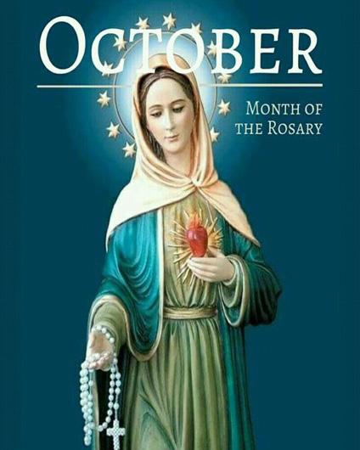
October, Rosary – Month
Lord Jesus, Mary, and the Holy Family,
In this month of the Rosary, it’s final week, we come to you to reflect on the mysteries of Jesus's life and Mary's role in it. We pray for guidance, peace, and a deeper connection with you through our prayers and meditations. Help us to overcome our weaknesses and live a life of virtue in imitation of your grace and love, so we can be worthy children of God and rejoice in your divine victory over sin and death.
KNOCK PILGRIMAGE – There is a one day Pilgrimage to Knock on the Feast of All Souls, Sunday 2nd November 2025. Departs St Agnes Church at 7.30 am. Price £26 (includes Tea & Scone). For further information contact Pat on 07946917354 or Harriet on 07812098991.
HANNAHSTOWN PARISH / FAMILY OF PARISHES / PATHWAYS
KNOCK ALL NIGHT VIGIL – Departs from Clonard Monastery at 1.45 pm on Sunday 7th December, Returns Monday 8th December. Price is £75.00 and this includes dinner & breakfast. For further informtion call Brendan 02890 665211 or pay a £20 deposit to Shearers Butchers beside Andersonstown Leisure Centre.
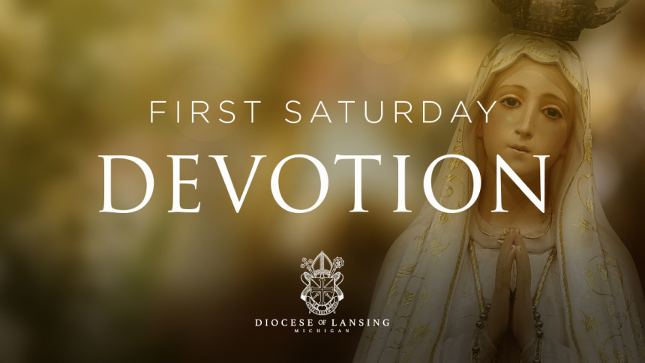
FIRST SATURDAY DEVOTIONS - First Saturday Devotions will take place in St. Matthias’s
Church, Glen Road on 1st November.
3.00 p.m. Adoration of the Blessed Sacrament, Confessions and Act of Consecration.,
Rosary and Divine Mercy Chaplet. 4.00 p.m. Holy Sacrifice of the Mass

MEN’S ROSARY - A men's public Rosary with Meditations on five Rosary Mysteries organised by the "Men's Rosary Ireland" group will be prayed on High Street, Ballymoney Town Centre, close to the "Taxi Stand" on All Saints Day, Saturday the 1st of November 2025 assembling at 12:45 p.m. to begin at 1p.m. This year is the 100th anniversary of Heaven's request to carry out the Five First Saturdays Devotion. Make this prayer meeting on All Saints Day in Ballymoney part of your First Saturday Devotion and by doing so help bring about Peace on Earth. Search mensrosaryireland.com for further details
Hannahstown Parish Draw -----TO ALL MEMBERS & PROMOTERS
HANNAHSTOWN PARISH / FAMILY OF PARISHES / PATHWAYS
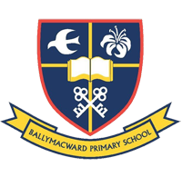
Please note all parish draw money is now due for 2024 – 2025, Please pay your promoter or call to the parish office to make a payment. You can also make a BACS Transfer to Danske Bank: Sort Code 95 01 03 Account 00325821, Give your full name as a reference. Many Thanks for the fantastic support you give our parish, we are very grateful. Again if anyone wishes to become a promoter, please contact the parish office. The monies raised goes towards the day to day costs for the Parish.
THE PARISH OF HANNAHSTOWN SCHOOL
COMMUNITY PRE-SCHOOL PLAYGROUP
Available for Our Parish School Ballymacward Primary School,
22 Rock Road, Stoneyford, Lisburn, Co Antrim, BT28 3SUTel: (028) 92648130, Principal: Mr Hugh Kennedy
Email: info@ballmacwardps.lisburn.ni.sch.uk
Pre-School Community Playgroup – Supervisor: Ms Sarah Scott. 02892648515
HANNAHSTOWN COMMUNITY HALL

Please contact Anthony Adams for any enquiries on 90 309795.
Mon – Fri 10 am – 1 pm.
Mondays – Coffee Morning after 9.15 am Mass.
Wednesdays – Seniors Group after 9.15 am Mass.
HALLOWEEN DISCO FUN For families & young children with free entry for all on Sunday 26th October 6 pm to 8 pm. We look forward to seeing you for a night of fancy dress, games & prizes.
HANNAHSTOWN ASSOCIATION AGM Our Annual General Meeting will be held on Monday 10th November at 6 pm in the Community Hall. We look forward to seeing you. (upstairs room).

