
EUCHARISTIC ADORATION
THE PARISH OF HANNAHSTOWN
St Peter’s Church - Friday’s 2 pm – 8.30 pm.
Daily Adoration, Rosary & The Divine Mercy Chaplet St Peter’s Church 6.30 pm – 7.30 pm every evening.
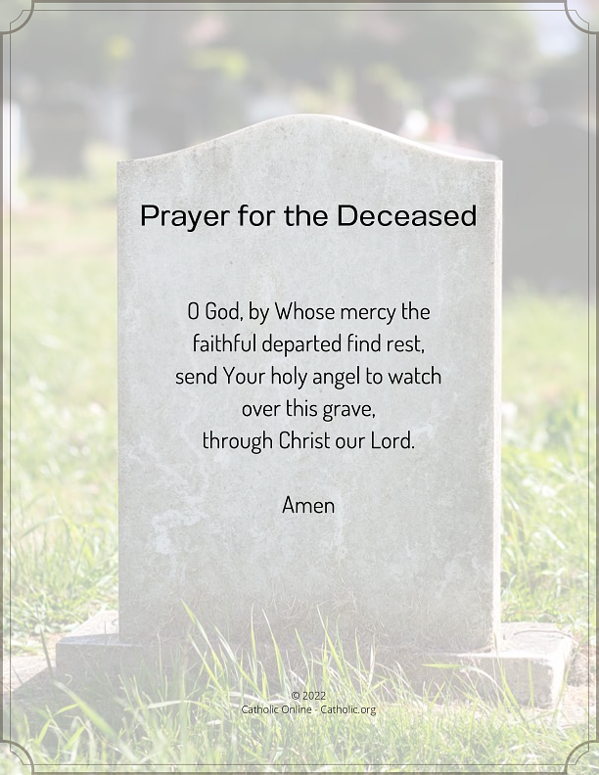
https://churchmedia.tv/st-peters-church-2
RECENTLY DECEASED – Marie Allen &
Theresa Feetham RIP
MONTH’S MIND – Pat Cushnahan
& Rosaleen Sturgeon RIP
ANNIVERSARIES – James Belshaw, Jimmy Cushnahan, Betty Ellis, Alex Quinn, Hugh Scollay, RIP

Please remember to visit Fr. Patrick in the Sacristy before Mass starts if it is Intended for your loved one.

WEEKLY COLLECTIONS
28/09/25 Weekly Collection £798.59
Thank you to everyone for their generosity to the Parish.
PARISH DRAW - Please collect a September Winners Sheet from the Church porch. Well Done to all our winners.
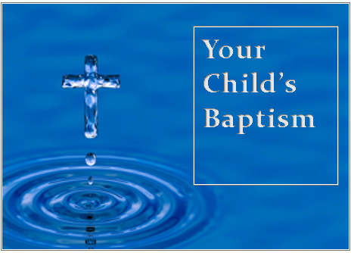
BAPTISMS
To arrange Baptisms please present the long birth certificate to the parish office.
We welcome John Joseph Collins, Daithi Magee & Ruairi McVeigh, to our parish family.

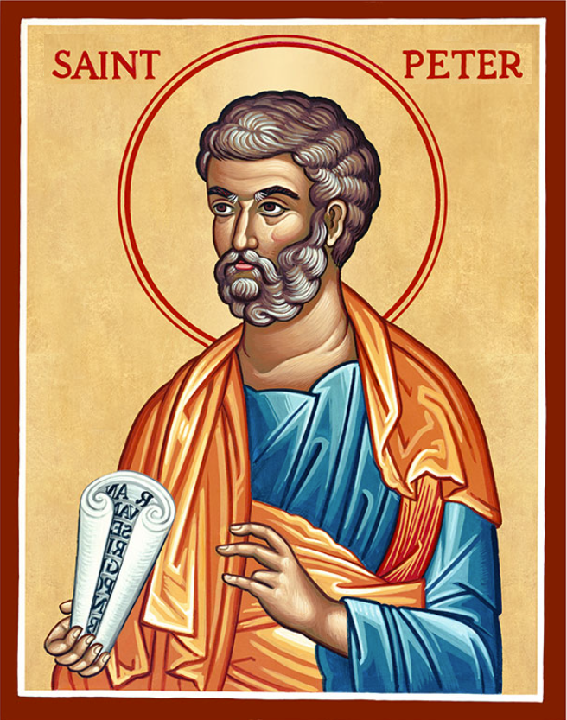
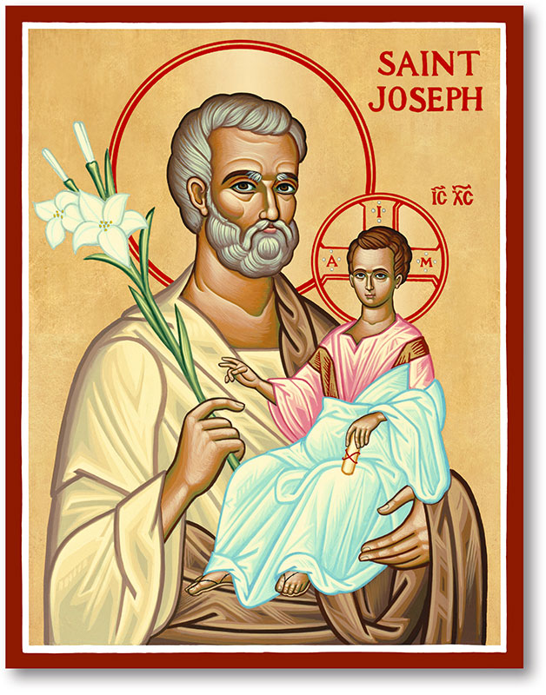
The Parish of Hannahstown
Saint Joseph’s and Saint Peter’s

5th October 2025
27th Sunday in Ordinary Time
Family of Parishes Emergency Sick Calls: 07549209775
Monday 9.15 am Prayer for Vocations Saint Joseph’s Wednesday 9.15 am Parish Novena to Our Lady Saint Joseph’s
Thursday 9.15 am Parish novena to Our Lady Saint Peter’s
Friday 9.15 am Sacred Heart and St Michael’s Prayer Saint Joseph’s
Saturday 6:00 pm Prayer of Hope, Jubilee 2025 Saint Joseph’s
Sunday 10:00 am Prayer of Hope, Jubilee 2025 Saint Peter’s
Sunday 11:30 am Prayer of Hope, Jubilee 2025 BSL Signed Saint Joseph’s
Very Reverend Patrick Devlin, Parish Priest,
Chaplain to the Deaf Community, Down and Connor Diocese
Chaplain to Antrim Area Hospital Thursday & Friday (Emergency calls)
Fr. Patrick, for Spiritual and Pastoral needs only, thank you Tel: 07910 833699
Parish Secretary: Mrs Grainne McArevey Tel: 028 90614567
Parish Email: hannahstown@downandconnor.org Parish Website: https://www.parishofhannahstown.com
27th Sunday in Ordinary Time

As Christ’s disciples we come together knowing that the gift of faith is given to us so that we may perservere in all our trails.
Faith will not change the circumstances of our lives. Instead, it changes us. Living in faith does not shield us from the pain and difficulties of life, it does not undo the past, and it will not guarantee a particular future. Rather, faith is the means by which we face and deal with the circumstances of life – the difficulties and losses, the joys and successes, the opportunities and possibilities. Faith, however, is not lived out in the abstract. It is practiced day after day in ordinary everyday circumstances.
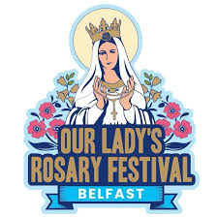
ROSARY FESTIVAL - The Legion of Mary and the Knights of Saint Columbanus present Our Lady’s Rosary Festival from Saturday 4 October to Sunday 12 October 2025. All details can be found at belfastrosaryfestival.com or on the Church noticeboard.
HANNAHSTOWN PARISH / FAMILY OF PARISHES / PATHWAYS


RECHARGE - Recharge is a young adult group based in St Colmcille’s Church in East Belfast for 18 to 35 year olds. We meet twice a month to “recharge” our spiritual batteries through prayer, intellectual formation and friendship. All are welcome! Dates for your diary for October:
- Tuesday 7th October @7.30pm: Holy Hour with Adoration followed by social in the church hall.
- Tuesday 22nd October @7.30pm: Group Study - Growing in Prayer. Followed by social.



LIFE CHAIN - Join Precious Life on Saturday 18th October 2025 at Belfast City Hall at 2pm for a Life Chain to mark the 6th Anniversary of Westminster imposing abortion on Northern Ireland. Stand with us in remembrance of the innocent babies lost since then, as we advocate for the protection of life. For more information, please contact Precious Life 028 90278484 or 07592280522
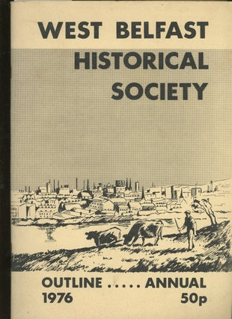
THE WEST BELFAST HISTORICAL SOCIETY - The October meeting will take place on Friday the 10th of October at 7.30pm in St. Michael's Parish Centre, Finaghy Road North (Access via Church Gateway on Finaghy Road North, just past the garage opposite the Church at the junction with Andersonstown Road).

Our Parish School Ballymacward Primary School,
THE PARISH OF HANNAHSTOWN SCHOOL
COMMUNITY PRE-SCHOOL PLAYGROUP
22 Rock Road, Stoneyford, Lisburn, Co Antrim, BT28 3SUTel: (028) 92648130, Principal: Mr Hugh Kennedy
Email: info@ballmacwardps.lisburn.ni.sch.uk

Pre-School Community Playgroup – Supervisor: Ms Sarah Scott. 02892648515

Please contact Anthony Adams for any enquiries on 90 309795.
HANNAHSTOWN COMMUNITY HALL
Mon – Fri 10 am – 1 pm.
Mondays – Coffee Morning after 9.15 am Mass.
Wednesdays – Seniors Group after 9.15 am Mass.
Please come along to our popular coffee morning. An opportunity to meet with fellow parishioners for some company and good craic.

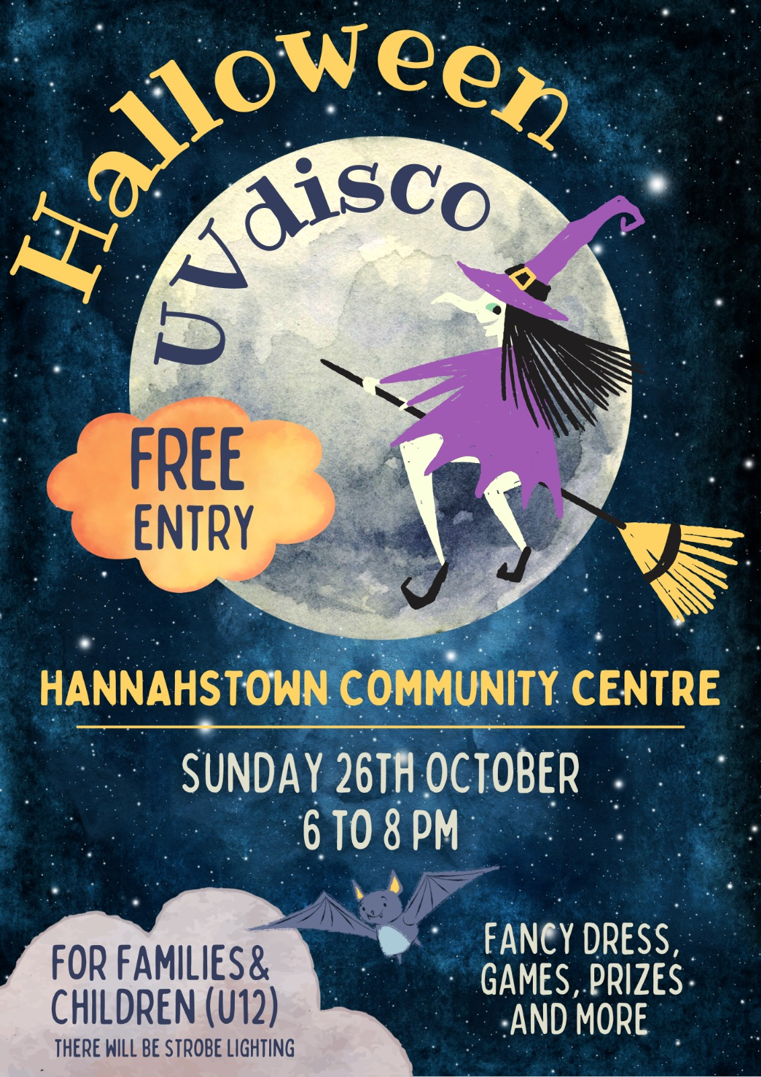

Halloween Disco Fun

For families & young children with free entry for all on Sunday 26th October
We look forward to seeing you for a night of fancy dress, games & prizes.

