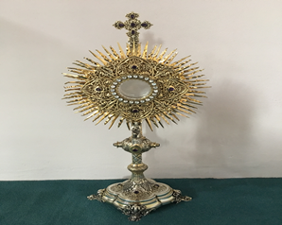
EUCHARISTIC ADORATION in St Peter’s Church - Every Friday from 2 pm – 8.30 pm.
THE PARISH OF HANNAHSTOWN
Every evening within St Peter’s Church, Adoration & Prayer from 6.30 pm – 7.30 pm
https://churchmedia.tv/st-josephs-church https://churchmedia.tv/st-peters-church-2


RECENTLY DECEASED – Winnifred Crean RIP
MONTH’S MIND – RIP
1st ANNIVERSARIES – RIP
ANNIVERSARIES – Patrick and Patricia Devlin,Anthony Mc Garrity RIP


WEEKLY COLLECTIONS
05/08/25 Weekly Collection £ 945.321
05/08/25 Monthly Offering £ 604.75

Thank you to everyone for their generosity to the Parish.


BAPTISMS
To arrange Baptisms, please present the long birth certificate to the parish office.
Baptisms will be arranged upon request.

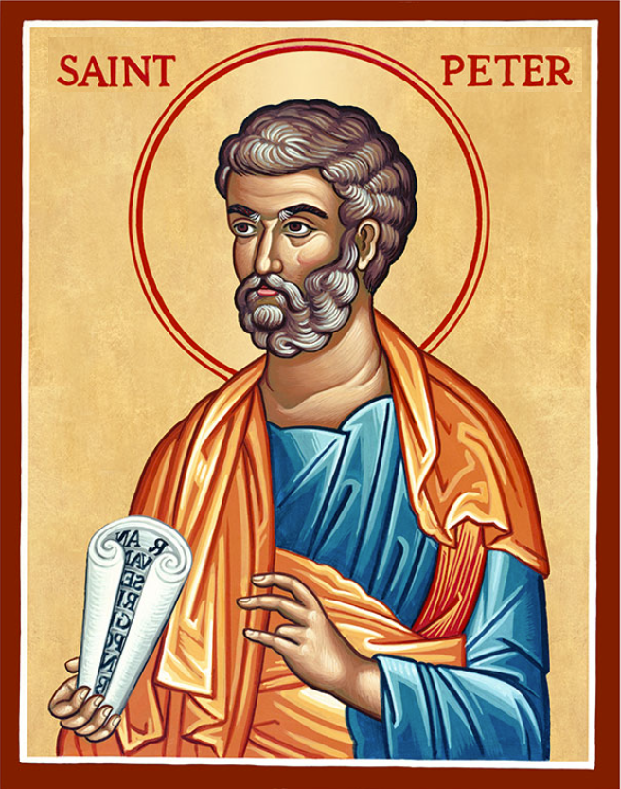
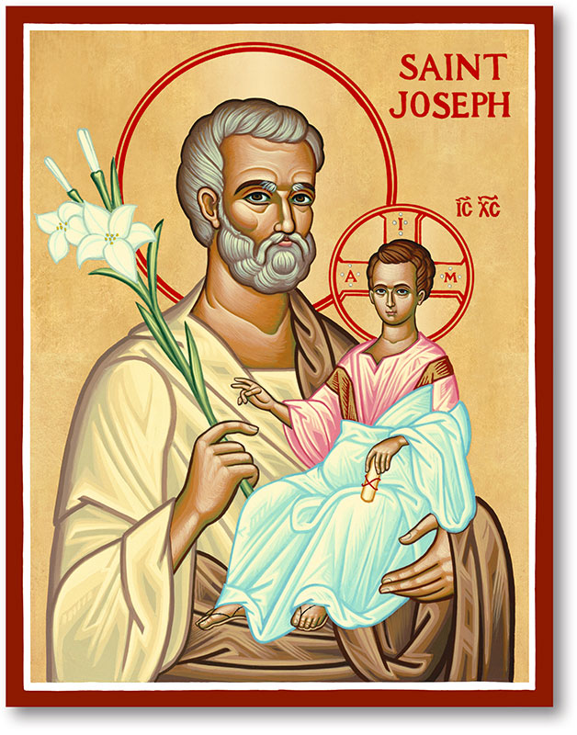
The Parish of Hannahstown
Saint Joseph’s and Saint Peter’s

16th Of August 2025
Fourteenth Sunday In Ordinary Time
Family of Parishes Emergency Sick Calls: 07549209775
Monday 09.15 am (Prayer for Vocations) Saint Joseph’s
Tuesday Fr. Patrick’s day off.
Wednesday 9.15 am (Parish novena to Our Lady) St Joseph’s
Thursday 9.15 am (Parish novena to Our Lady) St Peter’s
Friday 9.15 am (Sacred Heart Prayer) Saint Joseph’s
Saturday 6:00 pm (St Michael the Archangel Prayer) Saint Joseph’s
Sunday 24th August 10:00 am NO MASS Saint Peter’s
Sunday 24th August 11:30 am ( Prayer to St Joseph ) Saint Joseph’s
Fr. Patrick covering in Family of Parishes from 13th July and AUGUST TIME)
Very Reverend Patrick Devlin, Parish Priest,
Chaplain to the Deaf Community, Down and Connor Diocese
Chaplain to Antrim Area Hospital, Thursday & Friday (Emergency calls)
Fr. Patrick, for Spiritual and Pastoral needs only, thank you Tel: 07910 833699
Parish Secretary: Mrs Grainne McArevey Tel: 028 90614567
Parish Email: hannahstown@downandconnor.org Parish Website:

https://www.parishofhannahstown.com

Fr Tommy Flaherty, a priest with the Society of African Missions (SMA), will be
saying Mass in the parish this weekend . He will be speaking
about the work the SMA priests carry out in various countries throughout the world.
There will not be a mission collection, but he will leave envelopes in the churches
for people to take and put a donation in. These envelopes can be returned with your
parish envelopes the following week and they will be passed on to the SMA Fathers.


Ballymacward Primary School,
HANNAHSTOWN PARISH SCHOOL / COMMUNITY PLAYGROUP
22 Rock Road, Stoneyford, Lisburn, Co Antrim, BT28 3SUTel: (028) 92648130, Principal: Mr Hugh Kennedy
Email: info@ballmacwardps.lisburn.ni.sch.uk
Ballymacward Community Pre-School Playgroup - Supervisor: Ms Sarah Scott. Tel: (028) 9264 8515

We would like to wish all the staff and children of Ballymacward a happy summer break.
HANNAHSTOWN PARISH/FAMILY OF PARISHES

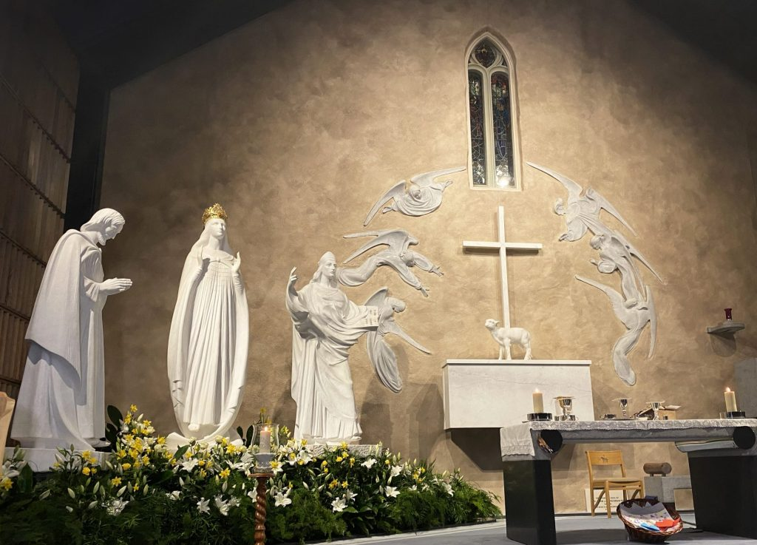
PILGRIMAGE TO KNOCK SHRINE Our Family of Parishes is organising a Pilgrimage to Knock on 2-3rd September. The cost will be £155 all inclusive.
HANNAHSTOWN PARISH/FAMILY OF PARISHES
The Pilgrimage will include Mass at the Apparition wall, Stations of the Cross, Rosary, Sacrament of the Sick, Confession, a visit to the Basilica and a stop at the Holy Well at Tobernault, Co. Sligo.
Sixteen places are available on a first-come, first-served basis. A deposit or full payment will secure a place.
Payment should be made by 20th August.
If you are interested in going on the Pilgrimage, please leave your name with your parish secretary. –.

BELFAST TRUST FOSTERING RECRUITMENT CAMPAIGN 25/26 - The Belfast Trust are seeking to make positive connections and build its Fostering Community. Currently, there are 3,154 children in the North of Ireland being looked after by a total of 2,562 foster carers. The reality is that there are local children who need local foster carers to care for and support them. Community input is essential. If you are interested, please get in touch with Aisling McLaughlin, Senior Practitioner, on 07385422706.

PRAYER FOR GOING ON HOLIDAY
Heavenly Father,

Please bless our holiday time. Help our family to have patience and understanding. Guide us to be mindful of this gift of time together.
Help us to make compromises when necessary and handle any
Chaos that comes our way with Your love and grace.
Open our eyes to truly see the beauty of the memories we are creating. Through Christ our Lord. Amen.

