
EUCHARISTIC ADORATION
THE PARISH OF HANNAHSTOWN
St Peter’s Church - Friday’s 2 pm – 8.30 pm.
Adoration, Rosary & The Divine Mercy Chaplet in St Peter’s Church 6.30 pm – 7.30 pm every evening.
https://churchmedia.tv/st-peters-church-2
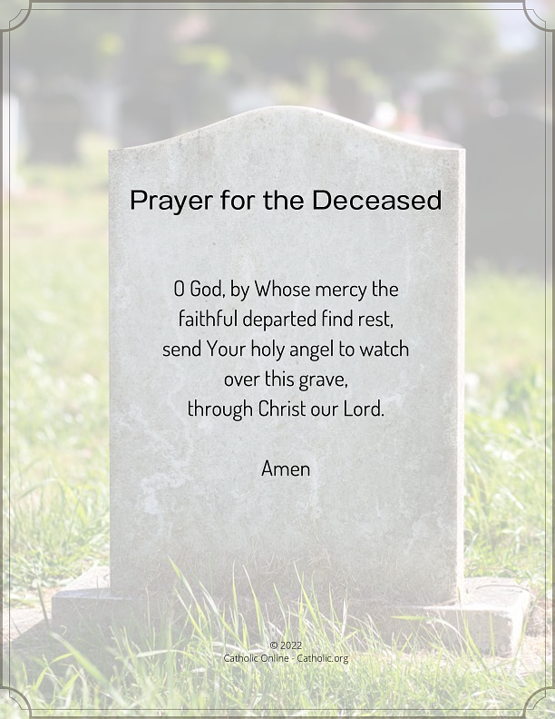
RECENTLY DECEASED – Rosaleen Jordan,
Pat Cushnahan, Kieran McGrath &
Rosaleen Sturgeon. RIP
ANNIVERSARIES – Bridie Grant, Rose Maguire, Mary Anne Mulligan, Adrian McGovern,
Nuala McGovern & Rose Rogan RIP
Please remember to visit Fr. Patrick in the Sacristy before Mass starts if it is Intended for your loved one.


WEEKLY COLLECTIONS
07/03/25 Weekly Collection £895.57
07/03/25 Monthly Collection £662.76
SMA Society of African Missions £1,100
Fr Tommy Faherty thankyou letter in porch

Thank you to everyone for their generosity to the Parish.
BAPTISMS
To arrange Baptisms please present the long birth certificate to the parish office.
We welcome James Scott, Fiadh McGuigan
& Lailah Munro to our parish family.
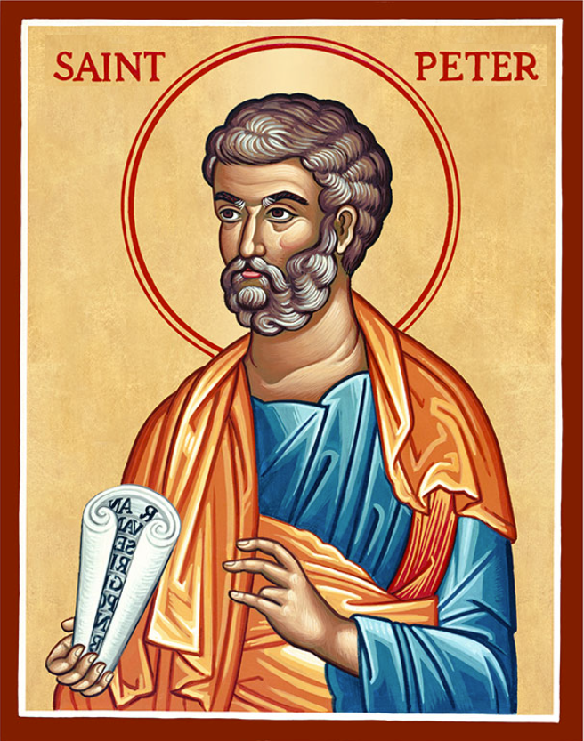
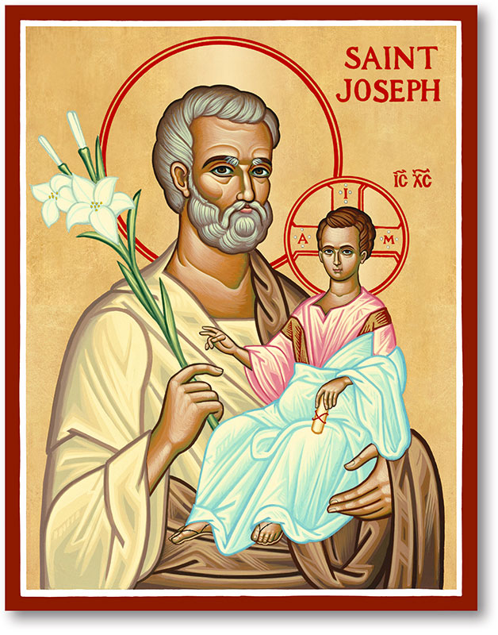
The Parish of Hannahstown
Saint Joseph’s and Saint Peter’s

14th September 2025
Exaltation of The Holy Cross

Family of Parishes Emergency Sick Calls: 07549209775
Monday 10 am Prayer for Vocations Saint Joseph’s Tuesday Fr. Patrick’s Day off
Wednesday 9.15 am Parish Novena to Our Lady Saint Joseph’s
Thursday 9.15 am Parish novena to Our Lady Saint Peter’s
Friday 9.15 am Sacred Heart and St Michael’s Prayer Saint Joseph’s
Saturday 6:00 pm Prayer of Hope, Jubilee 2025 Saint Joseph’s
Sunday 10:00 am Prayer of Hope, Jubilee 2025 Saint Peter’s
Sunday 11:30 am Prayer of Hope, Jubilee 2025 BSL Signed Saint Joseph’s

Very Reverend Patrick Devlin Parish Priest,
Chaplain to the Deaf Community, Down and Connor Diocese
Chaplain to Antrim Area Hospital Thursday & Friday (Emergency calls)
Fr. Patrick, for Spiritual and Pastoral needs only, thank you Tel: 07910 833699
Parish Secretary: Mrs Grainne McArevey Tel: 028 90614567
Parish Email: hannahstown@downandconnor.org Parish Website: https://www.parishofhannahstown.com

THE EXALTATION OF THE HOLY CROSS

WALK THE CROSS EUCHARISTIC PROCESSION - Saint Michaels Church, Finaghy, Walk The Cross today Sunday September 14th starts at 4 pm.
Meet at St Michaels for the procession that will end at St Peter’s Cathedral. Unite your hearts to the Eucharistic heartbeat of Christ as heaven blesses Belfast. Ending with Holy Mass, Anointing of the Sick & Benediction. Visit www.walkthecross.ie for more information.
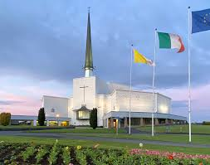
PILGRIMAGE TO KNOCK - The next Pilgrimage to Knock for our Family of Parishes will take place on the 7/8th October. The cost is £155 all inclusive.The Pilgrimage will include Mass at the Apparition Wall, Stations of the Cross, Rosary, Sacrament of the Sick, Confession, a tour of the Basilica and a visit to the Holy Well at Tobernalt, Co. Sligo.
HANNAHSTOWN PARISH / FAMILY OF PARISHES / PATHWAYS
Sixteen places are available. Contact your parish secretary to book your place and make your payment before 26th September.

Hannahstown Parish Draw August 2025 Congratulations to everyone.
Please call to the parish office if you have not received your prize as we have been unable to contact several winners

Prize  Place | Prize  Money | Prize Winner | Nunber | Promoter
1st | £250 | Rita Mc Auley | 70 | Mary Peyton
2nd | £150 | Teresa Mc Gowan | 290 | Irene Phillips
3rd | £100 | K Lennon | 296 | Irene Phillips
4th | £100 | Catherine Mc Peake | 474 | Raymond Jordan
5th | £50 | Nicola Mc Auley | 12 | Parish Office
6th | £50 | Colette Mc Polin | 427 | Raymond Jordan
7th | £50 | Etain Mc Quillan | 441 | Johnny Mc Quillan
8th | £50 | Maeve Farrelly | 2 | Irene Phillips
9th | £50 | Rosanne Mc Gowan | 209 | Parish Office
10th | £50 | Lucy Mc Kibben | 55 | Johnny Mc Quillan
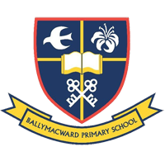
Our Parish School Ballymacward Primary School,
THE PARISH OF HANNAHSTOWN SCHOOL
COMMUNITY PRE-SCHOOL PLAYGROUP
22 Rock Road, Stoneyford, Lisburn, Co Antrim, BT28 3SUTel: (028) 92648130, Principal: Mr Hugh Kennedy
Email: info@ballmacwardps.lisburn.ni.sch.uk

Pre-School Community Playgroup – Supervisor: Ms Sarah Scott. 02892648515

Fr Patrick welcomes all our children back to a new school term, and looks forward to seeing the children in the classrooms soon.

Please contact Anthony Adams for any enquiries on 90 309795.
HANNAHSTOWN COMMUNITY HALL
Mon – Fri 10 am – 1 pm.

Monday – Coffee Morning
after 9.15 am Mass.
Please come along to our popular coffee morning. An opportunity to meet with fellow parishioners for some company and good craic.

Wednesday Morning
Seniors Group
after 9.15 am Mass
Re-commencing after the summer break, bring your knitting or just yourself, no judgments, just a chance to share some friendhsips and good conversations.

