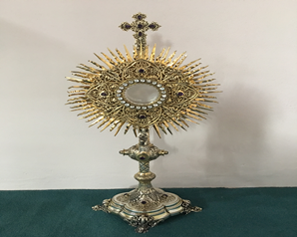
EUCHARISTIC ADORATION in St Peter’s Church - Every Friday from 2 pm – 8.30 pm.
THE PARISH OF HANNAHSTOWN
Every evening with in St Peter’s Church Adoration & Prayer from 6.30 pm – 7.30 pm
https://churchmedia.tv/st-josephs-church https://churchmedia.tv/st-peters-church-2

RECENTLY DECEASED – Nora McCarthy (Requiem Mass Thursday 5th at 11 am in St Joseph’s Church).
Also Rosie Clarke RIP
ANNIVERSARIES – Charlotte Colette Brown, Harry McDonald, Kathleen McLarnon, James McLarnon

& Clare Scollay RIP
WEEKLY COLLECTIONS
25/05/25 Weekly Collection £948.96
25/05/25 Cemetery Sunday £2,758.96


Thank you to everyone for their generosity to the Parish.
BAPTISMS
To arrange Baptisms please present the long birth certificate to the parish office. Baptisms will be arranged upon request.

CEMETERY SUNDAY
St Peter’s The Rock on 8th June @ 3 pm
Tullyrusk on 15th June @ 3 pm
If you are available to serve as a minister for the Holy Eucharist please let Fr. Patrick know. Thank you.

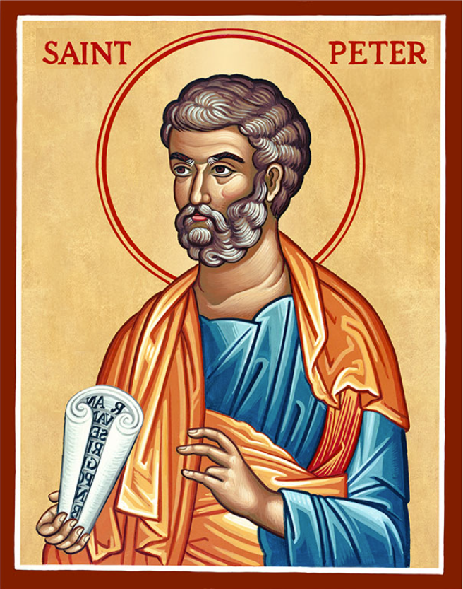
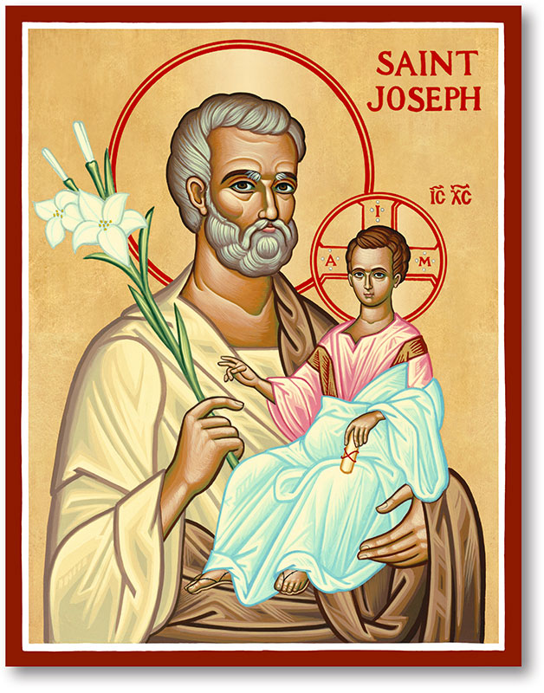
The Parish of Hannahstown
Saint Joseph’s and Saint Peter’s

1st June 2025
THE ASCENSION OF THE LORD

Family of Parishes Emergency Sick Calls: 07549209775
Monday 09.15 am (Prayer for Vocations) Saint Joseph’s
Tuesday Fr. Patrick’s day off.
Wednesday 9.15 am (Parish novena to Our Lady) St Joseph’s
Thursday 9.15 am (Parish novena to Our Lady) St Peter’s
Friday 9.15 am (Sacred Heart Prayer) Saint Joseph’s
Saturday 6:00 pm (St Michael the Archangel Prayer) Saint Joseph’s
Sunday 10:00 am (Prayer for Pope’s intentions) Saint Peter’s
Sunday 11:30 am (Saint Joseph Prayer) ( BSL Signed ) Saint Joseph’s

Very Reverend Patrick Devlin, Parish Priest,
Chaplain to the Deaf Community, Down and Connor Diocese
Chaplain to Antrim Area Hospital, Thursday & Friday (Emergency calls)
Fr. Patrick, for Spiritual and Pastoral needs only, thank you Tel: 07910 833699
Parish Secretary: Mrs Grainne McArevey Tel: 028 90614567
Parish Email: hannahstown@downandconnor.org Parish Website: https://www.parishofhannahstown.com

No matter what suffering there is in the world and in our lives there is also beauty. We cannot explain why it is so, we can only accept that it is so.
In accepting suffering, we are also free to accept and savour all the more, the beauty we see and experience in the world. Try praying for others: hold close to your heart in prayer all those who are suffering at this time; hold close to your heart in prayer all those who are sick; hold close to your heart in prayer all those who do not or cannot see beauty in their lives at this moment.
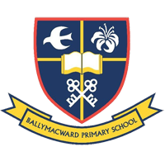
Our Parish School Ballymacward Primary School,
HANNAHSTOWN PARISH SCHOOL / COMMUNITY PLAYGROUP
22 Rock Road, Stoneyford, Lisburn, Co Antrim, BT28 3SUTel: (028) 92648130, Principal: Mr Hugh Kennedy
Email: info@ballmacwardps.lisburn.ni.sch.uk
Ballymacward Community Pre-School Playgroup - Supervisor: Ms Sarah Scott. Tel: (028) 9264 8515
HANNAHSTOWN COMMUNITY HALL
Please contact Anthony Adams for any enquiries on 90 309795.
Mon – Fri 10 am – 1 pm.
Monday – Coffee Morning after 9.15 am Mass.


Wednesday Morning Seniors Group after 9.15 am Mass
The Car Boot Sale is Postponed
Until further notice

GOOD QUALITY BRIC-A-BRAC ITEMS REQUIRED, GOOD QUALITY CLOTHING-HOUSEHOLD ITEMS-GAMES AND TOYS.
CONTACT 90- 309795
Hannahstown and the Rock Parish Draw May 2025
Family of Parishes
Prize Place | Prize  Money | Name | Number | Collector
1st | £250 | Michael Brady | 163 | Mary Peyton
2nd | £150 | Seamus & Caroline McGarry | 18 | Irene Phillips
3rd | £100 | Jimmy King | 269 | Johnny McQuillan
4th | £100 | Name Witheld | 5 | Elizabeth Lee
5th | £50 | Cyril Jordan | 242 | Stephen Mulligan
6th | £50 | Bronagh O’Rawe | 166 | Bronagh O’Rawe
7th | £50 | Brian Ferris | 383 | Mary Ferris
8th | £50 | Stephen Finnegan | 186 | Robert Finnegan
9th | £50 | Marie & Brendan Lee | 33 | Parish Office
10th | £50 | Anne McMullan | 86 | Elizabeth Lee


_______________________________________________________________________________________

PENTECOST SUNDAY - “The Spirit sustains us and shows us the way to follow” (Pope Leo XIV, Sunday 27 May St John Lateran, Rome).
There will be a service to mark the Feast of Pentecost on Sunday, 8th June at 4.30 pm in Clonard.
The preacher will be the Rev Danielle McCullagh who is serving as a Chaplain at Queens’ University. This service will recognise the 1700th anniversary of the Council of Nicaea”.

