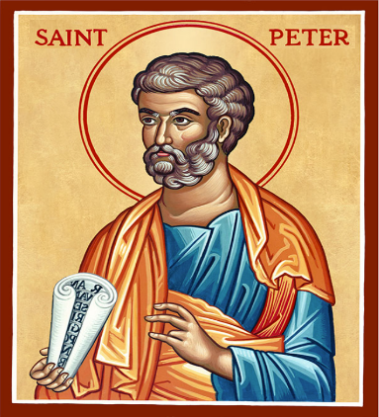
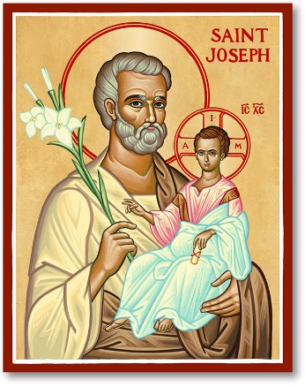

Hannahstown Parish Cemetery Committee

June 2025

1. INTRODUCTION

There is to be a Cemetery Committee in the Parish of Hannahstown of the Diocese of Down and Connor to help the Parish Priest/Administrator in the administration of the cemeteries of the Parish.

All persons, whether clerics or laity, who take part in the administration of the cemeteries, are bound to fulfil their duties in the name of the Church.

2. STATUS and ROLE of PARISH CEMETERY COMMITTEE

The Parish Priest/Administrator is responsible for all the cemeteries of the Parish.

The Parish Cemetery Committee will advise and work with the Parish Priest/Administrator in the sound administration of the cemeteries of the Parish and it is a separate body to the Parish Finance Committee, the Parish Council or the Parish Pastoral Council.

The Cemetery Committee assists the Parish Priest/Administrator in his task of administering the Parish cemeteries, maintaining the Parish cemetery properties, planning for future capital cemetery works and formulating strategies for raising cemetery funds. The Parish Cemetery Committee may be directly involved in the day-to-day management of the Parish cemeteries, as necessary.

3. MEMBERSHIP of PARISH CEMETERY COMMITTEE

The Parish Cemetery Committee is to consist of:

- The Curates/Assistant Priests of the Parish. (Ex officio)
(It should be noted that the Parish Priest/Administrator is not a member of the Parish Cemetery Committee, but he should be present at every meeting of the
Committee.)

- Six to eight parishioners should be chosen and appointed by the Parish Priest/Administrator. It is advisable that the membership should include people who are skilled in one or other of the following: project management, property management, human resources, the law, outdoor groundworks and general building expertise. When appointing members to the Parish Cemetery Committee care should be taken to avoid any conflict of interest.

If the Parish lacks parishioners with any of the above skills then persons from outside the Parish can be co-opted onto the Committee. When in a particular instance two non-parishioners may have to be co-opted the Parish Priest/Administrator may decide, so that the size of the Committee does not become unwieldy, to confine the number of parishioners, say, to four.

Members of the Parish Cemetery Committee are to be honest, known for their integrity, and actively committed to the Parish and the practice of the faith.

No Parish employees or family members of an employee or relative of the Parish Priest/Administrator may serve on the Parish Cemetery Committee.

The lay members of the Committee should be appointed for four years and may be re-appointed for a further term. Rotation should be phased over time to ensure stability and retention of experience and skills.

While recognising the power to appoint and remove Cemetery Committee members is vested in the Parish Priest/Administrator, if a vacancy arises on the committee, this should be advertised for parishioners to apply, and to be appointed, if they so wish. If a member is to be removed the Bishop should be informed and the reason for removal given. The Bishop should also be notified of any new appointments to the Committee.

4. MEETINGS

- The Committee Secretary is to convene meetings of the Committee and to draw up an agenda for each meeting. See sample agenda. (See Attachment)

- The Parish Priest/Administrator or Committee Chair shall call meetings of the Committee as often as business requires but at least four meetings should be held during each year:

- As far as possible seven days notice of each meeting shall be
given to members.

- The members of the Committee shall appoint a chair, vice chair and secretary from amongst themselves. Full minutes should be kept of each meeting and a copy forwarded to the Bishop within two weeks after the meeting.

- A quorum for meetings is four appointed members.

- At every meeting current Parish cemetery information should be presented to the members.

- The Committee Secretary shall call a special meeting if so requested in writing by two members.

5. TERMS of REFERENCE of THE CEMETERY COMMITTEE

The Parish Cemetery Committee will assist the Parish Priest /Administrator in the administration of the cemeteries of the Parish by advising: -

- on good practice in regard to the procedures associated with the cemeteries;

- on the maintenance, repair and upkeep of the Parish Cemetery property;

- on compliance with all relevant statutory and local regulations and standards;

- generally, on other appropriate matters when so requested by
the Parish Priest/Administrator.
___________________________________________________

6. CEMETERY COMMITTEE to LIAISE WITH PARISH SECRETARY
REGARDING THEIR DUTIES RESPONSIBILITIES LAID OUT BELOW

- The Parish Secretary, with the support of the Cemetery Committee has day to day responsibility for the management of the cemeteries and will provide confidential, efficient, and effective secretarial support to the Cemetery Committee, the Parish Priest, and assistance to visitors and parishioners who visit or make contact with the Parish office.

- To effectively and efficiently manage and maintain the Parish Office.

Such duties will include

Burials
- Liaise with funeral directors;
- Process burial forms;
- Update computer database;
- Deal with bereaved families;
- Process payments & maintenance fees for burials;
- Ensure paperwork is completed accurately;
- Send letters to next of kin post burial.

Burial of Ashes
- Liaise with families;
- Obtain cremation certificate;
- Complete admin paperwork.

Grave Enquiries
- Grave searches;
- Issue copy leases;
- Issue new leases;
- Deal with all complaints.

Columbarium
- Associated admin in respect of maps, new leases
and payments;
- Liaise with the nominated Funeral Directors/ Monumental Sculptors
re inurnments/plaques and urn supplies.

Headstones/Monumental Sculptors
- Receive & approve all new headstone planning
applications and process accordingly;
- Process all invoices for same;
- Ensure payments are received.

Keyholder
- Keyholder to all three cemeteries.

Monumental Sculptors & Funeral Directors Database
- Ensure all relevant paperwork is signed and updated
and all rules and regulation adhered to.

Cemetery Committee Meetings
- Be available to attend meetings;
- Follow up on any actions;
- Process payments;
- Present relevant information to the Finance
Committee.

Cemetery Sunday
- Organise & co-ordinate Cemetery Sunday

7. DOCUMENTS

The Cemetery Committee support the Parish Secretary in relation to drafting and settling the following documents

Columbaria/Inurnments
Columbarium Rules & Regulations (signed by Grantee)
Parish of Hannahstown Columbarium Form (signed by N.O.K & Secretary)
Columbaria Certificate of Grant of Right of Inurnment (Lease)

Cemetery/Burials
Cemetery Certificate of Grant of Right of Burial (Lease)
Rules & Regulations (given to N.O.K)
Burial Form (signed by Secretary, N.O.K & Funeral Director)

Monumental Work
List of Monumental Sculptors (given to N.O.K)
Rules & Regulations for Cemetery (signed by approved monumental sculptors, held in the office.

Hannahstown
Parish Cemetery Committee
First Meeting
Date
Time
Location

Sample Agenda

- Opening Prayer.

- Introduction of proposed members.

- Presentation of Hannahstown Parish Norms.

- Acceptance of Membership & Signing of Code of Conduct & Confidentiality.

- Appointment of Chairperson, Vice Chairperson and Secretay.

- Presentation – Overview of Parish Cemetery Finances.

- PP/Adm Comments.

- Schedule of Future Meetings.

- Closing Prayer.

Date

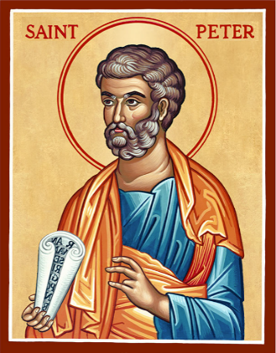

Parish of Hannahstown

I, the undersigned, hereby acknowledge that the Parish Priest/Administrator of the

above Parish, Very Rev. Patrick Devlin, has provided me with full details of the Parish

Norms in regard to the Hannahstown Parish Cemetery Committee.

I am also aware that the following Code of Conduct and Confidentiality applies to all

who accept membership of the Hannahstown Parish Cemetery Committee:

- While serving and thereafter, members shall keep confidential all matters of record or reference, whether or not communicated or discussed in meetings or among those serving, until such time as such matters are officially publicised.

- Members shall always speak and act, inside and outside of the Hannahstown Parish Cemetery Committee, in a manner supportive of Hannahstown Parish.

- Members shall avoid any conflict of interest, or the appearance of a conflict of interest with the Parish. Any business or transaction with the Parish in which a Member of the Committee, a member’s relative or business connection, may be involved should be made known to the Parish Priest/Administrator.

I hereby agree to accept the Parish Priest’s/Administrator’s offer to serve as a member

of the Hannahstown Parish Cemetery Committee in accordance with the

Hannahstown Parish Norms.

________________________________ _______________________
Member Date

_________________________________________ ______________________________
PP/Adm Date

Hannahstown
Parish Cemetery Committee
2nd Meeting
Date
Time
Location

Sample Agenda

- Opening Prayer.

- Apologies.

- Review & Approve Minutes of Previous Meeting.

- Matters Arising from previous Minutes.

- Current Financial Cemetery Reports.

- Cemetery & Grounds.(Condition Update)

- Budget Planning.

- Parish Cemetery Development Plans.

- Parish Cemetery Controls

- Health & Safety

- Safeguarding

- PP/Admin’s Business.

- Schedule of Future Meetings.

- AOB

- Closing Prayer.

Date

