
SPIRITUAL EXERCISES FOR LENT
THE PARISH OF HANNAHSTOWN
EUCHARISTIC ADORATION St Peter’s Church—Every Friday from 2 pm—8.30 pm. Every evening, Adoration and Prayer in St Peter’s Church, 6.30 pm—7.30 pm.
Also St Joseph’s Church every Wednesday during Lent from after Morning Mass until 1 pm. Let Fr Patrick know what hour you are available for.

ANNIVERSARIES – Marie Brown RIP
MONTH’S MIND – Brendan Mulholland RIP


WEEKLY COLLECTIONS
23/02/25 Weekly Collection £ 910.96
Thank you to everyone for their generosity to the Parish.

BAPTISMS
To arrange Baptisms please present the long birth certificate to the parish office.


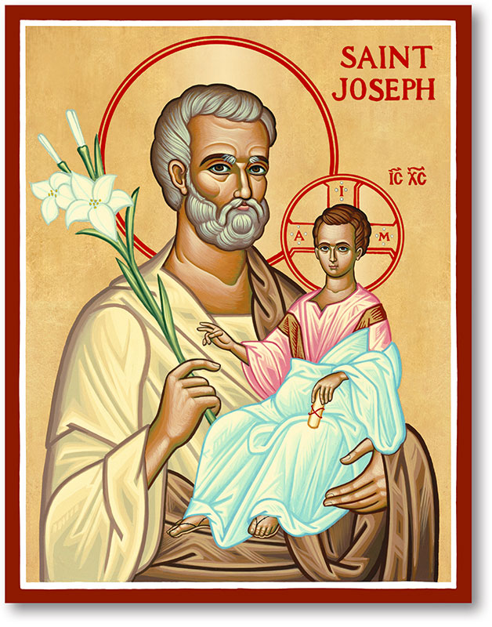
The Parish of Hannahstown
Saint Joseph’s and Saint Peter’s

2nd March 2025
Eighth Sunday in Ordinary Time

Family of Parishes Emergency Sick Calls: 07549209775
Monday 9.15 am Prayer for Vocations Saint Joseph’s
Tuesday Fr. Patrick’s Day off
Wednesday 9.15 am Ash Wednesday Saint Joseph’s
Thursday 9.15 am Parish novena to Our Lady Saint Peter’s
Friday 9.15 am Sacred Heart and St Michael’s Prayer Saint Joseph’s
Saturday 6:00 pm Prayer of Hope, Jubilee 2025 Saint Joseph’s
Sunday 10:00 am Prayer of Hope, Jubilee 2025 Saint Peter’s
Sunday 11:30 am Prayer of Hope, Jubilee 2025 BSL Signed Saint Joseph’s

Very Reverend Patrick Devlin Parish Priest,
Chaplain to the Deaf Community, Down and Connor Diocese
Chaplain to Antrim Area Hospital Thursday & Friday (Emergency calls)
Fr. Patrick, for Spiritual and Pastoral needs only, thank you Tel: 07910 833699
Parish Secretary: Mrs Grainne McArevey Tel: 028 90614567
Parish Email: hannahstown@downandconnor.org Parish Website: https://www.parishofhannahstown.com

Eighth Sunday in Ordinary Time
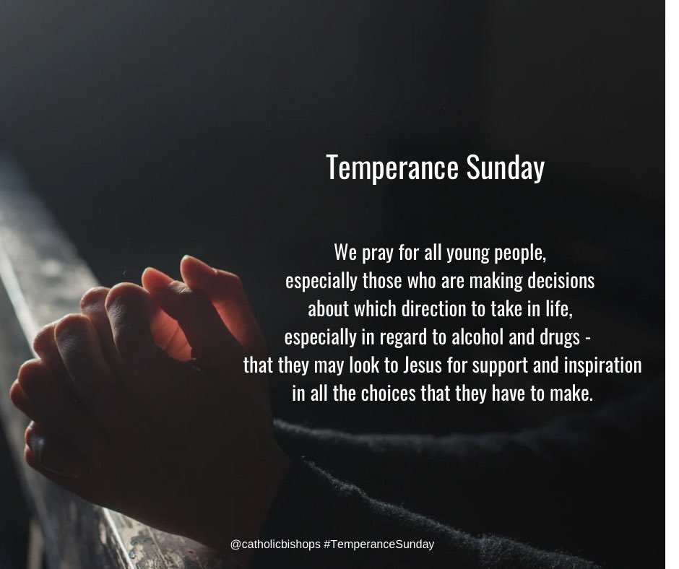
Day of Temperance

May I come to recognise the grace of moderation that brings contentment and appreciation. Let temperance grow in me and lead me to discover other virtues that bring deeper union with you. In your sacred name, I pray, Amen
Hannahstown Parish Draw February 2025 Congratulation
HANNAHSTOWN PARISH / FAMILY OF PARISHES / PATHWAYS

Prize  Place | Prize  Money | Name | Number | Collector
1st | £250 | Bernadette Goan | 355 | Tom Mc Garrity
2nd | £150 | David & Eva Ferguson | 169 | Mary Ferguson
3rd | £100 | Paul Murray | 358 | Tom Mc Garrity
4th | £100 | Lilly Young | 59 | Mary Ferguson
5th | £50 | Kathleen Braden | 438 | Angela Mc Gowan
6th | £50 | Michael Douglas | 285 | Irene Phillips
7th | £50 | Mary Ferguson | 50 | Mary Ferguson
8th | £50 | Duncan Mc Auley | 239 | Johnny Mc Quillan
9th | £50 | Mary Clarke | 25 | Angela Mc Gowan
10th | £50 | Shea &Aoife Linskey | 11 | Jim Ferguson

GROWING IN FAITH TOGETHER – Day Retreat. St Paul’s Parish Centre. Saturday 8th March 2025, 10 am – 4 pm. Speaker Fr. Darren Brennan. For further information contact Collette on 07791078453, Please bring a packed lunch, tea and coffee will be provided.
LENTAL BIBLE STUDIES / ST PAUL’S PARISH - Come along to the Legion of Mary Bible Study, St. Paul’s Pastoral Centre (on the grounds of St. Paul’s Church), 125 Falls Road, Belfast. Starting Tuesday 4 March at 7.30 pm and continuing every Tuesday of Lent. Light refreshments are provided after session.


WALKING IN THE STEPS OF JESUS THIS LENT
We invite you to join us on our new Lenten programme. A six-week Lenten journey inspired by the Sunday gospels and the lives of the Irish saints who embraced faith in times of challenge. From St Patrick’s prayers on the mountain to St Brigid’s acts of compassion, their lives remind us that holiness is lived in simple, everyday choices.
When: Wednesday 5th March (The first session will be after Mass on Ash Wednesday)
TIME: 7 pm
VENUE: St Agnes Parish Hall

HANNAHSTOWN VICTIMS & SURVIVORS OF ABUSE WITHIN OUR CHURCH - FRIDAY 7th March 2025 in Saint Patrick’s Church, Donegall Street, Belfast at 1:00 pm
HANNAHSTOWN PARISH / FAMILY OF PARISHES

Sacristan/Caretaker Hannahstown Parish - An opportunity has arisen for a Sacristan/Caretaker for our Parish. 20 hrs per week Mon-Sun. Flexibility required. Closing date 13th March before noon.

FOSTERING - There is a desperate shortage of foster carers across the UK. Our faith teaches us that children need love and nurture. Unfortunately, this is not the experience of over 30,000 children entering the care system each year. Having faith in fostering situations can be hugely beneficial for these vulnerable young people who may have experienced trauma, abuse, and neglect. Our faith can provide them with structure, stability, and a whole community to support the fostering family. If you think you could change a child’s life for the better and welcome them into your heart and your home, contact your local fostering service today. There are many organisations out there that welcome faith in fostering and who do not profit from the services they provide for young people. It’s easier than you think, you just need an open heart and a spare room. Here are some links you might find useful. https://www.actionforchildren.org.uk/fostering/why-choose-us/faith-in-fostering/ https://media.actionforchildren.org.uk/documents/AfC_FIF_A4Poster.pdf
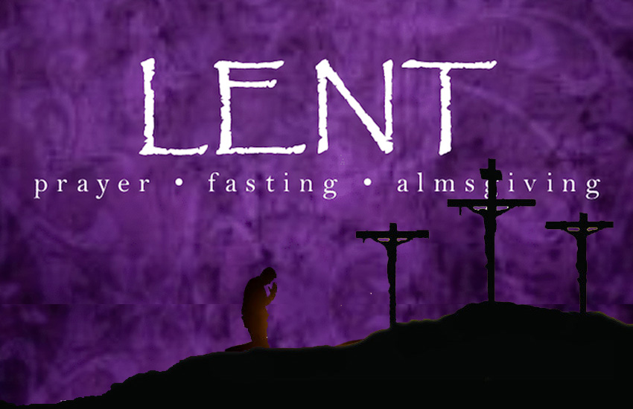
LENTEN PLEDGE - Pope Francis has invited us this Lent to “journey in hope together”. A short-term pledge is available via www.pioneerassociation.org for parishioners who wish to become a “pilgrim of hope” for people who are living under the shadow of addiction.

