
EUCHARISTIC ADORATIONSt Peter’s Church - Every Friday from 2 pm – 8.30 pm. Every evening Adoration & Prayer in St Peter’s Church 6.30 pm – 7.30 pm
THE PARISH OF HANNAHSTOWN
https://churchmedia.tv/st-josephs-church https://churchmedia.tv/st-peters-church-2

RECENTLY DECEASED Sheila Grogan RIP (died in Canada, formerly of Hannahstown).
MONTH’S MIND – Margaret Hughes RIP
ANNIVERSARIES – Margaret, Mairead &
Barney Brannigan, John, Sadie & Diarmuid Frazer,

Michael Hall, Esther McCorry, Gerard & Harry McGowan & Carol O’Callaghan RIP
WEEKLY COLLECTIONS
30/03/25 Weekly Collection £895.55
30/03/25 200TH Anniversary £454.81
Thank you to everyone for their generosity to the Parish.


BAPTISMS
To arrange Baptisms please present the long birth certificate to the parish office.



The Parish of Hannahstown
Saint Joseph’s and Saint Peter’s

6th April 2025
Fifth Sunday of Lent

Family of Parishes Emergency Sick Calls: 07549209775
Monday 10 am Prayer for Vocations Saint Joseph’s Tuesday Fr. Patrick’s Day off
Wednesday 9.15 am Parish Novena to Our Lady Saint Joseph’s
Thursday 9.15 am Parish novena to Our Lady Saint Peter’s
Friday 9.15 am Sacred Heart and St Michael’s Prayer Saint Joseph’s
Saturday 6:00 pm Prayer of Hope, Jubilee 2025 Saint Joseph’s
Sunday 10:00 am Prayer of Hope, Jubilee 2025 Saint Peter’s
Sunday 11:30 am Prayer of Hope, Jubilee 2025 BSL Signed Saint Joseph’s

Very Reverend Patrick Devlin Parish Priest,
Chaplain to the Deaf Community, Down and Connor Diocese
Chaplain to Antrim Area Hospital Thursday & Friday (Emergency calls)
Fr. Patrick, for Spiritual and Pastoral needs only, thank you Tel: 07910 833699
Parish Secretary: Mrs Grainne McArevey Tel: 028 90614567
Parish Email: hannahstown@downandconnor.org Parish Website: https://www.parishofhannahstown.com
Fifth Sunday of Lent
Thought for the Day


Jesus never wants evil. He only wants what is good and life-giving. Therefore, in his great mercy, he instituted the sacrament of Reconciliation so that no one will be lost, so that we can all find the forgiveness we need, no matter how great our mistakes have been. As Pope Francis said; ‘Let us no forget this: God never tires of forgiving us! The problem is that we ourselves get tired, we do not want to ask, we grow weary of asking for forgiveness. He never tires of forgiving, but at times we get tired of asking for forgiveness. Let’s never get tired! And let us too learn to be merciful to everyone.

LENTEN TALK - LENTEN TALK SATURDAY 12th APRIL 2025 at 2PM in St AGNE’S PARISH CENTRE, St AGNE’S DRIVE.
HANNAHSTOWN PARISH / FAMILY OF PARISHES / PATHWAYS
WHO DO YOU SAY I AM? (Mt 16:17) A TALK BY Arthur Nolan on the SHROUD OF TURIN & Fr Raymond McCullagh speaking on SCARAMENT OF RECONICILIATION. Schedule for the day: 1pm Holy mass, 1:30pm Eucharistic Adoration, 2:00pm Talks in Parish Centre where Tea & Coffee will be served. This event is hosted by the Legion of Mary.


TRÓCAIRE- RTE Mass - Trócaire are delighted to lead the Holy Thursday Liturgy this year, live on RTE, on April 17th at 4.40pm. Please do join us by tuning in.
Fr Patrick encourages all parishioners to reflect on the good work of Trócaire in these final few weeks of Lent, and to remind you all at the end of Lent to please return your Trócaire boxes and any donations to the parish office or leave into the Sacristy. Many Thanks for all you help in this worthy appeal.

CHRISM MASS – ST PETER’S CATHEDRAL - The Mass of Chrism will be celebrated by Bishop Allan in the Cathedral on Spy Wednesday, 16 April, at 12 noon.
You can join us online Churchservices.tv

HANNAHSTOWN PARISH / FAMILY OF PARISHES / PATHWAYS
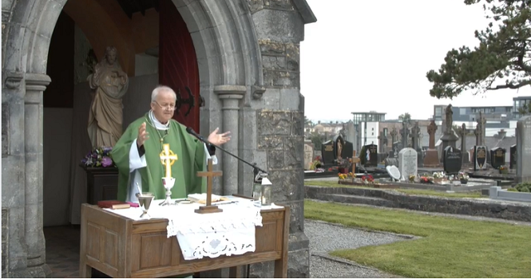
HANNAHSTOWN PARISH CEMETERY SUNDAY MASS
DATES
Mass at St Joseph’s Hannahstown 25th May 2025
Mass at St Peter’s The Rock 8th June 2025
Mass at Tullyrusk Cemetery 15th June 2025

Please contact Anthony Adams for any enquiries on 90 309795.
HANNAHSTOWN COMMUNITY HALL
Mon – Fri 10 am – 1 pm.
Monday – Coffee Morning after 9.15 am Mass.
Wednesday Morning Seniors Group after 9.15 am Mass

Our Parish School Ballymacward Primary School,
THE PARISH OF HANNAHSTOWN SCHOOLS
22 Rock Road, Stoneyford, Lisburn, Co Antrim, BT28 3SUTel: (028) 92648130, Principal: Mr Hugh Kennedy
Email: info@ballmacwardps.lisburn.ni.sch.uk
Pre-School Playgroup - Supervisor: Ms Sarah Scott. Tel: (028) 9264 8515

