Hannahstown Parish – February 2026 St Joseph’s Church 200th Year Anniversary
HANNAHSTOWN PARISH FEBRUARY SCHEDULE
Themes: Mercy, Healing and Unity
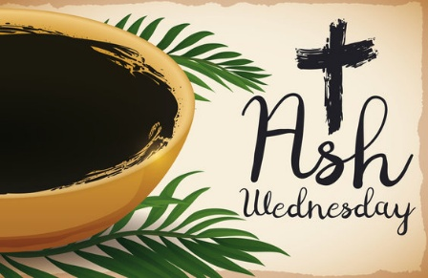
Ash Wednesday – 18th February

Lent begins with ashes which is a sign of our human frailty, but also of hope. This Ash Wednesday, we mark the start of Lent together as a parish family, standing before God in prayer, reflection, and renewal.

Masses: 9.15– St Peter’s Church 7.00pm – St Joseph’s Church

Special Outdoor Opportunity:
For those passing the church during the day, ashes and a short prayer will be offered in the car park near the entrance gate, 8.00am–8.00pm, served by Fr Devlin and Eucharistic Ministers. This is a quiet, dignified moment, not a replacement for Mass, inviting everyone to pause, reflect, and receive God’s blessing.
You are also welcome to receive a Lenten calendar, a Prayer to St Joseph, and an invitation to our Evenings of Mercy, Healing, and Unity later in the month. ASH WEDNESDAY Receive Ashes and Go in peace.
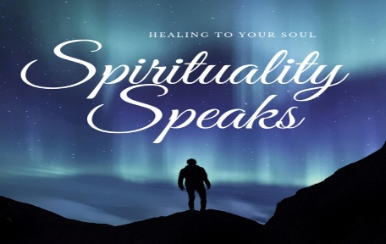
A Time of Prayer 1. Tuesday 24th February 2026 7pm St Joseph’s Church 200th Year Anniversary. Fr Needish St Lukes Parish + Donnald Joseph’s Testimony
Theme: Mercy
Join us for a reflective prayer time on God’s mercy, prayer, and healing within families. Scripture, reflection, silence, and prayer will help us bring mercy into our homes and parish life. All generations welcome.

A Time of Prayer 2. Thursday 26th February 2026 7pm St Joseph’s Church 200th Year Anniversary.
Theme: Healing Fr Darren Brennan St Pauls Parish + Mícheál Ó Coisneacháin’s testimony
Within the Family and Parish please join us for a reflective time of prayer, Scripture, and the Divine Mercy Chaplet, seeking healing from the Heart of Jesus for families, loved ones, and the parish community. All generations welcome.

A Time of Prayer 3. Tuesday 3rd of March 2026 7pm St Joseph’s Church 200th Year Anniversary.
Theme: Unity in the Heart of Jesus Fr. Brendan Mulholland from Holy Trinity Parish + Maeve Clarke’s testimony
Within the Family and Parish please join us for a reflective time of prayer, Scripture, and guided family prayer, seeking unity in the Heart of Jesus for families, loved ones, and the parish community. All generations welcome.
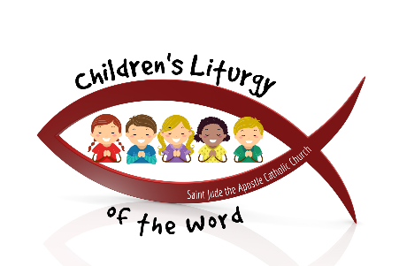
Hannahstown Parish – February 2026 St Joseph’s Church 200th Year Anniversary
Children’s Liturgy of the Word – Commissioning of Leaders Sunday 22nd February 2026 | 11:30am | St Joseph’s Church

As part of our Bicentenary Year, we are delighted to announce the training and commissioning of our Children’s Liturgy Leaders.

Key Points: Commissioning: Leaders will be officially commissioned at 1130 Mass on 22nd February, preparing to begin ministry on Sunday 1st March at the 1130 mass.

Purpose: Children’s Liturgy of the Word offers children a chance to hear and reflect on the Sunday Gospel at a level they can understand, in a safe and welcoming environment. Leaders: All leaders have completed training, are confident in their roles, and are fully compliant with parish safeguarding requirements.

Parents: Please note participation is voluntary. Children will return to the main Mass for the Eucharist, and safeguarding measures are in place to ensure everyone’s safety.

We thank the leaders, families, and parish community for supporting this ministry and helping our children grow in faith.

