
WEEKLY COLLECTIONS:
THE PARISH OF HANNAHSTOWN
24/5/26 Weekly Collection £835.08. Thank you for your vital support to our Parish.

Collectors/ Volunteers Application Forms available on parish website, or in the Church Sacristy. Thank you.


HANNAHSTOWNTOWN COMMUNITY CENTRE: SPRING/SUMMER FESTIVAL FRIDAY-12TH JUNE-SUNDAY JUNE 14TH Fri-Seniors Tea-Dance 12-3.30 pm -Live music/Bingo/Ballots Sat-Historical Society Coach Trip (more information to follow) Sun- Outdoor Mass at 11.30am-followed by Tea in the community Centre Please provide any Bric-a-Brac such as good clothing, toys, games, books, etc.
For further information please contact Anto at Hannahstown Community Centre on
02890-309795 more info will follow.

BAPTISMS DIOCESIAN AND PARISH NORMS:

Parents will be asked to complete a short form confirming whether any other person holds parental responsibility for the child and that they are aware of the request for baptism and have raised no objection. This procedure is required in line with diocesan guidance and civil law. Please bring with you a copy of the baby’s long birth certificate to the parish office.
CONSIDERING MARRIAGE?
“Above all, let your love for one another be intense.” (1 Peter 4:8)
We would be delighted to welcome couples to meet, view the church, and arrange their wedding. Please contact Parish Office
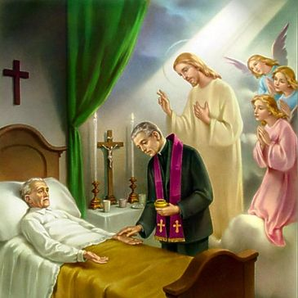
PASTORAL VISIT TO THE SICK AND HOUSEBOUND “The Lord is close to the broken-hearted.” (Psalm 34:18) Families are encouraged to let us know if a loved one is housebound and would need a visit from the priest. Contact Fr Patrick or the Parish office.

SAFEGUARDING IN OUR PARISH “Let the little ones come to me.” (Mark 10:14)
We are pleased to share that diocesan safeguarding requirements for 2026 have now been completed, helping ensure our parish remains a safe, respectful, and caring community.

ALL VOLUNTEERS: “Each of you has a gift to use in the service of others.” (1 Peter 4:10)
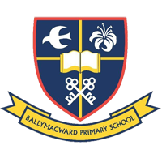
To support good safeguarding and governance, we invite all volunteers to complete a General Volunteer Application Form at the parish office. This helps us keep an up-to-date picture of parish life and ensures volunteers are properly supported
PARISH SCHOOL – BALLYMACWARD PRIMARY SCHOOL:
22 Rock Road, Stoneyford, Lisburn, Co Antrim, BT28 3SUTel: (028) 92648130, Principal: Mr Hugh Kennedy
Email: info@ballmacwardps.lisburn.ni.sch.uk
Ballymacward Community Pre-School Playgroup - Supervisor: Ms Sarah Scott. Tel: (028) 9264 8515
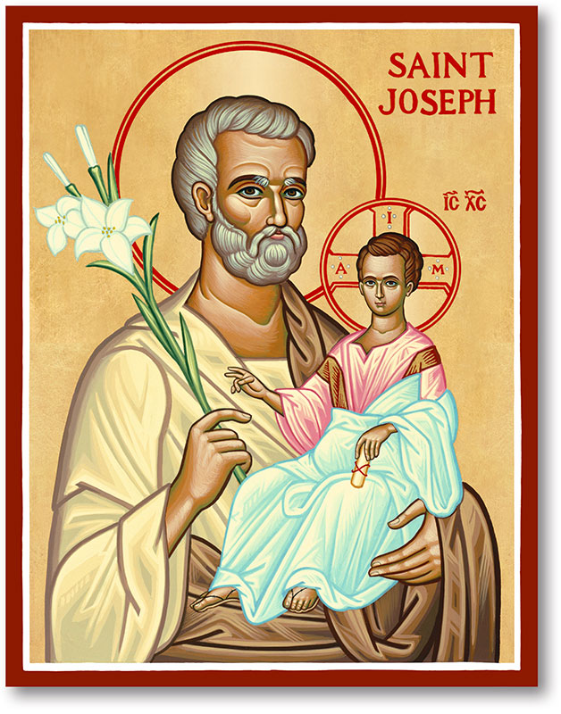
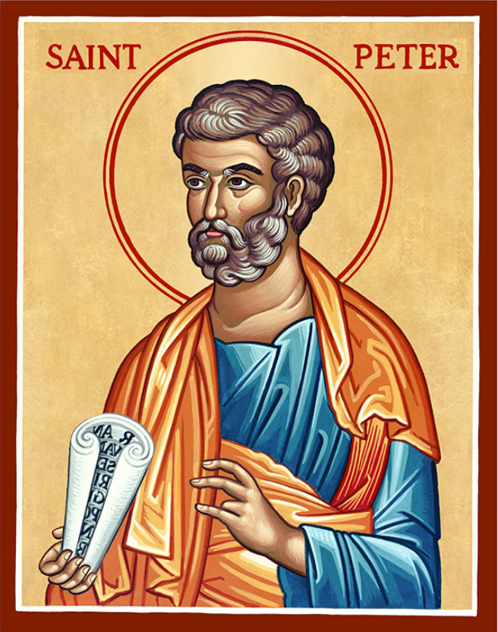
The Parish of Hannahstown
Saint Joseph’s and Saint Peter’s

31st May 2026
Family of Parishes Emergency Sick Calls: 07549209775

Very Reverend Patrick Devlin, Parish Priest.
Chaplain to the Deaf Community Down & Connor. Chaplain Antrim Hospital Thurs / Frid (Emergency Calls)
Contact Fr. Patrick for Spiritual and Pastoral needs only, Tel: 07910 833699.
Parish Secretary Grainne McArevey 02890 614567
Email address: hannahstown@downandconnor.org Website: parishofhannahstown.com
Monday | 9.15 am  6.30-7.30 pm | Morning Mass Prayer for Vocations  Adoration, Rosary and Divine Chaplet  https://churchmedia.tv/st-peters-church-2 | St Joseph’s  St Peter’s
Tuesday | 6.30-7.30 pm | Fr Patrick Away  Adoration, Rosary and Divine Chaplet | St Peter’s
Wednesday | 9.15 am  6.30-7.30 pm | Morning Mass Novena to Our Lady  Adoration, Rosary and Divine Chaplet | St Joseph’s  St Peter’s
Thursday | 9.15 am  6.30-7.30 pm | Morning Mass Novena to Our Lady  Adoration, Rosary and Divine Chaplet | St Peter’s  St Peter’s
Friday | 9.15 am  2.pm-8.30 pm  3.pm | Morning Mass Prayer to the Sacred Heart  Adoration, Rosary & Divine Mercy Chaplet  Adoration and Divine Mercy Chaplet | St Joseph’s  St Peter’s  St Joseph’s
Saturday | 6.00 pm  6.30-7.30 pm | Vigil Mass The Angelus Prayer  Adoration, Rosary and Divine Chaplet | St Joseph’s  St Peter’s
Sunday | 10.00 am  6.30-7.30 pm | Morning Mass Prayer to St Peter  Adoration, Rosary and Divine Chaplet | St Peter’s  St Peter’s
Sunday | 11.30 am  6.30-7.30 pm | Morning Mass Prayer to St Joseph  Adoration, Rosary and Divine Chaplet | St Joseph’s  St Peter’s
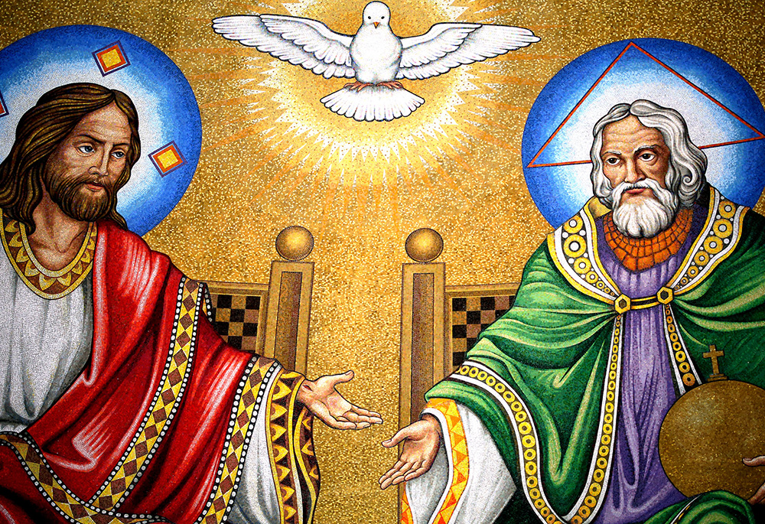
THE MOST HOLY TRINITY: Prayer to the Most Holy Trinity
O Most Holy Trinity, Father, Son, and Holy Spirit, I adore You profoundly.
I thank You for the gift of life, for the grace of salvation, and for the love that unites You eternally. O Blessed Trinity, one God in three Persons, may my life reflect Your unity, may my heart be filled with Your peace, and may I one day rejoice with You in eternal glory. Amen.


ANNIVERSARIES: – Nora McCarthy 1st Anniversary RIP.
Barbato Matassa & James & Kathleen McLarnon RIP.


CEMETERY SUNDAYS: – You are warmly invited to our Cemetery Sunday Masses, as we remember and pray for our loved ones (31st May Hannahstown 3pm)
7th June – St Peter’s The Rock 3pm
14th June – Tullyrusk 3pm
“I am the resurrection and the life, says the Lord; whoever believes in me will live, even though they die.”

HANNAHSTOWN PARISH JUNE 2026 ST. JOSEPH’S CHURCH 200TH ANNIVERSARY
HANNAHSTOWN PARISH PASTORAL COUNCIL (PPC)
Themes: Mercy, Healing and Unity June
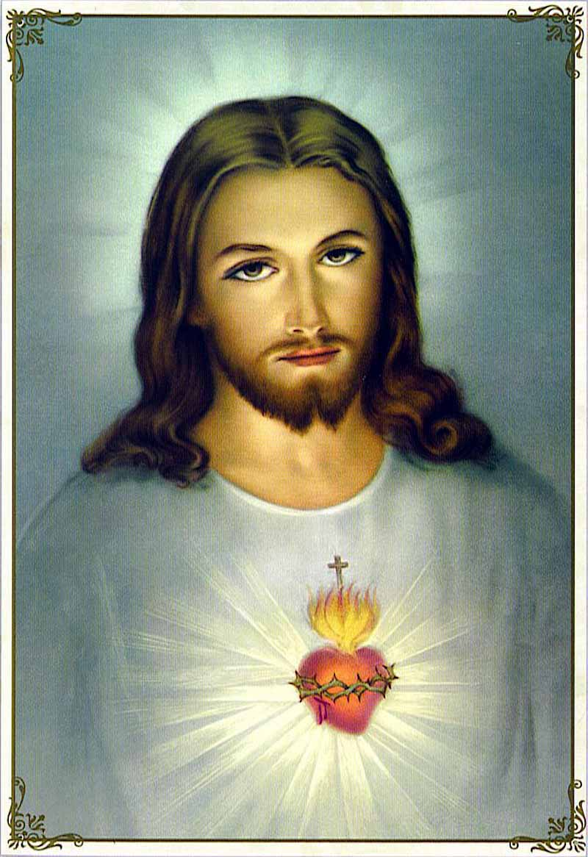
SACRED HEART OF JESUS NOVENA – STARTS 4TH JUNE
Down & Connor Diocesan Novena to The Sacred Heart
June 4th to June 12th, the feast of the Sacred Heart of Jesus.
It is with great joy as a diocese we celebrate the Novena to The Sacred Heart. The Sacred Heart Novena invites you to nine days of prayer, cumulating in the celebration of the Feast of the Sacred Heart. Come to Me. These words of Jesus are among the tenderest in all of the Gospels. They are not a command but an invitation - offered freely, offered personally, offered to each one of us.
Novena booklets available in Church porches. Voluntary donation can be placed into the shrines.
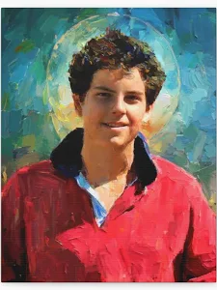

HANNAHSTOWN PARISH JUNE 2026 ST. JOSEPH’S CHURCH 200TH ANNIVERSARY
ST JOSEPH’S & ST PETER’S CHURCHES – CORPUS CHRISTI CELEBRATIONS
The parish is delighted to mark the 200th Anniversary of St Joseph’s Church with a special celebration of Corpus Christi — a joyful occasion of faith, thanksgiving, and devotion to the Holy Eucharist. As part of the celebrations, there will also be a picture solemnly unveiled and blessed of Saint Carlo Acutis. This young modern-day witness to Eucharistic faith, highlighting his life, holiness, and deep love for the Eucharist. We warmly invite all parishioners, families, and friends to join us for this special anniversary celebrations.
St. Peter’s Church – Sunday 7th June at 10.00am Mass St. Joseph’s Church – Sunday 7th June at 11.30am Mass. Please come and celebrate this important milestone in the life of our parish as we give thanks for 200 years of faith, prayer, and unity.
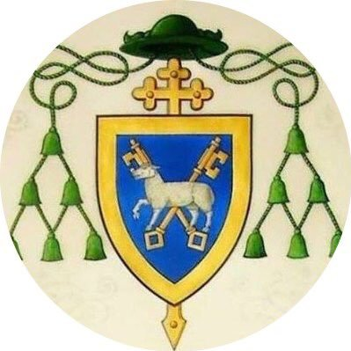
DOWN AND CONNOR VOCATIONS: Fr Conor McGrath and David Goodwin warmly invite parishioners to a Vocation “Allies” Evening on Tuesday 9th June at 6.30pm in the Catholic Chaplaincy, Queen’s University Belfast. This evening is an opportunity for anyone interested in supporting and encouraging vocations to the priesthood and religious life within our diocese. Come along to hear inspiring stories, share in conversation and prayer, and explore how we can all play a part in fostering vocations in our parishes and communities. All are welcome.
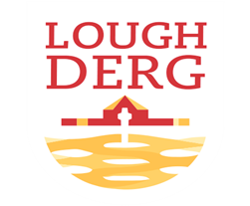
THREE DAY PILGRIMAGE TO LOUGH DERG: Bishop Alan McGuckian SJ and Jim Deeds will lead the Three-Day Pilgrimage to Lough Derg. Date: 19th – 21st June 2026. The bus will depart from St Patrick’s Church Donegal Street. Cost £100. Places are limited early booking advised. To book contact
Claire on 028 90690920 or email: pathwaystothefuture@downandconnor.org


ENCOUNTER WEEKEND DONEGAL: Radisson Blu Hotel, Letterkenny. 6.00pm - 10.30pm Friday 5th June. 9.00am - 10.30pm. Saturday 6th June. Expect to experience the presence of God through the celebration of the Sacraments, Spirit-led worship, inspiring talks, healing service, and fellowship. Come and be refreshed and empowered by the Holy Spirit and learn from the Saints how to live the lifestyle God intended you to live. Keynote Speakers: Patrick Reis: co-founder and Executive Director of Encounter Ministries USA & Fr. Patrick Gonyeau who serves with the U.S. Province of the Missionaries of the Precious Blood in Ohio. Bookings at https://encounterschoolofministrydoneg.regfox.com/encounter-conference-donegal
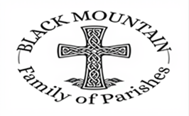
BLACK MOUNTAIN FAMILY OF PARISHES NEWS
BLACK MOUNTAIN FAMILY OF PARISHES PRAYER BEFORE AN EXAM: Loving God be with me now, as I prepare for my exams. Thank you for the many talents and gifts you have given me and for the opportunity of education. Calm my nerves and anxiety. Help me to remember all that I have studied, to express it clearly and to answer the questions the very best I can. Holy Spirit, sit with me in my exam and always. AMEN
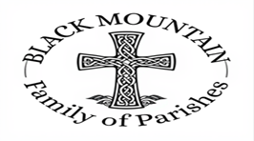
DIVINE INSPIRATION: You are invited to share their memories of St Michael's parish which is turning 50 this year. We hope to publish the best of them in our parish commemorative magazine. Also if anyone has any memories of the pilgrimage to the Holy Land - and photographs. Parishioners are also invited to say in 100 words or less what their faith means to them. We will endeavour to publish them! Please email or write to martinapurdy1@gmail.com or leave a hand written note with personal details for Martina's attention in the parish office.
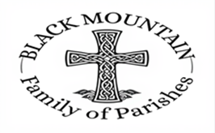
FIRST DEVOTIONS: will take place in St. Matthias’s Church, Glen Road on 6th June
3.00 p.m. Adoration of the Blessed Sacrament, Confessions and Act of Consecration, Rosary and Divine Mercy Chaplet. 4.00 p.m. Holy Sacrifice of the Mass

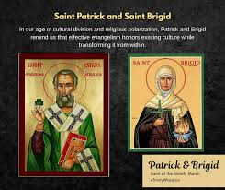
BLACK MOUNTAIN FAMILY OF PARISHES: invites you to a three-day pilgrimage to the Shrines of St Brigid and St Oliver Plunkett on 10th, 11th and 13th June. Ballymascanlon Hotel, single Room £330 Double Room £450 Twin £450 B&B and 2 evening meals 3 course transport included.
A time of Mass, prayer and fellowship as we journey together in faith and step away from the busyness of life.
All are most welcome. Booking: Contact your local parish office (cash only).
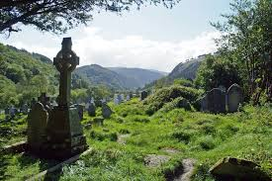
BLACK MOUNTAIN FAMILY OF PARISHES: Warmly invites you to a three-day pilgrimage to Glendalough from Monday 7th to Wednesday 9th September. Join us for a prayerful journey in the beautiful setting of St Kevin’s Glendalough, with opportunities for Mass, prayer, reflection, and fellowship. Tulfarris Hotel, prices include B&B, two 3-course evening meals, and transport: Single Room – £340, Double Room – £410, Twin Room – £410. All are welcome. Booking: Please contact your local parish office (cash payments only)
KINGHTS OF COLUMBANUS 151 FAMILY OF PARISHES NEWS
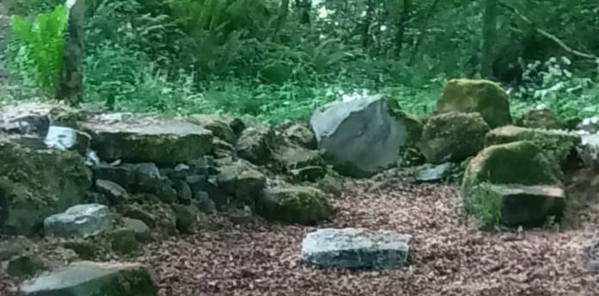
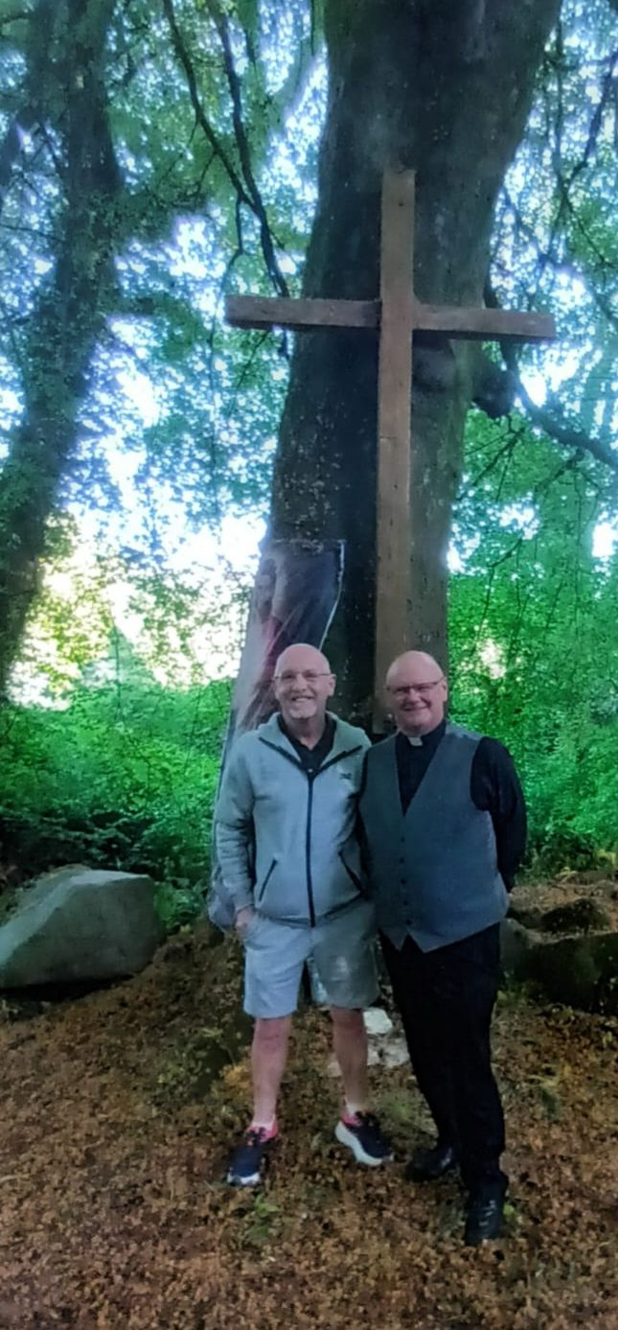
HOLY MASS AT THE HISTORIC MASS ROCK – COLIN GLEN: The parish warmly invites you to a special celebration of Holy Mass at the historic Mass Rock in Colin Glen on Saturday 20th June. This sacred and secluded site is one of several authentic historical Mass Rocks hidden among the hills and glens surrounding Hannahstown. During the years of the Penal Laws, when the celebration of the Catholic faith was forbidden, local people gathered quietly in these remote places to celebrate Mass in secret and to keep alive their faith and devotion to the Eucharist. The Colin Glen Mass Rock, situated at the base of a ravine and marked by a simple stone altar and wooden cross, remains a powerful reminder of the courage, perseverance, and faith of those who went before us. The day’s programme will include:
10.00am – Rosary Walk Eucharistic Adoration 11.30am – Holy Mass at the Mass Rock As we gather once again in this holy place, we give thanks for the steadfast faith of our ancestors and renew our own commitment to Christ and His Church. This will be a deeply prayerful and meaningful occasion, offering an opportunity to reconnect with the rich spiritual heritage of our parish and the enduring witness of those who safeguarded the faith in difficult times. All parishioners, families, and friends are most welcome to attend.

