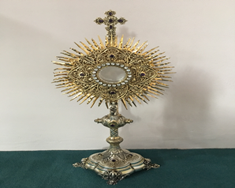
EUCHARISTIC ADORATIONSt Peter’s Church - Every Friday from 2 pm – 8.30 pm. Every evening Adoration & Prayer in St Peter’s Church 6.30 pm – 7.30 pm
THE PARISH OF HANNAHSTOWN
https://churchmedia.tv/st-josephs-church https://churchmedia.tv/st-peters-church-2

RECENTLY DECEASED – Oliver Kelly RIP
ANNIVERSARIES – Mary & Paddy Cunningham,
Neil McCague, Marie Prior RIP


WEEKLY COLLECTIONS
09/03/25 Weekly Collection £996.39
09/03/25 Building Fund £592.32
Thank you to everyone for their generosity to the Parish.


BAPTISMS
To arrange Baptisms please present the long birth certificate to the parish office.
We welcome Esmee Marie Shaw, Felix Dax Smart into our parish family.
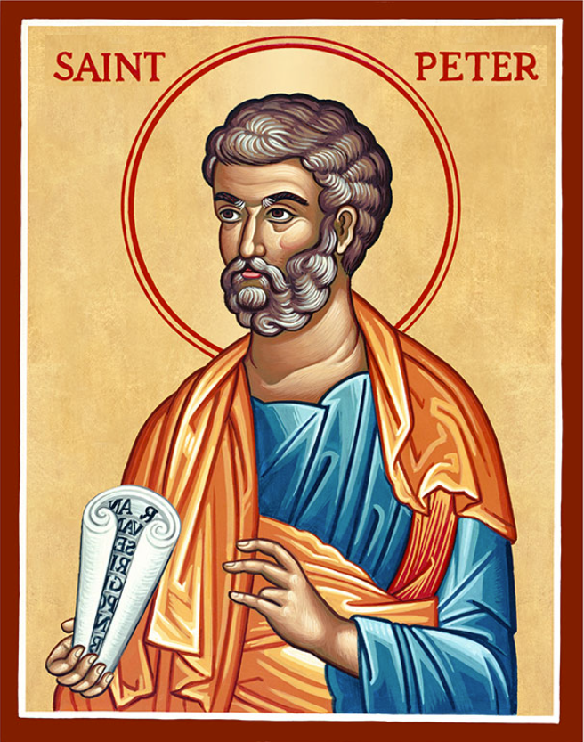
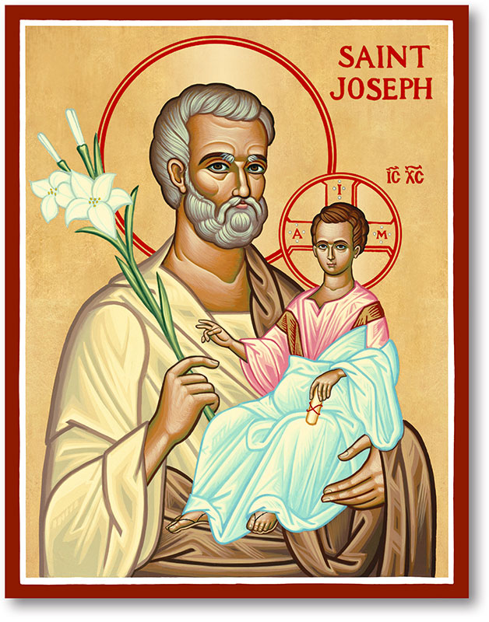
The Parish of Hannahstown
Saint Joseph’s and Saint Peter’s

16th March 2025
Second Sunday of Lent

Family of Parishes Emergency Sick Calls: 07549209775
Monday 10 am St Patrick’s Day Saint Peter’s
Monday 11.30 am St Patrick’s Day Saint Joseph’s
Tuesday Fr. Patrick’s Day off
Wednesday 9.15 am Parish Novena to Our Lady Saint Joseph’s
Thursday 9.15 am Parish novena to Our Lady Saint Peter’s
Friday 9.15 am Sacred Heart and St Michael’s Prayer Saint Joseph’s
Saturday 6:00 pm Prayer of Hope, Jubilee 2025 Saint Joseph’s
Sunday 10:00 am Prayer of Hope, Jubilee 2025 Saint Peter’s
Sunday 11:30 am Prayer of Hope, Jubilee 2025 BSL Signed Saint Joseph’s

Very Reverend Patrick Devlin Parish Priest,
Chaplain to the Deaf Community, Down and Connor Diocese
Chaplain to Antrim Area Hospital Thursday & Friday (Emergency calls)
Fr. Patrick, for Spiritual and Pastoral needs only, thank you Tel: 07910 833699
Parish Secretary: Mrs Grainne McArevey Tel: 028 90614567
Parish Office will be closed on Monday 18th March 2025
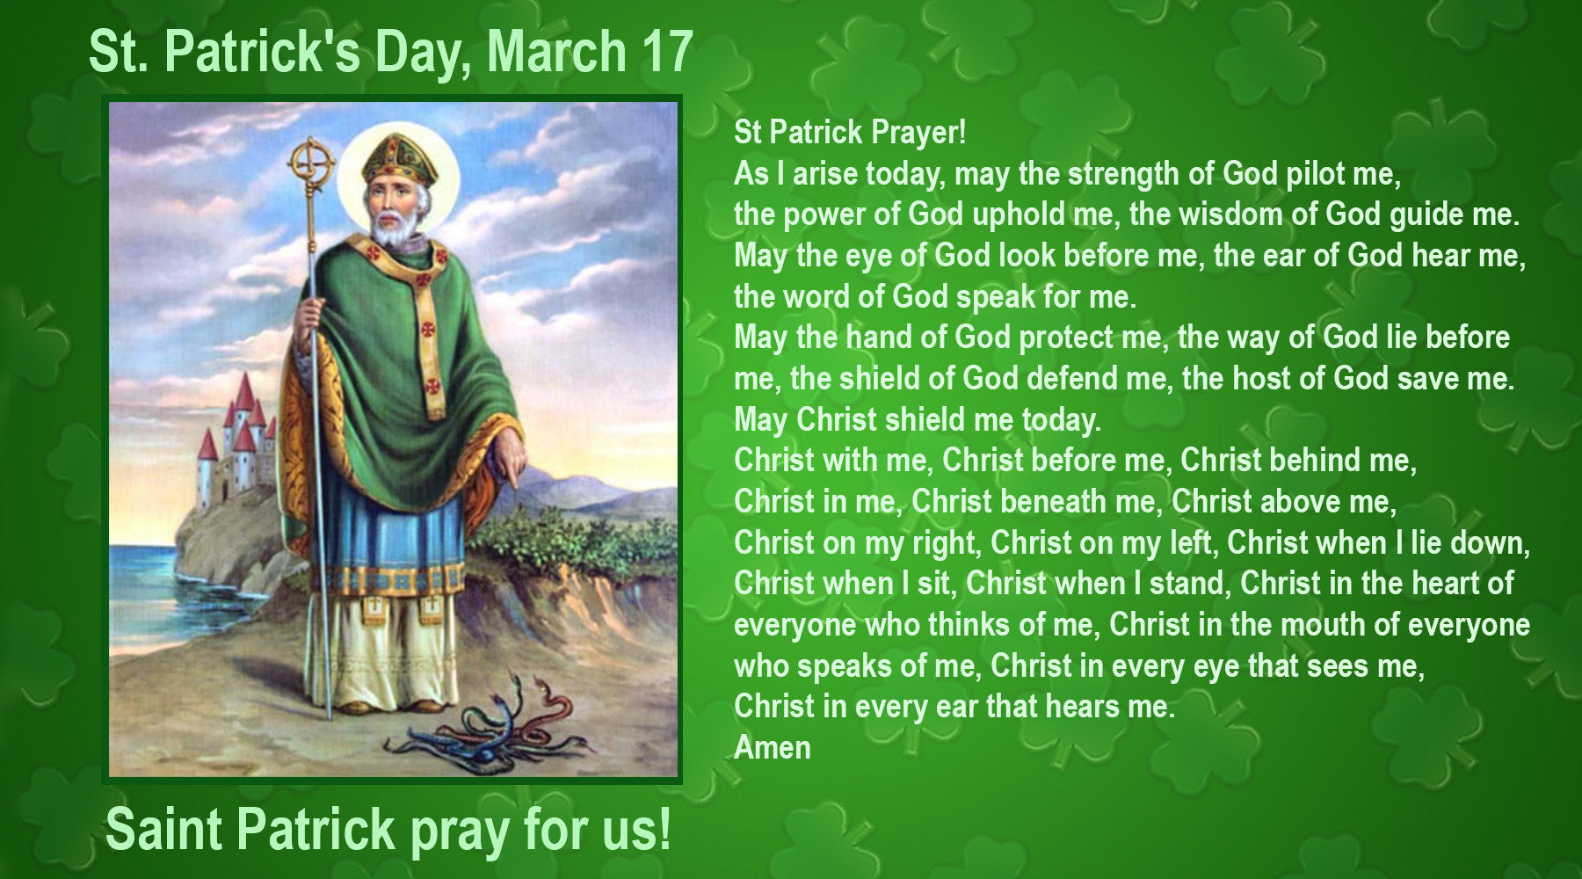
Parish Email: hannahstown@downandconnor.org Parish Website: https://www.parishofhannahstown.com
HANNAHSTOWN PARISH / FAMILY OF PARISHES / PATHWAYS
ST PATRICKS DAY SLEMISH MASS- Monday 17th March 2025 Mass at Mass Rock on Slemish Mountain. Family Rosary @ 2 pm, Mass @ 3 pm celebrated by Fr. Fitzsimmons. Free shuttle bus all day from Michelin Tyre Factory in Ballymena to Slemish. You can park your car at Michelin. Please allow enough time to get to Michelin to make the bus departure. Make a family day of it – food vans and toilet facilities at Slemish Carpark. All welcome contact Owen 07525166090

SAINT PATRICKS DAY DAWN PRAYER - Continuing the legacy of Saint Patrick who tells us in his Confessions that he rose as many as one hundred times before dawn to pray, a group of Christians will gather at 5:45 am at his grave on Saint Patrick's morning, Monday 17th March. We will pray The Our Father/ The Lord's Prayer one hundred times for peace and unity in Christ among our peoples. Everyone welcome. Please spread the word among friends from different Christian denominations.

LENTEN EVENTS AT DRUMALIS RETREAT CENTRE -
“See, I’m doing something New” Saturday 22nd March from 9:30 am 0 4 pm.
A Lenten renewing with Dr. Grainne Doherty. In this day of input and quiet reflection, we will meditate on what is helping and what is blocking our embracing of God’s Love, and God’s plans for each one of us.
The Passion Story: “A Work of Infinite Love” Saturday, 12 April from 9:30 am - 4 pm. A Day of Prayer and Reflection with Fr Aidan Troy. Fr Aidan will lead us in a day of prayer and reflection as we enter into Holy Week, where we are invited to immerse ourselves in this story of hope and unconditional love.
To book a place(s) or for further details, please contact Drumalis during office hours (Mon-Fri, 9 am – 5 pm) – 028 28276455/28272196 or email drumalis@btconnect.com Further information also available on Drumalis website: http://www.drumalis.co.uk
PILGRIM SACRED HEART STATUE - Bishop Alan is delighted to welcome one of the four pilgrim statues blessed by His Holiness Pope Francis. This statue will be sent to our Down and Connor Diocese to rekindle faith in the love of Jesus, represented in this devotion, and to offer everyone a ‘heart to heart’ encounter with His most Sacred Heart. The diocesan Sacred Heart Novena will run from 19th to the 27th of June 2025.
HANNAHSTOWN PARISH / FAMILY OF PARISHES / PATHWAYS
Bishop Alan's wish is for the Pilgrim Sacred Heart statue to visit as many churches as possible within our diocese throughout this Jubilee Year, especially those named and dedicated to the Sacred Heart. The highlight of the celebrations will take place at Knock on June 22nd, where His Grace, Archbishop Eamon Martin, will be the chief celebrant. On this day, he will renew the consecration of Ireland to the Sacred Heart alongside other attending Bishops. Information is available www.sacredheartcrusade.ie

EUCHARISTIC PROCESSION - Eve of St Patricks Day Eucharstic Procession Athlone. 3 pm Divine Mercy Chaplet at St. Mary’s Church Athlone N37 XP66. Jubilee Eucharstic Procession through Athlone's streets; Extraordinary Grace's for The Renewal of Ireland's Faith! 5pm Adoration and finish with Holy Mass at 6pm

Please contact Anthony Adams for any enquiries on 90 309795.
HANNAHSTOWN PARISH COMMUNITY HALL
Mon – Fri 10 am – 1 pm. Monday –
Coffee Morning after 9.15 am Mass.
Wednesday Morning Womens Group after 9.15 am Mass

