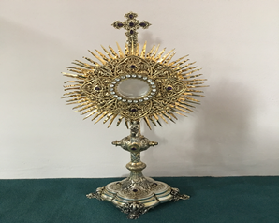**EUCHARISTIC ADORATION in St Peter’s Church - Every Friday from 2 pm – 8.30 pm.**

THE PARISH OF HANNAHSTOWN

**Every evening with in St Peter’s Church Adoration & Prayer from 6.30 pm – 7.30 pm**

**https://churchmedia.tv/st-josephs-church https://churchmedia.tv/st-peters-church-2**



**MONTH’S MIND**  Mary Curran & David Brady RIP

**ANNIVERSARIES** – Robert Duffy 1st Anniversary RIP

**WEEKLY COLLECTIONS**

**11/05/25 Weekly Collection £911.24**

**11/05/25 Building Fund Collection £364.19**

***Thank you to everyone for their generosity to the* Parish.**



**BAPTISMS**

To arrange Baptisms please present the long birth certificate to the parish office. Baptisms will be arranged upon request.

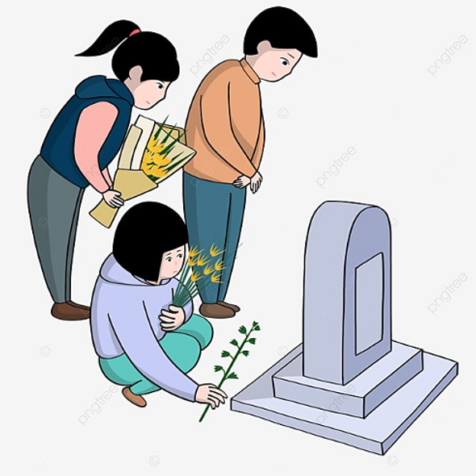**CEMETERY SUNDAY**

Hannahstown @ 3 pm (Mass) 25/05/25

The Rock @ 3 pm (Mass) 08/06/25

Tullyrusk @ 3pm (Mass) 15/06/25

**If you are available to serve as a minister for the Holy Eucharist please let Fr. Patrick know. Thank you.**

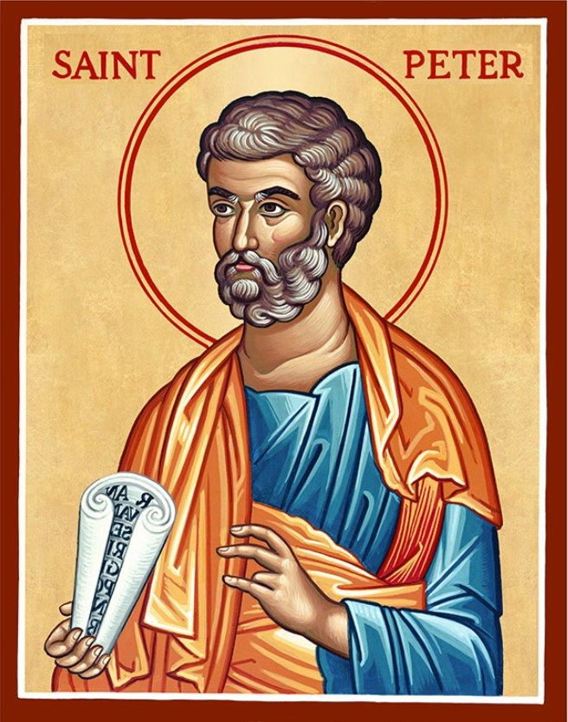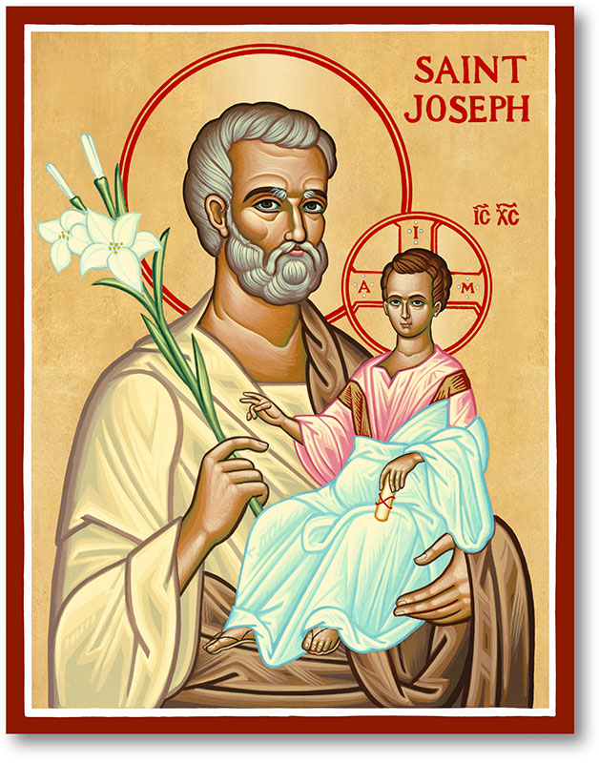

The Parish of Hannahstown

Saint Joseph’s and Saint Peter’s

**18th May 2025**

**Fifth Sunday of Easter**

**FIRST HOLY COMMUNION**

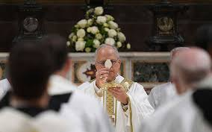POPE LEO THE 14th May 8th 2025

The children from ***Ballymacward Primary School***, will make their First Holy Communion today. This is a day of great rejoicing for us as a Parish. Today we witness **Alfie, Caileigh, Cody, Corey, Grace, Mia, Sam, Shane & Theo** come to the Altar to receive the **Body of Christ** for the first time; to welcome the real presence of **Jesus** into their hearts and souls.

On this very special and sacred day in their lives may we the faithful pause and reflect on the wonderful privilege for us as Catholics to be able to receive the real presence of Jesus in Holy Communion. On this sacred occasion let us thank the Lord for the gift He has given us in the Eucharist! It is a very great gift and that is why it is so important to go to Mass on Sunday. Go to Mass, not just to pray, but to receive Communion, the bread that is the **Body of Jesus Christ** who saves us, forgives us and unites us to the Father. It is a beautiful thing to do! And we go to Mass every Sunday because that is the day of the resurrection of the Lord.

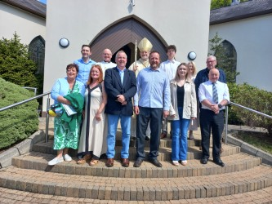That is why Sunday is so important to us. And in this Eucharist we feel this belonging to the Church, to the People of God, to the Body of God, to Jesus Christ.

Congratulations..

New Parish Pastoral Council Hannahstown Parish

Commissioned by Bishop Allan

May te Holy Spirit conutinue to guide them.

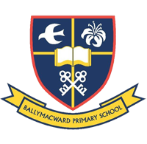**Our Parish School Ballymacward Primary School,**

HANNAHSTOWN PARISH SCHOOL / COMMUNITY PLAYGROUP

**22 Rock Road, Stoneyford, Lisburn, Co Antrim, BT28 3SUTel: (028) 92648130, Principal: Mr Hugh Kennedy**

**Email:** [**info@ballmacwardps.lisburn.ni.sch.uk**](mailto:info@ballmacwardps.lisburn.ni.sch.uk)

**Blessings with all our children celebrating their First Holy Communion.**

**Ballymacward Community Pre-School Playgroup - Supervisor: Ms Sarah Scott. Tel: (028) 9264 8515**

HANNAHSTOWN COMMUNITY HALL

Please contact Anthony Adams for any enquiries on 90 309795.

Mon – Fri 10 am – 1 pm.

Monday – Coffee Morning after 9.15 am Mass.

Wednesday Morning Seniors Group after 9.15 am Mass





HANNAHSTOWN COMMUNITY HALL

**SENSORY MASS**

HANNAHSTOWN PARISH / FAMILY OF PARISHES

**Sensory Friendly Mass** at St Colmcille's Church, Ballyhackamore, Belfast,  on **Saturday 28th June at 12.00 noon.** We welcome and embrace neurodiverse persons, those suffering from Alzheimer's and Dementia conditions, and those with sensory needs. Join us for a sensory friendly liturgy, which includes lower lights, softer music, and literal homilies.  Feel free to get up and move if needed, bring alternative seating, use quiet fidgets or noise cancelling headphones.

Save the date and come celebrate the Eucharist in an environment free of stigma. Please contact [n.dunn@downandconnor.org](mailto:n.dunn@downandconnor.org) to express your interest, or for enquiries.