
THE PARISH OF HANNAHSTOWN
WEEKLY COLLECTIONS:
1/4/26 Weekly Collection £687.27, 12/4/26 Monthly Collection £ 577.44
Collectors/ Volunteers Application Form available on parish website, thank you to everyone.


BAPTISMS DIOCESIAN AND PARISH NORMS:
Parents will be asked to complete a short form confirming whether any other person holds parental responsibility for the child and that they are aware of the request for baptism and have raised no objection. This procedure is required in line with diocesan guidance and civil law. Please bring with you a copy of the baby’s long birth certificate to the parish office.

CONSIDERING MARRIAGE?
“Above all, let your love for one another be intense.” (1 Peter 4:8)
We would be delighted to welcome couples to meet, view the church, and arrange their wedding. Please contact Parish Office
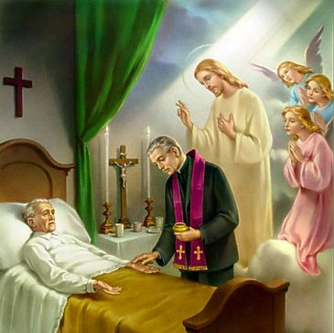
PASTORAL VISIT TO THE SICK AND HOUSEBOUND “The Lord is close to the broken-hearted.” (Psalm 34:18) Families are encouraged to let us know if a loved one is housebound and would need a visit from the priest. Contact Fr Patrick or the Parish office.


SAFEGUARDING IN OUR PARISH “Let the little ones come to me.” (Mark 10:14)
We are pleased to share that diocesan safeguarding requirements for 2026 have now been completed, helping ensure our parish remains a safe, respectful, and caring community.


ALL VOLUNTEERS: “Each of you has a gift to use in the service of others.” (1 Peter 4:10)
To support good safeguarding and governance, we invite all volunteers to complete a General Volunteer Application Form at the parish office. This helps us keep an up-to-date picture of parish life and ensures volunteers are properly supported.

HANNAHSTOWNTOWN COMMUNITY SPRING/SUMMER FESTIVAL FRIDAY-12TH JUNE-SUNDAY JUNE 14TH Fri-Seniors Tea-Dance 12-3.30 pm -Live music/Bingo/Ballots Sat-Historical Society Coach Trip (more information to follow) Sun- Outdoor Mass at 11.30am-followed by Tea in the community Centre Please provide any Bric-a-Brac such as good clothing, toys, games, books, etc. by contacting Anto at Hannahstown Community Centre on 02890-309795 More info to follow.


LIGHTS, CAMERA, ACTION! – BBC Drama Time
Our Parish Church will be used as a filming location for the acclaimed BBC drama Time (starring actors such as Sean Bean and Stephen Graham). Members of the congregation are invited to apply to be extras in the filming. If interested, please register with the casting company at: https://www.theextrasdept.com/ A wonderful and unique moment in our bicentenary year — our parish moving from 200 years of history to prime-time television!
LIGHTS, CAMERA, ACTION! – BBC Drama Time

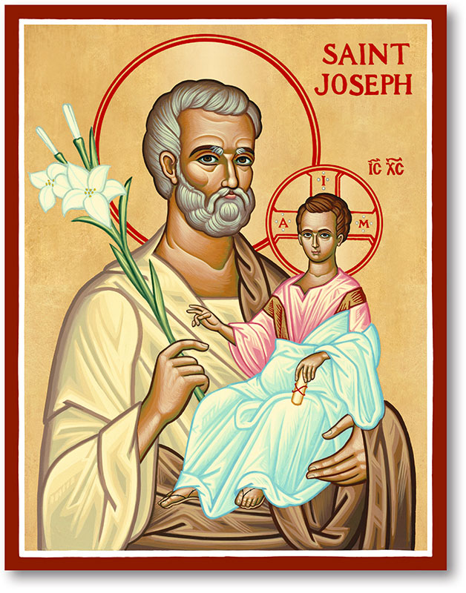
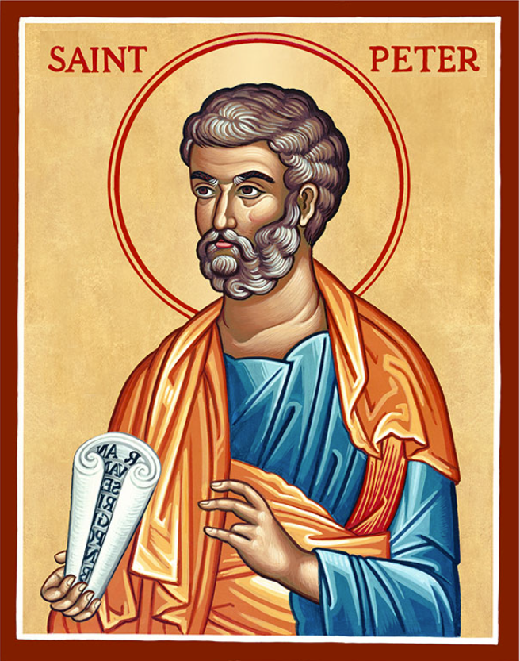
The Parish of Hannahstown
Saint Joseph’s and Saint Peter’s

17th April 2026
Family of Parishes Emergency Sick Calls: 07549209775
Very Reverend Patrick Devlin, Parish Priest.
Chaplain to the Deaf Community Down & Connor. Chaplain Antrim Hospital Thurs / Frid (Emergency Calls)
Contact Fr. Patrick for Spiritual and Pastoral needs only, Tel: 07910 833699. Parish Secretary Grainne McArevey 02890 614567 Email address: hannahstown@downandconnor.org Website: parishofhannahstown.com
Monday | 9.15 am  6.30-7.30 pm | Prayer for Vocations & Requiem Mass for Phillis Vincent RIP.  Coffee morning. Hannahstown Community Hall afterwards.  Adoration, Rosary and Divine Chaplet  https://churchmedia.tv/st-peters-church-2 | St Joseph’s  St Peter’s
Tuesday | 6.30-7.30 pm | Fr Patrick Away  Adoration, Rosary and Divine Chaplet | St Joseph’s  St Peter’s
Wednesday | 9.15 am  6.30-7.30 pm | Morning Mass Parish Novena to Our Lady  Adoration, Rosary and Divine Chaplet | St Joseph’s  St Peter’s
Thursday | 9.15 am  6.30-7.30 pm | Morning Mass Parish Novena to Our Lady  Adoration, Rosary and Divine Chaplet | St Peter’s  St Peter’s
Friday | 9.15 am  2.pm-8.30 pm  3.pm | Morning Mass Prayer to the Sacred Heart  Adoration, Rosary and Divine Chaplet  Divine Chaplet | St Joseph’s  St Peter’s  St Joseph’s
Saturday | 6.00 pm  6.30-7.30 pm | Vigil Mass Angelus  Adoration, Rosary and Divine Chaplet | St Joseph’s  St Peter’s
Sunday | 10.00 am  6.30-7.30 pm | Morning Mass Prayer to St Peter  Adoration, Rosary and Divine Chaplet | St Peter’s  St Peter’s
Sunday | 11.30 am  6.30-7.30 pm | Morning Mass Prayer to St Joseph  Adoration, Rosary and Divine Chaplet | St Joseph’s  St Peter’s


THIRD SUNDAY OF EASTER
In Luke 24:13–35, the risen Jesus walks with the disciples on the road to Emmaus, though they do not recognize Him at first. Their eyes are opened in the breaking of the bread. This reminds us that Christ is with us, especially in times of doubt, and is revealed in Scripture, fellowship, and the Eucharist. Let us pray for open hearts to recognize Him in our daily lives. “Were not our hearts burning within us while He talked with us on the road…?” (Luke 24:32)

REST IN PEACE: Kathleen Wilson RIP

ANNIVERSARIES – David Brady 1st Anniversary & Margaret Toland RIP
MONTH’S MIND – Eileen Rooney & Elizabeth (Lily) Young RIP



Team HCB ZAMBIA 2026: A Legacy of Giving - Thank you to everyone who supported the collection for Zambia 2026. Over £3000 was raised and Holy Cross Zambia Team are more than grateful to the parish of Hannahstown for their generosity & Kindness. The team will report back after the trip. Thank you so much.
HANNAHSTOWN PARISH PASTORAL COUNCIL (PPC)
Themes: Mercy, Healing and Unity
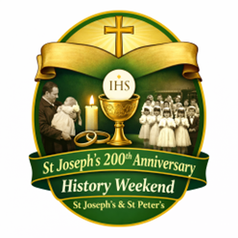
HISTORY WEEKEND: As we prepare to celebrate 200 years of St Joseph’s Church, we are organising a special History Weekend to honour the story of both St Joseph’s and St Peter’s. We warmly invite parishioners to share any photographs of parish life — Baptisms, First Confession, First Holy Communion, Confirmation, Weddings, visiting Priests or Bishops, School events, Parish Missions, or old photographs of the Churches. Please place photos in an envelope with: Your name, Contact number, Brief details of the photo. Photos can be left in the Sacristy or Parish Office by Monday 12th April and will be carefully returned after the event. Help us celebrate the generations of faith that have shaped our parish.

HANNAHSTOWN PARISH APRIL 2026 ST. JOSEPH’S CHURCH 200TH ANNIVERSARY

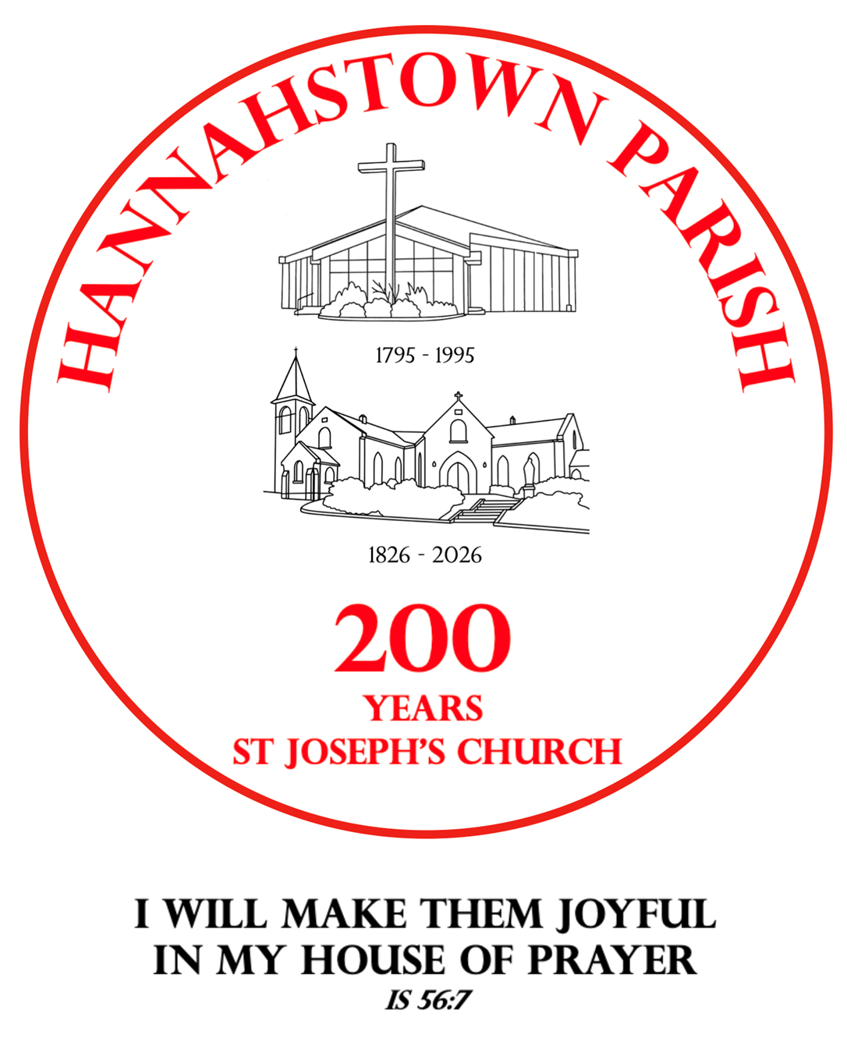
TODAY IS OUR SPECIAL BLESSING SERVICE FOR ALL BABIES WHO WERE BAPTISED INTO OUR PARISH IN THE PAST THREE YEARS.

A joyful and prayerful celebration including a short Liturgy of the Word, Procession, and Blessing of Children and Families, with Guardian Angel prayer cards given as a gift.
Afterwards, join us outside for ice cream, balloons, and fun characters for the children.
A lovely opportunity to give thanks and continue the journey of faith together. Pray for nice WEATHER! All are welcome.



TREE PLANTING AND TIME CAPSULE CELEBRATION:

As part of our 200-year celebrations of St Joseph’s Church, we invite parishioners to a special moment of remembrance and hope for the future.

A tree will be planted as a symbol of faith and growth, and a time capsule will be created to capture memories of our parish for future generations. Further details to follow.

HANNAHSTOWN PARISH MAY 2026 ST. JOSEPH’S CHURCH 200TH ANNIVERSARY

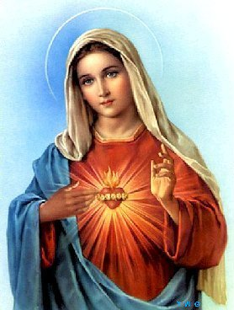
Theme: With Mary – A Journey of Faith, Hope and Love. As we enter the beautiful month of May, dedicated to Mary, the Mother of the Church, we move into a new and prayerful stage of our 200th Anniversary celebrations at St Joseph’s. Having honoured our history and celebrated new life in Baptism, we now turn to Our Lady, who gently leads us ever closer to her Son. SUNDAY 17TH MAY – CROWNING OF OUR LADY and ROSARY PROCESSION
We warmly invite all parishioners, families, and especially our children, to take part in a special Crowning of Our Lady and Rosary Procession on Sunday 17th May.
Together, we will: Honour Mary as our Mother and Queen Pray the Rosary for our parish, our families, and peace in the world. Entrust the next chapter of our parish journey to her loving care. Children are especially invited to take part in the crowning, a beautiful and memorable moment in our celebration.
This will be a joyful and prayerful gathering, uniting generations in faith, as we continue to give thanks for 200 years of St Joseph’s Church and look forward with hope to the future.
Further details to follow.
Let us walk with Mary, trusting in her intercession, as we continue this amazing journey together. “My soul glorifies the Lord, and my spirit rejoices in God my Saviour.


CEMENTRY SUNDAYS: – Invitation You are warmly invited to our Cemetery Sunday Masses, as we remember and pray for our loved ones.
D&C DIOCESE & HANNAHSTOWN & FAMILY OF PARISHES NEWS NWESNNEWS
Sunday 31st May – St Joseph’s Sunday, 7th June – St Peter’s,
Sunday 14th June – Tullyrusk All are most welcome.
“I am the resurrection and the life, says the Lord; whoever believes in me will live, even though they die.”
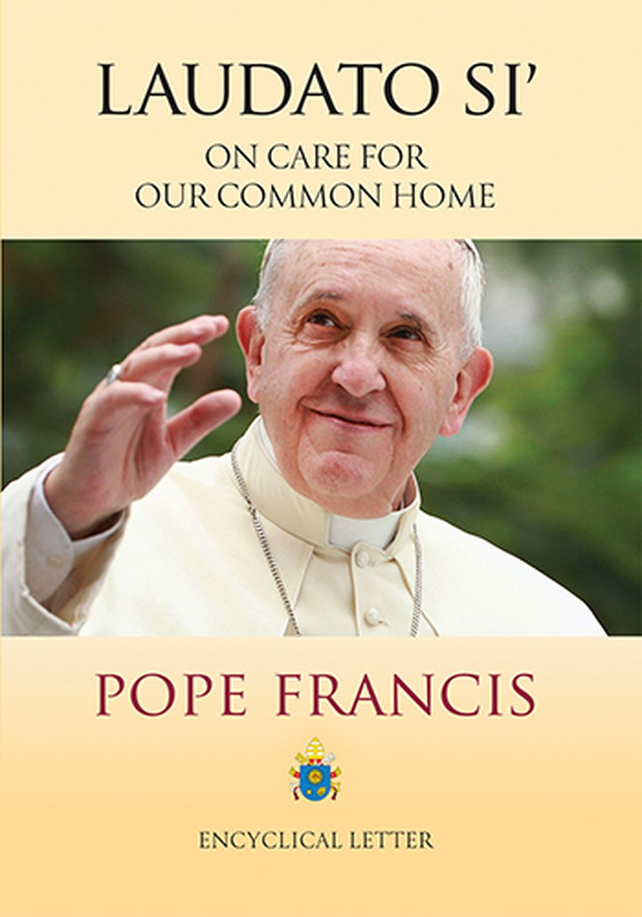
LAUDATO SI CONFERENCE (QUB) When: April 22, 2026 @ 9:30 am – 1:00 pm
Where: Queens University Belfast
A great opportunity to hear from Dr Lorna Gold, Executive Director Laudato Si’, and also to meet with Lorna in person. Join others who share a common interest in living more sustainably; discuss actions that are being implemented and their impact; explore bold alternatives to our economic system. Your presence and contribution is very welcome.
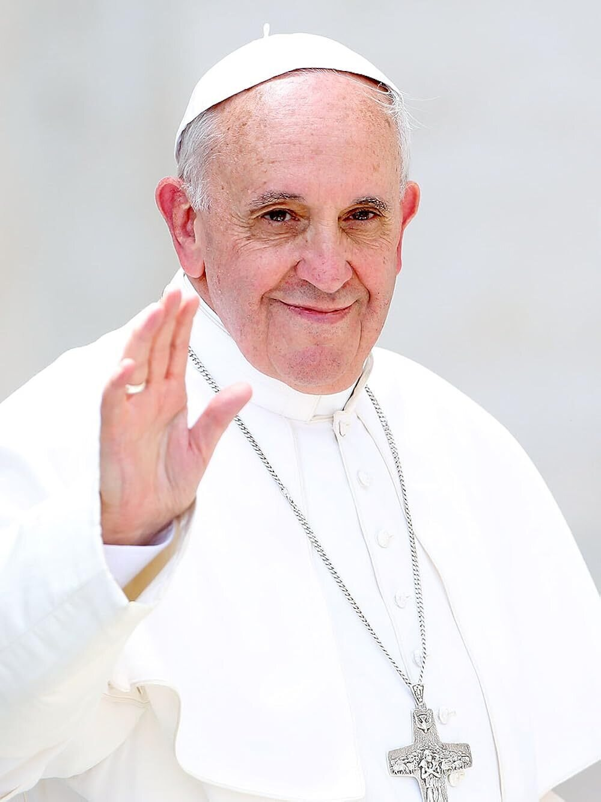

BISHOP Allan McGUCKIAN SJ: will celebrate mass to mark the First Anniversary of the death of Pope Francis in St Peter’s Cathedral Tuesday 21 April 2026 at 7pm. All are welcome.


PRECIOUS LIFE: invites young people to a Pro-Life Apologetics Day on Saturday, 25 April from 2:00–4:00pm at St Mary’s Church Hall, Chapel Lane, Belfast. This session will help equip youth to respond confidently and compassionately to pro-life questions. Free pizza will be provided afterwards. For more info, contact 07956 451655.


DOWN AND CONNOR: Pilgrimage to Lourdes 2026: 8th – 15th July 2026
Join the Diocese of Down and Connor on a pilgrimage to Lourdes—a place of prayer, healing, and hope. This sacred journey offers time for reflection, participation in the Sacraments, and prayer at the Grotto, inviting pilgrims to deepen their faith and seek spiritual renewal.
All are welcome, especially those seeking peace, healing, or companionship in faith. For more information or to register, please contact the Diocesan Pilgrimage Office.
"Come to me, all you who labour and are burdened, and I will give you rest." (Matthew 11:28)

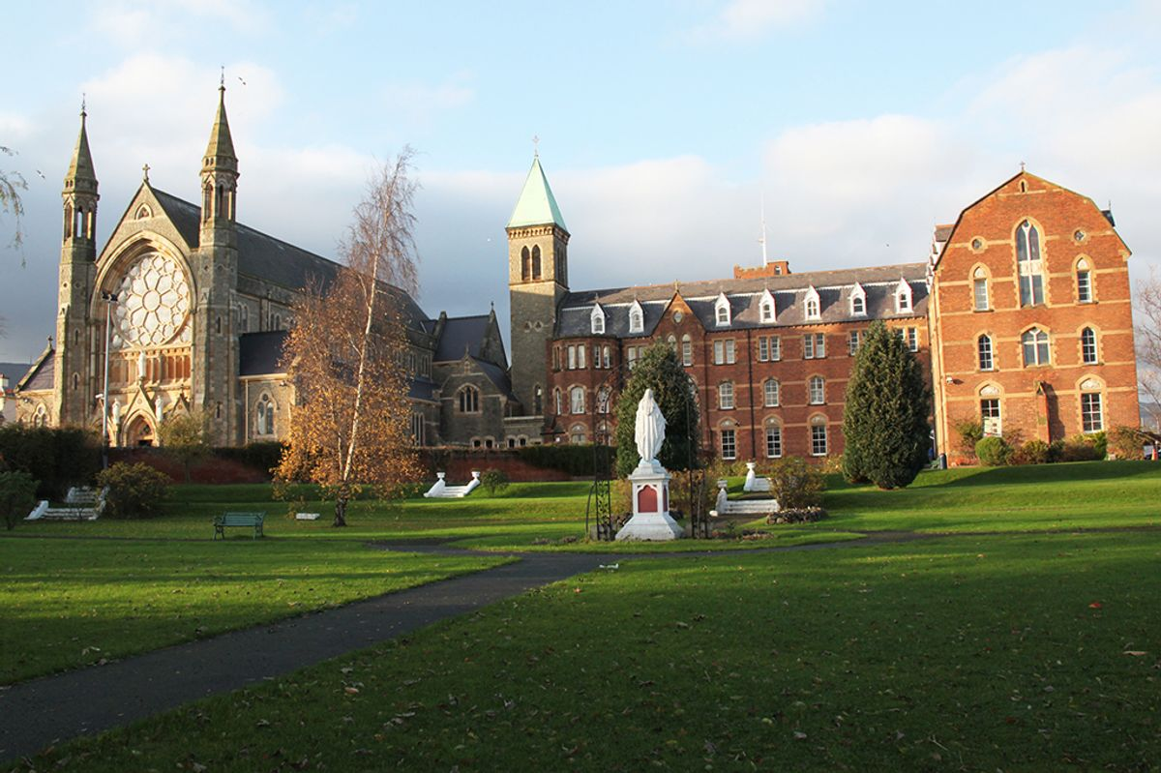
CLONARD SOLEMN NOVENA 2026:
The annual Clonard Solemn Novena will begin on Wednesday, 18th June 2026. This special time of prayer and reflection is a cherished tradition in our community, drawing people from near and far to gather in faith, hope, and renewal.
Over the nine days, there will be a rich programme of Masses, devotions, and guest speakers, offering inspiration and spiritual nourishment for all who attend. Whether you come seeking peace, guidance, or simply a moment of quiet in a busy world, the Novena provides a welcoming space for everyone.
Parishioners are warmly encouraged to participate and to invite family, friends, and neighbours to share in this meaningful event. Further details, including the full schedule, will be announced in the coming weeks.
Let us prepare our hearts to make this year’s Novena a time of grace and blessing for all.

