
EUCHARISTIC ADORATION
THE PARISH OF HANNAHSTOWN
St Peter’s Church - Friday’s 2 pm – 8.30 pm.
St Peter’s Church Daily 6.30 pm – 7.30 pm with
Adoration, Rosary & The Divine Mercy Chaplet.
https://churchmedia.tv/st-peters-church-2
St Joseph’s Church – Friday’s 3 pm – 4 pm with Adoration & Divine Mercy Chaplet.
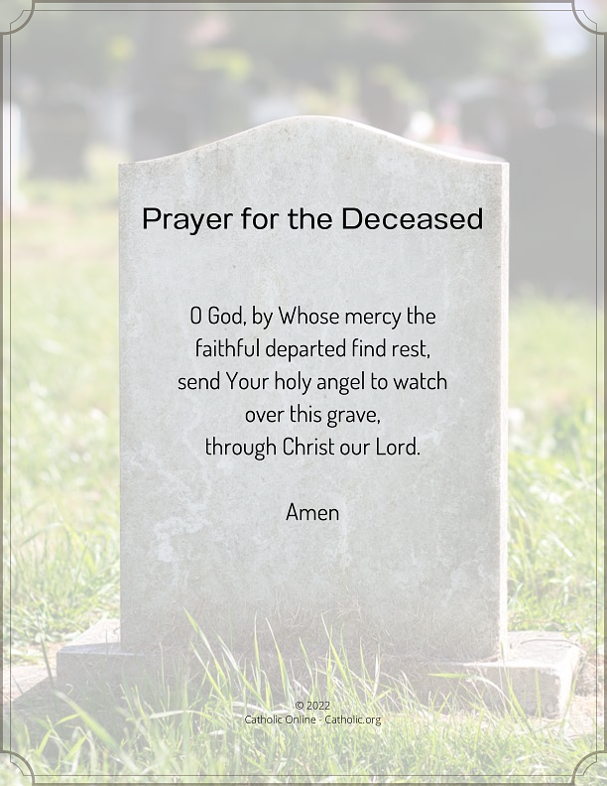
MONTH’S MIND – Winifrede Clarkin RIP
1st ANNIVERSARY – Daryl Fegan,
Brendan Mulholland RIP
ANNNIVERSARIES – Raymond Clarkin 40th A, Eamon Cleary, John & Margaret Keegan
& Arthur McKenna, RIP

WEEKLY COLLECTIONS
25/01/26 Weekly Collection £992.20
Thank you to everyone for their generosity to the Parish.


BAPTISMS
Baptisms are upon request and you must visit the parish office to book one. Please bring with you a copy of the baby’s long birth certificate.

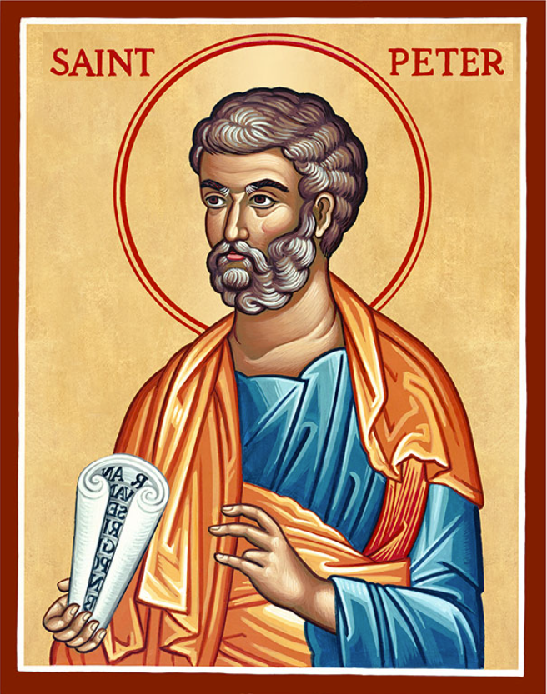
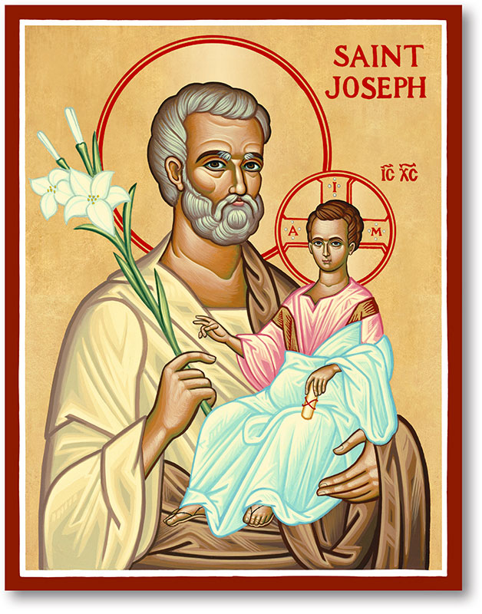
The Parish of Hannahstown
Saint Joseph’s and Saint Peter’s

1st February 2026
St Brigid, Abbess, Secondary Patron Of Ireland
Family of Parishes Emergency Sick Calls: 07549209775
Monday | 9.15 am | Prayer for Vocations  Coffee morning in Hannahstown Community Hall afterwards. | St Joseph’s
Tuesday |  | Fr Patrick Away
Wednesday | 9.15 am | Parish Novena to Our Lady  Seniors group in Hannahstown Community Hall afterwards. | St Joseph’s
Thursday | 9.15 am | Parish Novena to Our Lady | St Peter’s
Friday | 9.15 am | Sacred Heart & St Michael’s Prayer | St Joseph’s
Saturday | 6.00 pm | Prayer of Hope, Jubilee 2025 | St Joseph’s
Sunday | 10.00 am | Prayer of Hope, Jubilee 2025 | St Peter’s
Sunday | 11.30 am | Prayer of Hope, Jubilee 2025 | St Joseph’s
Very Reverend Patrick Devlin, Parish Priest, Chaplain to the
Deaf Community Down & Connor.
Chaplain to Antrim Hospital Thursday & Friday (Emergency calls)
Fr. Patrick, Spiritual and Pastoral needs only, Tel: 07910 833699.
Parish Secretary Grainne McArevey 02890 614567
Email address: hannahstown@downandconnor.org Website: parishofhannahstown.com
St Bridgid, Abbess, Secondary Patron Of Ireland
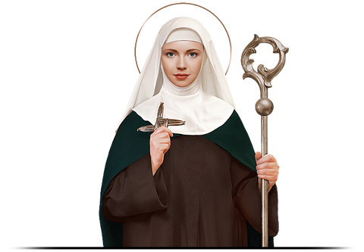
The Qualities of women: By Bishop Michael Router catholicbishops.ie
Time and again in the gospel we see that Jesus needed the cooperation of women, to carry out his mission. They supported him at every moment of his public ministry. The qualities that made Saint Brigid great have been found in so many women down through the centuries. Some of these women entered religious life and were extremely dedicated to their vocation and mission. The vast majority, however, have been women who in their homes, workplaces and communities helped to nurture and to spread the faith. Without them the Church would have found it hard to survive and flourish. Their contribution is incalculable and the gratitude we owe them immense.
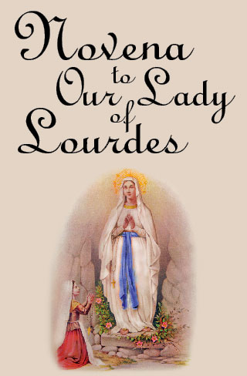
ST AGNES PARISH NOVENA TO OUR LADY OF LOURDES - Our Lady of Lourdes 2026 begins 10am Tuesday 3rd Feb. Schedule as follows; Sunday: 9.30am & 12.30pm. Monday to Friday: 10am & 7pm.Saturday: 1pm & 6.30pm (Vigil). Penitential Service: Friday 7th Feb 7pm. Mass for the Sick: Sat 8th Feb 1pm. Gathering of Youth: Sunday 9th Feb 7pm
HANNAHSTOWN PARISH / FAMILY OF PARISHES / PATHWAYS
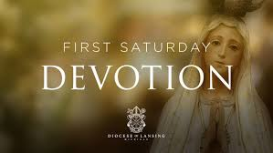
FIRST SATURDAY DEVOTIONS -
St. Matthias’s Church, Glen Road on 7th February 2026. 3.00 p.m. Adoration of the Blessed Sacrament, Confessions and Act of Consecration., Rosary and Divine Mercy Chaplet. 4.00 p.m. Holy Sacrifice of the Mass
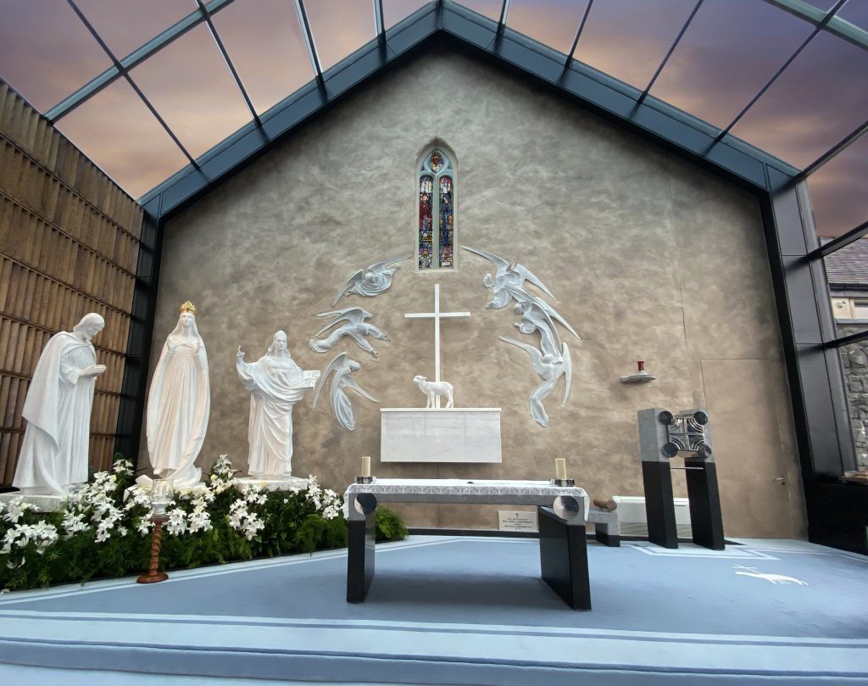
FAMILY OF PARISHES PILGRIMAGE TO KNOCK – Departing Tuesday 24th March at 10 am from Hannahstown parish office and returning Wednesday 25th March at 8 pm. Cost is £155 and price includes bus, accommodation at Knock House Hotel, dinner, bed and breakfast. Refreshments at Kellyhevlin Hotel. Please contact the parish office to reserve your place.

POPE LEO’S MONTHLY INTENTION –
For children with incurable diseases: Let us pray that children suffering from incurable diseases and their families receive the necessary medical care and support, never losing strength and hope.

HANNAHSTOWN PARISH / FAMILY OF PARISHES
Hannahstown and the Rock Parish Draw January 2026

Prize  Place | Prize  Money | Winners Name | No | Promoter
1st | £250 | Ronan McQuillan | 152 | Johnny McQuillan
2nd | £150 | Guiseppa McKenna | 380 | Jim Ferguson
3rd | £100 | Philomena Hayes | 343 | Stephen Mulligan
4th | £100 | Hugh O’Rawe | 68 | Bronagh O’Rawe
5th | £50 | Maureen Irvine | 123 | Rachel Connolly
6th | £50 | Mary Barrett /Tim Finnegan | 229 | Joe Finnegan
7th | £50 | Enda Martin | 424 | Mary Ferguson
8th | £50 | Brian Young | 64 | Parish Office
9th | £50 | Carol Loughery (please contact the parish office for prize). | 78 | Mary Peyton
10th | £50 | Yolanda Kane | 67 | Parish Office

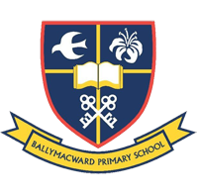
Our Parish School
HANNAHSTOWN PARISH / FAMILY OF PARISHES
Ballymacward Primary School,
22 Rock Road, Stoneyford, Lisburn, Co Antrim, BT28 3SUTel: (028) 92648130, Principal: Mr Hugh Kennedy
Email: info@ballmacwardps.lisburn.ni.sch.uk
Ballymacward Community Pre-School Playgroup - Supervisor: Ms Sarah Scott. Tel: (028) 9264 8515

Congratulations to all our transfer children who all did exceptional in their test.

