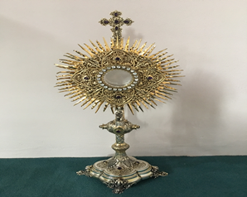
EUCHARISTIC ADORATION
THE PARISH OF HANNAHSTOWN
St Peter’s Church - Every Friday from 2 pm – 8.30 pm. Every evening Adoration & Prayer in St Peter’s Church 6.30 pm – 7.30 pm
https://churchmedia.tv/st-josephs-church https://churchmedia.tv/st-peters-church-2

ANNIVERSARIES – Moya Browning,
Frank McCloskey, Grace, Carol & Liam Quinn, RIP

RECENTLY DECEASED – Elizabeth Donnelly RIP


WEEKLY COLLECTIONS
5/1/2025 Weekly Collection £738.10
5/1/2025 Monthly Collection £507.10
Thank you to everyone for their generosity to the Parish.

BAPTISMS
Baptisms are upon request and you must visit the parish office to book one. Please bring with you a copy of the baby’s long birth certificate.
For first-time parents there is a Baptsim course within the Family of Parishes that must be attended prior to the Baptism. Further information upon booking.
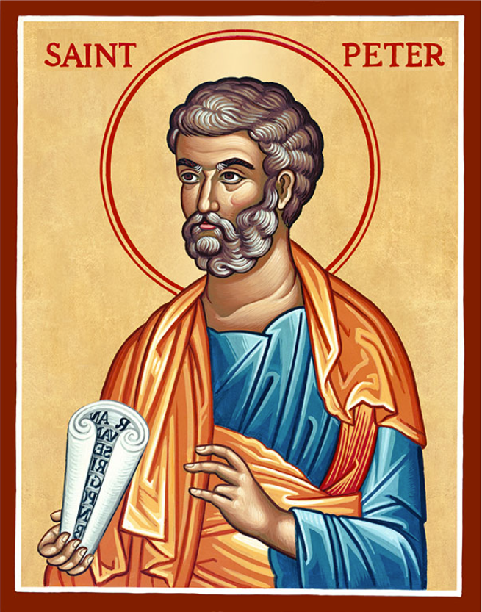
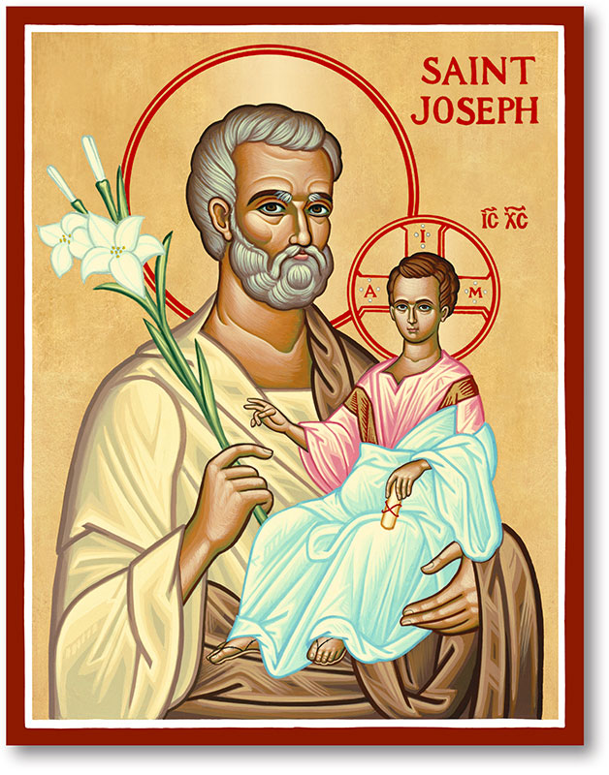
The Parish of Hannahstown
Saint Joseph’s and Saint Peter’s

12th January 2025
The Baptism of the Lord

Family of Parishes Emergency Sick Calls: 07549209775
Monday 09.15 am (Prayer for Vocations) Saint Joseph’s
Tuesday No Mass as Fr. Patrick’s day off.
Wednesday 9.15 am (Parish novena to Our Lady) St Joseph’s
Thursday St Stephen’s Day @ 9.15 am Saint Peter’s
Friday 09.15 am (Sacred Heart Prayer) Saint Joseph’s
Saturday 6:00 pm (St Michael the Archangel Prayer) Saint Joseph’s
Sunday 10:00 am (Prayer for Pope’s intentions) Saint Peter’s
Sunday 11:30 am (Saint Joseph Prayer) ( BSL Signed ) Saint Joseph’s

Very Reverend Patrick Devlin Parish Priest,
Chaplain to the Deaf Community, Down and Connor Diocese
Chaplain to Antrim Area Hospital Thursday & Friday (Emergency calls)
Fr. Patrick, for Spiritual and Pastoral needs only, thank you Tel: 07910 833699
Parish Secretary: Mrs Grainne McArevey Tel: 028 90614567
Parish Email: hannahstown@downandconnor.org Parish Website: https://www.parishofhannahstown.com

The Baptism of the Lord

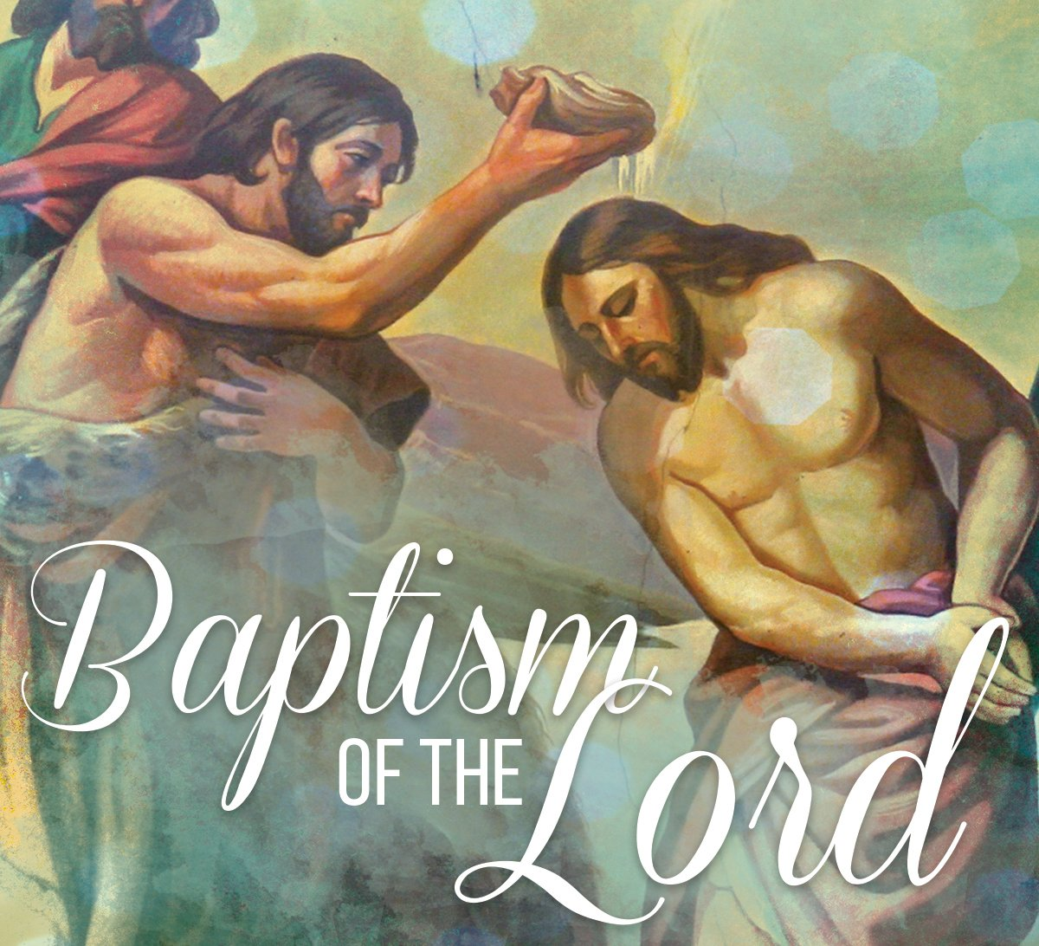
Keep us, your children born of water and the Spirit faithful to our calling. We ask this through our Lord Jesus Christ, your Son, who lives and reigns with you and the Holy Spirit, one God, for ever and ever. Amen

Please contact: Anthony Adams for any enquiries on 90 309795.

HANNAHSTOWN COMMUNITY HALL
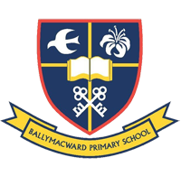
Mon – Fri 10 am – 1 pm. Monday – Coffee Morning after 9.15 am Mass. Wednesday Morning Womens Group after 9.15 am Mass
Our Parish School Ballymacward Primary School,
THE PARISH OF HANNAHSTOWN SCHOOLS
22 Rock Road, Stoneyford, Lisburn, Co Antrim, BT28 3SUTel: (028) 92648130, Principal: Mr Hugh Kennedy
Email: info@ballmacwardps.lisburn.ni.sch.uk

Pre-School Playgroup – Supervisor: Ms Sarah Scott. 02892648515
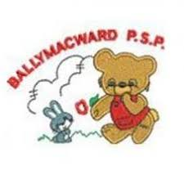
Ballymacward Pre-School Playgroup's Open Day has been rescheduled to Tuesday 14th January 2025 (weather permitting) from 1:00 pm to 2:00 pm. If you are unable to attend, please email the pre=school @ Ballymacward_pre-school@hotmail.com and alternative arrangements can be made.


Welcoming Spring: Day of Reflection led by Breige O’Hare. 11am – 4 pm Saturday 1 February 2025. Holy Rosary Parish Hall, 503 Ormeau Road, Belfast. BT7 3GR. Join us for a day of story and song, scripture and prayer in the company of the early Christian leader Brigid and the Jesus she loved. It's time to slow down, a chance for new beginnings and fresh starts, ending with a beautiful liturgy commissioned for the season with new music by Mairead Duffy. Bring a packed lunch. Tea/coffee provided. Booking essential: email info@firststeipwell.com
HANNAHSTOWN PARISH / FAMILY OF PARISHES / PATHWAYS
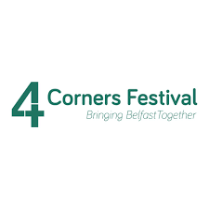
4 CORNERS FESTIVAL Invitation ….In this 10th anniversary year of Pope Francis’ Encyclical “Laudato Sì”, Belfast is privileged to host Lorna Gold, Chair of the International Laudato Sì Movement, at the 4 Corners Festival on Sunday 2nd February (7pm, Jennymount Methodist Church, 222 North Queen Street, BT15 3DH). Let’s come together for a future of hope and justice. Further info from info@jointhedotstogether.org Register here: https://www.tickettailor.com/events/4cornersfestival2/1489258
HANNAHSTOWN PARISH / FAMILY OF PARISHES / PATHWAYS

BEGINNING EXPERIENCE - The loss of a partner through death, separation or divorce is devastating. Beginning Experience is offering a programme of bereavement support in St Bride’s Hall, Derryvolgie Ave., Belfast on three Saturdays (25th January; 22nd February and 29th March) Booking is essential.
To find out more, contact 07519289185 OR belfastbe@yahoo.com
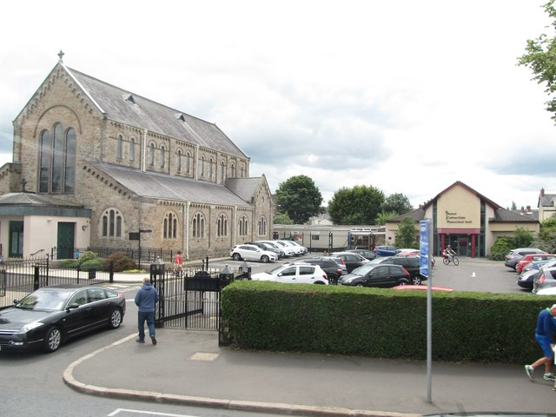
ALPHA Join us at St Colmcille's Parish, 191 Upper Newtownards Road Belfast BT4 3JB.... starting this Wednesday 15th January at 8.00 pm. for ALPHA. The Alpha experience includes food, a video presentation and small group discussions. It is a place where you can be yourself. You can say what you think about faith issues, and challenge everything. No question is too complex or too simple. Your point of view is as important as anyone else's. To register your interest contact Noeleen by emailing: n.dunn@downandconnor.org or text: 07879 498131.

MEDJUGORJE 2025 – Both myself (Fr. Patrick) & our parish secretary are looking forward to our Medjugorje Pilgrimage on 2nd May. Maybe this is an opportunity for you (if you have been thinking about it), to go on this wonderful trip. Our 2023 pilgrims loved the experience and we know you will too. Please get in touch with the parish office for further information or to ask any questions.
Is our Blessed Mother calling you?

