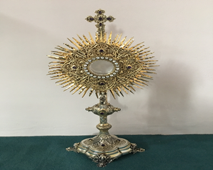
EUCHARISTIC ADORATION
THE PARISH OF HANNAHSTOWN
St Peter’s Church - Every Friday from 2 pm – 8.30 pm. Every evening Adoration & Prayer in St Peter’s Church 6.30 pm – 7.30 pm
https://churchmedia.tv/st-josephs-church https://churchmedia.tv/st-peters-church-2

ANNIVERSARIES – Rita, Eamon & Gerald Cleary, Daniel Hickland, Margaret Hughes, Margaret Keegan, Joseph & Geraldine McGowan, Ann Mulligan & Maureen Quinn RIP.
RECENTLY DECEASED – Daryl Fegan RIP Wednesday 29th January at 10 am
MONTHS MIND - Jean Marley RIP

WEEKLY COLLECTIONS
19/01/25 Weekly £1,214.10
19/01/25 Living Church £318.26

Thank you to everyone for their generosity to the Parish.
BAPTISMS
We welcome Oísín Burke, James Butler & Aódla McKiernan into our Parish Family.
For first-time parents there is a Baptsim course within the Family of Parishes that must be attended prior to the Baptism. Further information upon booking.

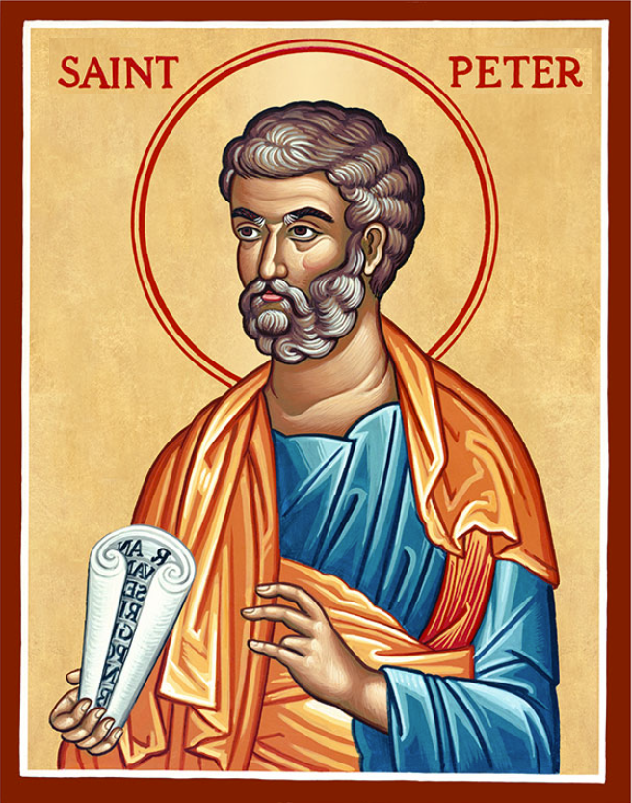
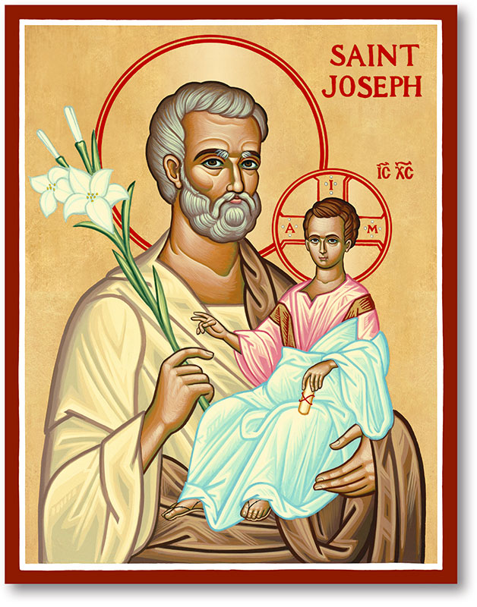
The Parish of Hannahstown
Saint Joseph’s and Saint Peter’s

26th January 2025
Third Sunday in Ordinary Time

Family of Parishes Emergency Sick Calls: 07549209775
Monday 09.15 am (Prayer for Vocations) Saint Joseph’s
Tuesday Fr. Patrick’s day off.
Wednesday 9.15 am (Parish novena to Our Lady) St Joseph’s
Thursday 9.15 am (Parish novena to Our Lady) St Peter’s
Friday 9.15 am (Sacred Heart Prayer) Saint Joseph’s
Saturday 6:00 pm (St Michael the Archangel Prayer) Saint Joseph’s
Sunday 10:00 am (Prayer for Pope’s intentions) Saint Peter’s
Sunday 11:30 am (Saint Joseph Prayer) ( BSL Signed ) Saint Joseph’s

Very Reverend Patrick Devlin Parish Priest,
Chaplain to the Deaf Community, Down and Connor Diocese
Chaplain to Antrim Area Hospital Thursday & Friday (Emergency calls)
Fr. Patrick, for Spiritual and Pastoral needs only, thank you Tel: 07910 833699
Parish Secretary: Mrs Grainne McArevey Tel: 028 90614567
Parish Email: hannahstown@downandconnor.org Parish Website: https://www.parishofhannahstown.com

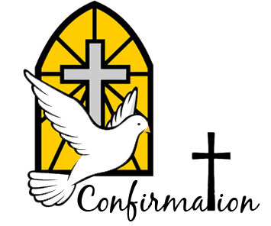
Thirs Sunday in Ordinary Time
Today we welcome Bishop Alan to our parish to celebrate the sacrament of Confirmation with our Year 7 children from Ballymacward Primary School.
Amelia, Cara, Christopher, Dylan, Eve, Heidi, Isla, Jenson, Maeve, Melissa, Seth & Zach will receive their gifts from the Holy Spirit, may He fill their hearts, and enkindle in them the fire of His Love. Amen
Please contact: Anthony Adams for any enquiries on 90 309795.

HANNAHSTOWN COMMUNITY HALL

Mon – Fri 10 am – 1 pm. Monday – Coffee Morning after 9.15 am Mass. Wednesday Morning Womens Group after 9.15 am Mass
Our Parish School Ballymacward Primary School,
THE PARISH OF HANNAHSTOWN SCHOOLS
22 Rock Road, Stoneyford, Lisburn, Co Antrim, BT28 3SUTel: (028) 92648130, Principal: Mr Hugh Kennedy
Email: info@ballmacwardps.lisburn.ni.sch.uk
Pre-School Playgroup – Supervisor: Ms Sarah Scott. 02892648515

Dear all, As we move forward with forming our Parish Pastoral Councils (PPC), I invite parishioners interested in becoming part of the PPC to the following information evening. Tuesday 28th January 7 pm -9 pm. Venue: St Teresa’s Parish Centre, Glen Road Belfast Tea/coffee served from 6:30 pm. This evening session will provide an overview of the context, role, and responsibilities of a PPC. It will also explore the gifts, skills, and qualities required to be a PPC member. These sessions will help those who may be interested in this leadership role to understand what it entails and to discern if this is a role for them in the life of their Parish. Please contact the Parish Office to note your interest in attending this meeting.
HANNAHSTOWN PARISH / FAMILY OF PARISHES / PATHWAYS
FIRST SATURDAY DEVOTIONS - Will take place in St. Matthias’s Church, Glen Road on 1st February. 3.00 p.m. Adoration of the Blessed Sacrament, Confessions and Act of Consecration., Rosary and Divine Mercy Chaplet. 4.00 p.m. Holy Sacrifice of the Mass
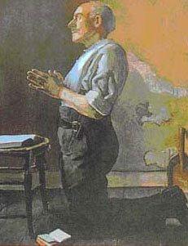
MATT TALBOT RELICS - Venerable Matt Talbot: ‘A Saint for our Times’ Arrival of the Relics of Venerable Matt Talbot at St Peter's Cathedral, Belfast, 3rd February 2025. The Relics will be received into St Peter’s Cathedral, Belfast at 5pm on Monday 3rd February 2025. Mass will be celebrated at 7.30pm with Veneration of the relics ongoing before, and after Mass, concluding with Night Prayer at 10pm. This blessed event, facilitated by the Order of the Knights of St Columbanus, will provide an opportunity for people of all backgrounds to reflect upon the heroic virtues of this 'Saint for our times' who overcame chronic alcohol addiction by living a life of prayer, self-sacrifice and abandonment to the love and mercy of Jesus. Everyone is very welcome.
JUBILEE PRAYER 2025
Matt Talbot Prayer Society at St Peter's—Mass is celebrated on the first Monday of every month at 10 a.m. in Saint Peter's Cathedral and offered for those struggling with addiction, their families, and all those affected by addiction. In this Mass, we ask for the intercession of Venerable Matt Talbot; the names of those enrolled in the Matt Talbot Prayer Society are placed on the Altar. All are welcome.

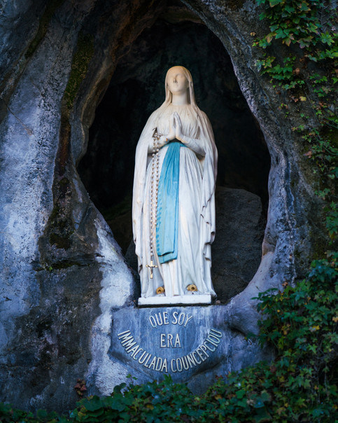
OUR LADY OF LOURDES NOVENA - St Agnes’ Parish Novena to:
Our Lady of Lourdes 3rd to 11th February 2025
Preachers: Fr Laurence Gallagher & Bridgeen Mc Nicholl Mass Times: Sunday: 9.30 am & 12.30 pm.
Monday to Friday: 10 am & 7 pm.
Saturday: 1 pm & 6.30 pm (Vigil)
Novena Mass for the Sick: Sat 8th Feb at 1 pm. The Sacrament of Reconciliation will be available during the Novena. ALL NOVENA SESSIONS WILL BE AVAILABLE ONLINE THROUGH THE PARISH WEBCAM

