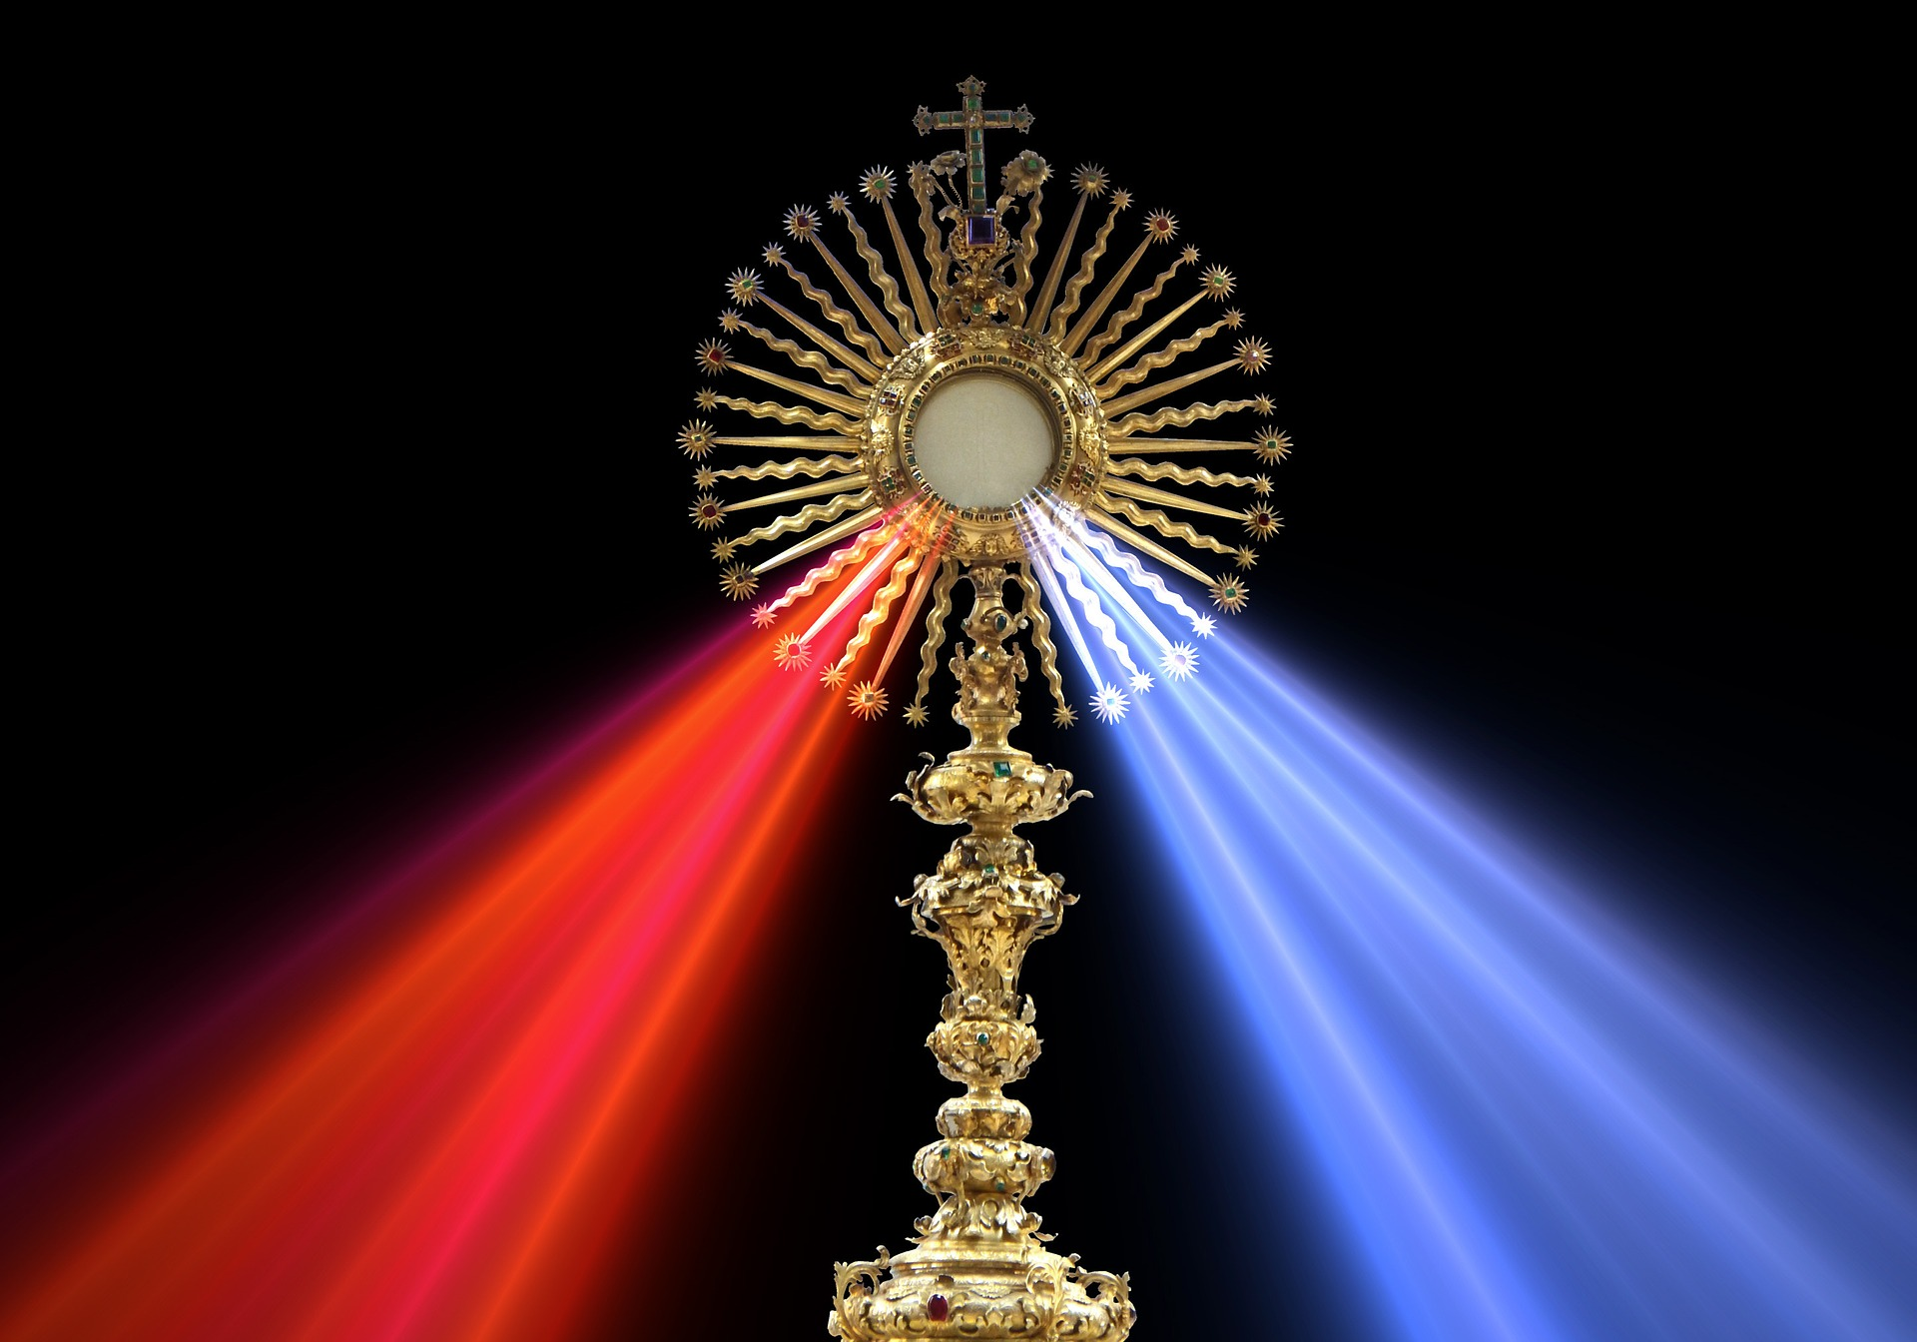
EUCHARISTIC ADORATION
THE PARISH OF HANNAHSTOWN
St Peter’s Church - Friday’s 2 pm – 8.30 pm.
Daily Adoration, Rosary & The Divine Mercy Chaplet St Peter’s Church 6.30 pm – 7.30 pm every evening. https://churchmedia.tv/st-peters-church-2
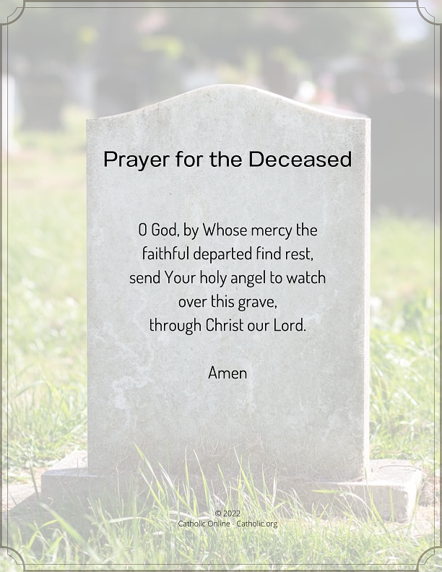
MONTH’S MIND – Liam Skelly RIP
ANNIVERSARIES – Elizabeth Campbell, Eileen Horner, Rosena Mulholland, Eileen Murray, Davy McGarry 30th Anniversary,
Annemarie Owens, Kathleen Owens,


WEEKLY COLLECTIONS
17/11/25 Weekly Collection £930.97
17/11/25 Bishops Collection £439.36
Thank you to everyone for their generosity to the Parish.

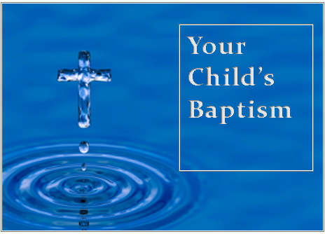
BAPTISMS
To arrange Baptisms, please present the long birth certificate to the parish office.

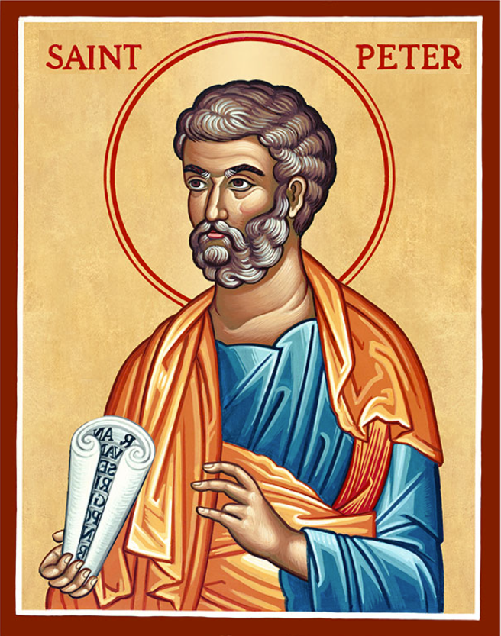
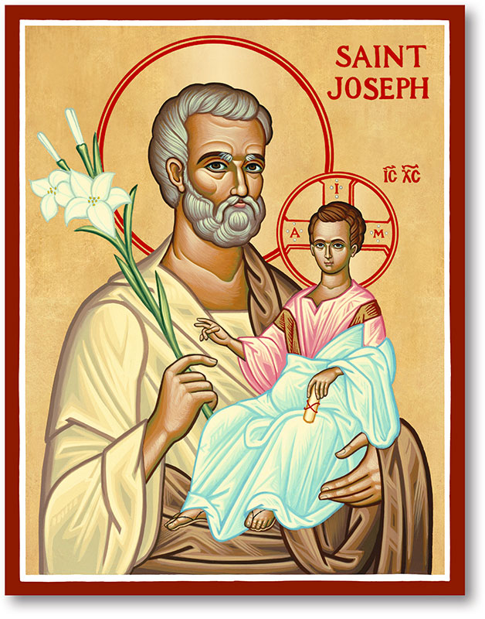
The Parish of Hannahstown
Saint Joseph’s and Saint Peter’s

23rd November 2025
Our Lord Jesus Christ, King of the universe
Family of Parishes Emergency Sick Calls: 07549209775
Monday | 9.15 am  12 noon | Praer for Vocations  Requiem Mass for Jackie Allingham | St Joseph’s
Tuesday |  | Fr Patrick Away
Wednesday | 9.15 am | Parish Novena to Our Lady | St Joseph’s
Thursday | 9.15 am | Parish Novena to Our Lady | St Peter’s
Friday | 9.15 am | Sacred Heart & St Michael’s Prayer | St Joseph’s
Saturday | 6.00 pm | Prayer of Hope, Jubilee 2025 | St Joseph’s
Sunday | 10.00 am | Prayer of Hope, Jubilee 2025 | St Peter’s
Sunday | 11.30 am | Prayer of Hope, Jubilee 2025 | St Joseph’s
Very Reverend Patrick Devlin, Parish Priest, Chaplain to the Deaf Community D & C
Chaplain to Antrim Area Hospital Thursday & Friday (Emergency calls)
Fr. Patrick, Spiritual and Pastoral needs only, Tel: 07910 833699. Parish Secretary Grainne McArevey 02890 614567
Email contact : hannahstown@downandconnor.org
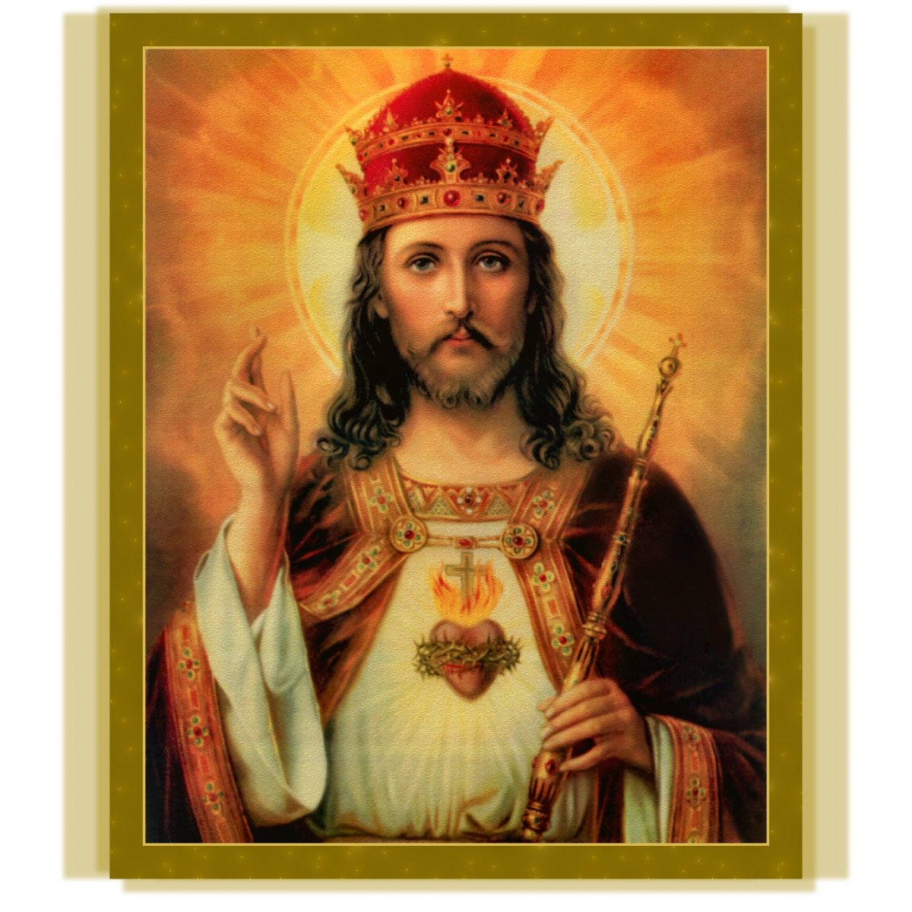
Christ The King
What is the Kingdom of God? What is the Kingdom of Christ the King?
The Kingdom of God is a space. It exists in every home where parents and children love each other. It exists in every region and country that cares for its weak and vulnerable. It exists in every parish that reaches out to the needy. The Kingdom of God is a time. It happens whenever someone feeds a hungry person, or shelters a homeless person, or shows care to a neglected person. It happens whenever we overturn an unjust law, or correct an injustice, or avert a war. It happens whenever people join in the struggle to overcome poverty, to erase ignorance, to pass on the Faith. The Kingdom of God is a condition. Its symptoms are love, justice, and peace. Jesus Christ is King!
We pray today that God may free all the world to rejoice in his peace, to glory in his justice, to live in his love.
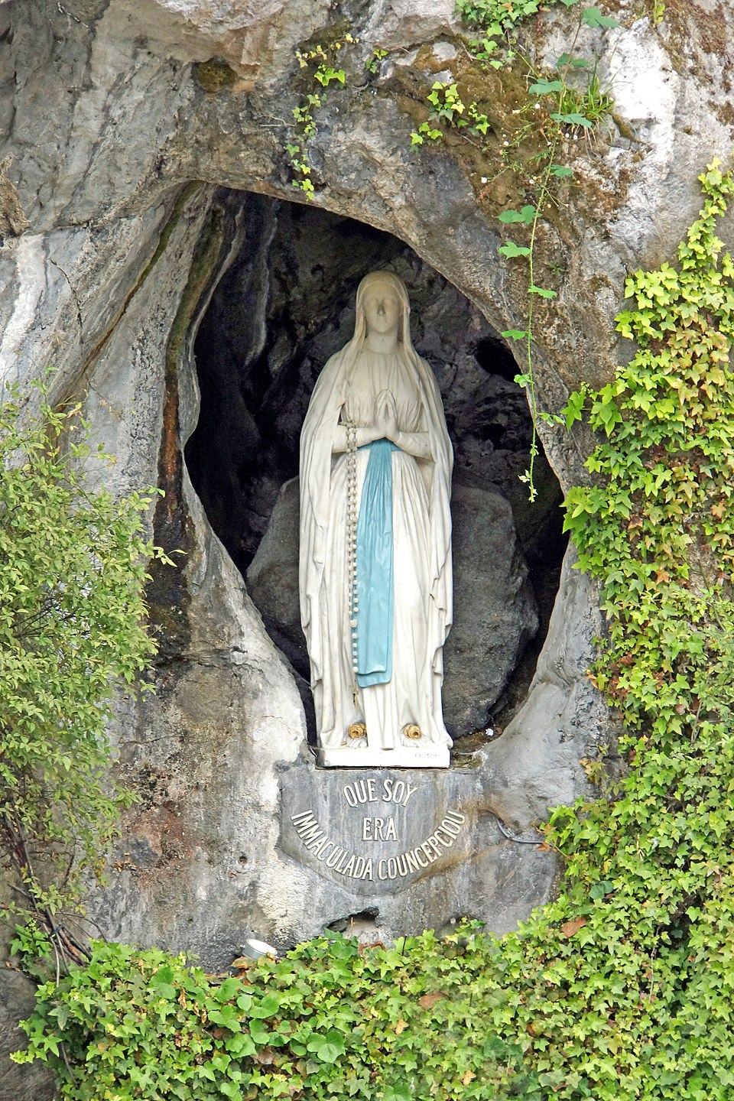
DOWN & CONNOR LOURDES PILGRIMAGE 2026 9 - 14 JULY 2026: We are seeking doctors, registered nurses and volunteers to care for pilgrims who need medical, nursing, personal care or assistance to make their pilgrimage to Lourdes possible. New members are welcome for our medical, nursing brancardier (adult male helpers) and handmaiden (adult female helpers) teams. For more information please email your contact details to lourdes@downandconnor.org. Details of the Youth Team applications will be circulated in February as usual.
HANNAHSTOWN PARISH / FAMILY OF PARISHES / PATHWAYS

Sensory-Friendly Mass Invitation 🌟 -
St Colmcille’s Parish Belfast warmly invites you to our monthly Sensory Mass on
Saturday, 29th November at 12:00 noon. This short service is designed for neurodivergent young people and adults as well as those with dementia or sensory sensitivities, and their families. We would love to see you there. St Nicholas will meet everyone with some gifts, at the refreshments after Mass, in the Parish Centre
For Young Women (18-40yrs) who are discerning a Vocation to Religious/Consecrated Life - Monthly meetings are held in Charleville Retreat Centre, Cork. The day includes prayer, talks, Holy Mass, Adoration and a chance to meet and chat with religious sisters of different communities. If you are interested in attending please email womendiscern@corkandross.org

Columbanus Festival - 22-23rd November 2025 in Bangor. Music/workshops/talk/guided walk/church service.For more information https://friendsofcolumbanusbangor.co.uk/events
Includes a special lecture on early Irish manuscripts by UCC professor.
Also tickets can be purchased by telephone – 02891 270069 , and contact email address –
bangorvic@ardsandnorthdown.gov.uk
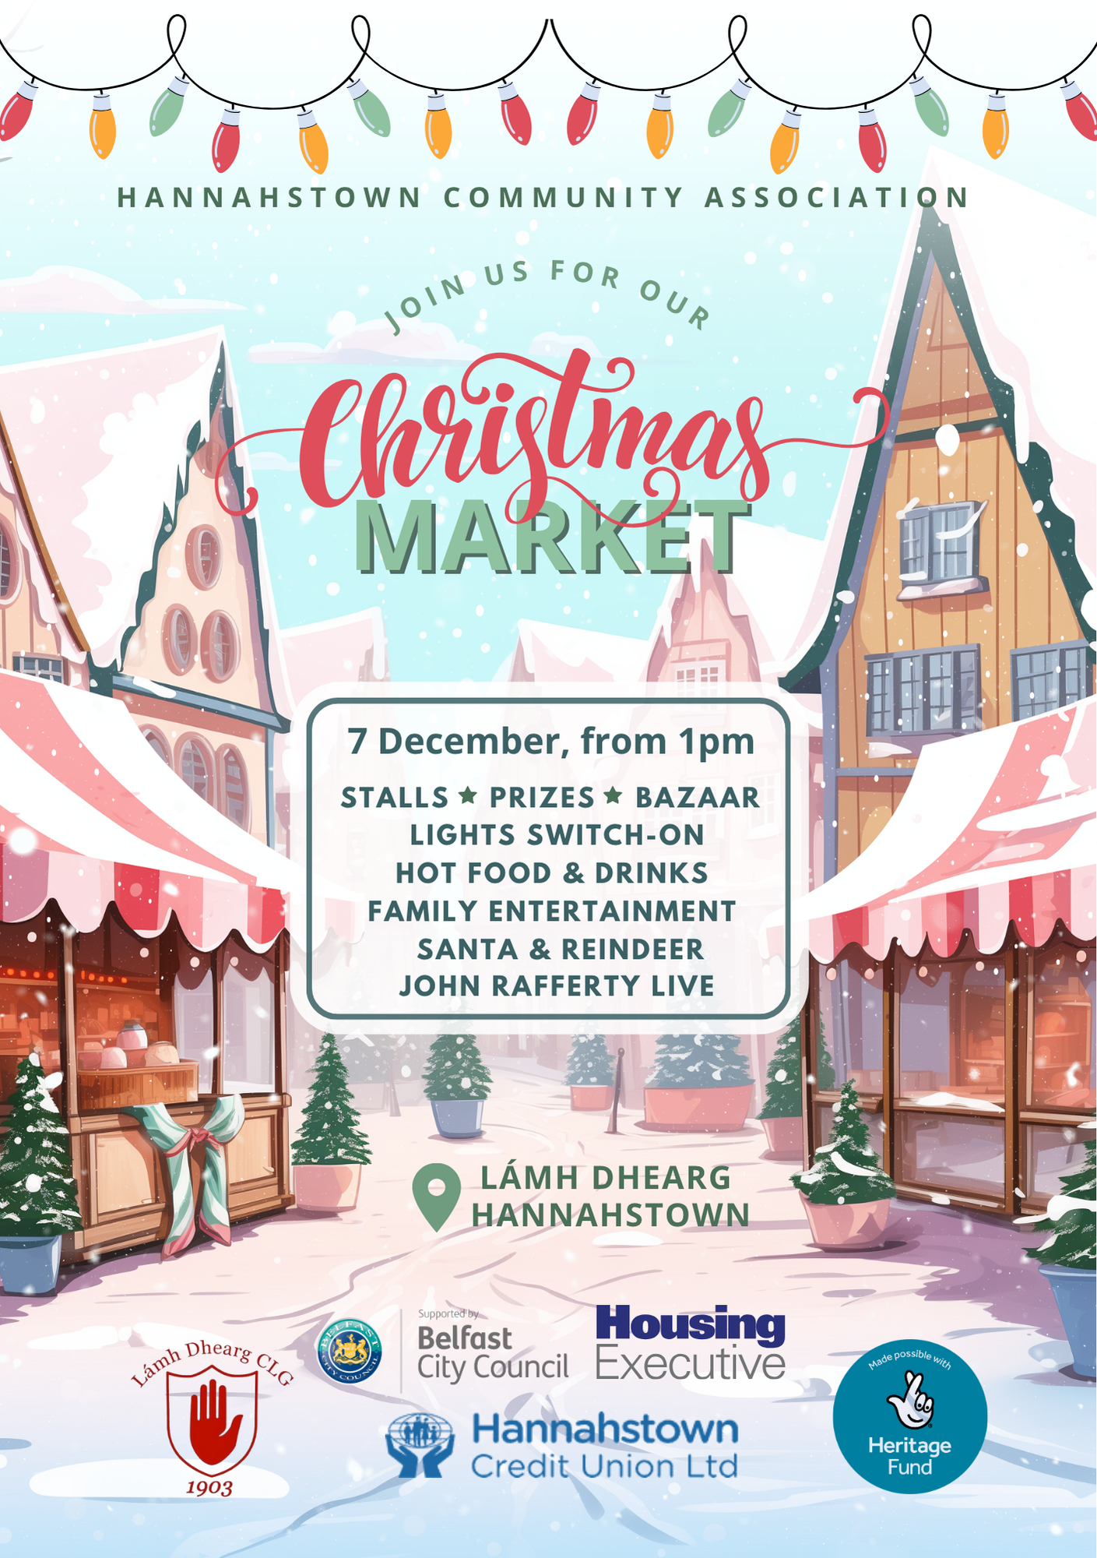
HANNAHSTOWN COMMUNITY HALL

