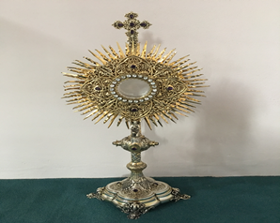
EUCHARISTIC ADORATIONSt Peter’s Church - Every Friday from 2 pm – 8.30 pm. Every evening Adoration & Prayer in St Peter’s Church 6.30 pm – 7.30 pm
THE PARISH OF HANNAHSTOWN
https://churchmedia.tv/st-josephs-church https://churchmedia.tv/st-peters-church-2

Recently Deceased – Margaret Hughes & Vincent O’Brien RIP
ANNIVERSARIES – Andy Finnegan, Teresa Owens, & James Phillips RIP
MONTH’S MIND – Arthur McKenna RIP
& Aidan Murray RIP

WEEKLY COLLECTIONS
02/03/25 Weekly Collection £1,012.34
02/03/25 Monthly Collection £ 843.35
Thank you to everyone for their generosity to the Parish.


BAPTISMS
To arrange Baptisms please present the long birth certificate to the parish office.
Last week we welcomed Rory Shaw into our Parish Community.

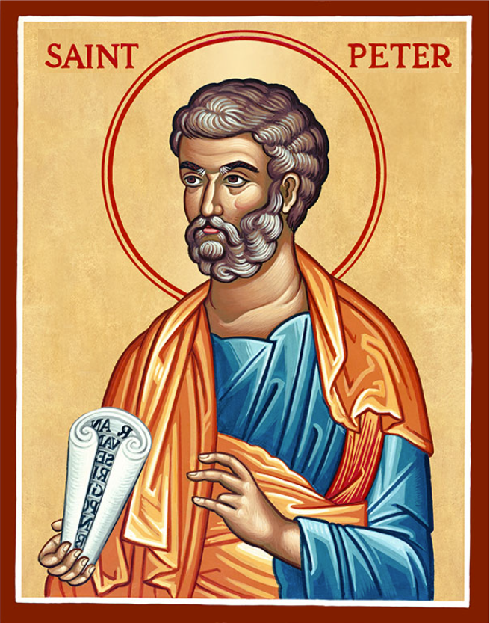
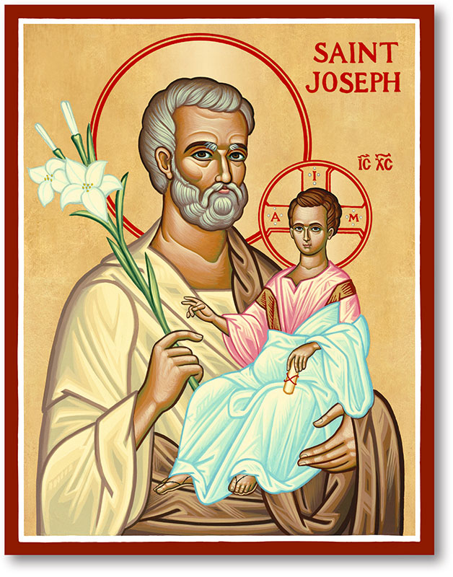
The Parish of Hannahstown
Saint Joseph’s and Saint Peter’s

9th March 2025
First Sunday of Lent

Family of Parishes Emergency Sick Calls: 07549209775
Monday 9.15 am Prayer for Vocations Saint Joseph’s
Tuesday Fr. Patrick’s Day off
Wednesday 9.15 am Ash Wednesday Saint Joseph’s
Thursday 9.15 am Parish novena to Our Lady Saint Peter’s
Friday 9.15 am Sacred Heart and St Michael’s Prayer Saint Joseph’s
Saturday 6:00 pm Prayer of Hope, Jubilee 2025 Saint Joseph’s
Sunday 10:00 am Prayer of Hope, Jubilee 2025 Saint Peter’s
Sunday 11:30 am Prayer of Hope, Jubilee 2025 BSL Signed Saint Joseph’s

Very Reverend Patrick Devlin Parish Priest,
Chaplain to the Deaf Community, Down and Connor Diocese
Chaplain to Antrim Area Hospital Thursday & Friday (Emergency calls)
Fr. Patrick, for Spiritual and Pastoral needs only, thank you Tel: 07910 833699
Parish Secretary: Mrs Grainne McArevey Tel: 028 90614567
Parish Email: hannahstown@downandconnor.org Parish Website: https://www.parishofhannahstown.com

FASTS AND FEASTS FOR LENT

Fast from judging others. Feast on Christ living in them.
Fast from darkness. Feast on the reality of light.
Fast from anger. Feast on patience.
Fast from bitterness. Feast on forgiveness.
Fast from worry. Feast on the providence of God.
Fast from pessimism. Feast on optimism.
Fast from negatives. Feast on the affirmation.
Fast from complaining. Feast on appreciation.
Fast from thoughts of sickness. Feast on the healing hand of God.
EUCHARISTIC PROCESSION - Eve of St Patricks Day Eucharstic Procession Athlone. Starts at 3 pm with the Divine Mercy Chaplet at St. Mary’s Church Athlone N37 XP66. Jubilee Eucharstic Procession through Athlone's streets; Extraordinary Grace's for The Renewal of Ireland's Faith! 5pm Adoration and finish with Holy Mass at 6pm
HANNAHSTOWN PARISH / FAMILY OF PARISHES / PATHWAYS

THE WEST BELFAST HISTORICAL SOCIETY - The March meeting will take place on Friday the 14th of March at 7.30 pm in St. Michael's Parish Centre on Finaghy Road North (Access via Church Gateway on Finaghy Road North just past the garage opposite the Church at the junction with Andersonstown Road). The March talk is entitled: "FAMOUS PEOPLE FROM ULSTER'S PAST WHO MADE AN IMPACT ON THE WORLD" The guest speaker will be Mr CHARLES NEVILLE. Refreshments will be provided

BEGINNING EXPERIENCE- The loss of a partner through death, separation or divorce is devastating. Beginning Experience is offering a weekend away for a lifetime of change’ at Drumalis Conference and Retreat Centre, Larne, Friday 21st – Sunday 23rd March 2025. To find out more, contact Pauline at 07519289185 or Marie at 07896119669 or email belfastbe@yahoo.com

DRUMALIS - Conclave: Behind the Scenes at Vatican II (Drumalis, Larne – Wednesday, 12 March from 7-9 pm) - An evening with Brian McKee, Director at Drumalis, as he takes you into the politics behind the closed doors and the conversations in the coffee shops of Rome that eventually led to the Second Vatican Council. Tea/coffee/refreshments will be served. Voluntary donation. To book a place(s), please contact Drumalis during office hours (Mon-Fri, 9 am – 5 pm) – 028 28276455/28272196 or email drumalis@btconnect.com Further information also available on Drumalis website: http://www.drumalis.co.uk
HANNAHSTOWN PARISH / FAMILY OF PARISHES

RECHARGE - Recharge is a young adult group based in Down and Connor for those aged 18 to 35. The group meet twice monthly on the first and third Tuesday of each month to “recharge” the spiritual batteries through Adoration, intellectual formation and social gatherings. We will be meeting on Tuesday the 4th and 18th of March at 7.30 pm in St Colmcille’s Church, Ballyhackamore. All welcome!

MESSAGE FROM BISHOP ALAN –

If you or a family member have been affected by a Mother and Baby Home Institution, Magdalene Laundry, or Workhouse, the Truth and Recovery programme would like to hear from you.

I would like to clarify that although the Northern Ireland Executive also commissions this work, it is entirely separate from the recent input you may have provided regarding Historical Abuse within Faith Organisations.

I kindly request that you prioritise these notices by publicizing them across your Parish/parish platforms, websites and notice boards and that the above message please be cut and pasted and included in your bulletin.

Thank you for your cooperation and support.
God Bless

MESSAGE FROM FR. PATRICK -

A few places available for Knock this coming Tuesday 11th March -12 March Contact Fr Patrick

