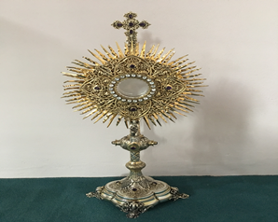
EUCHARISTIC ADORATIONSt Peter’s Church - Every Friday from 2 pm – 8.30 pm. Every evening Adoration & Prayer in St Peter’s Church 6.30 pm – 7.30 pm
THE PARISH OF HANNAHSTOWN
https://churchmedia.tv/st-josephs-church https://churchmedia.tv/st-peters-church-2

RECENTLY DECEASED Joe Cushnahan,
Ciara Dornan & James Edwards RIP
MONTH’S MIND – Kathleen Prior RIP
ANNIVERSARIES – Leanna Bell 1st Anniversary, Thomas Corr, Bob Connolly, William Cooley, Joseph & John Doone Daniel Hamilton, Ruth McAuley, Paddy McGarrity, Catherine Smylie RIP

WEEKLY COLLECTIONS
24/03/25 Weekly Collection £899.11
Thank you to everyone for their generosity to the Parish.

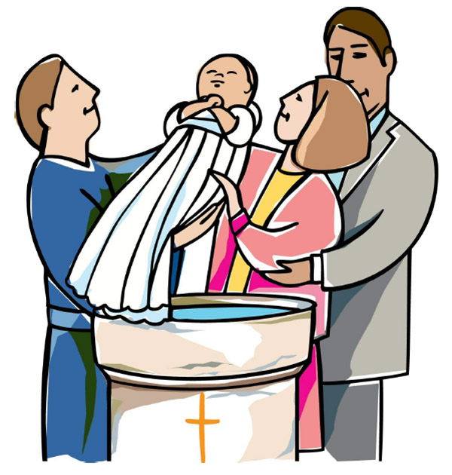
BAPTISMS
To arrange Baptisms please present the long birth certificate to the parish office.
We welcome Thomas Christopher Ryan McCausland into our parish family.

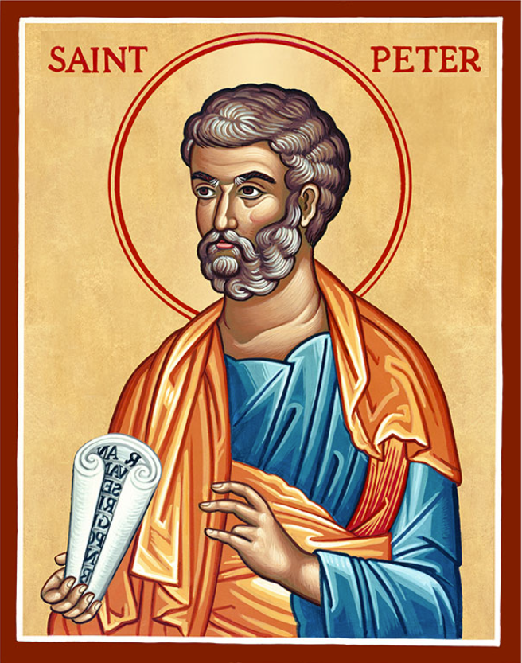
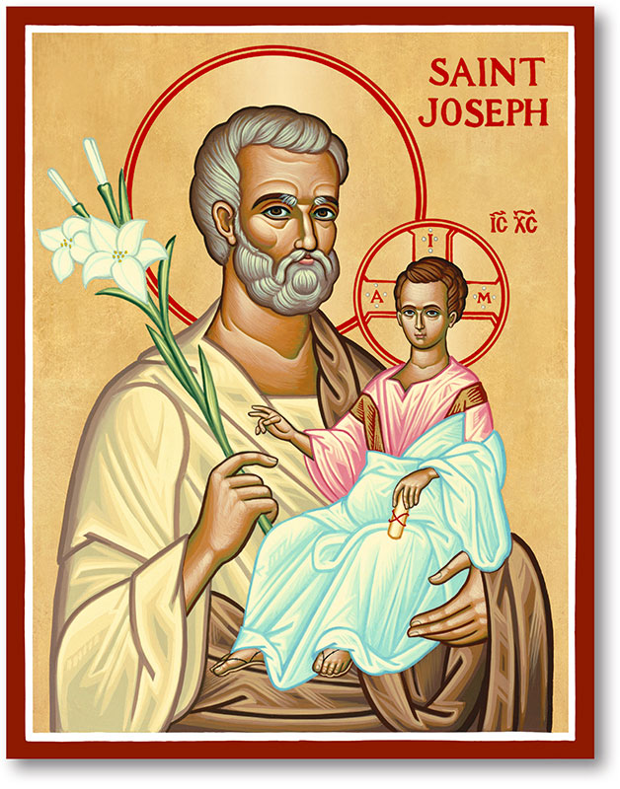
The Parish of Hannahstown
Saint Joseph’s and Saint Peter’s

6th April 2025
Fifth Sunday of Lent

Family of Parishes Emergency Sick Calls: 07549209775
Monday 10 am Prayer for Vocations Saint Joseph’s Tuesday Fr. Patrick’s Day off
Wednesday 9.15 am Parish Novena to Our Lady Saint Joseph’s
Thursday 9.15 am Parish novena to Our Lady Saint Peter’s
Friday 9.15 am Sacred Heart and St Michael’s Prayer Saint Joseph’s
Saturday 6:00 pm Prayer of Hope, Jubilee 2025 Saint Joseph’s
Sunday 10:00 am Prayer of Hope, Jubilee 2025 Saint Peter’s
Sunday 11:30 am Prayer of Hope, Jubilee 2025 BSL Signed Saint Joseph’s

Very Reverend Patrick Devlin Parish Priest,
Chaplain to the Deaf Community, Down and Connor Diocese
Chaplain to Antrim Area Hospital Thursday & Friday (Emergency calls)
Fr. Patrick, for Spiritual and Pastoral needs only, thank you Tel: 07910 833699
Parish Secretary: Mrs Grainne McArevey Tel: 028 90614567
Parish Email: hannahstown@downandconnor.org Parish Website: https://www.parishofhannahstown.com
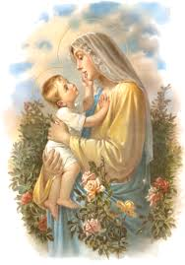

Heavenly Father,
I lift up to you today my mother and all mothers. Bless them with strength to continue to care for their children, with the same bold, selflessness Mary showed Jesus. Help my mother and all mothers feel our gratitude and truly know their impact.
CHRISM MASS ST PETER’S CATHEDRAL
HANNAHSTOWN PARISH / FAMILY OF PARISHES / PATHWAYS
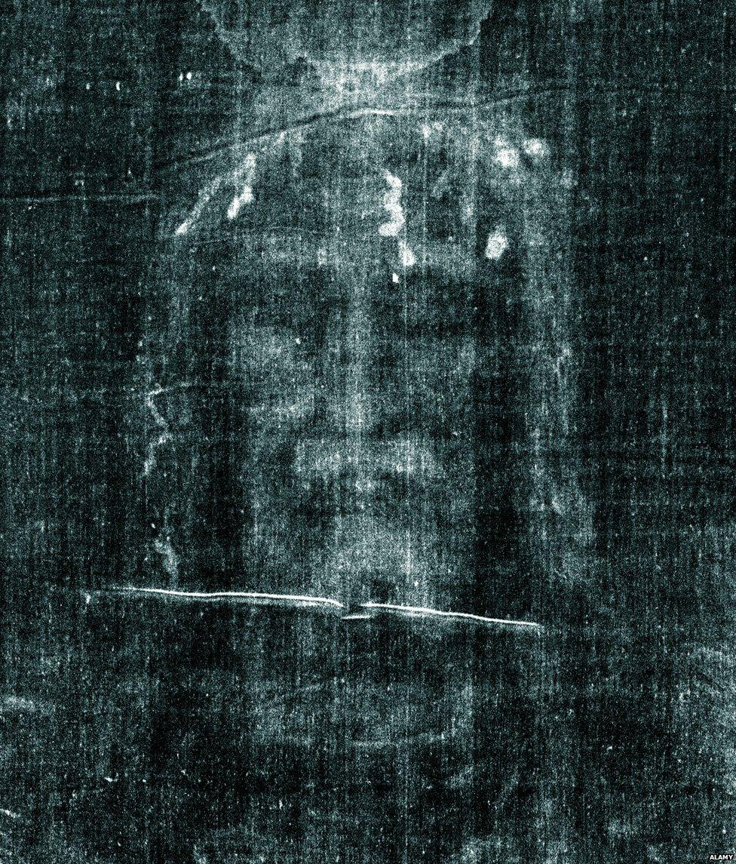
LENTEN TALK - LENTEN TALK SATURDAY 12th APRIL 2025 at 2PM in St AGNE’S PARISH CENTRE, St AGNE’S DRIVE.
WHO DO YOU SAY I AM? (Mt 16:17) A TALK BY Arthur Nolan on the SHROUD OF TURIN & Fr Raymond McCullagh speaking on SCARAMENT OF RECONICILIATION. Schedule for the day: 1pm Holy mass, 1:30pm Eucharistic Adoration, 2:00pm Talks in Parish Centre where Tea & Coffee will be served. This event is hosted by the Legion of Mary.

TRÓCAIRE- Trócaire works with parishes and communities across the island of Ireland to educate, inspire and motivate people to take action for global justice. We are supported in this work by Bishops, priests, pastoral workers and parishioners in every diocese.
RTE Mass - Trócaire are delighted to lead the Holy Thursday Liturgy this year, live on RTE, on April 17th at 4.40pm. Our celebrant is Bishop Paul Dempsey and music is by Aontas Youth Choir. Please do join us by tuning in.
Fr Patrick encourages all parishioners to reflect on the good work of Trócaire in these final few weeks of Lent, and to remind you all at the end of Lent to please return your Trócaire boxes and any donations to the parish office or leave into the Sacristy. Many Thanks for all you help in this worthy appeal.
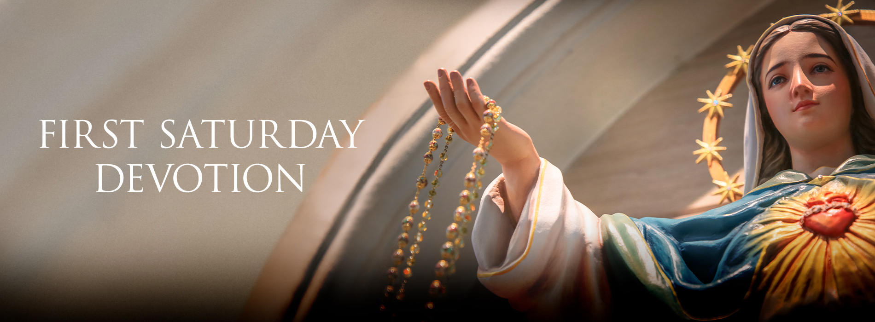
HANNAHSTOWN PARISH / FAMILY OF PARISHES / PATHWAYS
First Saturday Devotions will take place in St. Matthias’s Church, Glen Road on 5th April.
3.00 p.m. Adoration of the Blessed Sacrament, Confessions and Act of Consecration., Rosary and Divine Mercy Chaplet,
4.00 p.m. Holy Sacrifice of the Mass

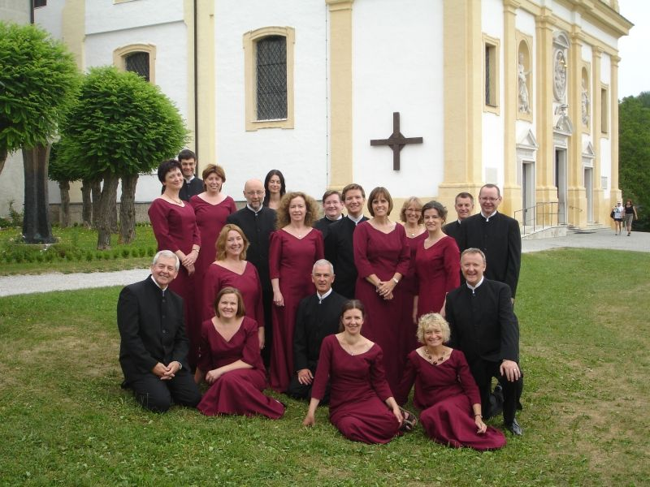
CAPPELLA CAECILIANA - Cappella Caeciliana present WORLDS OF LIGHT in Clonard Monastery on
Sunday 6th April at 5.30pm. Programme includes the Fauré Requiem with
professional orchestra. Tickets £20 from www.caeciliana.org, Clonard
reception and Matchetts, Wellington Place. Students and under 25s free.

Please contact Anthony Adams for any enquiries on 90 309795.
HANNAHSTOWN COMMUNITY HALL
Mon – Fri 10 am – 1 pm.
Monday – Coffee Morning after 9.15 am Mass.
Wednesday Morning Seniors Group after 9.15 am Mass

