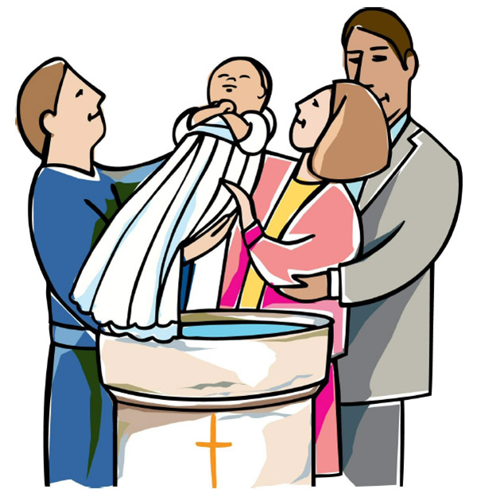
THE PARISH OF HANNAHSTOWN
BAPTISMS DIOCESIAN AND PARISH NORMS:
Parents will be asked to complete a short form confirming whether any other person holds parental responsibility for the child and that they are aware of the request for baptism and have raised no objection. This procedure is required in line with diocesan guidance and civil law. Please bring with you a copy of the baby’s long birth certificate to the parish office.
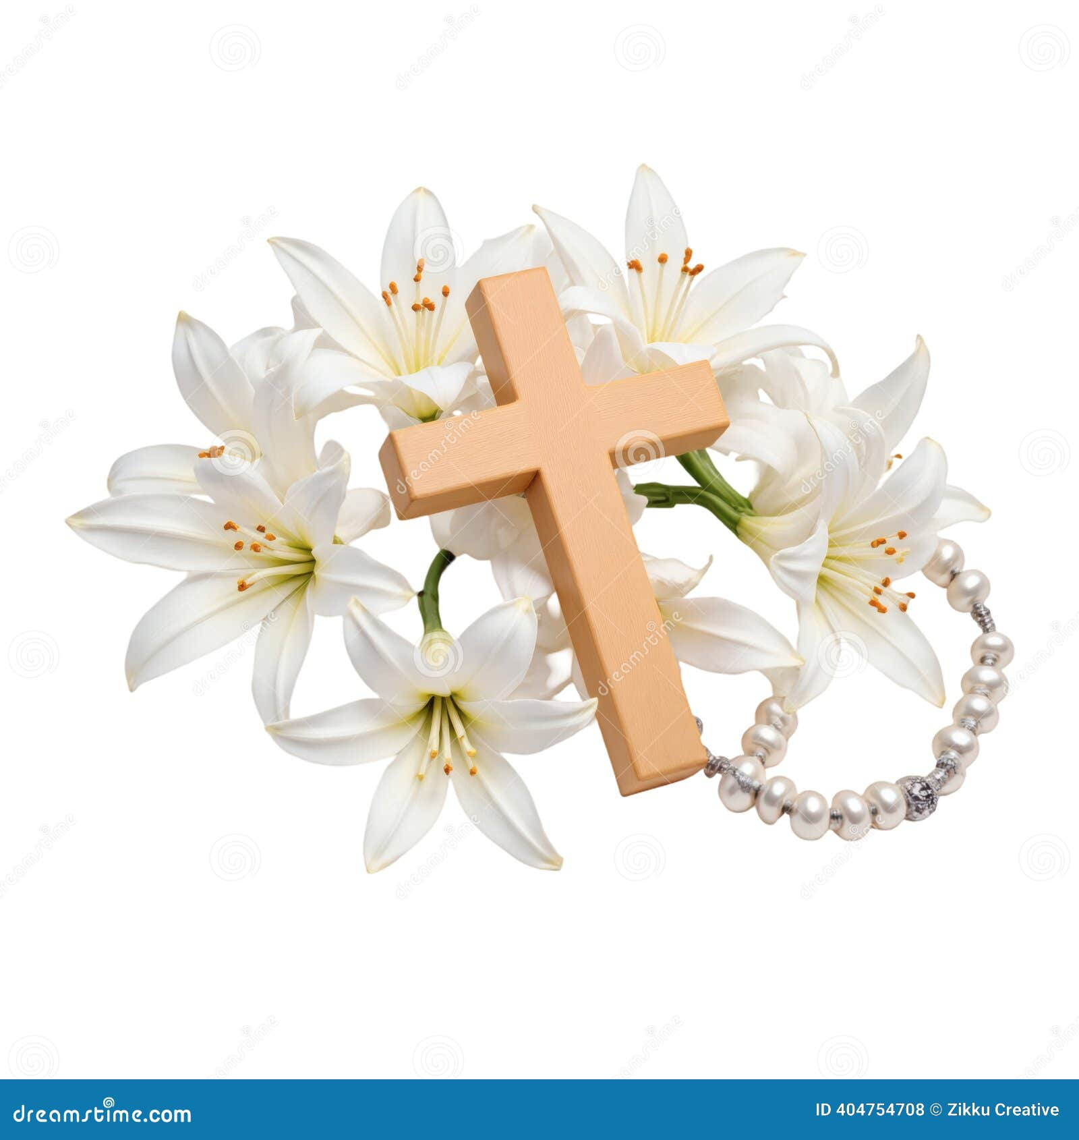
CONSIDERING MARRIAGE?
“Above all, let your love for one another be intense.” (1 Peter 4:8)
We would be delighted to welcome couples to meet, view the church, and arrange their wedding. Please contact Parish Office
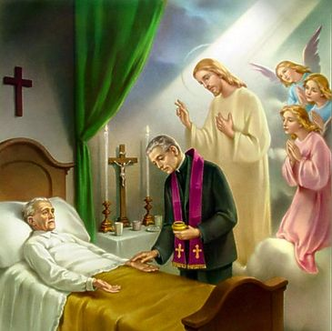
PASTORAL VISIT TO THE SICK AND HOUSEBOUND “The Lord is close to the broken-hearted.” (Psalm 34:18) Families are encouraged to let us know if a loved one is housebound and would need a visit from the priest. Contact Fr Patrick or the Parish office.


SAFEGUARDING IN OUR PARISH “Let the little ones come to me.” (Mark 10:14)
We are pleased to share that diocesan safeguarding requirements for 2026 have now been completed, helping ensure our parish remains a safe, respectful, and caring community.


ALL VOLUNTEERS: “Each of you has a gift to use in the service of others.” (1 Peter 4:10)
To support good safeguarding and governance, we invite all volunteers to complete a General Volunteer Application Form at the parish office. This helps us keep an up-to-date picture of parish life and ensures volunteers are properly supported
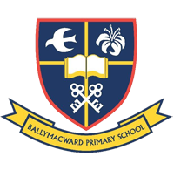

PARISH SCHOOL – BALLYMACWARD PRIMARY SCHOOL:
Ballymacward Community Pre-School Playgroup - Supervisor: Ms Sarah Scott. Tel: (028) 9264 8515
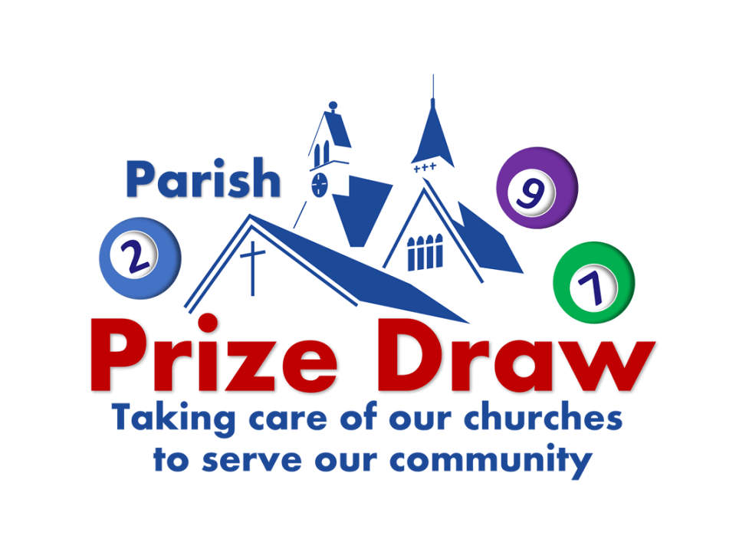

HANNAHSTOWN PARISH DRAW – OPEN MEETING

The Parish Draw Committee invite you to attend an open meeting that will be held in Hannahstown Centre on Tuesday 1st Sept @ 7.30 pm. This meeting will explore the available options to continue/discontinue the Parish Draw.
This meeting is open to all. We look forward to seeing you.

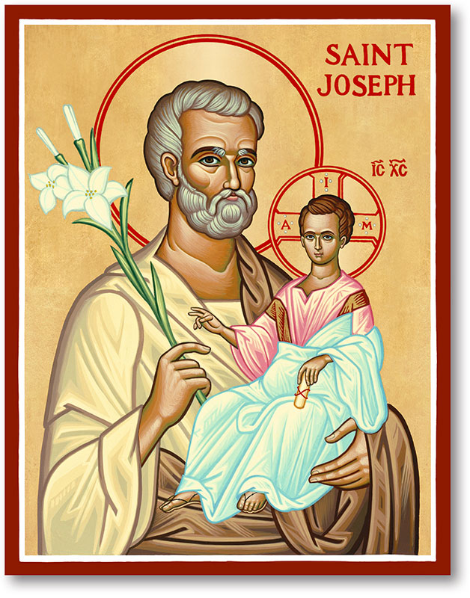
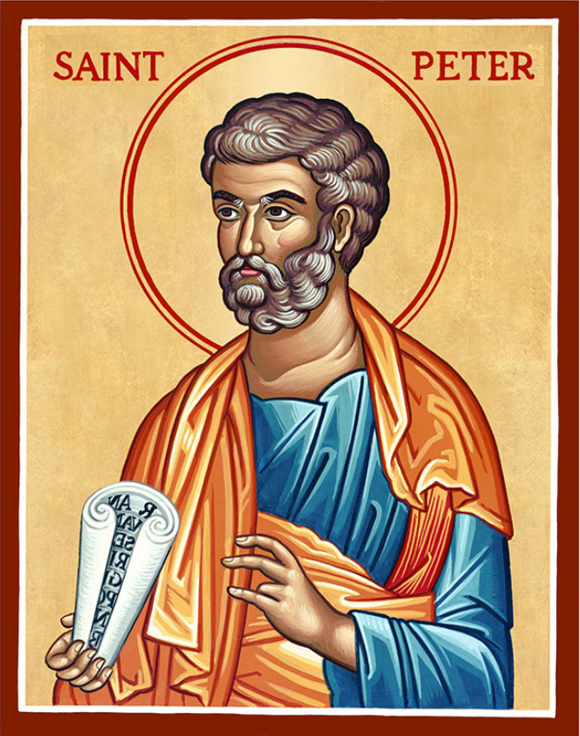
The Parish of Hannahstown
Saint Joseph’s and Saint Peter’s

30th August 2026

Twenty-Second Sunday in Ordinary Time
Family of Parishes Emergency Sick Calls: 07549209775
Very Reverend Patrick Devlin, Parish Priest.
Chaplain to the Deaf Community Down & Connor. Chaplain Antrim Hospital Thurs / Frid (Emergency Calls)
Contact Fr. Patrick for Spiritual and Pastoral needs only, Tel: 07910 833699.
As part of the transition to new role titles in the Diocese and Hannahstown Parish. I would like to share with everyone that Grainne is now referred to as the ‘Parish Support Officer’
Grainne McArevey 02890 614567
Email address: hannahstown@downandconnor.org Website: parishofhannahstown.com
Monday | 9.15 am  6.30-7.30 pm | Morning Mass Prayer for Vocations  Adoration, Rosary and Divine Chaplet  https://churchmedia.tv/st-peters-church-2 | St Joseph’s  St Peter’s
Tuesday | 6.30-7.30 pm | Fr Patrick Away  Adoration, Rosary and Divine Chaplet | St Peter’s
Wednesday | 9.15 am  6.30-7.30 pm | Morning Mass Novena to Our Lady  Adoration, Rosary and Divine Chaplet | St Joseph’s  St Peter’s
Thursday | 9.15 am  6.30-7.30 pm | Morning Mass Novena to Our Lady  Adoration, Rosary and Divine Chaplet | St Peter’s  St Peter’s
Friday | 9.15 am  2.pm-8.30 pm  3.pm | Morning Mass Prayer to the Sacred Heart  Adoration, Rosary & Divine Mercy Chaplet  Adoration and Divine Mercy Chaplet | St Joseph’s  St Peter’s  St Joseph’s
Saturday | 6.00 pm  6.30-7.30 pm | Vigil Mass The Angelus Prayer  Adoration, Rosary and Divine Chaplet | St Joseph’s  St Peter’s
Sunday | 10.00 am  6.30-7.30 pm | Morning Mass Prayer to St Peter  Adoration, Rosary and Divine Chaplet | St Peter’s  St Peter’s
Sunday | 11.30 am  6.30-7.30 pm | Morning Mass Prayer to St Joseph  Adoration, Rosary and Divine Chaplet | St Joseph’s  St Peter’s

BACK TO SCHOOL PRAYER
Dear Lord, as our students begin a new school year, I pray that you will keep them in your care. Send your Spirit to open their minds to all that is true and beautiful and good. Help them to see the gifts and talents you have given them and to use them well. Help them to grow in knowledge and wisdom. Help them to be kind to others and lead others to be kind to them. Give their teachers patience and understanding and help them teach what is just and true. Send your angels to guide and guard our children and to keep them from all harm. Open their young hearts to your presence and enfold them in your peace and protection. Hold them in the palm of your hand and bring them home safely at day’s end. Amen
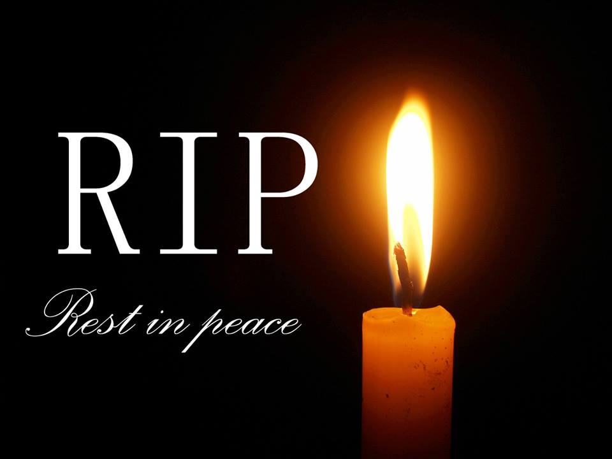
RECENTLY DECEASED: Jackie Rice RIP

ANNIVERSARIES:
Ena Jordan 1st Anniversary,

RECHARGE – Young Adult Group – St Colmchille’s Church
Join us on the first and third Tuesday of every month to recharge your spiritual batteries through prayer, study and friendship. First Tuesday – Adoration with guided meditation & confession. Third Tuesday – Group Study Course. St Colmcill’es Church Belfast at 7.30pm. See poster in Church porch.

CATHOLIC MEN’S RETREAT – STANDING IN THE BREACH
A Catholic Men’s Retreat will take place at Portglenone Monastery on Saturday 19th September from 9 am to 1 pm.
The theme is “It is no longer I who live, but Christ who lives in me”. Fr. Eddie McGee is the keynote speaker.
All men are very welcome. For further information, contact Thomas Carey on 07967 620435 or email sean@catholicminute.co.uk

DOWN AND CONNOR VOCATIONS NEWSLETTER
We are delighted to provide you with a Diocese of Down and Connor Vocations Summer Newsletter. We hope that this will provide some insight and encouragement into what is happening across our Diocese in terms of vocations. Please do feel free to share with your parishioners.

West Belfast Historical Society
See email re Historical Talk

ROSARY VIGIL FOR LIFE
Outside Belfast City Hall Sunday 30th August at 2 pm. Join Precious Life in prayer to uphold the dignity of unborn life, and pray that Belfast Council will reject plans to illuminate the City Hall in celebration of abortion. For more information, contact 02890 27 8484 or email info@preciouslife.com

BLACK MOUNTAIN FAMILY OF PARISHES NEWS
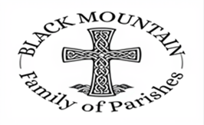
DIVINE INSPIRATION: You are invited to share their memories of St Michael's parish which is turning 50 this year. We hope to publish the best of them in our parish commemorative magazine. Also if anyone has any memories of the pilgrimage to the Holy Land - and photographs. Parishioners are also invited to say in 100 words or less what their faith means to them. We will endeavour to publish them! Please email or write to martinapurdy1@gmail.com or leave a hand written note with personal details for Martina's attention in the parish office.

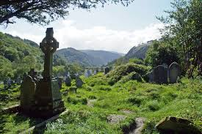
BLACK MOUNTAIN FAMILY OF PARISHES: HE WEST BELFAST HISTORICAL SOCIETY
The September meeting will take place on Friday the 11th of September at 7.30pm in St. Michael's Parish Centre, Finaghy Road North (Access via Church Gateway on Finaghy Road North, just past the garage opposite the Church at the junction with Andersonstown Road).

The September talk is entitled:

"The Lusitania and the U Boat Campaign 1914 -1918"
The guest speaker will be Mr Michael McConway

Refreshments will be provided.

HANNAHSTOWN PARISH PASTORAL COUNCIL (PPC)

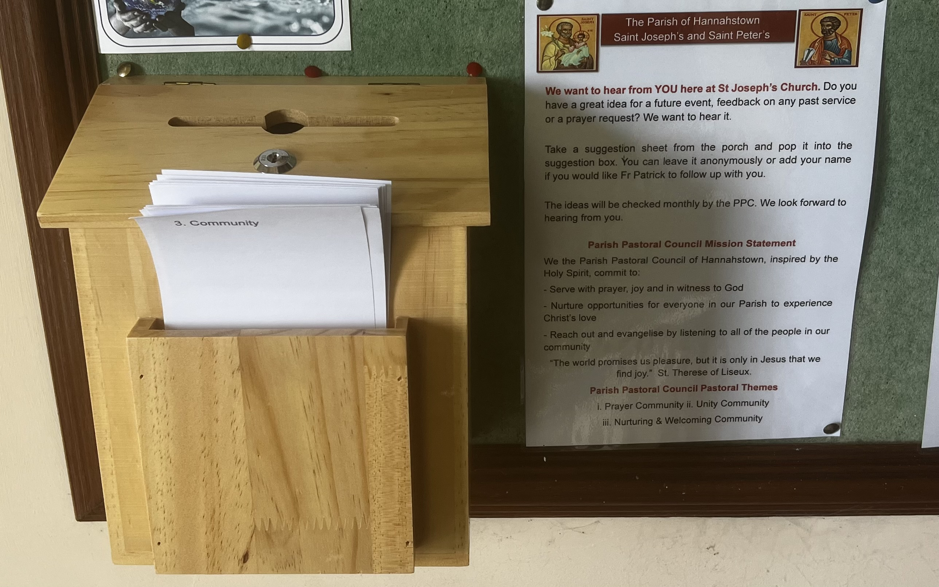
We want to hear from YOU here at St. Peter’s Church. Do you have a great idea for a future event, feedback on any past service or a prayer request? We want to hear it.

Take a suggestion sheet from the porch and pop it into the suggestion box. You can leave it anonymously or add your name if you would like Fr Patrick to follow up with you.

The ideas will be checked monthly by the PPC. We look forward to hearing from you.

Parish Pastoral Council Mission Statement
We the Parish Pastoral Council of Hannahstown, inspired by the Holy Spirit, commit to:
- Serve with prayer, joy and in witness to God
- Nurture opportunities for everyone in our Parish to experience Christ’s love
- Reach out and evangelise by listening to all of the people in our community
“The world promises us pleasure, but it is only in Jesus that we find joy.” St. Therese.

Parish Pastoral Council Pastoral Themes
i. Prayer Community ii. Unity Community
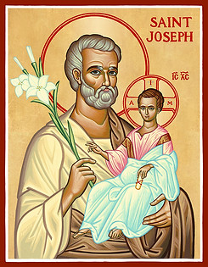
iii. Nurturing & Welcoming Community
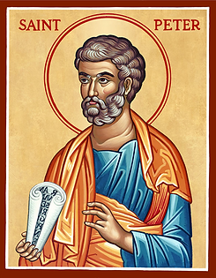
PARISH PASTORAL COUNCIL
TRAINING & FORMATION SUNDAY
Sunday 4th October
4.00pm – 6.00pm
DATE FOR THE DIARY
A special afternoon for all members of the Hannahstown Parish Pastoral Council.
This will be an opportunity to:
Reflect on our role and mission as a Pastoral Council;
Grow together as a team;
Look at how we can serve our Parish more effectively;
Listen, share ideas and discern together;
Prepare for the work and journey ahead as a Parish community.
This is an important part of our work together, so we ask all Council members to please keep the afternoon free and make every effort to attend.
COME • LISTEN • DISCERN • SERVE
Sunday 4th October | 4.00pm – 6.00pm
Please put the date in your diary now.

