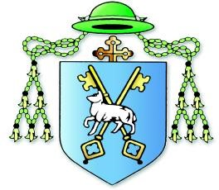

DOWN and CONNOR DIOCESAN TRUST
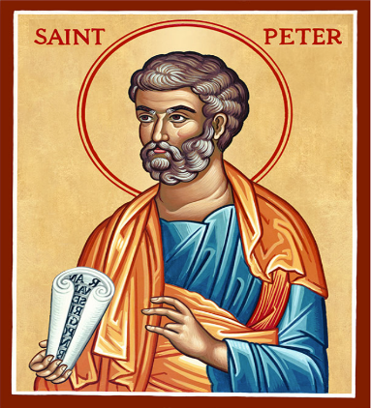
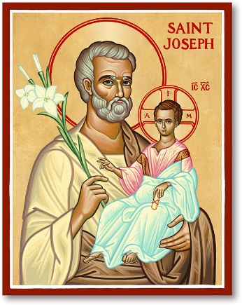

Hannahstown Parish Safeguarding Committee
Claire McAllister: Nurse
Míchéal Ó Coisneacháin: Teacher
Rachel McArevey: Teacher (Chair)
Father Patrick Devlin: Parish Priest
Kerrie McConnell: Doctor
If you have any concerns please contact 028 9049 2798 or email office@soddc.org

