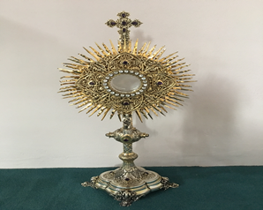
EUCHARISTIC ADORATIONSt Peter’s Church - Every Friday from 2 pm – 8.30 pm. Every evening Adoration & Prayer in St Peter’s Church 6.30 pm – 7.30 pm
THE PARISH OF HANNAHSTOWN
https://churchmedia.tv/st-josephs-church https://churchmedia.tv/st-peters-church-2

RECENTLY DECEASED – Brendan McCann RIP
ANNIVERSARIES – Eileen & James Brady,
Bob Connolly Sean Keegan, Lucy McStravick, Barney O’Kane RIP


WEEKLY COLLECTIONS
09/03/25 Weekly Collection £889.77
09/03/25 Needy Parishes £342.35
Thank you to everyone for their generosity to the Parish.


BAPTISMS
To arrange Baptisms please present the long birth certificate to the parish office.
We welcome Lily Robin Stott into our parish family.

.
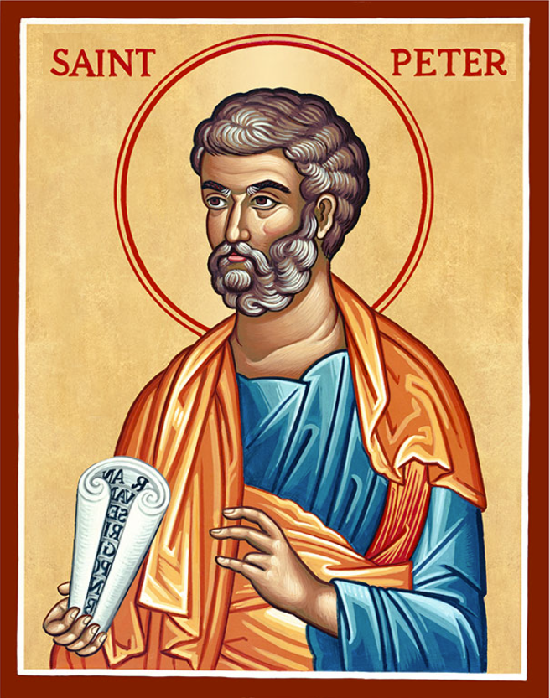
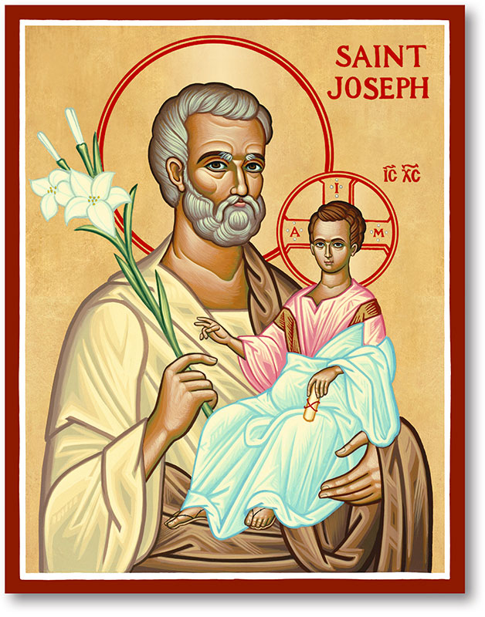
The Parish of Hannahstown
Saint Joseph’s and Saint Peter’s

23rd March 2025
Third Sunday of Lent

Family of Parishes Emergency Sick Calls: 07549209775
Monday 10 am Prayer for Vocations Saint Joseph’s Tuesday Fr. Patrick’s Day off
Wednesday 9.15 am Parish Novena to Our Lady Saint Joseph’s
Thursday 9.15 am Parish novena to Our Lady Saint Peter’s
Friday 9.15 am Sacred Heart and St Michael’s Prayer Saint Joseph’s
Saturday 6:00 pm Prayer of Hope, Jubilee 2025 Saint Joseph’s
Sunday 10:00 am Prayer of Hope, Jubilee 2025 Saint Peter’s
Sunday 11:30 am Prayer of Hope, Jubilee 2025 BSL Signed Saint Joseph’s

Very Reverend Patrick Devlin Parish Priest,
Chaplain to the Deaf Community, Down and Connor Diocese
Chaplain to Antrim Area Hospital Thursday & Friday (Emergency calls)
Fr. Patrick, for Spiritual and Pastoral needs only, thank you Tel: 07910 833699
Parish Secretary: Mrs Grainne McArevey Tel: 028 90614567
Parish Email: hannahstown@downandconnor.org Parish Website: https://www.parishofhannahstown.com
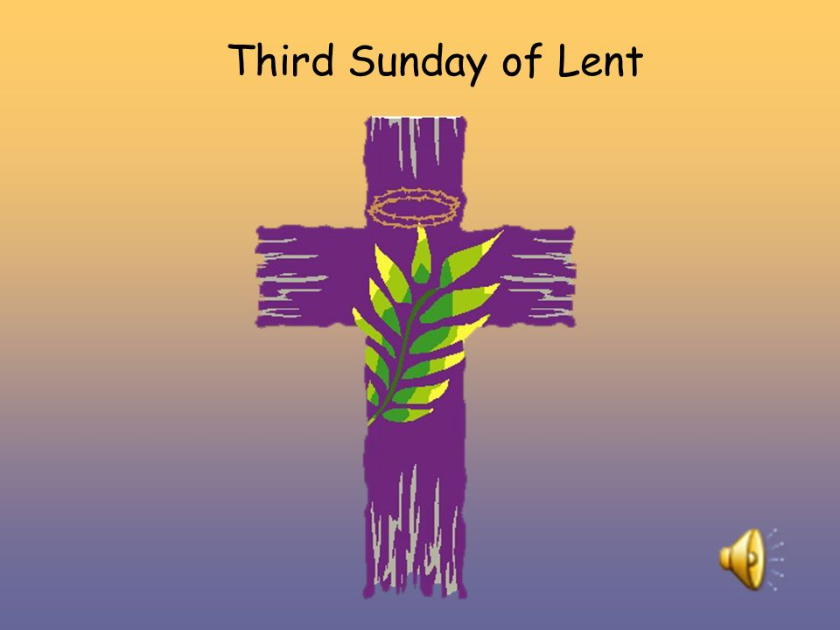
At Lent, we should try the key to our heart’s door, it may have gathered rust. If so, this is the time to oil it, in order that the heart’s door may open more easily when the Lord Jesus wants to enter at Easter time! Lord, oil the hinges of our heart’s door that they may swing gently and easily to welcome your coming.

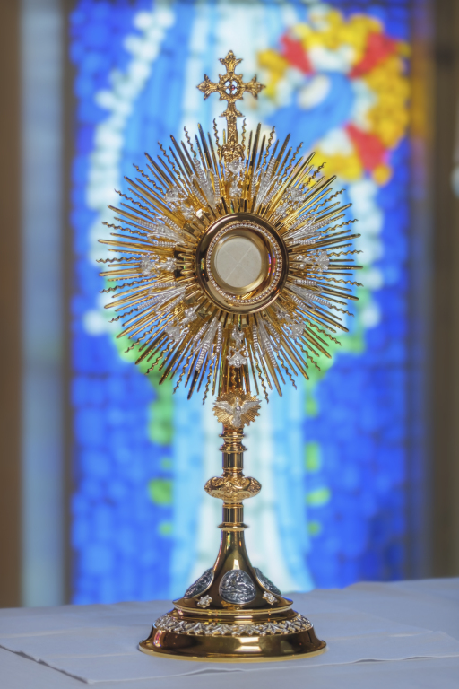
HANNAHSTOWN PARISH / FAMILY OF PARISHES / PATHWAYS
ADORATION PILGRIMAGE TO KNOCK - Calling ALL ADORERS of the Blessed Sacrament in DOWN & CONNOR DIOCESE. National Eucharistic Adoration Pilgrimage to Knock on Sunday 6th April (weekend of 5th Sunday of Lent)
Full Bus details on www.eucharisticadoration.ie

LENTEN EVENTS AT DRUMALIS RETREAT CENTRE -
The Passion Story: “A Work of Infinite Love” Saturday, 12 April from 9:30 am - 4 pm. A Day of Prayer and Reflection with Fr Aidan Troy. Fr Aidan will lead us in a day of prayer and reflection as we enter into Holy Week. To book a place(s) or for further details, please contact Drumalis during office hours (Mon-Fri, 9 am – 5 pm) – 028 28276455/28272196 or email drumalis@btconnect.com Further information also available on Drumalis website: http://www.drumalis.co.uk
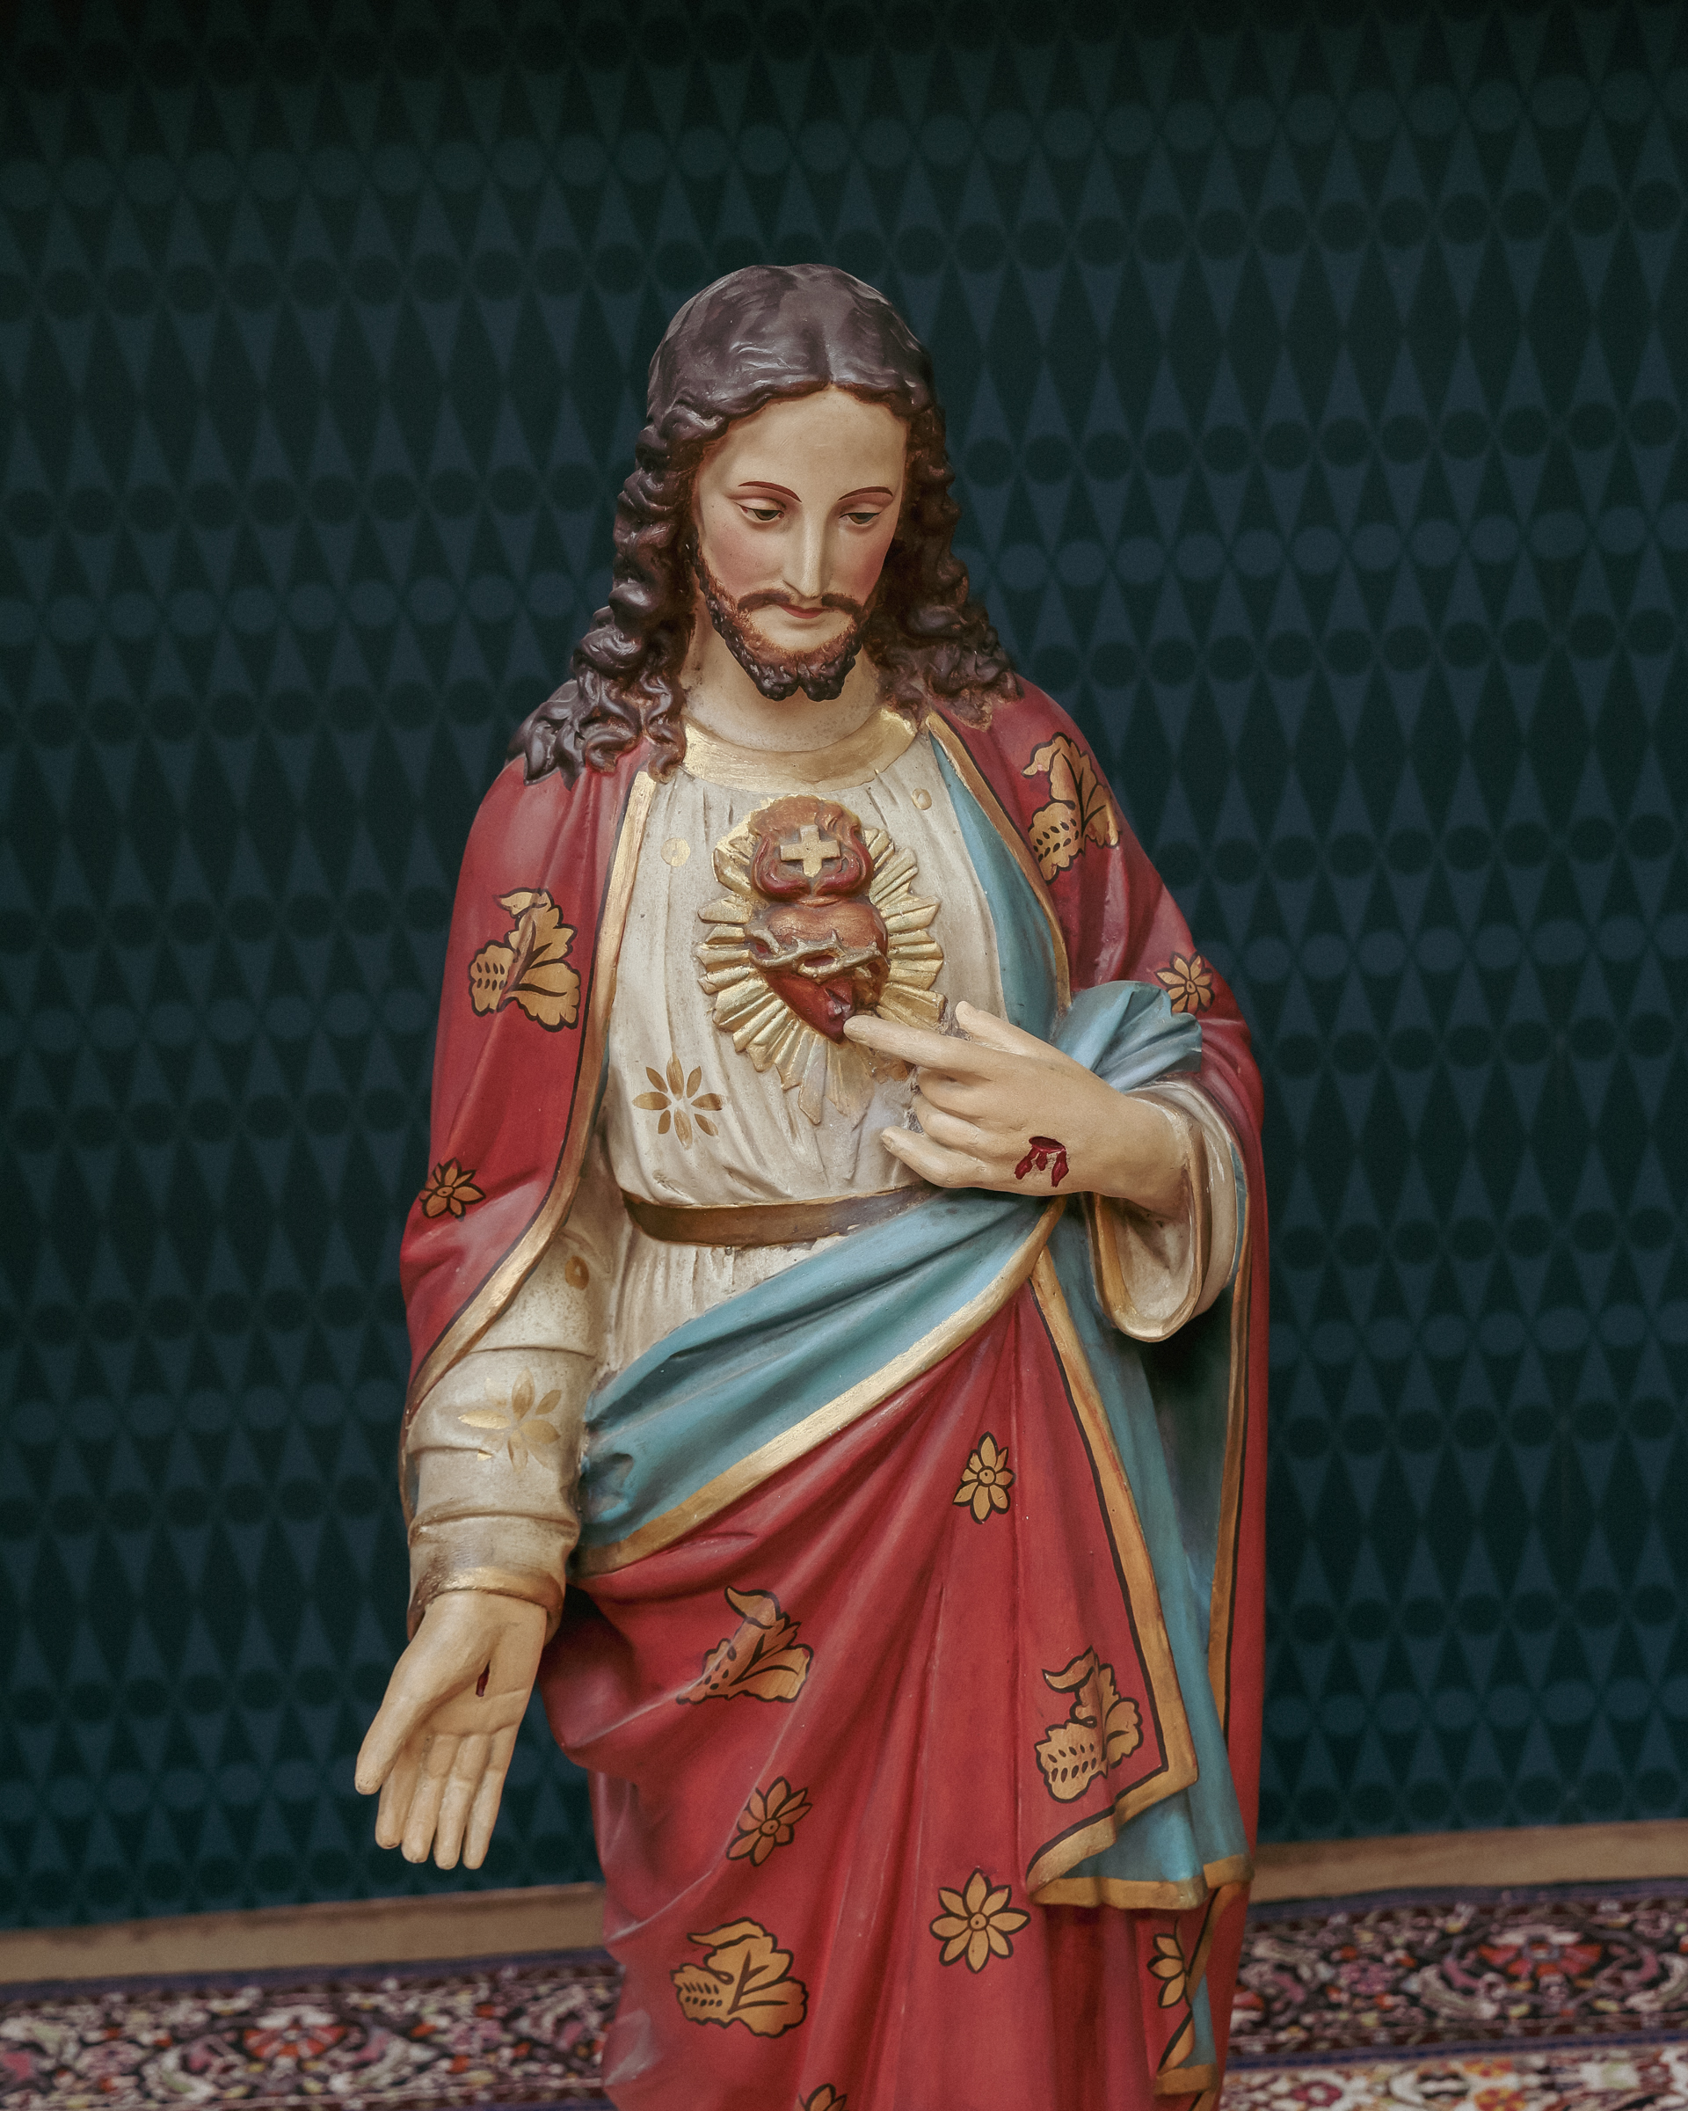
PILGRIM SACRED HEART STATUE - Bishop Alan is delighted to welcome one of the four pilgrim statues blessed by His Holiness Pope Francis. This statue will be sent to our Down and Connor Diocese to rekindle faith in the love of Jesus. The diocesan Sacred Heart Novena will run from 19th to the 27th of June 2025. Bishop Alan's wish is for the Pilgrim Sacred Heart statue to visit as many churches as possible within our diocese throughout this Jubilee Year, especially those named and dedicated to the Sacred Heart. The highlight of the celebrations will take place at Knock on June 22nd, where His Grace, Archbishop Eamon Martin, will be the chief celebrant. On this day, he will renew the consecration of Ireland to the Sacred Heart alongside other attending Bishops. Information is available www.sacredheartcrusade.ie
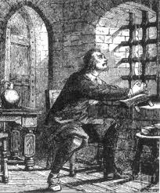
HANNAHSTOWN PARISH / FAMILY OF PARISHES / PATHWAYS
APPEAL FROM FR. STEPHEN MCBREARTY LEAD PRISON CHAPLIN - The Independent Monitoring Board is a group of lay people from all sections of our community who wish to offer their time and expertise in the Monitoring of Prisons in Northern Ireland. As lead Catholic Chaplain can I encourage you to consider this role and apply. (Fr. Stephen McBrearty). Do the right thing
IMB members are unpaid public appointees, appointed by ministers to provide independent oversight of what happens in places of detention. It is a varied and rewarding role. You could be talking to a prisoner or detained person who is worried or vulnerable, who isn’t able to access the support they need, or who needs help to sort out some practical problems. You will get to see and report on everything that happens behind the walls: what day-to-day life is like, whether there is enough education and training to help with rehabilitation, what support there is for the most vulnerable, how physical and mental health needs are met.
https://www.justice-ni.gov.uk/news/board-opportunity-independent-monitoring-board-seeking-members
First Saturday Devotions will take place in St. Matthias’s Church, Glen Road on 5th April.
3.00 p.m. Adoration of the Blessed Sacrament, Confessions and Act of Consecration., Rosary and Divine Mercy Chaplet,
4.00 p.m. Holy Sacrifice of the Mass
Please contact Anthony Adams for any enquiries on 90 309795.
HANNAHSTOWN PARISH COMMUNITY HALL
Mon – Fri 10 am – 1 pm.
Monday – Coffee Morning after 9.15 am Mass.
Wednesday Morning Seniors Group after 9.15 am Mass

