
EUCHARISTIC ADORATION for Advent
THE PARISH OF HANNAHSTOWN
St Peter’s Church - Friday’s 2 pm – 8.30 pm.
Adoration, Rosary & The Divine Mercy Chaplet St Peter’s Church 6.30 pm – 7.30 pm every evening. https://churchmedia.tv/st-peters-church-2
St Joseph’s Church – Friday’s 3 pm – 4 pm Adoration & Divine Mercy Chaplet.

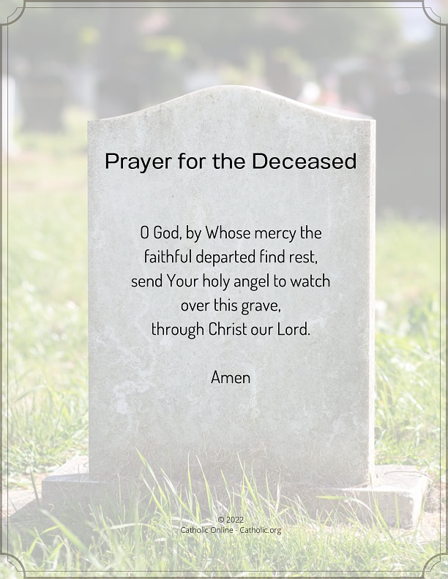
RECENTLY DECEASED – Marie McCann RIP
ANNNIVERSARIES – Margaret Cooley,
Elizabeth Donnelly 1st Anniversary,
Frank McCloskey, Deirdre Sinclair,
Carol, Grace & Liam Quinn,
& John Timmons RIP

WEEKLY COLLECTIONS
29/12/25 Weekly Collection £433.79
29/12/25 Christmas Collection £2,279.93
Christmas Collection SVP £2,595.00
04/01/26 Weekly Collection £ 580.00
04/01/26 Monthly Collection £ 434.00
Thank you to everyone for their generosity to the Parish.

BAPTISMS
Baptisms are upon request and you must visit the parish office to book one. Please bring with you a copy of the baby’s long birth certificate.

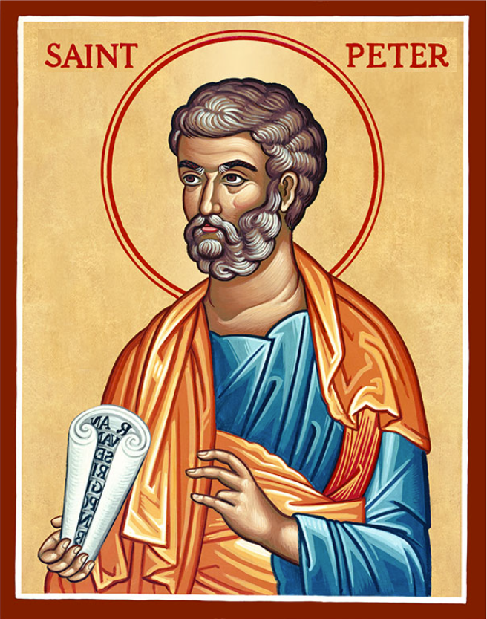
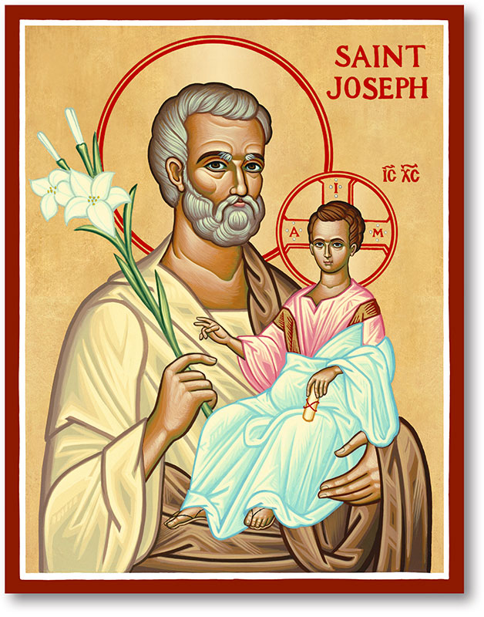
The Parish of Hannahstown
Saint Joseph’s and Saint Peter’s

11TH JANUARY 2026
The Baptsim of the Lord

Family of Parishes Emergency Sick Calls: 07549209775
Monday | 9.15 am | Prayer for Vocations  Coffee morning in Hannahstown Community Hall afterwards. | St Joseph’s
Tuesday |  | Fr Patrick Away
Wednesday | 9.15 am | Parish Novena to Our Lady  Seniors group in Hannahstown Community Hall afterwards. | St Joseph’s
Thursday | 9.15 am | Parish Novena to Our Lady | St Peter’s
Friday | 9.15 am | Sacred Heart & St Michael’s Prayer | St Joseph’s
Saturday | 6.00 pm | Prayer of Hope, Jubilee 2025 | St Joseph’s
Sunday | 10.00 am | Prayer of Hope, Jubilee 2025 | St Peter’s
Sunday | 11.30 am | Prayer of Hope, Jubilee 2025 | St Joseph’s
Very Reverend Patrick Devlin, Parish Priest, Chaplain to the
Deaf Community Down & Connor.
Chaplain to Antrim Hospital Thursday & Friday (Emergency calls)
Fr. Patrick, Spiritual and Pastoral needs only, Tel: 07910 833699.
Parish Secretary Grainne McArevey 02890 614567
Email address: hannahstown@downandconnor.org Website: parishofhannahstown.com

The Baptism of the Lord
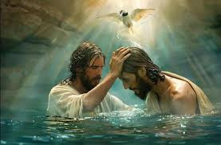
Lord God almighty, in the waters of baptism you make us your beloved sons and daughters in Christ. Renew the living spring of your life within us and protect us in body and soul, that we may live the faith we profess and, at the last, inherit the promise of eternal life. Through Christ our Lord. Amen
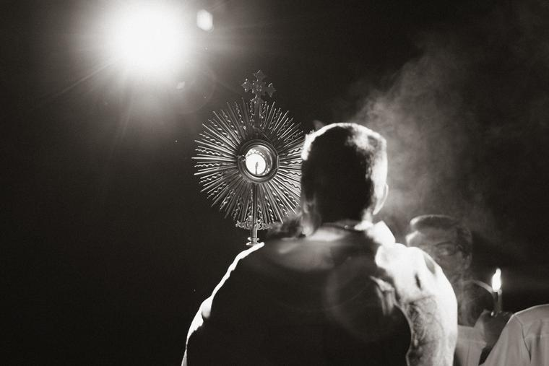
HANNAHSTOWN PARISH / FAMILY OF PARISHES / PATHWAYS
EUCHARISTIC HEALING - There will be a Eucharistic Healing Service in St Matthew’s Church, Short Strand, East Belfast, on Thursday 22nd January at 7pm.
Music with Fionnuala O Neill and Family. Tea and light refreshments to follow.

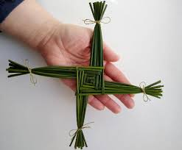
ST BRIGID CROSS MAKING - Saturday 7th February in the North Down Museum Bangor: Enjoy a demonstration of St Brigid Cross Making and using the materials provided make your own cross. Refreshments provided. Limited number of places. For more information and to book now go to https://www.visitardsandnorthdown.com/whats-on/celtic-saints-a-journey-through-time-and-tradition-p948071

LET JUSTICE FLOW LIKE RIVERS CONFERENCE - Andrew Muir MLA, Minister for Agriculture, Environment and Rural Affairs, will attend, alongside a government representative from the Republic of Ireland, highlighting the all-island significance of this gathering. Tickets are £10 to be purchased at https://letjustflow.eventbrite.ie Further info from: info@irishchurches.org

HANNAHSTOWN PARISH / FAMILY OF PARISHES
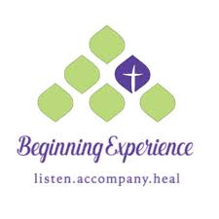
BEGINNING EXPERIENCE
The loss of a partner through death, separation or divorce is devastating. Beginning Experience is offering a programme of bereavement support in St Bride’s Hall, Derryvolgie Ave., Belfast on three Saturdays (31st January, 28th February and 28th March) Booking essential. To find out more, contact Pauline 07519289185 or Marie 07896119669 or email belfastbe@yahoo.com

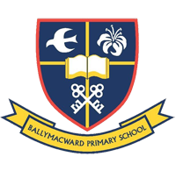
Our Parish School
HANNAHSTOWN PARISH / FAMILY OF PARISHES
Ballymacward Primary School,
22 Rock Road, Stoneyford, Lisburn, Co Antrim, BT28 3SUTel: (028) 92648130, Principal: Mr Hugh Kennedy
Email: info@ballmacwardps.lisburn.ni.sch.uk
Ballymacward Community Pre-School Playgroup - Supervisor: Ms Sarah Scott. Tel: (028) 9264 8515

