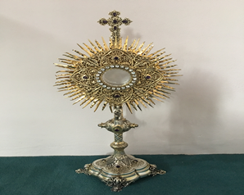
EUCHARISTIC ADORATION in St Peter’s Church - Every Friday from 2 pm – 8.30 pm.
THE PARISH OF HANNAHSTOWN
Every evening within St Peter’s Church, Adoration & Prayer from 6.30 pm – 7.30 pm
https://churchmedia.tv/st-josephs-church https://churchmedia.tv/st-peters-church-2

MONTH’S MIND – Terry Murphy & Harry Rafferty RIP
1st ANNIVERSARIES –Sean Connor & Billy Green RIP
ANNIVERSARIES – Billy Grant, Alice Hunter, Billy Hunter, Stephen McAulfied, Robert McNally, & Danny Mulholland RIP

WEEKLY COLLECTIONS
16/6/25 Weekly Collection £ 795.40
16/6/25 Popes Collection £ 488.55
Total Cemetery Sundays Collection £4,651.19
Hannahstown, The Rock & Tullyrusk
(Last weeks figure was incorrect)
Thank you to everyone for their generosity to the Parish, especially at our Cemetery Sunday collections. This money goes a long way to help cover the costs of
Cemetery Sunday and also towards the maintenance of our beautiful grounds.

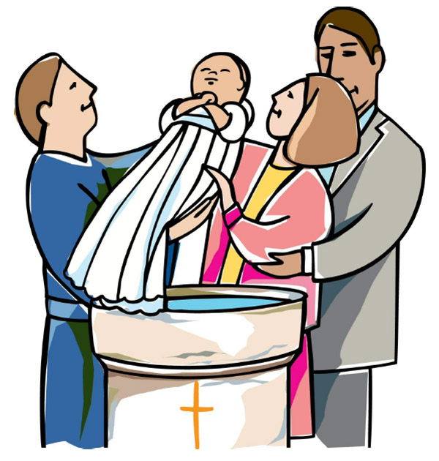
BAPTISMS
To arrange Baptisms, please present the long birth certificate to the parish office. Baptisms will be arranged upon request.
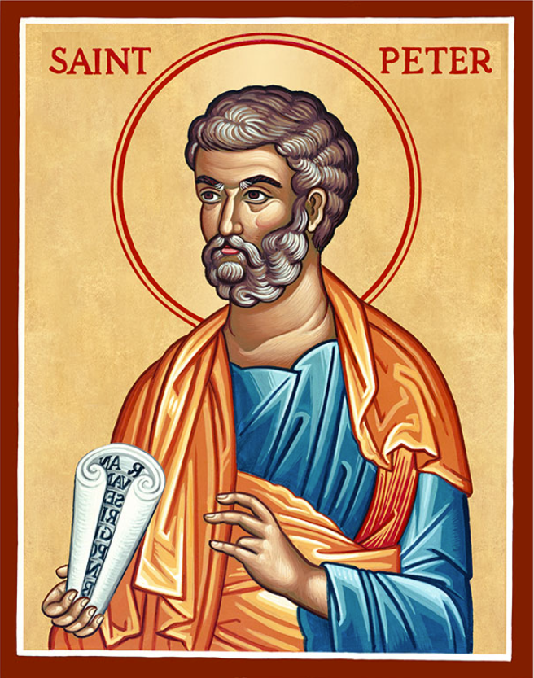
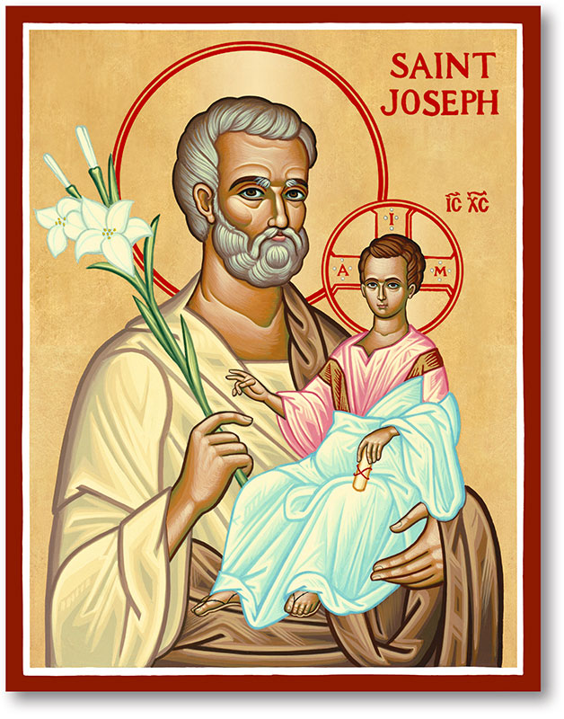
The Parish of Hannahstown
Saint Joseph’s and Saint Peter’s

22nd June 2025
THE MOST HOLY BODY AND BLOOD
OF CHRIST (CORPUS CHRISTI)
Family of Parishes Emergency Sick Calls: 07549209775
Monday 09.15 am (Prayer for Vocations) St Joseph’s
Tuesday Fr. Patrick’s day off.
Wednesday 9.15 am (Parish novena to Our Lady) St Joseph’s
Thursday 9.15 am (Parish novena to Our Lady) St Peter’s
Friday 9.15 am (Sacred Heart Prayer) St Joseph’s
Saturday 6:00 pm (St Michael the Archangel Prayer) St Joseph’s
Sunday 10:00 am (Prayer for Pope’s intentions) St Peter’s
Sunday 11:30 am (Saint Joseph Prayer) ( BSL Signed ) St Joseph’s
Very Reverend Patrick Devlin, Parish Priest,
Chaplain to the Deaf Community, Down and Connor Diocese
Chaplain to Antrim Area Hospital, Thursday & Friday (Emergency calls)
Fr. Patrick, for Spiritual and Pastoral needs only, thank you Tel: 07910 833699
Parish Secretary: Mrs Grainne McArevey Tel: 028 90614567
Parish Email: hannahstown@downandconnor.org Parish Website: https://www.parishofhannahstown.com

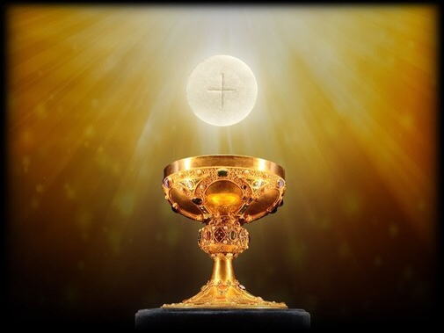
CORPUS CHRISTI

Lord Jesus, You are the living bread who satisfies the hunger of the human heart.
In the Eucharist, the bread and wine become Your Body and Blood, the gift of Yourself to the Church.
Deepen our faith in Your Eucharistic presence and strengthen us as members of the Church, the Body of Christ.
Amen.
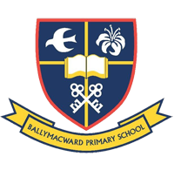
Ballymacward Primary School,
HANNAHSTOWN PARISH SCHOOL / COMMUNITY PLAYGROUP
22 Rock Road, Stoneyford, Lisburn, Co Antrim, BT28 3SUTel: (028) 92648130, Principal: Mr Hugh Kennedy
Email: info@ballmacwardps.lisburn.ni.sch.uk
Ballymacward Community Pre-School Playgroup - Supervisor: Ms Sarah Scott. Tel: (028) 9264 8515
HANNAHSTOWN PARISH/FAMILY OF PARISHES
CLONARD NOVENA – There are four days remaining of the Novena.
The Mass times for tomorrow through to the last day on Thursday 26th are 6.45 am,
9.30 am, 11.30 am, 4 pm, 6 pm & 8 pm. You are warmly welcome to attend.
HEARTS ON FIRE – A CALL TO PRAYER & RENEWAL - In this Jubilee Year of Hope, the Diocese of Down and Connor will host a special two-day gathering of parish leaders from across our parish families and extending throughout Ireland and beyond on 25 and 26 June in Belfast. Focused on renewing our vision for evangelisation, Hearts on Fire will invite parish leaders to explore ways to inspire and equip Families of Parishes to reignite the Church’s missionary spirit. We warmly invite all to join us in prayer at the opening Mass for Hearts on Fire in St Peter’s Cathedral, Belfast, at 7:00pm on Tuesday, 24 June 2025.
ALL-IRELAND RALLY FOR LIFE - All-Ireland Rally for Life takes place in Dublin on Saturday 5th July. Make a stand to protect Ireland's unborn babies. A coach will be travelling from Belfast City Centre. To book your seat contact 07592280522.

SREBRENICA GENOCIDE – Remembering the Srebrenica Genocide – 30th Anniversary, Wednesday 25 June in Belfast City Hall 6.00pm - 7.00pm. This event will help us learn more, reflect and understand the importance of working together to challenge prejudice. All welcome. To book your place email northernireland@Srebrenica.org.uk
EUCHARISTIC HEALING SERVICE - There will be a Healing Service in St Matthew’s Church, Short Strand, East Belfast on Wednesday 25th June at 7pm. Focussing on the Healing power of Eucharistic Benediction. The service will be led by Fr Peter Carlin, PP, and Music Ministry will be provided by Fionnuala O’Neill and family. Everyone welcome. Tea & refreshments afterwards in the parish hub.
HANNAHSTOWN PARISH/FAMILY OF PARISHES
FIRST SATURDAY DEVOTIONS - First Saturday Devotions will take place in St. Matthias’s Church, Glen Road on 5th July;
3.00 p.m. Adoration of the Blessed Sacrament, Confessions and Act of Consecration., Rosary and Divine Mercy Chaplet, 4.00 p.m. Holy Sacrifice of the Mass
SENSORY MASS - There will be a Sensory Friendly Mass at St Colmcille's Church, Ballyhackamore, Belfast, next Saturday 28th June at 12.00 noon. We welcome and embrace neurodiverse persons, those suffering from Alzheimer's and Dementia conditions, and those with sensory needs. Join us for a sensory friendly liturgy, which includes lower lights, softer music, and literal homilies. Feel free to get up and move if needed, bring alternative seating, use quiet fidgets or noise-cancelling headphones. Save the date and come celebrate the Eucharist in an environment free of stigma. Please contact n.dunn@downandconnor.org to express your interest, or for enquiries.
Share this message with others please.
DIVINE MERCY CHAPLET – Saint Faustina wrote extensively about the Divine Mercy Chaplet, empahasizing its power and the graces associated with praying it.
Our parish is planning to have one hour every week with Exposition of the Blessed Sacrament on a Friday at 3 pm. During this hour we will have Adoration & pray the Divine Mercy Chaplet in St Joseph’s Church..
We will inform you next week of when this will commence and we encourage you to come along to pray for Peace in our World, peace in our own families, our parish, or any personal intentions you may have.
PARISH PILGRIMAGE TO KNOCK SHRINE – Tuesday 15th July – Wednesday 16th July staying at The Knock House Hotel. There are 16 places available. Please give your name to Fr. Patrick or ring the parish office to reserve a place. Price TBC.

