
THE PARISH OF HANNAHSTOWN
WEEKLY COLLECTIONS: 29/3/26 Weekly Collection £1,053.95,
200th Anniversary Collection £318.98 Collectors and Counting, Norms/ Volunteers Application Form available on parish website, thank you to everyone.


BAPTISMS DIOCESIAN AND PARISH NORMS:
Parents will be asked to complete a short form confirming whether any other person holds parental responsibility for the child and that they are aware of the request for baptism and have raised no objection. This procedure is required in line with diocesan guidance and civil law. Please bring with you a copy of the baby’s long birth certificate to the parish office.

CONSIDERING MARRIAGE?
“Above all, let your love for one another be intense.” (1 Peter 4:8)
We would be delighted to welcome couples to meet, view the church, and arrange their wedding. Please contact Parish Office
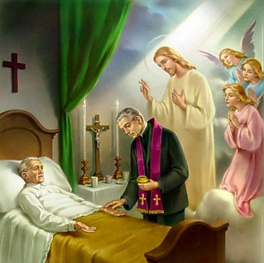

PASTORAL VISIT TO THE SICK AND HOUSEBOUND “The Lord is close to the broken-hearted.” (Psalm 34:18) Families are encouraged to let us know if a loved one is housebound and would need a visit from the priest. Contact Fr Patrick or the Parish office.
REST IN PEACE: Sonya Highan RIP

ANNIVERSARIES – William Cooley, Michael Hall, Lucy McStravick, Catherine Smyth RIP


SAFEGUARDING IN OUR PARISH “Let the little ones come to me.” (Mark 10:14)
We are pleased to share that diocesan safeguarding requirements for 2026 have now been completed, helping ensure our parish remains a safe, respectful, and caring community.


ALL VOLUNTEERS: “Each of you has a gift to use in the service of others.” (1 Peter 4:10)
To support good safeguarding and governance, we invite all volunteers to complete a General Volunteer Application Form at the parish office. This helps us keep an up-to-date picture of parish life and ensures volunteers are properly supported PRAYER FOR

GRASS CUTTING AND GROUNDS MAINTENANCE
Quotations are requested for the cemetery grass cutting and grounds maintenance at Hannahstown and the Rock. Details, including specification are available from the Parish Office on 028 90614567. Successful bidder must have the specified liability insurance in place i.e. Tenderers must provide evidence of Employers and Public Liability Insurance to the level of £1,000,000.00 and £5,000,000.00 respectively.
Quotations are to be returned by 11:00am Thursday 8th April 2026.

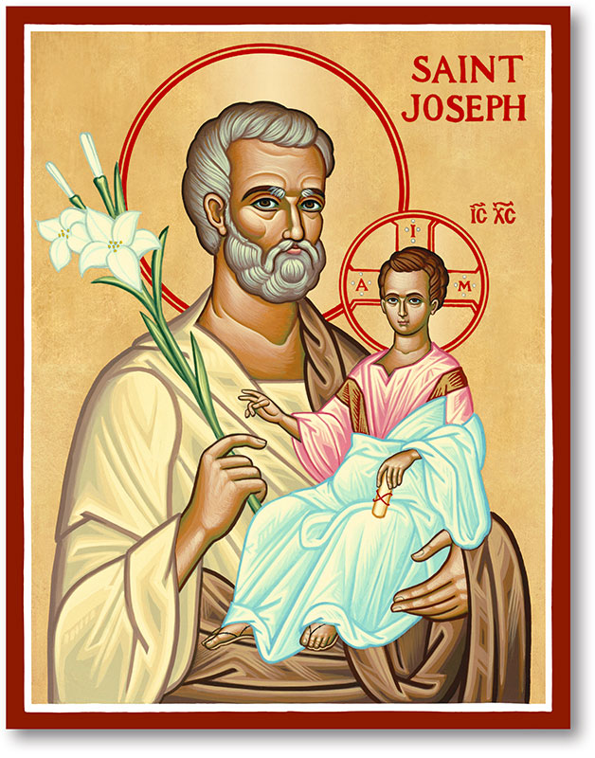
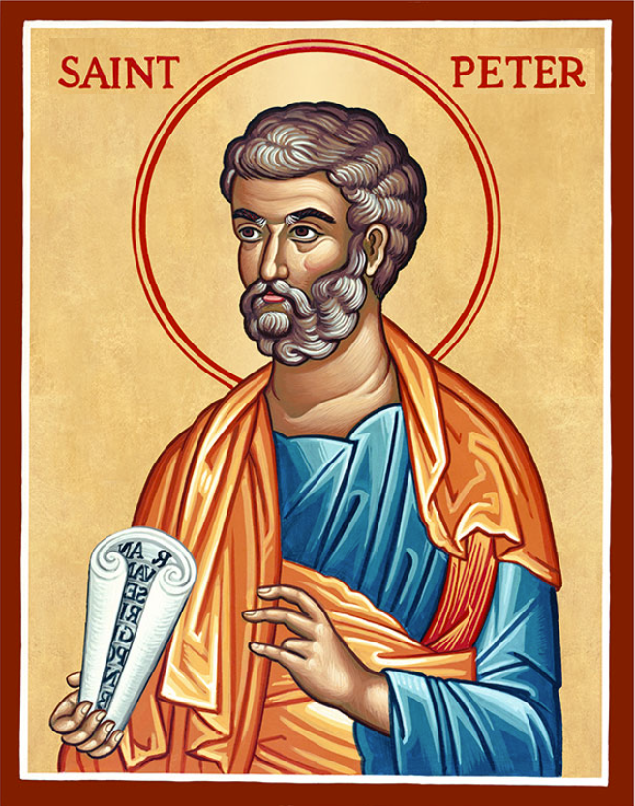
The Parish of Hannahstown
Saint Joseph’s and Saint Peter’s

5th April 2026
Easter Sunday of the Resurrection of the Lord

Family of Parishes Emergency Sick Calls: 07549209775 Very Reverend Patrick Devlin, Parish Priest. Chaplain to the Deaf Community Down & Connor.
Chaplain to Antrim Hospital Thursday & Friday (Emergency Calls)
Please contact Fr. Patrick for Spiritual and Pastoral needs only, Tel: 07910 833699. Parish Secretary Grainne McArevey 02890 614567 Email address: hannahstown@downandconnor.org Website: parishofhannahstown.com
Monday | 9.15 am | Prayer for Vocations  Coffee morning. Hannahstown Community Hall afterwards. | St Joseph’s
Tuesday |  |  | St Peter’s
Wednesday | 12 noon | The Chrism Mass: Blessing of Oils: Oil of the Sick: Oil of Catechumens  Sacred Chrism (used in Baptism, Confirmation, Ordination, Dedication of churches): Renewal of Priestly Promises: Priests renew their commitment to ministry in union with Bishop Allean.  Sign of Diocesan Unity: Bishop, priests, and people gathered as one Church | St Peter’s Cathedral Belfast
Thursday | 7.00pm | Mass of the Lord’s Supper | St Joseph’s
Friday | 3.00pm  7.00pm | The Passion and Death of Christ (Collection for Holy Land)  Stations of the Cross | St Joseph’s  St Peter’s
Saturday | 6.00 pm | Vigil Mass | St Joseph’s
Sunday | 10.00 am | Morning Mass | St Peter’s
Sunday | 11.30 am | Morning Mass | St Joseph’s
PALM SUNDAY OF THE LORD’S PASSION: (Matthew 26:14–27:66)
The Passion of our Lord Jesus Christ reveals the depth of God’s love poured out through suffering, betrayal, and the Cross. Jesus enters freely into His Passion, remaining faithful even when abandoned, denied, and condemned. In the face of violence and rejection, He responds with mercy, forgiveness, and trust in the Father. While some recognise Him as the Son of God, others turn away or remain indifferent.
Holy Week invites us to walk with Christ through His suffering—so that we may recognise our own frailty and sin, receive His mercy, and stand more faithfully with Him. As we journey from the Cross toward the Resurrection, we are called not only to witness His sacrifice but to take up our own cross, trusting that through His Passion comes the fullness of life and salvation.
HOLY WEEK SPIRITUAL EXERCISES: ADORATION OF THE BLESSED SACRAMENT: SEE ABOVE

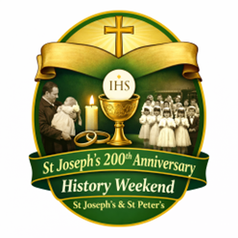

HANNAHSTOWN PARISH – MARCH 2026 ST. JOSEPH’S CHURCH 200TH ANNIVERSARY
HANNAHSTOWN PARISH PASTORAL COUNCIL (PPC)

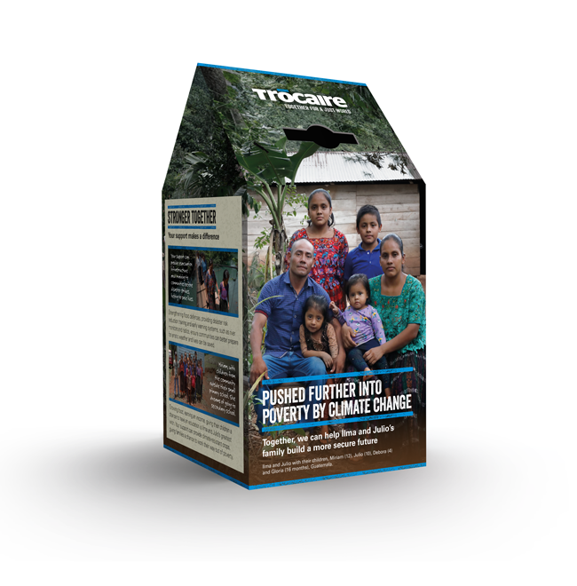
Themes: Mercy, Healing and Unity
PLEASE COLLECT YOU TROCIARE BOXES AND LEAVE TO OFFICE OR IN THE SACRISTY, THANK YOU.

HISTORY WEEKEND: As we prepare to celebrate 200 years of St Joseph’s Church, we are organising a special History Weekend to honour the story of both St Joseph’s and St Peter’s. We warmly invite parishioners to share any photographs of parish life — Baptisms, First Confession, First Holy Communion, Confirmation, Weddings, visiting Priests or Bishops, School events, Parish Missions, or old photographs of the Churches. Please place photos in an envelope with: Your name, Contact number, Brief details of the photo. Photos can be left in the Sacristy or Parish Office by Friday the 30th March and will be carefully returned after the event. Help us celebrate the generations of faith that have shaped our parish.

HANNAHSTOWNTOWN COMMUNITY SPRING/SUMMER FESTIVAL FRIDAY-12TH JUNE-SUNDAY JUNE 14TH Fri-Seniors Tea-Dance 12-3.30pm-Live music/Bingo/Ballots Sat-Historical Society Coach Trip (more information to follow) Sun- Outdoor Mass at 11.30am-followed by Tea in community Centre Please provide any Bric-a-Brac such as good clothing-toys-games -books- etc by contacting Anto at Hannahstown Community Centre on 02890-309795 More info to follow on Events

Team HCB Zambia 2026: A Legacy of Giving
Since 2014, Team HCB (Holy Cross Boys’ Primary) has transformed lives in Zambia. Led by Fr Patrick Devlin and Kevin McArevey, our 2026 mission builds on a decade of impact, including the construction of United Hearts School and the sustainable "Chicken Run" project.
Our primary goal for 2026 is building a Church to serve as a spiritual and social hub. Your donations also provide life-saving food for children with HIV/AIDS, teacher wages, to support seminarian priests and essential school supplies.
Your support is our backbone. Please help us fund infrastructure, education, and health to continue this life-changing legacy.
Thanks Love

HANNAHSTOWN PARISH APRIL 2026 ST. JOSEPH’S CHURCH 200TH ANNIVERSARY

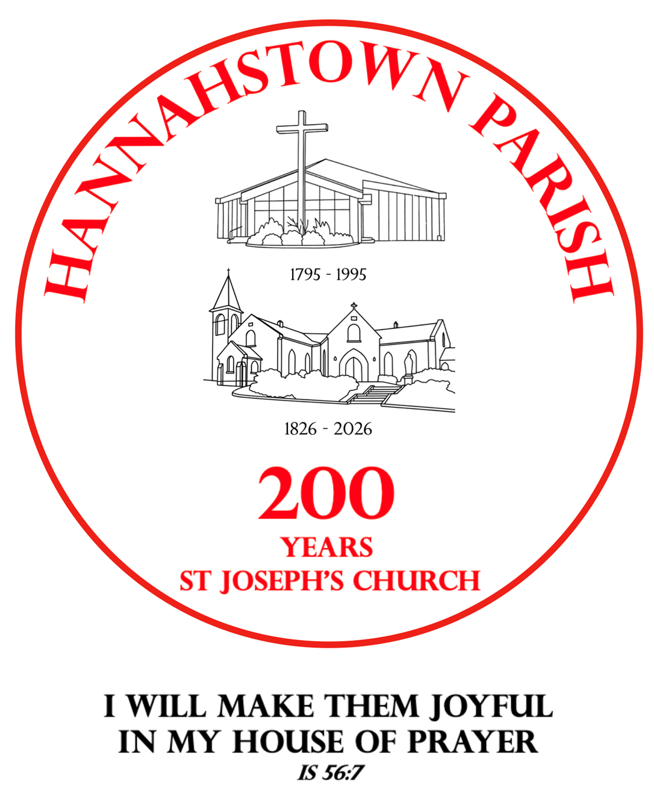
CONTINUING THE AMAZING JOURNEY: …April is a time of new life, resurrection, and renewed hope in our parish and in our faith. In that spirit, we warmly invite families to gather in celebration and thanksgiving for the gift of Baptism.
All children baptised in the past three years, along with their families, are invited to a special Blessing and Celebration Service:

A joyful and prayerful celebration including a short Liturgy of the Word, Procession, and Blessing of Children and Families, with Guardian Angel prayer cards given as gift.
Afterwards, join us outside for ice cream, balloons, and fun characters for the children.
A lovely opportunity to give thanks and continue the journey of faith together. Pray for nice WEATHER! All are welcome.

TREE PLANTING AND TIME CAPSULE CELEBRATION:


As part of our 200-year celebrations of St Joseph’s Church, we invite parishioners to a special moment of remembrance and hope for the future.

A tree will be planted as a symbol of faith and growth, and a time capsule will be created, capturing memories of our parish to be shared with future generations. Further details to follow.

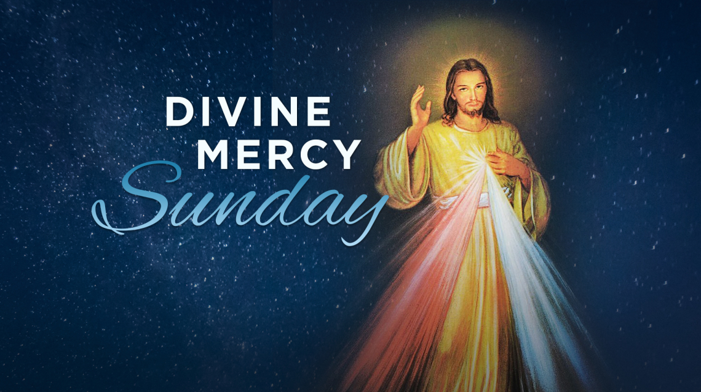
Will be celebrated on the Second Sunday of Easter, on the 12th April 2026 in Hannahstown Parish in St Joseph’s Church. The feast was promoted through the revelations associated with Saint Faustina Kowalska and was established for the universal Church by Pope John Paul II in 2000.
D&C DIOCESE & HANNAHSTOWN & FAMILY OF PARISHES NEWS NWESNNEWS
Emphasis on the Divine Mercy Image and Devotion
Confession and Trust in God’s Mercy
The Divine Mercy Chaplet 2-3 adoration and Confessions.
Blessing of Devine Image before 3:00 pm Holy Mass
Gospel of John 20:19–31 (Thomas and the Mercy of Christ)


CEMENTRY SUNDAYS: – Invitation You are warmly invited to our Cemetery Sunday Masses, as we remember and pray for our loved ones.
Sunday 31st May – St Joseph’s
Sunday, 7th June – St Peter’s, Sunday 14th June – Tullyrusk All are most welcome.
“I am the resurrection and the life, says the Lord; whoever believes in me will live, even though they die.”


LIGHTS, CAMERA, ACTION! – BBC Drama Time
Our Parish Church will be used as a filming location for the acclaimed BBC drama Time (starring actors such as Sean Bean and Stephen Graham).
Members of the congregation are invited to apply to be extras in the filming. If interested, please register with the casting company at:
https://www.theextrasdept.com/ A wonderful and unique moment in our bicentenary year — our parish moving from 200 years of history to prime-time television!

PARISH FOLK GROUP: We are hoping to further enhance congregational singing at our 11.30am Mass and would love to hear your suggestions. If there are any hymns you particularly enjoy or would like to hear at Mass, please let us know. If you are having a Mass celebrated for a loved one and there is a favourite hymn or piece of music that would mean something special to your family, we would be very happy to try to include it. Please speak to a member of the Folk Group after Mass or message Tina on 07746 620553. All suggestions are very welcome. If we do not already know the hymn, we will do our best to learn it for you.

