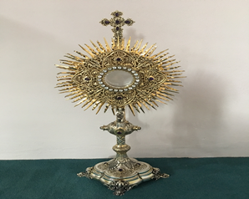
EUCHARISTIC ADORATIONSt Peter’s Church - Every Friday from 2 pm – 8.30 pm. Every evening Adoration & Prayer in St Peter’s Church 6.30 pm – 7.30 pm
THE PARISH OF HANNAHSTOWN
https://churchmedia.tv/st-josephs-church https://churchmedia.tv/st-peters-church-2

RECENTLY DECEASED – Kathleen Prior RIP
1st ANNIVERSARIES – Marion Ellis, Annie Kelly & Carmen O’Hare RIP
ANNIVERSARIES - Joey Murray & Lois McMahon RIP
MONTH’S MIND – Daryl Fegan RIP


WEEKLY COLLECTIONS
16/02/25 Weekly Collection £931.97
16/02/25 Sick & Retired Priests £532.09
Thank you to everyone for their generosity to the Parish.

BAPTISMS

To arrange Baptisms please present the long birth certificate to the parish office.

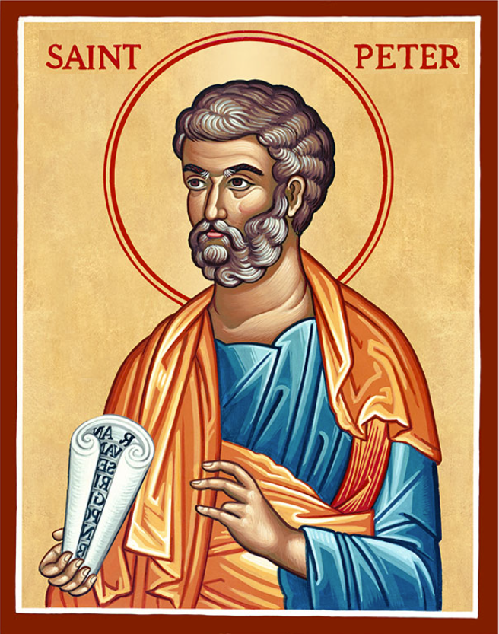
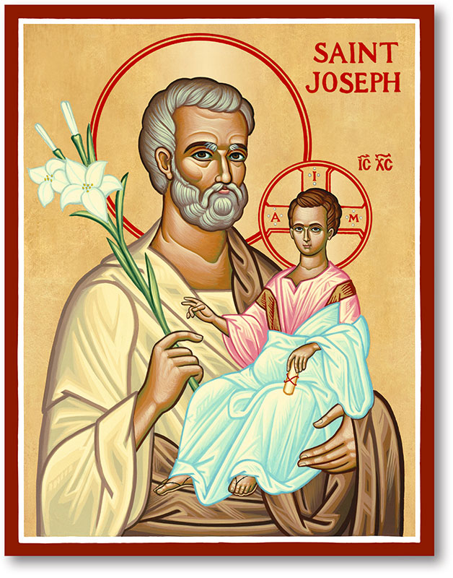
The Parish of Hannahstown
Saint Joseph’s and Saint Peter’s

23rd February 2025
Seventh Sunday in Ordinary Time

Family of Parishes Emergency Sick Calls: 07549209775
Monday 09.15 am (Prayer for Vocations) Saint Joseph’s
Tuesday Fr. Patrick’s day off.
Wednesday 9.15 am (Parish novena to Our Lady) St Joseph’s
Thursday 9.15 am (Parish novena to Our Lady) St Peter’s
Friday 9.15 am (Sacred Heart Prayer) Saint Joseph’s
Saturday 6:00 pm (St Michael the Archangel Prayer) Saint Joseph’s
Sunday 10:00 am (Prayer for Pope’s intentions) Saint Peter’s
Sunday 11:30 am (Saint Joseph Prayer) ( BSL Signed ) Saint Joseph’s

Very Reverend Patrick Devlin Parish Priest,
Chaplain to the Deaf Community, Down and Connor Diocese
Chaplain to Antrim Area Hospital Thursday & Friday (Emergency calls)
Fr. Patrick, for Spiritual and Pastoral needs only, thank you Tel: 07910 833699
Parish Secretary: Mrs Grainne McArevey Tel: 028 90614567
Parish Email: hannahstown@downandconnor.org Parish Website: https://www.parishofhannahstown.com

Seventh Sunday in Ordinary Time

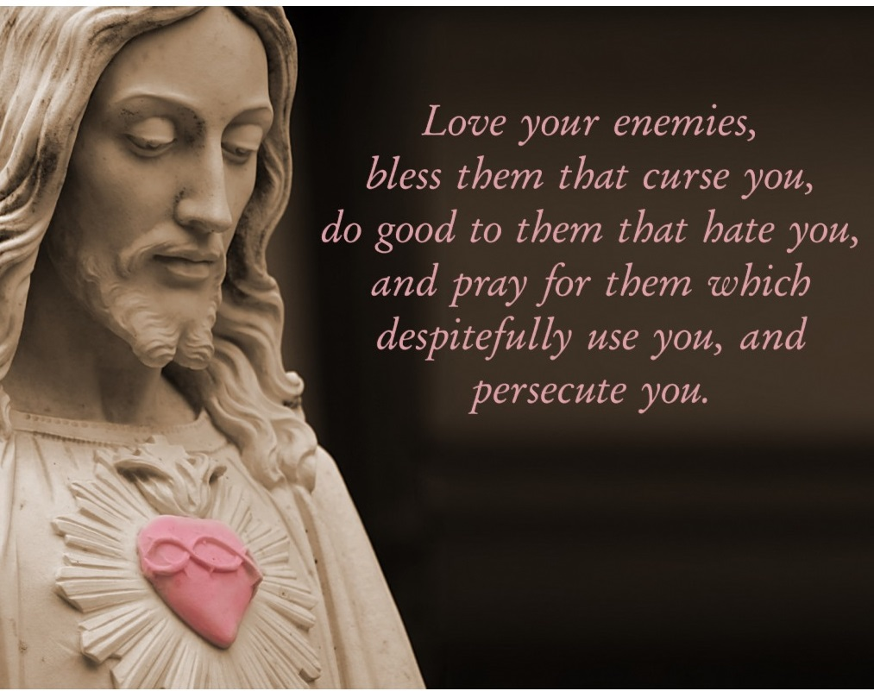
Is it possible to love your enemies and do good to those who hate you?
Jesus made the point that that is precisely what God does. Essentially, God is love. The Hebrew Scriptures spoke constantly of God’s merciful and faithful love. God can love enemies because God is free.
Jesus personified this freedom.
Jesus’ strength came from his clear sense of who he was. He knew himself to be loved by God. The capacity to love enemies is not achieved simply by wishing for it or by feeling obliged to do so. It is a factor of maturity and the capacity to empathise. It originates from a strong sense of God’s love
Hannahstown and the Rock Parish Draw February 2025
HANNAHSTOWN PARISH / FAMILY OF PARISHES / PATHWAYS

Prize  Place | Prize  Money | Name | Number | Collector
1st | £250 | Bernadette Goan | 355 | Tom Mc Garrity
2nd | £150 | David & Eva Ferguson | 169 | Mary Ferguson
3rd | £100 | Paul Murray | 358 | Tom Mc Garrity
4th | £100 | Lilly Young | 59 | Mary Ferguson
5th | £50 | Kathleen Braden | 438 | Angela Mc Gowan
6th | £50 | Michael Douglas | 285 | Irene Phillips
7th | £50 | Mary Ferguson | 50 | Mary Ferguson
8th | £50 | Duncan Mc Auley | 239 | Johnny Mc Quillan
9th | £50 | Mary Clarke | 25 | Angela Mc Gowan
10th | £50 | Shea &Aoife Linskey | 11 | Jim Ferguson
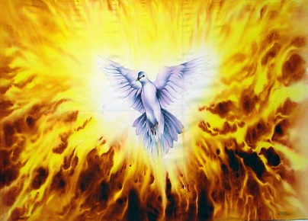
__________________________________________________________________________
GROWING IN FAITH TOGETHER – Day Retreat. St Paul’s Parish Centre. Saturday 8th March 2025, 10 am – 4 pm. Speaker Fr. Darren Brennan.

“He has anointed me to bring Good News to the poor” Lk.4:18)

At the beginning of our Lenten Journey let us join
for a day of Teaching, Praise, and the celebration of Mass.
GROWING IN FAITH TOGETHER

For further information contact Collette on 07791078453, Please bring a packed lunch, tea and coffee will be provided. HOSTED BY DOWN AND CONNER CHARISMATIC RENEWAL COMMITTEE


HANNAHSTOWN VICTIMS & SURVIVORS OF ABUSE WITHIN OUR CHURCH - FRIDAY 7th March 2025 in Saint Patrick’s Church, Donegall Street, Belfast at 1:00pm
HANNAHSTOWN PARISH / FAMILY OF PARISHES
to pray for and remember victims and survivors of abuse within our Church.
At this mass the Candle of Atonement will be lit. You are invited to attend this important Diocesan event. In addition, all parishes are invited to organise their own service or moment of prayer and include a prayer for victims.

‘Sing for Joy!' - A Day of Music and Ministry
Are you involved, or keen to become involved in Church Music in your Parish, School, University etc.? We invite you to join us for ‘Sing for Joy!' - A Day of Music and Ministry. Saturday 26th April 2025 at Lough Derg, Pettigo, Co. Donegal. Boat departs at 9:30am.
This day is open to young people aged 18-35 and is free to attend (supported by the Knights of St Columbanus). Registration is essential via https://bit.ly/SingforJoy . For further information please contact info@knightsofstcolumbanusomagh.co.uk / +447759496677.

THE PARISH OF HANNAHSTOWN SCHOOLS
Our Parish School Ballymacward Primary School,
22 Rock Road, Stoneyford, Lisburn, Co Antrim, BT28 3SUTel: (028) 92648130, Principal: Mr Hugh Kennedy
Email: info@ballmacwardps.lisburn.ni.sch.uk
Pre-School Playgroup – Supervisor: Ms Sarah Scott. 02892648515

