
EUCHARISTIC ADORATION
THE PARISH OF HANNAHSTOWN
St Peter’s Church - Friday’s 2 pm – 8.30 pm.
Daily Adoration, Rosary & The Divine Mercy Chaplet St Peter’s Church 6.30 pm – 7.30 pm every evening. https://churchmedia.tv/st-peters-church-2
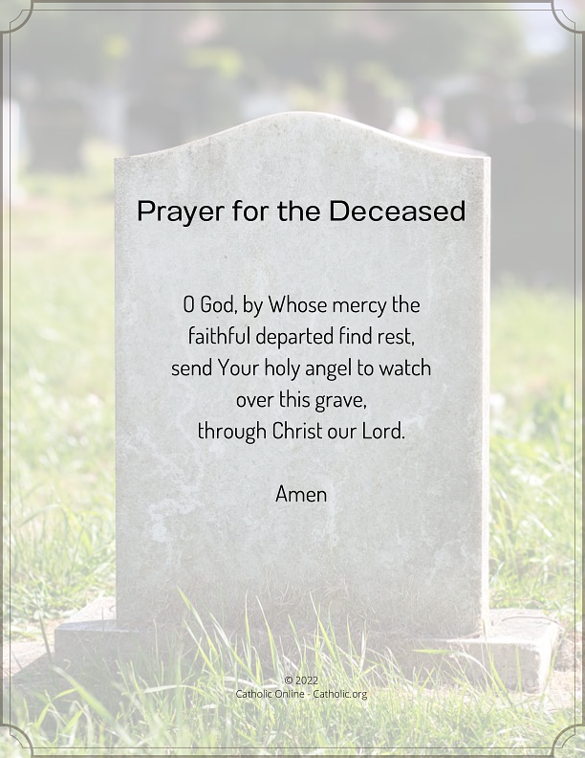
RECENTLY DECEASED – Tess Mc Cullough RIP
MONTH’S MIND Ned Keenan RIP
ANNIVERSARIES – Conor mc Mahon,Hugh Mc Mahon Mary Mc McMahon, Annie Killough, Mark Sinclair, Marian Baxter, Jim Curran, Francis Mc Peake,
Gerardine White RIP.
Please remember to visit Fr. Patrick in the Sacristy before Mass starts if it is Intended for your loved one.


WEEKLY COLLECTIONS
6/10/25 Weekly Collection £914.27
6/10/25 Monthly Collection £670.26
Thank you to everyone for their generosity to the Parish.

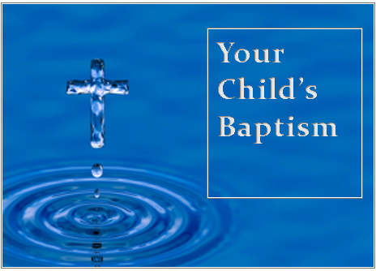
BAPTISMS
To arrange Baptisms, please present the long birth certificate to the parish office.

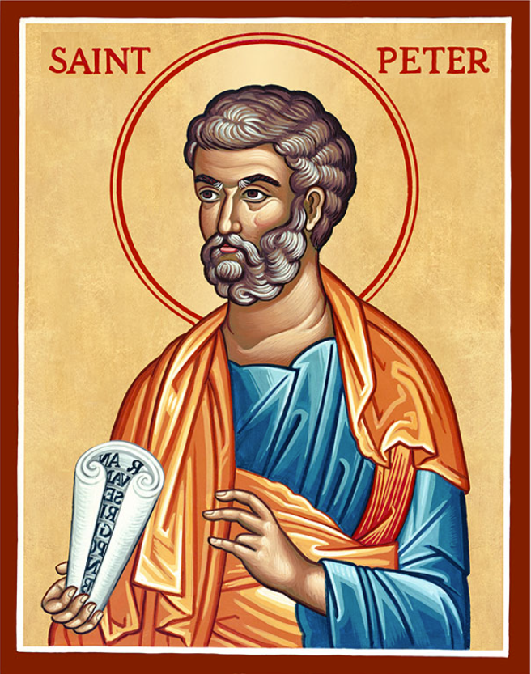
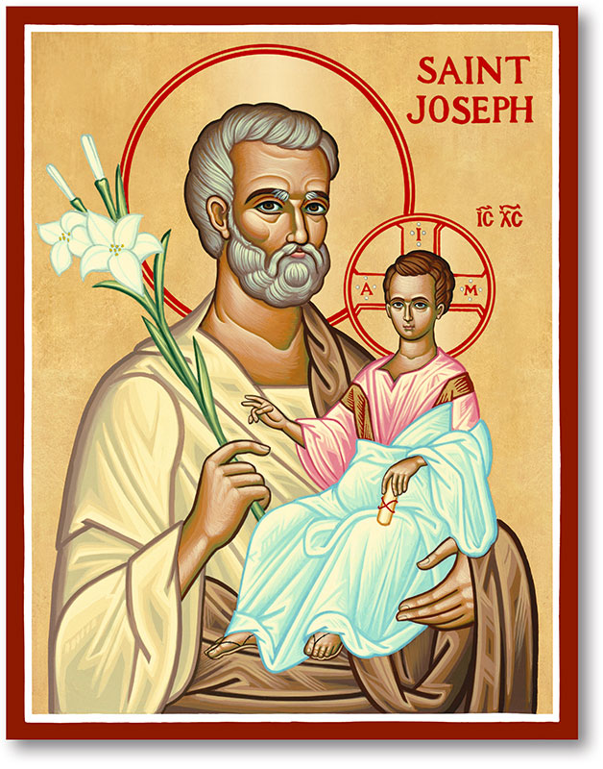
The Parish of Hannahstown
Saint Joseph’s and Saint Peter’s

12th October 2025
28th Sunday in Ordinary Time
Family of Parishes Emergency Sick Calls: 07549209775
Monday 9.15 am Prayer for Vocations Visiting Priest Saint Joseph’s
Monday Cover Family of Parishes Funeral Holy Trinity 10:00 am
Tuesday Fr Patrick ‘s Day Away (Mass cover in St Michael’s 10.00am)
Tuesday 4.00pm Tess Mc Cullough RIP Removal to the Saint Peter’s
Wednesday 9.15 am Parish Novena to Our Lady Saint Joseph’s
Funeral Mass 11.00am Tess Mc Cullough RIP Funeral Mass Saint Peter’s
Thursday 9.15 am Parish novena to Our Lady Saint Peter’s
Friday 9.15 am Sacred Heart and St Michael’s Prayer Saint Joseph’s
Saturday 6:00 pm Prayer of Hope, Jubilee 2025 Saint Joseph’s
Sunday 10:00 am Prayer of Hope, Jubilee 2025 Saint Peter’s
Sunday 11:30 am Prayer of Hope, Jubilee 2025 BSL Signed Saint Joseph’s
Very Reverend Patrick Devlin, Parish Priest,
Chaplain to the Deaf Community, Down and Connor Diocese
Chaplain to Antrim Area Hospital Thursday & Friday (Emergency calls)
Fr. Patrick, for Spiritual and Pastoral needs only, thank you Tel: 07910 833699
Parish Secretary: Mrs Grainne McArevey Tel: 028 90614567
Parish Email: hannahstown@downandconnor.org Parish Website: https://www.parishofhannahstown.com
PRISONERS’ SUNDAY SUNDAY 12TH OCT – SUNDAY 18TH OCT.

A Message from Bishop Alan McGuckian.
During this Prisons Week, I
invite all the faithful across our Diocese to join in prayer for the Prison Parishes of Hydebank, Maghaberry, and Magilligan. These communities, though behind walls, are very much part of our Church family. On Thursday, October 16th, I will visit Hydebank Women’s Prison and Yound Offenders College to spend time in prayer with the residents and staff. It is my hope that through our shared prayer, we may bring light, hope, and the healing presence of Christ to those who carry heavy burdens. Let us remember that no one is beyond the reach of God’s mercy, and that in this Jubilee Year of Hope, we are called to be instruments of compassion and reconciliation.

HANNAHSTOWN PARISH / FAMILY OF PARISHES / PATHWAYS
LIFE CHAIN - Join Precious Life on Saturday 18th October 2025 at Belfast City Hall at 2pm for a Life Chain to mark the 6th Anniversary of Westminster imposing abortion on Northern Ireland. Stand with us in remembrance of the innocent babies lost since then, as we advocate for the protection of life. For more information, please contact Precious Life 028 90278484 or 07592280522

“A Family Guide to Planning and Celebrating a Funeral in the Catholic Church”:
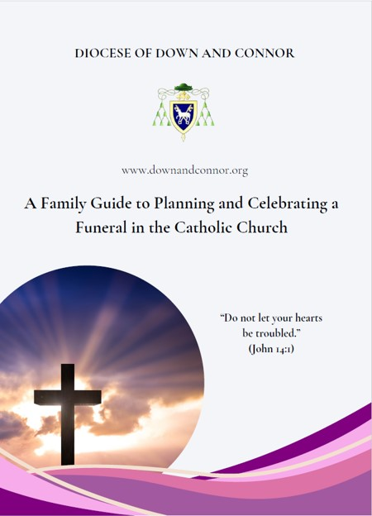
Available for download on parishofhannahstown.com under “funerals”. This official booklet was put together by the Diocese of Down and Connor. It Contains: A pastoral message from Bishop Alan Mc Guckian, guidance for families after the death of a loved one, as well as an explanation of a Catholic funeral. It also provides information about the prayers.

Important to note, there are no eulogies permitted in the Diocese of Down & Connor and therefore not permitted in the Parish of Hannahstown.
Please remember to visit Fr. Patrick, or visiting priest in the sacristy before Mass starts. This will ensure that your loved ones name will be read out.
May all our loved ones Rest in Peace.
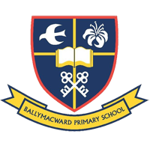
Our Parish School Ballymacward Primary School,
THE PARISH OF HANNAHSTOWN SCHOOL
COMMUNITY PRE-SCHOOL PLAYGROUP
22 Rock Road, Stoneyford, Lisburn, Co Antrim, BT28 3SUTel: (028) 92648130, Principal: Mr Hugh Kennedy
Email: info@ballmacwardps.lisburn.ni.sch.uk

Pre-School Community Playgroup – Supervisor: Ms Sarah Scott. 02892648515

Please contact Anthony Adams for any enquiries on 90 309795.
HANNAHSTOWN COMMUNITY HALL
Mon – Fri 10 am – 1 pm.
Mondays – Coffee Morning after 9.15 am Mass.
Wednesdays – Seniors Group after 9.15 am Mass.
Please come along to our popular coffee morning or our seniors group, an opportunity to meet with fellow parishioners for some company and good craic.

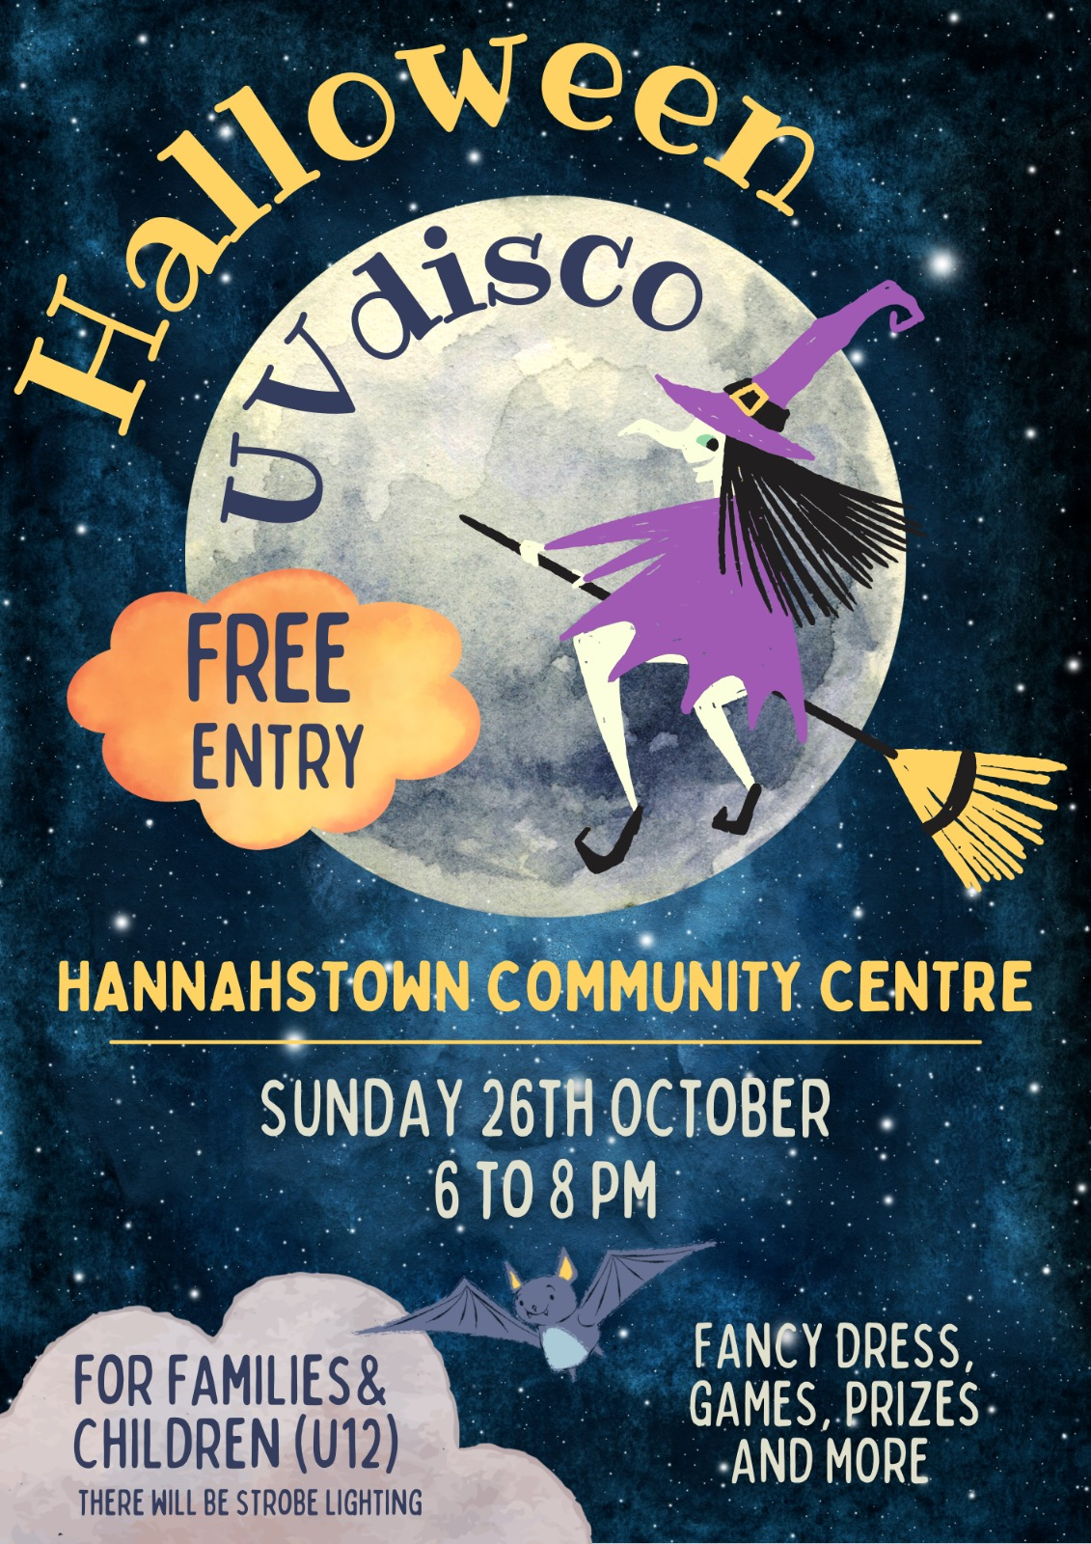

Halloween Disco Fun

For families & young children with free entry for all on Sunday 26th October
We look forward to seeing you for a night of fancy dress, games & prizes.

