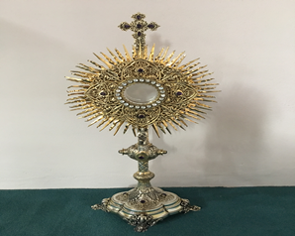
EUCHARISTIC ADORATIONSt Peter’s Church - Every Friday from 2 pm – 8.30 pm. Every evening Adoration & Prayer in St Peter’s Church 6.30 pm – 7.30 pm
THE PARISH OF HANNAHSTOWN
https://churchmedia.tv/st-josephs-church https://churchmedia.tv/st-peters-church-2

RECENTLY DECEASED David Brady RIP
MONTH’S MIND Ciara Dornan, James Edward
& Brendan McCann RIP
ANNIVERSARIES – Gerry Barry, Frank McCague
& Vincent Reid RIP

WEEKLY COLLECTIONS
20/04/25 Weekly Collection £1267.35
19/04/25 Holy Land Collection £ 434.40
20/04/25 Easter Collection £ 818.13
Thank you to everyone for their generosity to the Parish.
OFFICE CLOSED
The Parish office will be closed from Thursday, May 1st, and will reopen on Wednesday, May 7th, as Fr. Patrick and Grainne (parish secretary) will be in Medjugorje on our Parish Pilgrimage. During this time, Fr Patrick asks if you wish special prayers at Medjugorje, please leave a petition/offering in the parish by WEDNESDAY.
Seeking Educational & Sensory Toy Donations!

I am continuing to collect new or gently used educational and sensory toys, Saint Joseph’s Centre for the Deaf, to support children’s learning and development. These toys will benefit children who thrive with hands-on, engaging play that builds important skills.
Items we’re looking for include: Puzzles, building blocks, and STEM toys Fidget tools, textured toys, and sensory bins. cause-and-effect or interactive learning toys Indoor and outdoor play equipment

Please drop off donations by Wednesday 7th May noon or contact Fr.Patrick for collection on 07910833699. Thank you for helping us create a supportive and fun learning environment for all children!

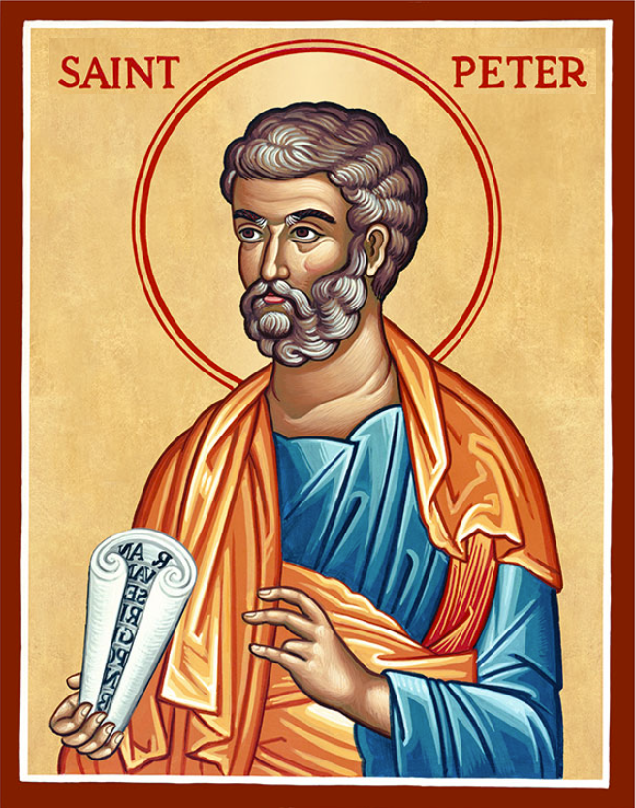
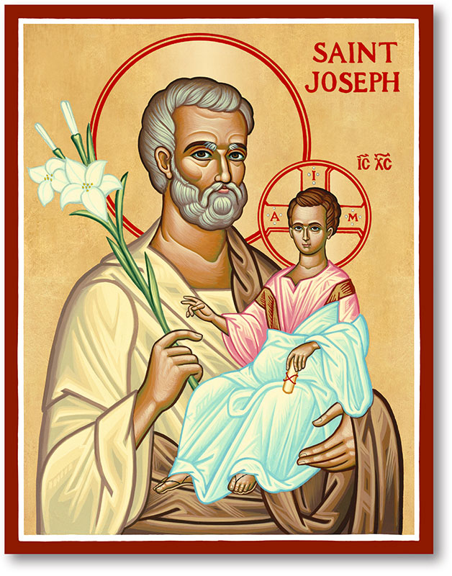
The Parish of Hannahstown
Saint Joseph’s and Saint Peter’s

27th April 2025

DIVINE MERCY SUNDAY
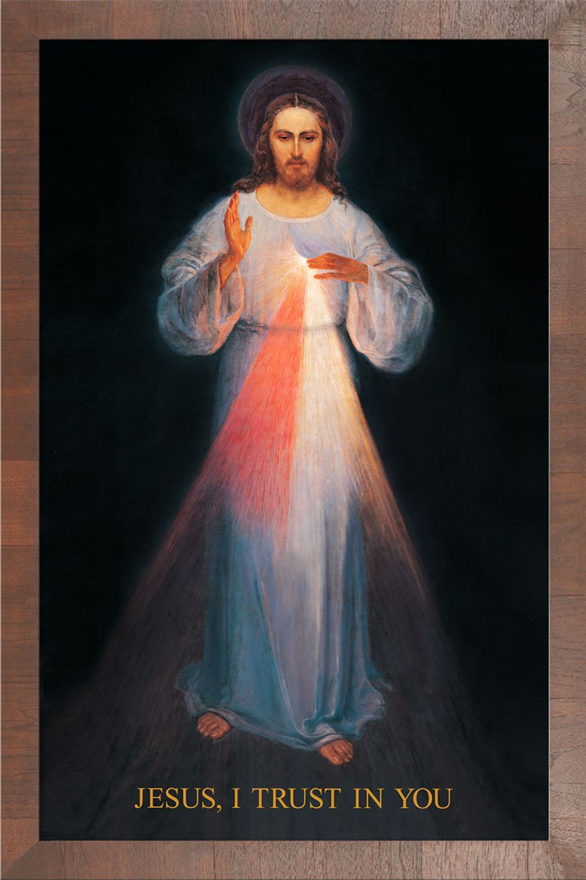
"Eternal Father, in the name of Your only Son, Our Lord Jesus Christ, we humbly beseech You. Have mercy on us, poor sinners, and open our hearts to the boundless ocean of Your mercy. For the sake of the bitter Passion of Your Son, look with compassion upon those who wander far from You and those who are struggling to live a holy life. Grant us the grace to repent of our sins, to trust in Your love, and to live as worthy children of Your infinite mercy. Help us to embrace the hour of Your great mercy and to immerse ourselves in Your Passion, especially in the moment of agony. May we never forget the profound love You have shown us, and may we always strive to be a reflection of Your mercy in this world. Amen."
The conditions for receiving this great grace, including going to confession, can be fulfilled by attending any of the following Churches on Divine Mercy Sunday, 27 April this year. St Peter’s Cathedral at 2 pm, or St Paul’s, Falls Rd at 2 pm.
Parish Mass Times
Monday 28th April – Wednesday 7th May
Monday 28th April 10 am Saint Joseph’s
Wednesday 30th April 10 am Saint Joseph’s
Weekend Masses as normal
Monday 5th May 10 am Saint Joseph’s
Wednesday 7th May 10 am Saint Joseph’s
Beyond, Mass Times as normal.

Our Parish School Ballymacward Primary School,
HANNAHSTOWN PARISH SCHOOL / COMMUNITY PLAYGROUP
22 Rock Road, Stoneyford, Lisburn, Co Antrim, BT28 3SUTel: (028) 92648130, Principal: Mr Hugh Kennedy
Email: info@ballmacwardps.lisburn.ni.sch.uk

Ballymacward Community Pre-School Playgroup - Supervisor: Ms Sarah Scott. Tel: (028) 9264 8515

HANNAHSTOWN PARISH / FAMILY OF PARISHES / PATHWAYS
ALL IRELAND ROSARY RALLY - Come and join us on the 10th of May at 4 pm, at Our Lady of Mercy Grotto in St Oliver Plunkett's carpark, Lenadoon, Belfast. For our annual All-Ireland Rosary Rally. Please bring a friend also.

ALPHA - St Colmcille's parish Belfast, is inviting you to their short ALPHA programme, which begins next THURSDAY 8th MAY at 7.00 pm to 8.30 pm, hosted in The Lampost Café, 19 Upper Newtownards Road BT4 3ht. Enjoy a free meal when you arrive, meet new people and explore the Christian faith together. Each session unpacks a big question of life, faith, and purpose. Come along, and see what you think. All welcome. Please contact Noeleen to register, as places are limited on this occasion: n.dunn@downandconnor.org

Parish Website updated
Thank you for all the good work. Please Enjoy
1st January 2023 until now…. 43053 View Counts! WOW
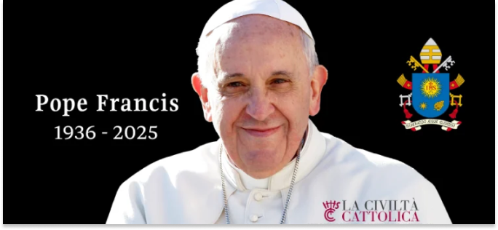
Pope Francis left us on April 21, 2025, at the age of 88, after giving us a blessing and leaving a final Urbi et Orbi message the day before, Easter Sunday. He did not miss a final popemobile ride in St. Peter’s Square, greeting pilgrims. On March 13, he had completed 12 years of pontificate. Rightly, the Church feels orphaned, and that means the Church is family, community, belonging, feelings. The Church feels orphaned, and at the same time is grateful. Therefore, at this time and together with the whole Church, La Civiltà Cattolica wants to express gratitude and thankfulness.
HANNAHSTOWN PARISH / FAMILY OF PARISHES / PATHWAYS
We want to express gratitude for the many gestures and words that have not left us indifferent, that have spurred and encouraged us to be better Christians. Pope Francis proclaimed the Gospel with his word, accompanied by the strength of his gestures. Thinking about these gestures, let us not forget his closeness to refugees and migrants, of which the trip to Lampedusa, the first of the pontificate, and the trip to the island of Lesbos were examples. Let us not forget his closeness to the sick or his visits to prisons. Let us not forget the prayer of March 27, 2020, in the dark days of the pandemic, in an empty St. Peter’s Square with the sound of ambulance sirens in the background. Let us not forget the commitment to peace, fraternity and integral human development, or care for the common home, involving other Christian churches and denominations, other religions and believing and non-believing world leaders.
