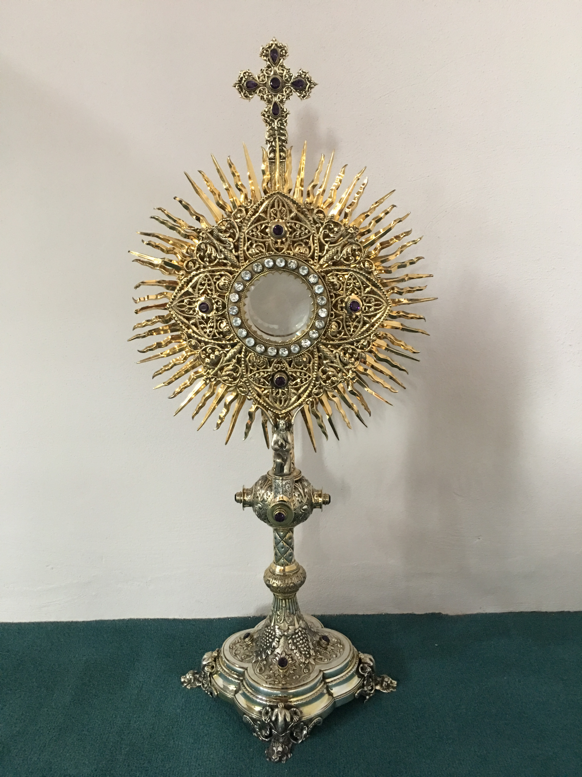
EUCHARISTIC ADORATION
The Parish of Hannahstown News
St Peter’s Church - Every Friday from 2 pm – 8.30 pm. Every evening Adoration & Prayer in St Peter’s Church 6.30 pm – 7.30 pm.
St Joseph’s Church Wednesdays during Lent from 9.45 am – 1.45 pm. You can join us in the Church or via the webcam. https://churchmedia.tv/st-josephs-church https://churchmedia.tv/st-peters-church-2
ANNIVERSARIES – Sean Bannon (1st Anniversary), Oliver Brennan, Jack Ellis, Margaret Toland RIP

RECENTLY DECEASED – Ryan Straney RIP

WEEKLY COLLECTIONS
14/04/2024 Weekly Collection £751.24
14/04/2024 Building Fund Collection £341.677
Final Count Easter Collection £1,325.25

Thank you to everyone for their generosity to the Parish.

To arrange a Baptism in the parish please bring the baby’s long birth certificate to the parish office.

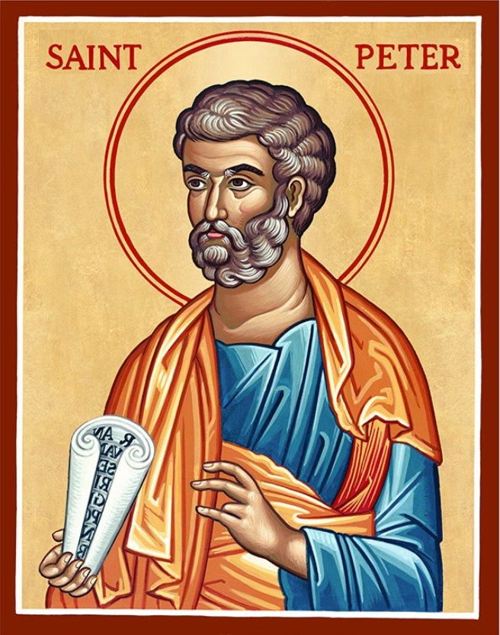
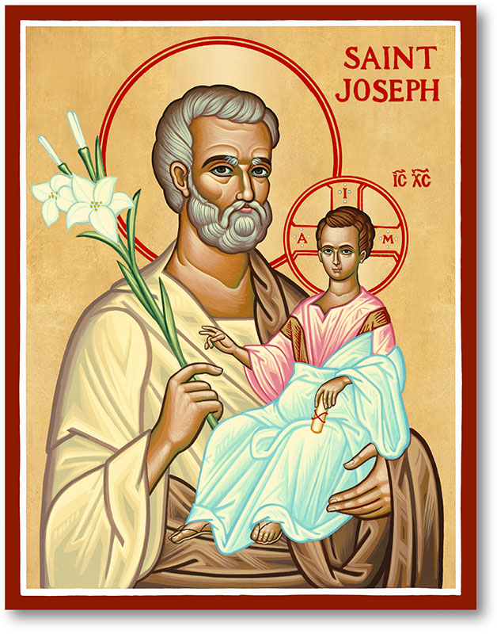
The Parish of Hannahstown
Saint Joseph’s and Saint Peter’s

21st April 2024
Fourth Sunday of Easter

Vicariate / Family of Parishes Emergency Sick Calls: 07549209775
Readings: Sunday Cycle B Weekdays Psalter Week
Monday 09:15 am (Prayer for Vocations) Saint Joseph’s.
Wednesday 09.15 am (Parish Novena to Our Lady) Saint Joseph’s
Thursday 09:15 am Parish School Service of Light Saint Peters
Friday 09:15 am (Sacred Heart Prayer) Saint Joseph’s
Saturday 6:00 pm (Saint Michael the Archangel Prayer) SaintJoseph’s Sunday 10:00 am (Prayer for Pope’s Intentions) Saint Peter’s
Sunday 11:30 am (Saint Joseph Prayer) BSL Signed Mass Saint Joseph’s
Very Reverend Patrick Devlin Parish Priest,
Chaplain to the Deaf Community, Down and Connor Diocese
Chaplain to Antrim Area Hospital Thursday & Friday (Emergency calls)
(Fr. Patrick’s mobile…. For Spiritual and pastoral needs only, thank you) Tel: 07910 833699
Parish Secretary: Mrs Grainne McArevey Tel: 028 90614567
Parish Email: hannahstown@downandconnor.org
Parish Website: https://www.parishofhannahstown.com

GOOD SHEPHERD SUNDAY
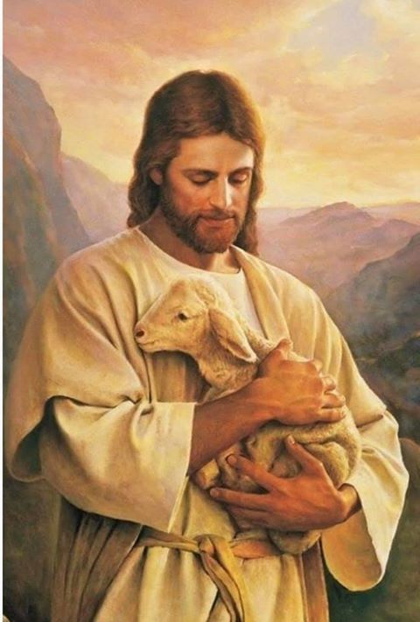
Oh Lord, you are my shepherd, there's nothing more I need. You guide me to still waters, with gentle care you lead. You call me to believe in you; you hold me to your heart. And show me those still seeking you, so I can do my part to bring them home.

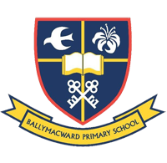
Our Parish School Ballymacward Primary School,
THE PARISH OF HANNAHSTOWN SCHOOLS
22 Rock Road, Stoneyford, Lisburn, Co Antrim, BT28 3SUTel: (028) 92648130, Principal: Mr Hugh Kennedy
Email: info@ballmacwardps.lisburn.ni.sch.uk

Pre-School Playgroup - Supervisor: Ms Sarah Scott. Tel: (028) 9264 8515
HANNAHSTOWN COMMUNITY HALL
Please contact Anthony Adams for any enquiries on 90 309795
Mon – Fri 10 am – 1 pm.
Monday – Coffee Morning after 9.15 am Mass, everyone welcome.
DOWN and CONNOR DIOCESAN TRUST - An opportunity has arisen for a Caretaker/Sacristan within Hannahstown Parish, Hannahstown Hill, Belfast, BT17 0LT.
LIVING CHURCH / HANNAHSTOWN PARISH
The responsibilities will include:
Responsibility for all Parish grounds and buildings. Ensuring the Churches and Parish grounds are opened and closed at the appropriate time, are maintained to the highest standard and that all who use them can do so safely and securely. Lead responsibility for the maintenance of the sacristy, ensuring that, with volunteers and others, the sanctuary is set up for Mass, other services, baptisms, and funerals, ensuring all the requisite books and sacramental vessels etc. are in place. The terms are based on a permanent appointment requiring 24 hours attendance each week from Monday - Sunday, work pattern to be agreed. Availability to work flexible hours is required from the post holder, from time to time. Rate of Pay - £11.44 gross per hour. Full details relating to the vacancy can be found on the Diocesan website at: http://www.downandconnor.org clicking on the tab: JOB VACANCIES and on the Community NI website, where terms and conditions relating to the role can also be accessed. Closing date for applications will be 12.00 noon on Monday 29th April 202

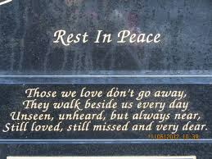
CEMETERY SUNDAY IN BELFAST CEMETERIES
LIVING CHURCH / Family of Parishes
Milltown (Service) Sunday 12th May @ 3 pm
City (Service) Sunday 19th May @ 3 pm
Hannahstown Parish……..
St Joseph’s (Mass) Sunday 26th May @ 3 pm
Tullyrusk (Mass) Sunday 16th June @ 1.30 pm
St Peter’s (Mass) Sunday 9th June @ 1.30 pm

Hannahstown and the Rock Parish Draw March 2024
Prize  Place | Prize  Money | Name | Number | Collector
1st | £1000 | Karen Stockton | 331 | Stephen Mulligan
2nd | £500 | Stephen McQuillan | 36 | Angela McGowan
3rd | £500 | Joan Cushnahan | 333 | Mary Ferris
4th | £250 | Martina Lee | 179 | Jim Ferguson
5th | £150 | Name withheld | 202 | Stephen Mulligan
6th | £100 | Jimmy King | 269 | Johnny McQuillan
7th | £100 | Pauline Gorman | 207 | Seamus Armstrong
8th | £50 | Angie McCabe | 225 | Seamus Armstrong
9th | £50 | Rita McAuley | 70 | Mary Peyton
10th | £50 | David Neeson | 417 | Irene Phillips
11th | £50 | Sheila Lappin | 174 | Mark Mulholland
12th | £50 | John Brankin | 361 | Stephen Mulligan
13th | £50 | Etain McQuillan | 440 | Johnny McQuillan

Collector’s Prize £50 Mark Mulholland

