
THE PARISH OF HANNAHSTOWN
WEKLY COLLECTION: 01/03/26: £770.80 Monthly Collection £607.94 Collectors and Counting, Norms/ Volunteers Application Form available on parish website Thank you to everyone.


BAPTISMS DIOCESIAN AND PARISH NORMS:
Parents will be asked to complete a short form confirming whether any other person holds parental responsibility for the child and that they are aware of the request for baptism and have raised no objection. This procedure is required in line with diocesan guidance and civil law. Please bring with you a copy of the baby’s long birth certificate to the parish office.

CONSIDERING MARRIAGE?
“Above all, let your love for one another be intense.” (1 Peter 4:8)
We would be delighted to welcome couples to meet, view the church, and arrange their wedding. Please contact Parish Office
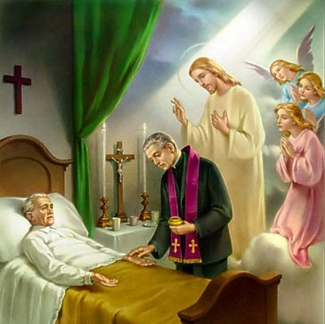
PASTORAL VISIT TO THE SICK AND HOUSEBOUND “The Lord is close to the broken-hearted.” (Psalm 34:18) Families are encouraged to let us know if a loved one is housebound and would need a visit from the priest. Contact Fr Patrick or the Parish office.

SAFEGUARDING IN OUR PARISH “Let the little ones come to me.” (Mark 10:14)
We are pleased to share that diocesan safeguarding requirements for 2026 have now been completed, helping ensure our parish remains a safe, respectful, and caring community.


ALL VOLUNTEERS: “Each of you has a gift to use in the service of others.” (1 Peter 4:10)
To support good safeguarding and governance, we invite all volunteers to complete a General Volunteer Application Form at the parish office. This helps us keep an up-to-date picture of parish life and ensures volunteers are properly supported.

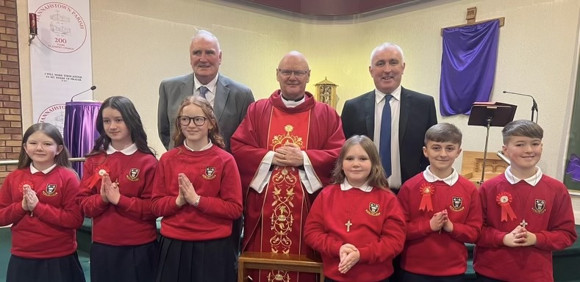
HANNAHSTOWN PARISH CONFIRMATION: BALLYMCWARD PRIMARY. We give thanks for the beautiful celebration of the Sacrament of Confirmation which took place on Sunday 1st March at 10.00am in St Peter’s Church. We warmly congratulate our young people who received the Gift of the Holy Spirit and thank their families, sponsors, teachers, and all who helped prepare them for this special day.
It was a moment of great grace for our parish community. May the Holy Spirit continue to guide and strengthen our newly confirmed, helping them to live their faith with courage, joy, and generosity. Please continue to keep them in your prayers as they grow in the life of Christ and in the mission of the Church.
2026: First Holy Communion, Sunday 26th April 10am, at St Peter’s Church.

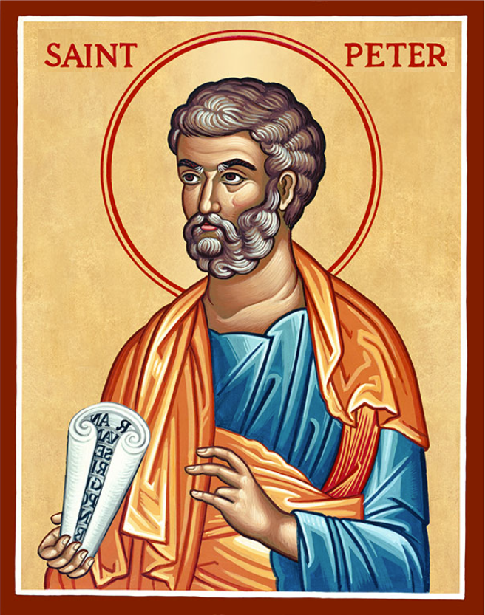
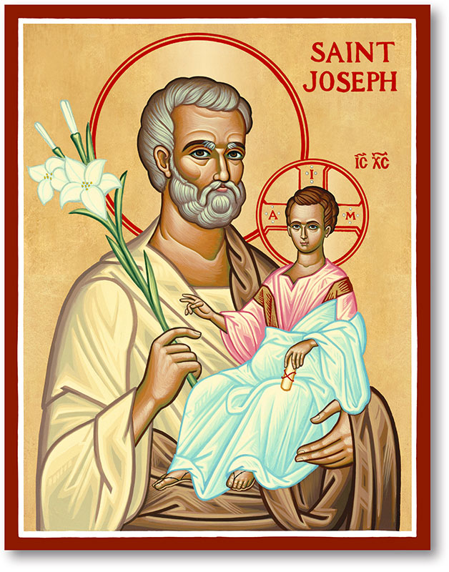
The Parish of Hannahstown
Saint Joseph’s and Saint Peter’s

8th March 2026
Family of Parishes Emergency Sick Calls: 07549209775
Monday | 9.15 am | Prayer for Vocations  Coffee morning. Hannahstown Community Hall afterwards. | St Joseph’s
Tuesday | 9.15am | Prayer for Peace | St Peter’s
Wednesday | 7pm | 1.Nine-Day Novena | St Joesph’s
Thursday | 7pm | 2. Nine-Day Novena | St Joseph’s
Friday | 7pm | 3. Nine-Day Novena | St Joseph’s
Saturday | 6.00 pm | 4. Nine-Day Novena | St Joseph’s
Sunday | 10.00 am | Prayer to St Peter | St Peter’s
Sunday | 11.30 am  7pm | Prayer to St Joseph  5.Nine-Day Novena | St Joseph’s
Very Reverend Patrick Devlin, Parish Priest. Chaplain to the Deaf Community Down & Connor.
Chaplain to Antrim Hospital Thursday & Friday (Emergency Calls)
Please contact Fr. Patrick for Spiritual and Pastoral needs only, Tel: 07910 833699. Parish Secretary Grainne McArevey 02890 614567 Email address: hannahstown@downandconnor.org Website: parishofhannahstown.com

Honouring 200 Years – St Joseph’s Church Bicentenary Nine-Day Novena 11th- 19th March 7 pm
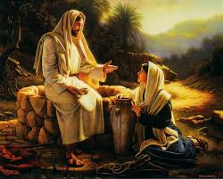
THIRD SUNDAY OF LENT: (John 4:5–42) Jesus waits beside the well and meets the Samaritan woman in her thirst. He speaks of living water that becomes a spring within the heart. What begins as a simple conversation becomes a moment of revelation and mercy.
Lent reminds us that Christ meets us in our ordinary places and hidden thirsts. As we listen to Him and receive the living water He offers, our hearts are renewed and we become witnesses who invite others to come and see the Saviour there.

LENTEN SPIRITUAL EXERCISES: ADORATION OF THE BLESSED SACRAMENT:
St Peter’s Church: Fridays 2.00pm – 8.30pm throughout Lent. Daily also from 6.30pm – 7.30pm with Adoration, Rosary and the Divine Mercy Chaplet. St Joseph’s Church: Fridays 3.00pm – 4.00pm with Adoration and the Divine Mercy Chaplet. Website parishofhannahstown.com.


REST IN PEACE: Recently Deceased Mary Cunningham, Ellen (Eileen) Rooney: ANNIVERSARIES – James Feely, James & Winifred Ferris, Margaret Hughes 1st Anniversary, Ronnie Hughes, Hugh Jordan & Aaron Roberts

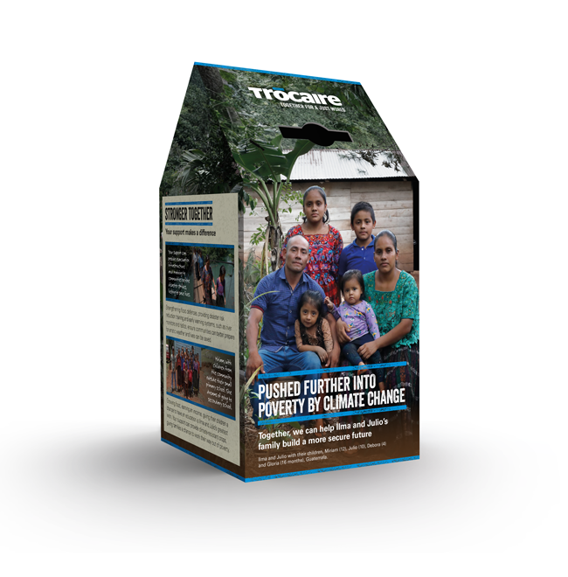

HANNAHSTOWN PARISH – March 2026 St Joseph’s Church 200th Year Anniversary
HANNAHSTOWN PARISH PASTORAL COUNCIL (PPC)
Themes: Mercy, Healing and Unity

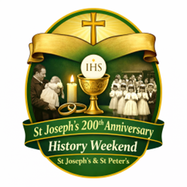
PLEASE COLLECT YOU TROCIARE BOXES

HISTORY WEEKEND: As we prepare to celebrate 200 years of St Joseph’s Church, we are organising a special History Weekend to honour the story of both St Joseph’s and St Peter’s. We warmly invite parishioners to share any photographs of parish life — Baptisms, First Confession, First Holy Communion, Confirmation, Weddings, visiting Priests or Bishops, School events, Parish Missions, or old photographs of the Churches. Please place photos in an envelope with: Your name, Contact number, Brief details of the photo. Photos can be left in the Sacristy or Parish Office by Friday the 20th March and will be carefully returned after the event. Help us celebrate the generations of faith that have shaped our parish.

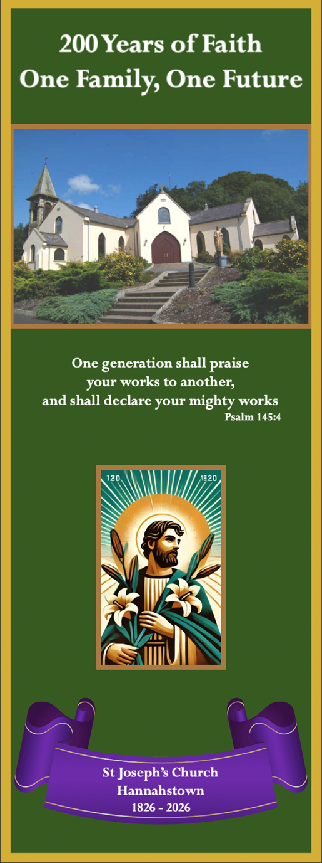
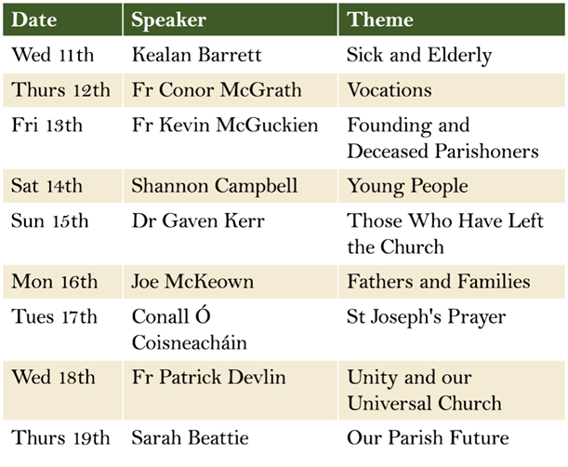
PARISH NOVENA TO ST JOSEPH:
Wednesday 11 March – Thursday 19 March Mass each evening at 7.00pm
St Joseph’s Church, Hannahstown

As part of our Bicentenary Celebrations, we warmly invite everyone in the parish and surrounding community to join us for a Nine-Day Novena to St Joseph.

This special time of prayer during Lent will be an opportunity to pause, reflect, and deepen our faith. Each evening Mass will include inspiring reflections and personal testimonies from special guest speakers and parishioners, enriched by the contribution of our talented parish musicians.
Each night of the novena will also be dedicated to a particular group or theme, offering perspectives that will challenge, inspire, and encourage us in our Christian faith.


Among those who will share with us during the novena are: Fr Kevin McGuckian, who will be warmly welcomed back to our parish. Dr Gaven Kerr, internationally renowned philosophy scholar and a native of our parish.

Shannon Campbell from the Queen’s University Chaplaincy, representing the faith and witness of the next generation of young Catholics.

Joe McKeown, who will share a powerful and moving personal testimony

For more than 200 years, St Joseph’s Church has been at the heart of our community — a place where generations have come to seek comfort in times of sorrow, and to celebrate the joyful moments of life in faith. Our Novena will conclude on the Feast of St Joseph (19 March), when we will consecrate the future of our Parish and its mission into the loving care of St Joseph. We encourage everyone to come along, pray together, and take part in this special moment in the life of our Parish. God bless.

D&C DIOCESE & HANNAHSTOWN & FAMILY OF PARISHES NEWS NWESNNEWS


‘BAPTISED AND SENT’
Pastoral Letter from Bishop Alan McGuckian SJ.
FEBRUARY 2026 (Available on Diocesian Website)


CEMENTRY SUNDAYS: – Invitation You are warmly invited to our Cemetery Sunday Masses, as we remember and pray for our loved ones. Sunday 31st May – St Joseph’s Sunday, 7th June – St Peter’s, Sunday 14th June – Tullyrusk All are most welcome.
“I am the resurrection and the life, says the Lord; whoever believes in me will live, even though they die.”
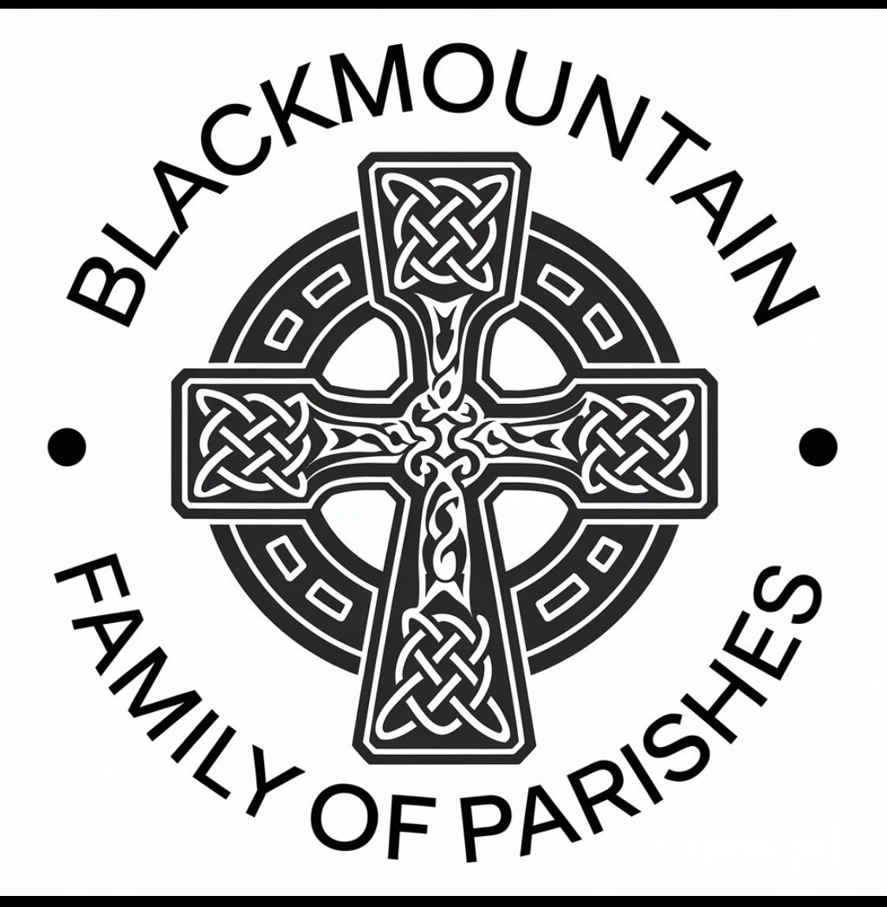
BLACK MOUNTAIN FAMILY OF PARISHES – WHAT DO YOU BELIEVE?
Informal courses about Christian faith and its relevance for life today. This LENT,
Black Mountain Family of Parishes are holding a 6-week series of presentations for those interested in learning more about the Catholic faith. All welcome! Wednesday 25th February at 7pm, in St Teresa’s Parish Centre, 135 Glen Road, Belfast. Call 02890 213122 leave your name and a contact number.

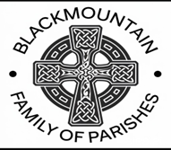
THIS SYCAMORE: – The Black Mountain Family of Parishes invite you to this event.
What Do You Believe? This Lent, the Black Mountain Family of Parishes invites you to a six-week Sycamore programme for anyone interested in learning more about the Catholic faith.
The programme begins on Wednesday 25 February 2026 at 7.00pm and will take place in
St Teresa’s Parish Centre, 135 Glen Road, Belfast BT11 8BL. All are very welcome.


LIGHTS, CAMERA, ACTION! – BBC Drama Time
Our Parish Church will be used as a filming location for the acclaimed BBC drama Time (starring actors such as Sean Bean and Stephen Graham).
Members of the congregation are invited to apply to be extras in the filming. If interested, please register with the casting company at:
https://www.theextrasdept.com/ A wonderful and unique moment in our bicentenary year — our parish moving from 200 years of history to prime-time television!
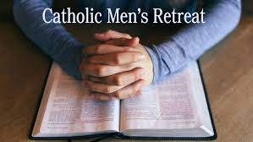
PARISH FOLK GROUP: We are hoping to further enhance congregational singing at our 11.30am Mass and would love to hear your suggestions. If there are any hymns you particularly enjoy or would like to hear at Mass, please let us know. If you are having a Mass celebrated for a loved one and there is a favourite hymn or piece of music that would mean something special to your family, we would be very happy to try to include it. Please speak to a member of the Folk Group after Mass or message Tina on 07746 620553. All suggestions are very welcome. If we do not already know the hymn, we will do our best to learn it for you.

CATHOLIC MENS RETREAT: Standing in the Breach - A morning retreat for Catholic men will take place at Portglenone Monastery on Saturday 14 March from 9am to 1pm. The theme will focus on spiritual warfare and remaining steadfast in faith during Lent, with a talk by Fr Martin Graham, along with testimonies from Catholic laity. The morning includes the Rosary, Holy Mass, and refreshments.

