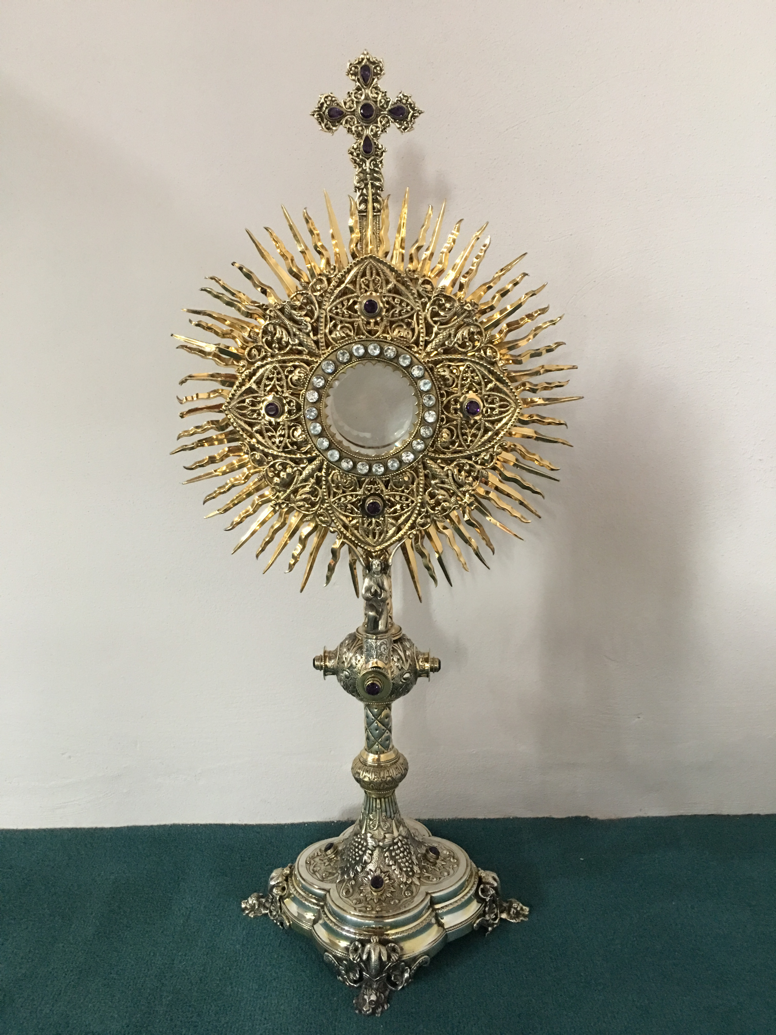
EUCHARISTIC ADORATION
The Parish of Hannahstown News
St Peter’s Church - Every Friday from 2 pm – 8.30 pm. Every evening Adoration & Prayer in St Peter’s Church 6.30 pm – 7.30 pm.
St Joseph’s Church Wednesdays during Lent from 9.45 am – 1.45 pm. You can join us in the Church or via the webcam. https://churchmedia.tv/st-josephs-church https://churchmedia.tv/st-peters-church-2
ANNIVERSARIES 7th April – Mairead & Barney Brannigan, Kathleen Brankin, Michael Hall, Sr. Sarah Jordan, Miles Ritchie Keenan (1st Anniversary), Gerard & Harry McGowan &
Pat McMahon RIP.
ANNIVERSARIES 14th April – Sean Bannon (1st Anniversary), Andy Finnegan, Hannah Jordan (1st Anniversary),
Geraldine McLarnon RIP
WEEKLY COLLECTIONS
08/04/2024 Weekly Collection £1028.01
08/04/2024 Easter Collection £1325.25
08/04/2024 Monthly Collection £ 785.75
Thank you to everyone for their generosity to the Parish.

BAPTISMS We recently welcomed babies Maeve Jayne Herron,
Danni Maria Kernan, Ted Jack McKee & Grace Nolláig McGuinness into our parish community.
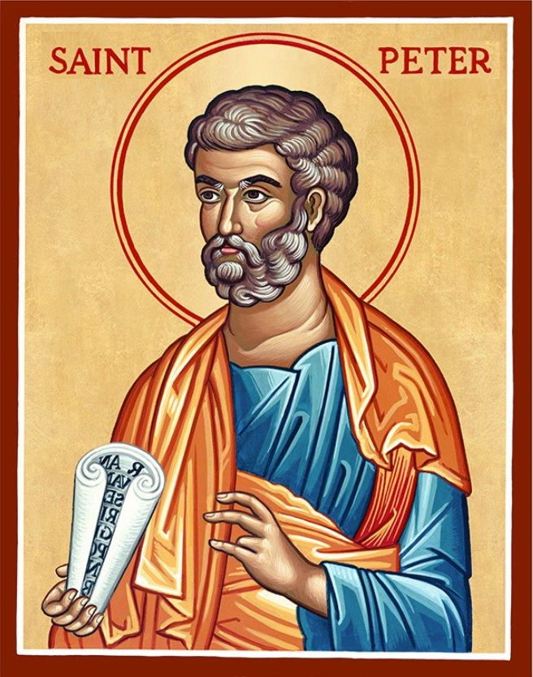
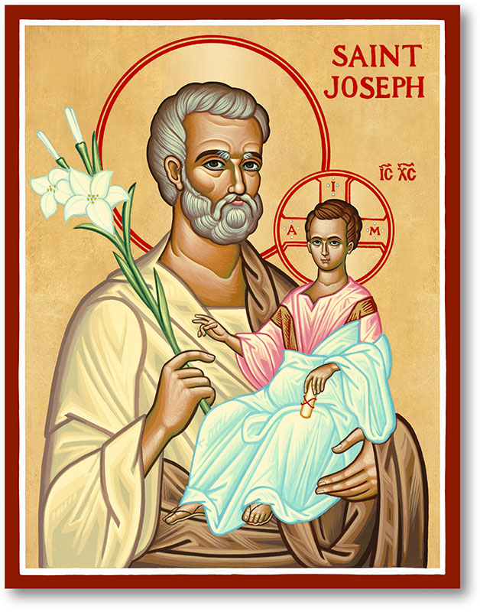
The Parish of Hannahstown
Saint Joseph’s and Saint Peter’s

14th April 2024
Third Sunday of Easter

Vicariate / Family of Parishes Emergency Sick Calls: 07549209775
Readings: Sunday Cycle B Weekdays Psalter Week
Monday 09:15 am (Prayer for Vocations) Saint Joseph’s.
Wednesday 09.15 am (Parish Novena to Our Lady) Saint Joseph’s
Thursday 09:15 am (Parish Novena to Our Lady) Saint Peter’s
Friday 09:15 am (Sacred Heart Prayer) Saint Joseph’s
Saturday 6:00 pm (Saint Michael the Archangel Prayer) SaintJoseph’s Sunday 10:00 am (Prayer for Pope’s Intentions) Saint Peter’s
Sunday 11:30 am (Saint Joseph Prayer) BSL Signed Mass Saint Joseph’s
Very Reverend Patrick Devlin Parish Priest,
Chaplain to the Deaf Community, Down and Connor Diocese
Chaplain to Antrim Area Hospital Thursday & Friday (Emergency calls)
(Fr. Patrick’s mobile…. For Spiritual and pastoral needs only, thank you) Tel: 07910 833699
Parish Secretary: Mrs Grainne McArevey Tel: 028 90614567
Parish Email: hannahstown@downandconnor.org
Parish Website: https://www.parishofhannahstown.com
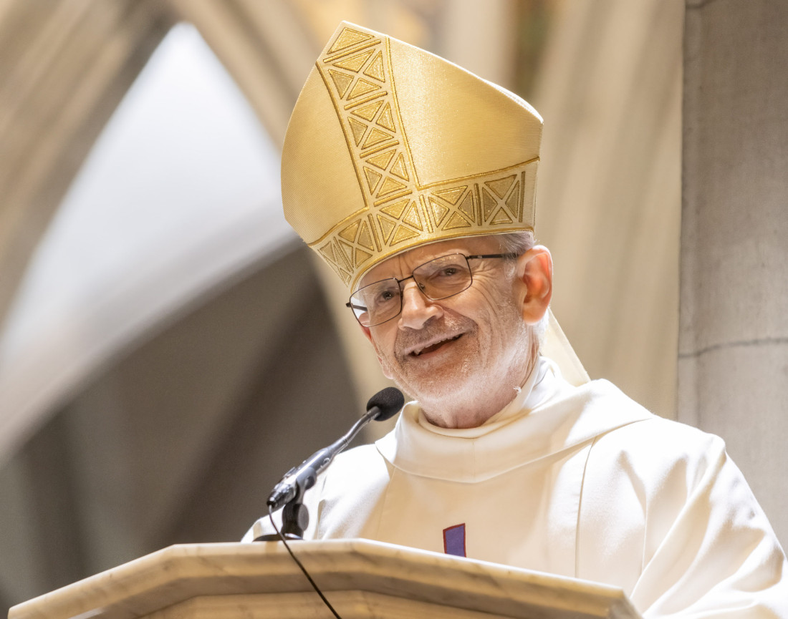
We celebrate the installation of our new Bishop Alan McGuckian

The installation of The Most Reverend Alan McGuckian SJ as Bishop of Down & Connor takes place today Sunday 14 April 2024 at St Peter’s Cathedral, Belfast.
As a parish we keep Bishop Alan in our prayers. May God Bless him and guide him to shepherd his flock in our Diocese and help bring us all closer to God and one another.
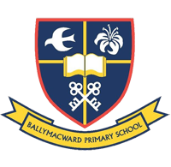
Our Parish School Ballymacward Primary School,
THE PARISH OF HANNAHSTOWN SCHOOLS
22 Rock Road, Stoneyford, Lisburn, Co Antrim, BT28 3SUTel: (028) 92648130, Principal: Mr Hugh Kennedy
Email: info@ballmacwardps.lisburn.ni.sch.uk

Pre-School Playgroup - Supervisor: Ms Sarah Scott. Tel: (028) 9264 8515
HANNAHSTOWN COMMUNITY HALL
Please contact Anthony Adams for any enquiries on 90 309795
Mon – Fri 10 am – 1 pm.
Monday – Coffee Morning after 9.15 am Mass, everyone welcome.

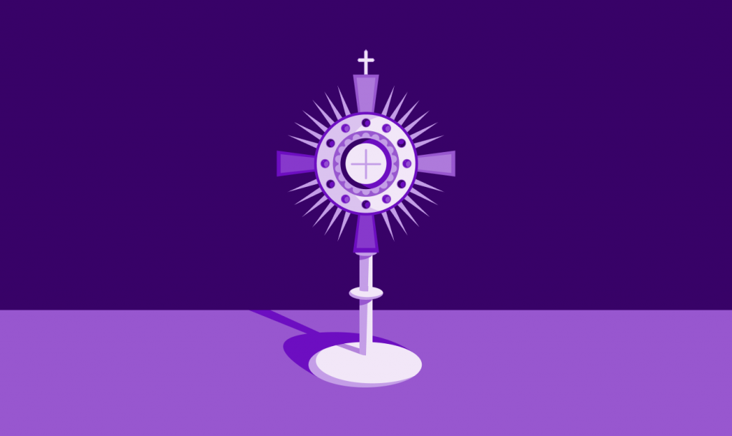
LIVING CHURCH / Family of Parishes
DIOCESAN HOLY HOUR FOR VOCATIONS SUNDAY – On the Vigil of the Feast of the Good Shepherd, a Holy Hour will be prayed before Jesus in the Blessed Sacrament in every Cathedral in Ireland for Vocation. Join us in St Peter’s Cathedral Belfast 20th April @ 5.30 pm for Vigil Mass for Vocations Sunday, & 6.30 pm Holy Hour for Diocesan Vocations.
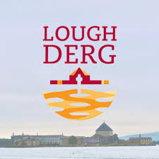
Lough Derg One Day Retreats in May - These guided days of prayer and reflection will take place on Sun5th, Mon6th, Sun12th, Tue14th, Sat18th, Sun25th and Mon27th. More details can be found at www.loughderg.ie. €45 per person, booking essential. The Lough Derg traditional Three Day Pilgrimage begins on Friday May 31st and continues until August 15th.
Spiritual and Pastoral Commitments: March 2024 - June 2024 Update
LIVING CHURCH / Family of Parishes
18th April 2024 Service of Light for Confirmation Saint Peter’s at 9:15 Mass
5th of May 2024, Parish School First Holy Communion, Saint Peter’s 10:00 am.
19th May 2024, Parish School Confirmations, Saint Peter’s 10:00 am
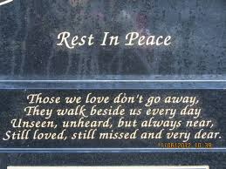
CEMETERY SUNDAY IN BELFAST CEMETERIES
Milltown (Service) Sunday 12th May @ 3 pm
City (Service) Sunday 19th May @ 3 pm
Hannahstown Parish……..
St Joseph’s (Mass) Sunday 26th May @ 3 pm
Tullyrusk (Mass) Sunday 16th June @ 1.30 pm
St Peter’s (Mass) Sunday 9th June @ 1.30 pm

BEGINNING EXPERIENCE - The loss of a partner through death, separation or divorce is devastating. Beginning Experience is offering a programme of bereavement support in St Bride’s Hall, Derryvolgie Ave., Belfast on three Saturdays (27th April, 25th May and 29th June 2024) Booking is essential. To find out more, contact Pauline at 07519289185 or Marie at 07896119669 or email belfastbe@yahoo.com
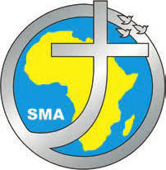
REFLECTION DAY - Reflection Day at SMA Dromantine. Saturday 4th May 9.30 am – 5.00 pm. Forgiveness; is the journey from hurt to healing, freedom, peace and happiness. Led by Fr. Des Corrigan SMA. Cost (incl. lunch) £38/€43. Tel 02830821964 email:dmin@dromantineconference.co

