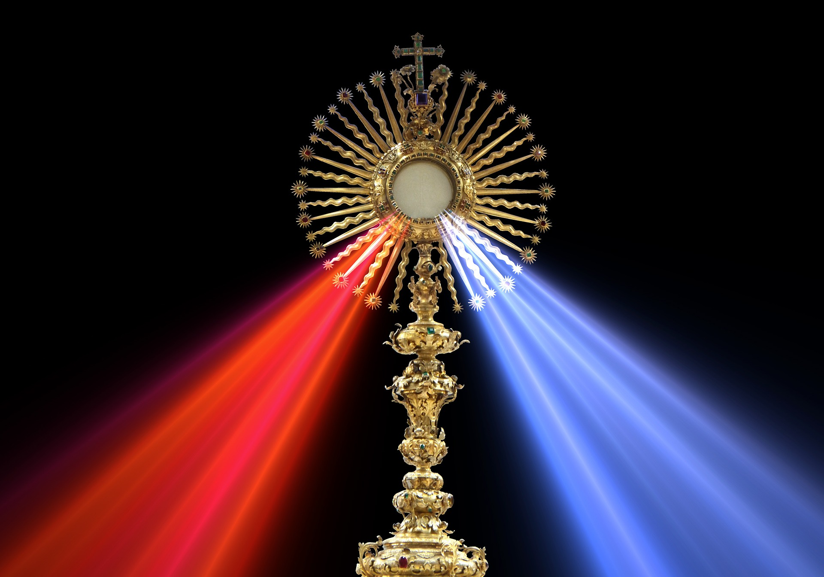
EUCHARISTIC ADORATION
THE PARISH OF HANNAHSTOWN
St Peter’s Church - Friday’s 2 pm – 8.30 pm.
Daily Adoration, Rosary & The Divine Mercy Chaplet St Peter’s Church 6.30 pm – 7.30 pm every evening. https://churchmedia.tv/st-peters-church-2
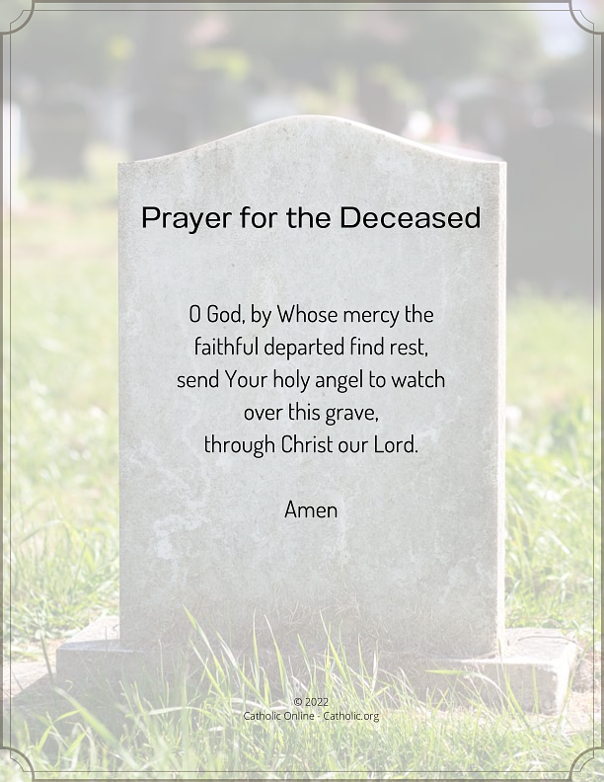
MONTH’S MIND – Liam Skelly RIP
ANNIVERSARIES – Elizabeth Campbell, Eileen Horner, Rosena Mulholland, Eileen Murray, Davy McGarry 30th Anniversary,
Annemarie Owens, Kathleen Owens,


WEEKLY COLLECTIONS
23/11/25 Weekly Collection £760.55

Thank you to everyone for their generosity to the Parish.

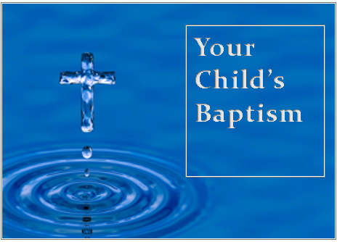
BAPTISMS
To arrange Baptisms, please present the long birth certificate to the parish office.

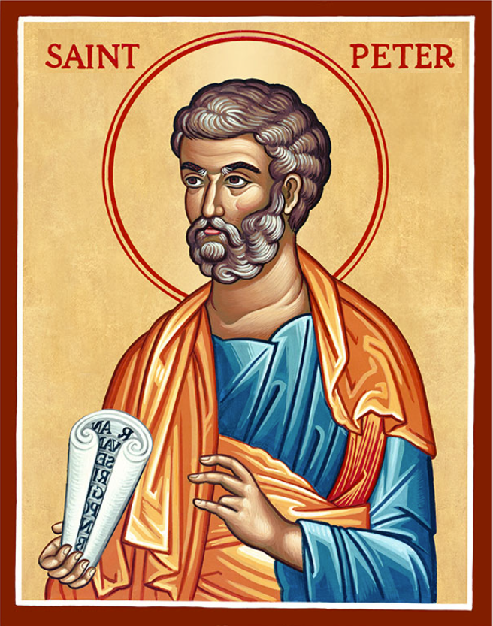
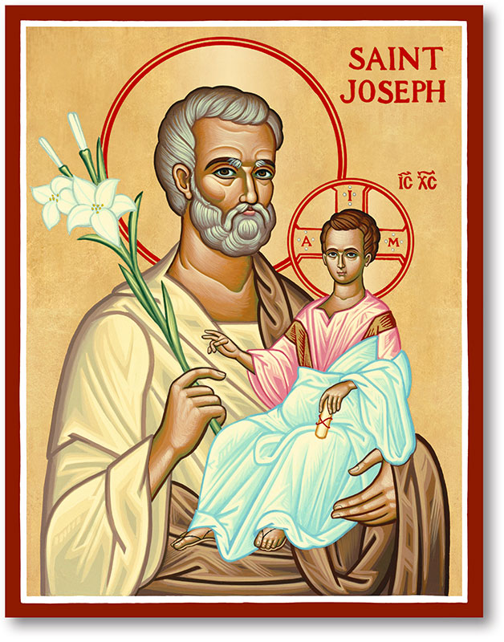
The Parish of Hannahstown
Saint Joseph’s and Saint Peter’s

23rd November 2025
Our Lord Jesus Christ, King of the universe
Family of Parishes Emergency Sick Calls: 07549209775
Monday | 9.15 am  12 noon | Praer for Vocations  Requiem Mass for Jackie Allingham | St Joseph’s
Tuesday |  | Fr Patrick Away
Wednesday | 9.15 am | Parish Novena to Our Lady | St Joseph’s
Thursday | 9.15 am | Parish Novena to Our Lady | St Peter’s
Friday | 9.15 am | Sacred Heart & St Michael’s Prayer | St Joseph’s
Saturday | 6.00 pm | Prayer of Hope, Jubilee 2025 | St Joseph’s
Sunday | 10.00 am | Prayer of Hope, Jubilee 2025 | St Peter’s
Sunday | 11.30 am | Prayer of Hope, Jubilee 2025 | St Joseph’s
Very Reverend Patrick Devlin, Parish Priest, Chaplain to the Deaf Community D & C
Chaplain to Antrim Area Hospital Thursday & Friday (Emergency calls)
Fr. Patrick, Spiritual and Pastoral needs only, Tel: 07910 833699. Parish Secretary Grainne McArevey 02890 614567
Email contact : hannahstown@downandconnor.org
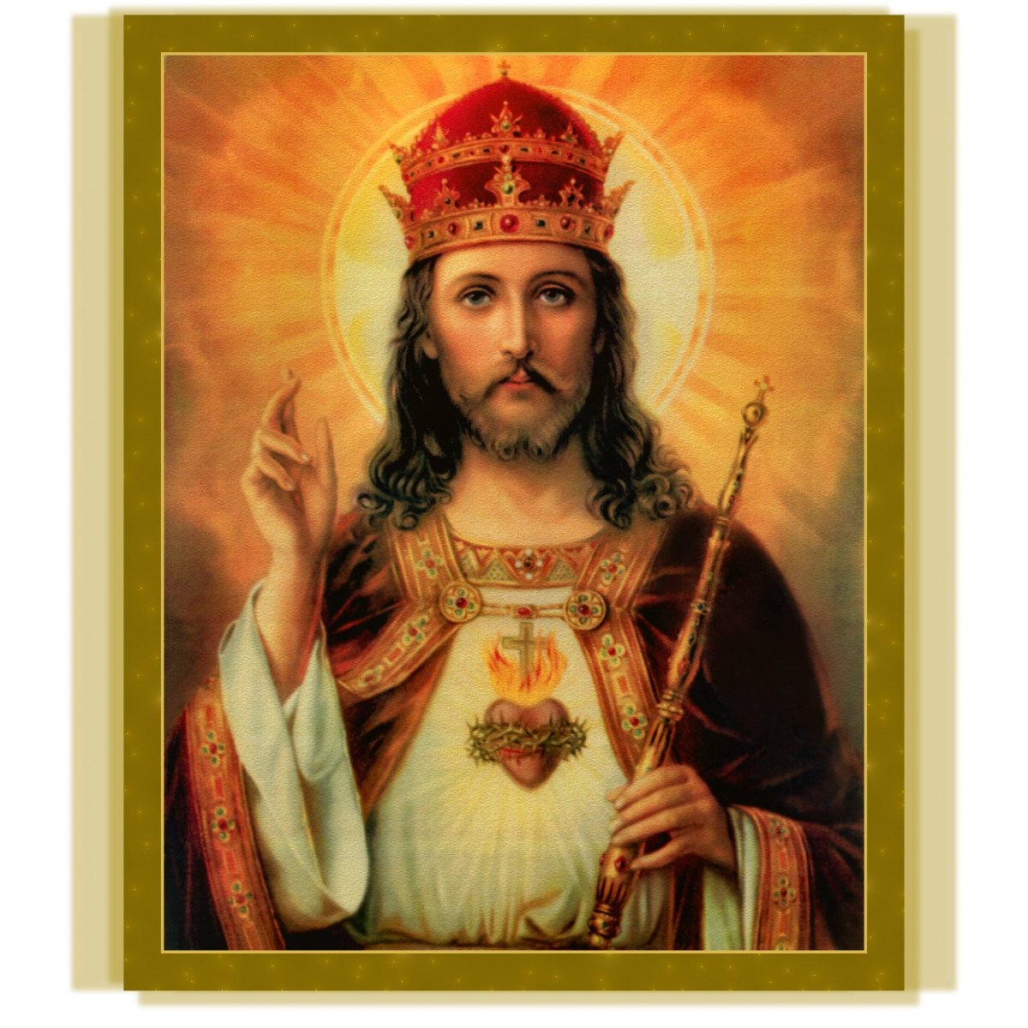
Christ The King
What is the Kingdom of God? What is the Kingdom of Christ the King?
The Kingdom of God is a space. It exists in every home where parents and children love each other. It exists in every region and country that cares for its weak and vulnerable. It exists in every parish that reaches out to the needy. The Kingdom of God is a time. It happens whenever someone feeds a hungry person, or shelters a homeless person, or shows care to a neglected person. It happens whenever we overturn an unjust law, or correct an injustice, or avert a war. It happens whenever people join in the struggle to overcome poverty, to erase ignorance, to pass on the Faith. The Kingdom of God is a condition. Its symptoms are love, justice, and peace. Jesus Christ is King!
We pray today that God may free all the world to rejoice in his peace, to glory in his justice, to live in his love.
Hannahstown Historical Society – Welcome all our parishioners to a night of Indian & Irish Culture. Saturday 6th December directly after our Vigil Mass in the Community Hall. Entrance is £5 per person, and this includes Indian Cuscine & Irish stew, Irish dance, Indian Bollywood dance and how to dress in a Sarah. We look forward to seeing you all.
HANNAHSTOWN PARISH / FAMILY OF PARISHES / PATHWAYS

Anam Cara, the organisation that supports bereaved parents, will hold its monthly Parent Support Evening on Monday 8th December at 7.30pm in the Crowne Plaza, Shaws Bridge, Belfast.

This event is free and open to all bereaved parents regardless of the age your child died, the circumstances of their death, or how recent their death was. You do not need to register in advance.

Recharge Young Adult Group - Advent Retreat

Aged 18-35? Join us this Advent to prepare well for Christmas but also for the future. Take some time to ask yourself: Where are you in life? Where are you going? Have you found your vocation? How can you live your vocation out more faithfully?

Saturday 13th December
10am-6pm
St Colmcille's Church, Belfast
Free Event - Register via Eventbrite

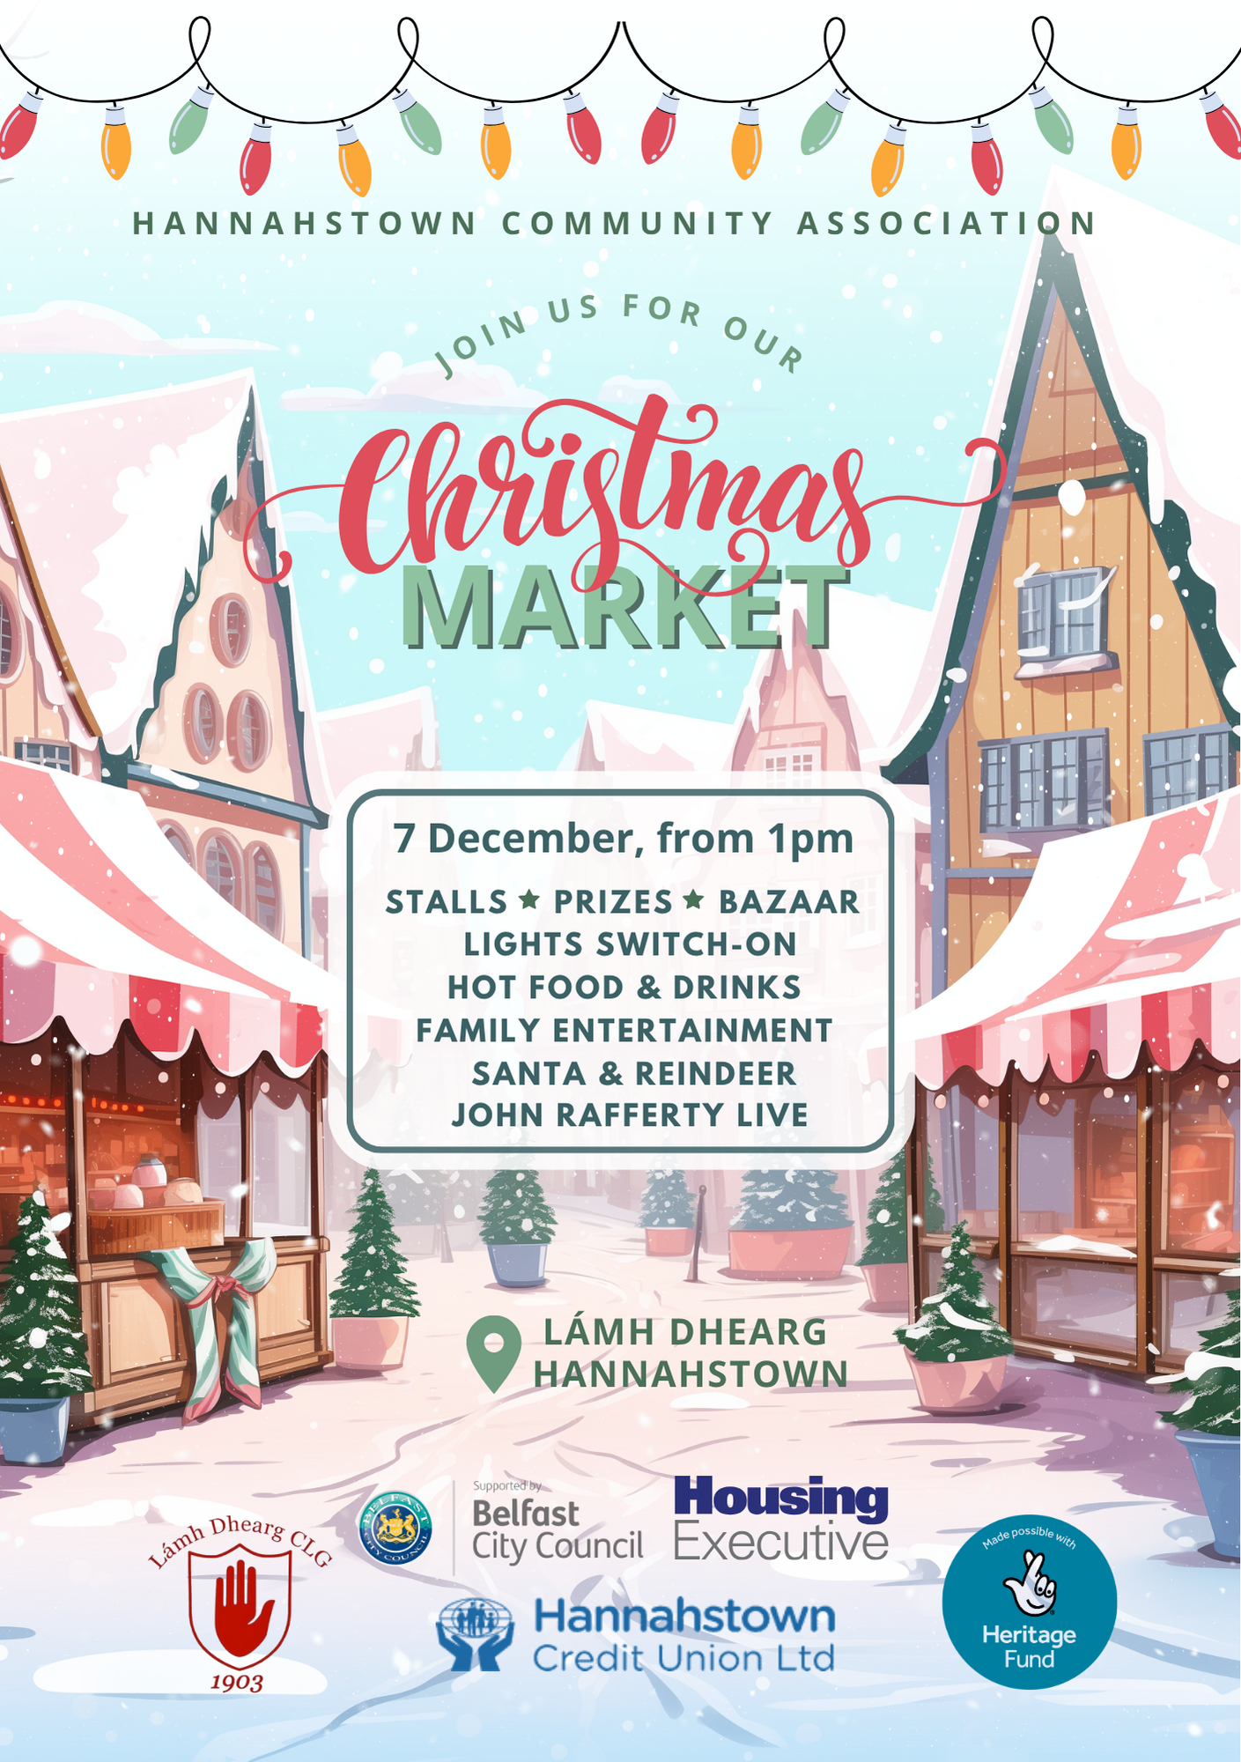
HANNAHSTOWN COMMUNITY HALL

