
EUCHARISTIC ADORATION
THE PARISH OF HANNAHSTOWN
St Peter’s Church - Friday’s 2 pm – 8.30 pm.
Daily Adoration, Rosary & The Divine Mercy Chaplet St Peter’s Church 6.30 pm – 7.30 pm every evening. https://churchmedia.tv/st-peters-church-2
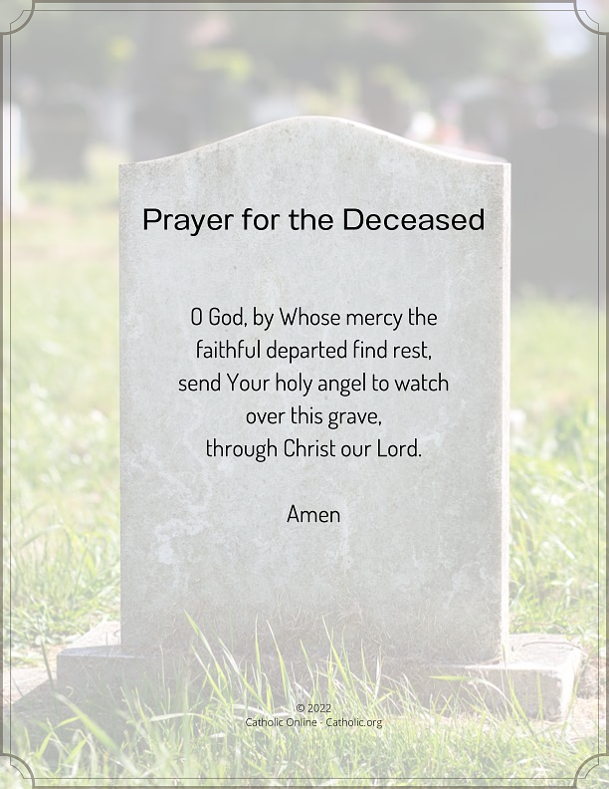
RECENTLY DECEASED – Tess Mc Cullough RIP
MONTH’S MIND Maeve McPeake RIP
ANNIVERSARIES – Frank Donnelly, Paddy McKenna, Martin McQuillan, Patricia (Paddy) O’Neill,
Paul Toland
Please remember to visit Fr. Patrick in the Sacristy before Mass starts if it is Intended for your loved one.


WEEKLY COLLECTIONS
13/10/25 Weekly Collection £649.96
13/10/25 Building Collection £503.90
Thank you to everyone for their generosity to the Parish.

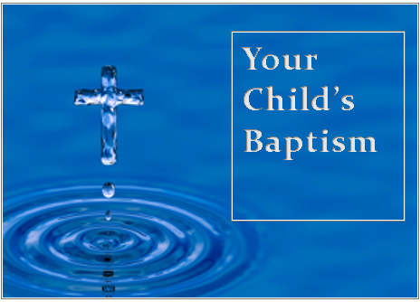
BAPTISMS
To arrange Baptisms please present the long birth certificate to the parish office.

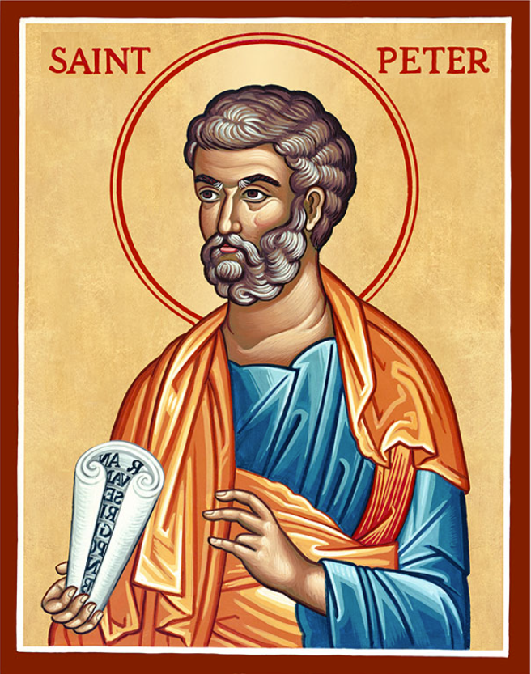
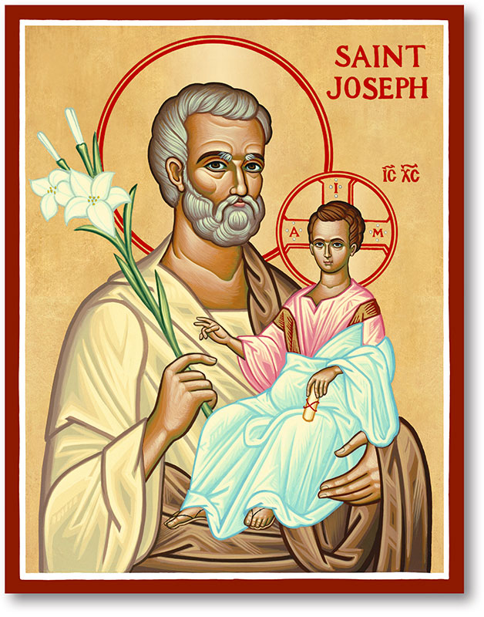
The Parish of Hannahstown
Saint Joseph’s and Saint Peter’s

20th October 2025
29th Sunday in Ordinary Time
Family of Parishes Emergency Sick Calls: 07549209775
Monday 9.15 am Prayer for Vocations Saint Joseph’s
Tuesday 630pm We welcome singers from the Philippines to a evening of singing..please come shortly before
no tickets needed….(collection to help with their costs during)
Wednesday 9.15 am Parish Novena to Our Lady Saint Joseph’s
Thursday 9.15 am Parish novena to Our Lady Saint Peter’s
Friday 9.15 am Sacred Heart and St Michael’s Prayer Saint Joseph’s
Saturday 6:00 pm Prayer of Hope, Jubilee 2025 Saint Joseph’s
Sunday 10:00 am Prayer of Hope, Jubilee 2025 Saint Peter’s
Sunday 11:30 am Prayer of Hope, Jubilee 2025 BSL Signed Saint Joseph’s
Very Reverend Patrick Devlin, Parish Priest,
Chaplain to the Deaf Community, Down and Connor Diocese
Chaplain to Antrim Area Hospital Thursday & Friday (Emergency calls)
Fr. Patrick, for Spiritual and Pastoral needs only, thank you Tel: 07910 833699
Parish Secretary: Mrs Grainne McArevey Tel: 028 90614567
Parish Email: hannahstown@downandconnor.org Parish Website: https://www.parishofhannahstown.com
MISSION SUNDAY

Transcript of the Holy Father's Appeal for World Mission Sunday 2025
Dear Brothers and Sisters, On World Mission Sunday every year, the whole Church prays, united, particularly for missionaries and the fruitfulness of their apostolic labors.
When I served as a missionary priest and then bishop in Peru, I saw first-hand how the faith, the prayer and the generosity shown on World Mission Sunday can transform entire communities. I urge every Catholic parish in the world to take part in World Mission Sunday. Your prayers, your support will help spread the Gospel, provide for pastoral and catechetical programs, help to build new churches, and care for the health and educational needs of our brothers and sisters in mission territories. This October 19th, as we reflect together on our baptismal call to be "missionaries of hope among the peoples," let us commit ourselves anew to the sweet and joyful task of bringing Christ Jesus our Hope to the ends of the earth. Thank you for everything you will do to help me help missionaries throughout the world. God bless you all!
MISSION SUNDAY – This is a time for the faithful of the world to show their appreciation towards the work of overseas missionaries. Missio Ireland have left envlopes in the Church porch, please give generously. Your contribution will go towards the work of the Pontifical Mission Societies, who are based in Dublin. Alternatively you can call Missio Ireland on (01) 497 2035 or visit www.missio.ie for further information. Many thanks for your support.
HANNAHSTOWN PARISH / FAMILY OF PARISHES / PATHWAYS

KNOCK PILGRIMAGE – There is a one day Pilgrimage to Knock on the Feast of All Souls, Sunday 2nd November 2025. Departs St Agnes Church at 7.30 am. Price £26 (includes Tea & Scone). For further information contact Pat on 07946917354 or Harriet on 07812098991.
FROM LAMENT TO LIBERTION - In Conversation with Rev. Ashraf Tannous of the Lutheran Christmas Church in Bethlehem, Tuesday, 21 October at 7.30pm in Knock Methodist Church (Belfast, BT5 6HS). Come and hear Rev. Ashraf’s Palestinian Christian perspective in light of October 7th, 2023, the genocide in Gaza these past two years, settlement expansion and annexations in the West Bank, and the recent ceasefire and peace plan. All are welcome. Organised by Kairos Ireland.

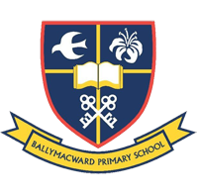
Available for Our Parish School Ballymacward Primary School,
THE PARISH OF HANNAHSTOWN SCHOOL
COMMUNITY PRE-SCHOOL PLAYGROUP
22 Rock Road, Stoneyford, Lisburn, Co Antrim, BT28 3SUTel: (028) 92648130, Principal: Mr Hugh Kennedy
Email: info@ballmacwardps.lisburn.ni.sch.uk

Pre-School Community Playgroup – Supervisor: Ms Sarah Scott. 02892648515
Please contact Anthony Adams for any enquiries on 90 309795.
HANNAHSTOWN COMMUNITY HALL
Mon – Fri 10 am – 1 pm.
Mondays – Coffee Morning after 9.15 am Mass.
Wednesdays – Seniors Group after 9.15 am Mass.
Please come along to our popular coffee morning or our seniors group, an opportunity to meet with fellow parishioners for some company and good craic.
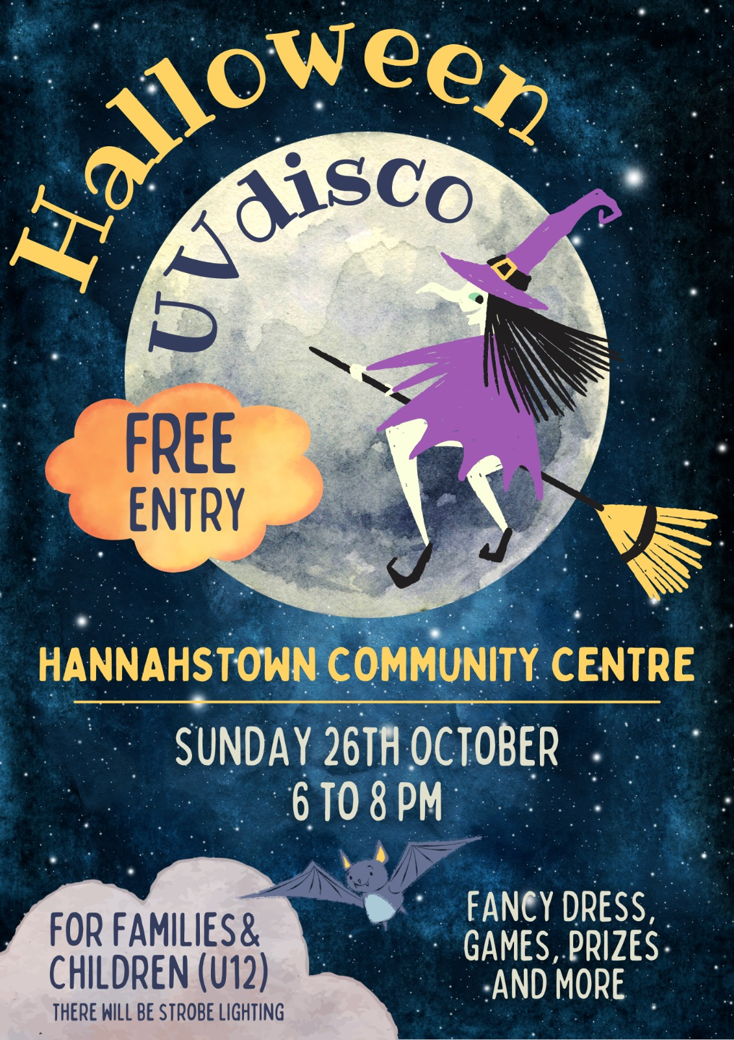
Halloween Disco Fun

For families & young children with free entry for all on Sunday 26th October
We look forward to seeing you for a night of fancy dress, games & prizes.

NOTICE TO ALL PARISH DRAW MEMBERS & PROMOTERS
You are invited to attend our AGM in the Hannahstown Community Hall on Wednesday, 22nd October at 7 pm. We encourage as many promoters as possible to come along. Please come also if you are a parish draw member or would like to become a promoter.
We have many older promoters who need help with collections and your efforts would be very much appreciated.
Please note all parish draw money is now due for 2024 – 2025, You could pay at the AGM or call to the parish office to make a payment if you have not been contacted by your usual promoter. You can also make a BACS Transfer to Danske Bank: Sort Code 95 01 03 Account 00325821, Give your full name as a reference. Many Thanks for the fantastic support you give our parish, we are very grateful.
HANNAHSTOWN ASSOCIATION AGM

Our Annual General Meeting will be held on Monday 10th November at 7 pm in the Community Hall. We look forward to seeing you. (upstairs room).

