
EUCHARISTIC ADORATION
THE PARISH OF HANNAHSTOWN
St Peter’s Church - Friday’s 2 pm – 8.30 pm.
Daily Adoration, Rosary & The Divine Mercy Chaplet St Peter’s Church 6.30 pm – 7.30 pm every evening. https://churchmedia.tv/st-peters-church-2
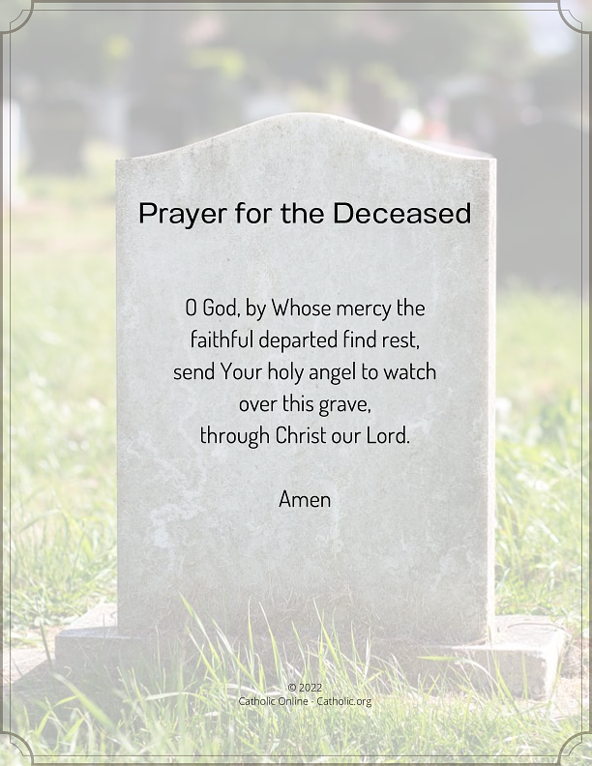
RECENTLY DECEASED – John Allingham RIP
ANNIVERSARIES –
Jim Mulholland 50th Anniverdary,
Mairead O’Hare 1st Anniversary
Patrick Prior, RIP


WEEKLY COLLECTIONS
09/11/25 Weekly Collection £854.16
09/11/25 Building Collection £440.32
Thank you to everyone for their generosity to the Parish.

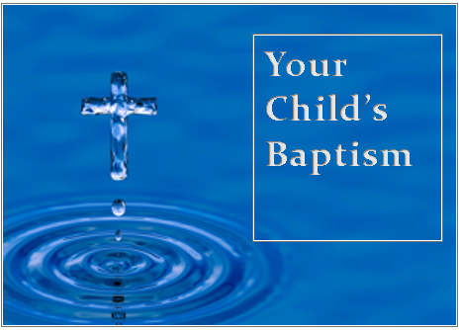
BAPTISMS
To arrange Baptisms, please present the long birth certificate to the parish office.
We welcome Saoirse McManus, Maddison Maguir into our parish family, who was recently baptised in St Peter’s Church.
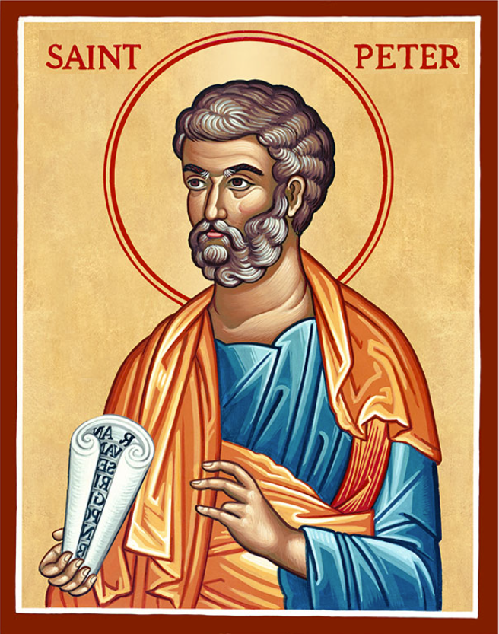
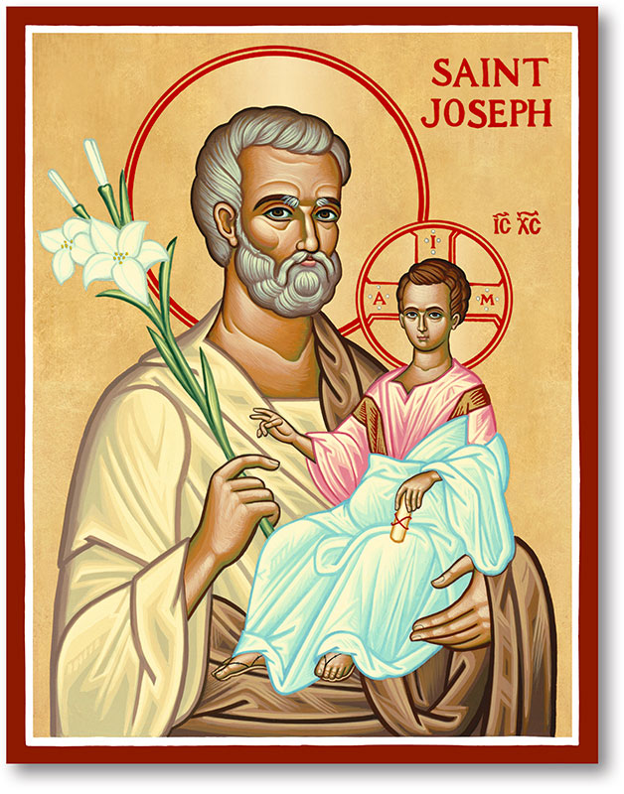
The Parish of Hannahstown
Saint Joseph’s and Saint Peter’s

16th November 2025
World Day of the Poor
Family of Parishes Emergency Sick Calls: 07549209775
Monday | 9.15 am  12 noon | Praer for Vocations  Requiem Mass for Jackie Allingham | St Joseph’s
Tuesday |  | Fr Patricks Day Off
Wednesday | 9.15 am | Parish Novena to Our Lady | St Joseph’s
Thursday | 9.15 am | Parish Novena to Our Lady | St Peter’s
Friday | 9.15 am | Sacred Heart & St Michael’s Prayer | St Joseph’s
Saturday | 6.00 pm | Prayer of Hope, Jubilee 2025 | St Joseph’s
Sunday | 10.00 am | Prayer of Hope, Jubilee 2025 | St Peter’s
Sunday | 11.30 am | Prayer of Hope, Jubilee 2025 | St Joseph’s
Very Reverend Patrick Devlin, Parish Priest, Chaplain to the Deaf Community D & C
Chaplain to Antrim Area Hospital Thursday & Friday (Emergency calls)
Fr. Patrick, Spiritual and Pastoral needs only, Tel: 07910 833699. Parish Secretary Grainne McArevey 02890 614567

WORLD DAY OF THE POOR
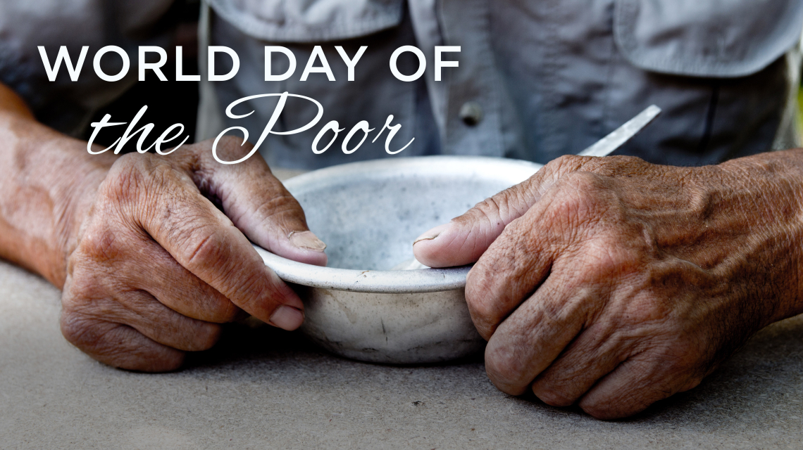
Fill us with peace, that we may live as brothers and sisters, harming no one. O God of the poor, help us to rescue the abandoned and forgotten of this earth, so precious in your eyes. Bring healing to our lives, that we may protect the world and not prey on it, that we may sow beauty, not pollution and destruction. Amen


HANNAHSTOWN PARISH / FAMILY OF PARISHES / PATHWAYS
Trócaire School Volunteers Notice - Are you a retired teacher or someone who has experience presenting to groups of school children? Trócaire is looking for volunteers to support our School Talks Programme for Lent 2026 in the Down and Connor Diocese. For more information call Fionnuala on 028 9080 8033 or email: fionnuala.mcguinness@trocaire.org


STELLA MARIS - Stella Maris a Catholic seafaring charity is looking for volunteers across Northern Ireland. Volunteering comes in many forms at Stella Maris but in the first instance we are looking for anyone who can knit woolly hats, an essential and welcome piece of clothing for seafarers. We also need parish contacts who could speak at the Mass (parish priest discretion) or simply lay out information in regard to the charity in the church. Further to this, ship visitors are also required to assist the port chaplain. For further information or if you are interested, please contact peter.mullen@stellamarismail.org. Thank you.
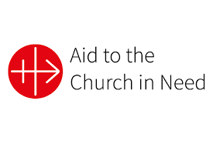
AID TO THE CHURCH IN NEED – Red Wednesday 19th November 2025. More Christians have been killed because of their faith in Christ in the las century than the previous 1,900 years of Christian history. Join us in standing with them in prayerful solidarity. This Red Wednesday, CAN invites you to wear something red, light a red candle in your window and pray for their welfare. acnireland.org.
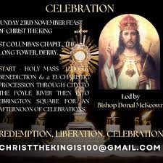
CHRIST THE KING – Sunday November 23rd, Feast of Christ The King. St Columbas Church, Derry 12 noon. Benediction & Eucharistic Procession through City to The Foyle River then into Ebrington Square for an afternoon of celebrations. Led by Bishop Donal McKeown. Christthekingis100gmail.com for further information. Our parish has a bus leaving next Sunday at 10.30 am from St Joseph’s Church. Limited places available.

Our Parish School Ballymacward Primary School
THE PARISH OF HANNAHSTOWN SCHOOL
COMMUNITY PRE-SCHOOL PLAYGROUP
22 Rock Road, Stoneyford, Lisburn, Co Antrim, BT28 3SU
Tel: (028) 92648130
Principal: Mr Hugh Kennedy
Email: info@ballmacwardps.lisburn.ni.sch.uk

Our Pre-School Community Playgroup
Supervisor: Ms Sarah Scott. 02892648515
HANNAHSTOWN COMMUNITY HALL

Please contact Anthony Adams for any enquiries on 90 309795. Mon – Fri 10 am – 1 pm.

Mondays – Coffee Morning after 9.15 am Mass.
Please join us for refreshements & chats


Wednesdays – Seniors Group after 9.15 am Mass.
A lovely morning to connect and share things we love to do.


HANNAHSTOWN COMMUNITY ASSOCIATION
Christmas Market - 7th December, from 1 pm

Stalls, Prizes, Bazaar, Lights switch-on, Hot food & drinks
Santa & Reindeer & John Rafferty live

See posters in Church porch for further info.

