
EUCHARISTIC ADORATION
THE PARISH OF HANNAHSTOWN
St Peter’s Church - Friday’s 2 pm – 8.30 pm.
St Peter’s Church Daily 6.30 pm – 7.30 pm with
Adoration, Rosary & The Divine Mercy Chaplet.
https://churchmedia.tv/st-peters-church-2
St Joseph’s Church – Friday’s 3 pm – 4 pm with Adoration & Divine Mercy Chaplet.
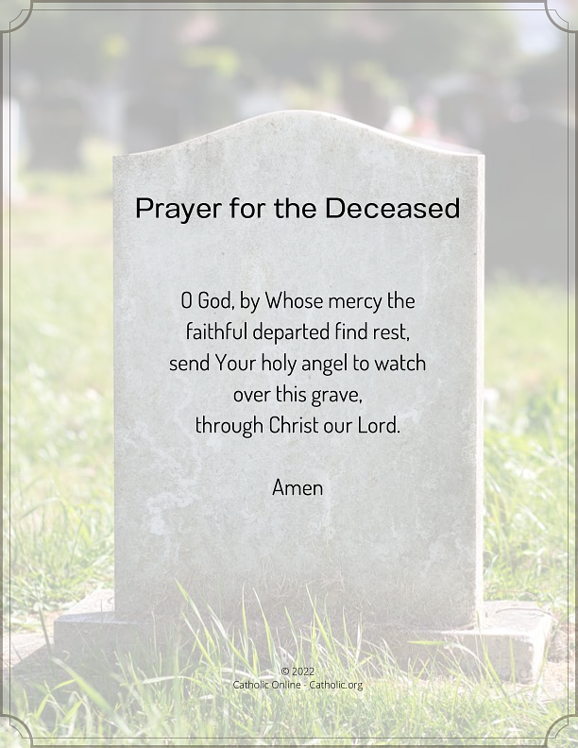
RECENTLY DECEASED –
Mary Cunningham RIP


WEEKLY COLLECTIONS
22/02/26 Weekly Collection £915.58
Thank you to everyone for their generosity to the Parish.


BAPTISMS
Baptisms are upon request and you must visit the parish office to book one. Please bring with you a copy of the baby’s long birth certificate.

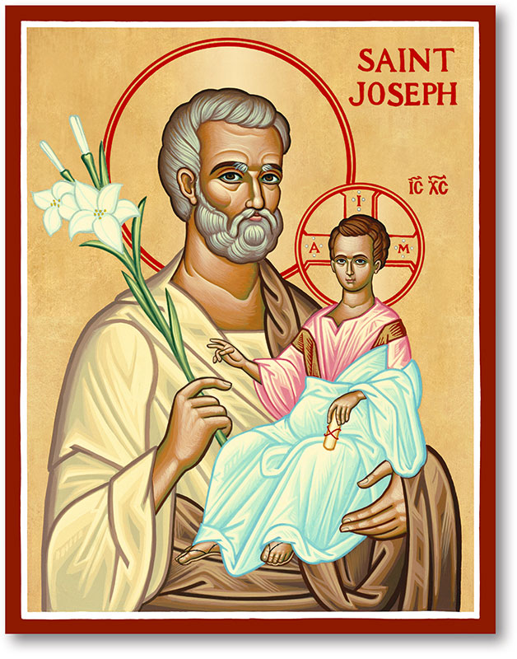
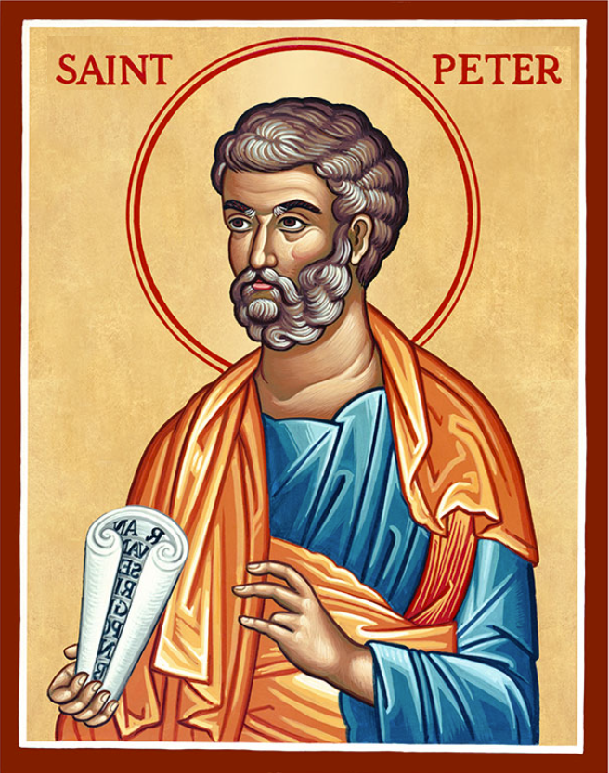
The Parish of Hannahstown
Saint Joseph’s and Saint Peter’s

1st March 2026
SECOND SUNDAY OF LENT

Family of Parishes Emergency Sick Calls: 07549209775
Monday | 9.15 am | Prayer for Vocations  Coffee morning in Hannahstown Community Hall afterwards. | St Joseph’s
Tuesday |  | Fr Patrick Away
Wednesday | 9.15 am | Parish Novena to Our Lady  Seniors group in Hannahstown Community Hall afterwards. | St Joseph’s
Thursday | 9.15 am | Parish Novena to Our Lady | St Peter’s
Friday | 9.15 am | Sacred Heart & St Michael’s Prayer | St Joseph’s
Saturday | 6.00 pm | Prayer of Hope, Jubilee 2025 | St Joseph’s
Sunday | 10.00 am | Prayer of Hope, Jubilee 2025 | St Peter’s
Sunday | 11.30 am | Prayer of Hope, Jubilee 2025 | St Joseph’s
Very Reverend Patrick Devlin, Parish Priest, Chaplain to the
Deaf Community Down & Connor.
Chaplain to Antrim Hospital Thursday & Friday (Emergency calls)
Fr. Patrick, Spiritual and Pastoral needs only, Tel: 07910 833699.
Parish Secretary Grainne McArevey 02890 614567
Email address: hannahstown@downandconnor.org Website: parishofhannahstown.com
SECOND SUNDAY OF LENT

CONFIRMATION 2026
Today we welcome Ella, Emily, Eva, James Michael and Sophie, to receive their gifts from the Holy Spirit.
We ask that they are strengthened and Blessed and that the Holy Spirit touches the hearts of their families and all of our parishioners. Make each of us an instrument of God’s Love. Amen

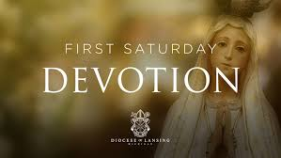
FIRST SATURDAY DEVOTIOTIONS
HANNAHSTOWN PARISH / FAMILY OF PARISHES / PATHWAYS
First Saturday Devotions will take place in St. Matthias’s Church, Glen Road on 7th March.
3.00 p.m. Adoration of the Blessed Sacrament, Confessions and Act of Consecration., Rosary and Divine Mercy Chaplet
4.00 p.m. Holy Sacrifice of the Mass
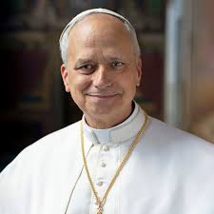
POPE LEO’S MONTHLY INTENTION
For disarmament and peace: Let us pray that nations move toward effective disarmament, particularly nuclear disarmament, and that world leaders choose the path of dialogue and diplomacy instead of violence.

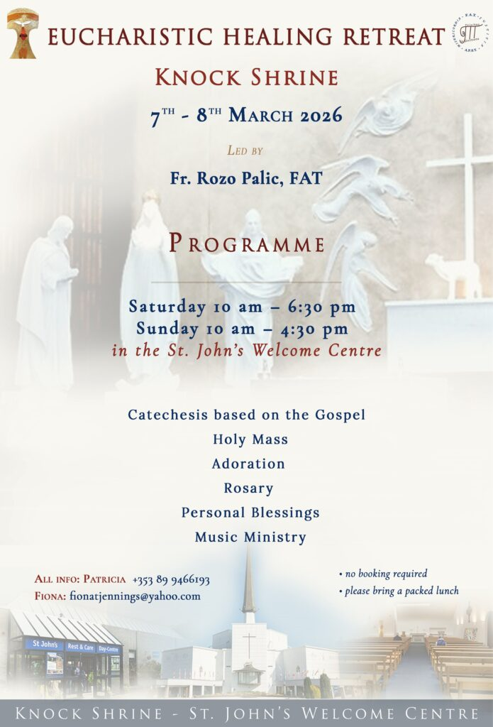
EUCHARISTIC HEALING RETREAT – KNOCK SHRINE
led by gifted Croatian Priest, Fr Rozo Palic Saturday March 7th & Sunday March 8th. Venue: St. John's Welcome Centre; Saturday 10:00 am - 6:30 pm & Sunday 10:00 am - 4:30 pm. He will be supported by his Croatian Music Ministry team; no prior booking required; everyone is most welcome and please bring a packed lunch. For further enquires please contact, Patricia on 089 9466193 or Fiona on fionatjennings@yahoo.com.

Encounter to Mission –
Parish Cells Ireland will be holding its National Seminar on the 28th and 29th of March this year at Drumalis Retreat Centre, Larne. Our theme will be From Encounter to Mission. Whether you are a Cell member or non-Cell member, this invitation is open to all parishioners as we explore our call to be witnesses for Christ. For enquiries please contact: Margaret Webb. Tel. 07779 729505. Email: magswebb1@gmail.com Anne McFerran. Tel. 078099 06792. Email: anne.mcferran@gmail.com Information is also available on posters and flyers available in the Church. For accommodation/catering bookings contact Drumalis Retreat Centre on 028 2827 2196.
HANNAHSTOWN PARISH / FAMILY OF PARISHES


Our Parish School
HANNAHSTOWN PARISH / FAMILY OF PARISHES
Ballymacward Primary School,
22 Rock Road, Stoneyford, Lisburn, Co Antrim, BT28 3SUTel: (028) 92648130, Principal: Mr Hugh Kennedy
Email: info@ballmacwardps.lisburn.ni.sch.uk
Ballymacward Community Pre-School Playgroup - Supervisor: Ms Sarah Scott. Tel: (028) 9264 8515

CONGRATUALTIONS TO ALL OUR CONFIRMATION CHILDREN TODAY

