
WEEKLY COLLECTIONS
THE PARISH OF HANNAHSTOWN
01/02/26 Weekly Collection £856.31 01/02/26 Monthly Collection £669.53
Collectors and Counting, Norms/ Application Form available on parish website
Thank you to everyone for their generosity to the Parish.
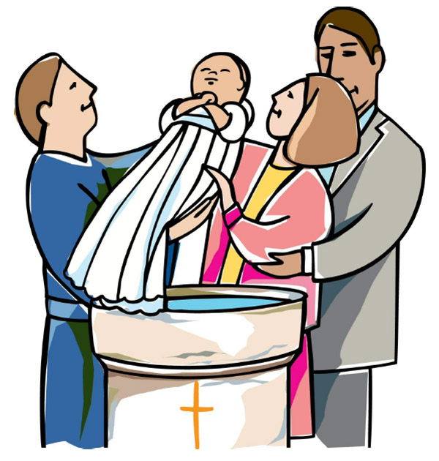
BAPTISMS DIOCESIAN AND PARISH NORMS
Baptisms are upon request and you must visit the parish office to book one. Please bring with you a copy of the baby’s long birth certificate.
Parents or guardians who wish to have a child baptised are warmly invited to contact the parish office. As part of the normal process for all baptism requests, parents will be asked to complete a short form confirming whether any other person holds parental responsibility for the child and that they are aware of the request for baptism and have raised no objection. This single procedure applies to every family and is required in line with diocesan guidance and civil law.

CONSIDERING MARRIAGE?
“Above all, let your love for one another be intense.” (1 Peter 4:8)
We would be delighted to welcome couples to meet, view the church, and arrange their wedding. Please contact Parish Office

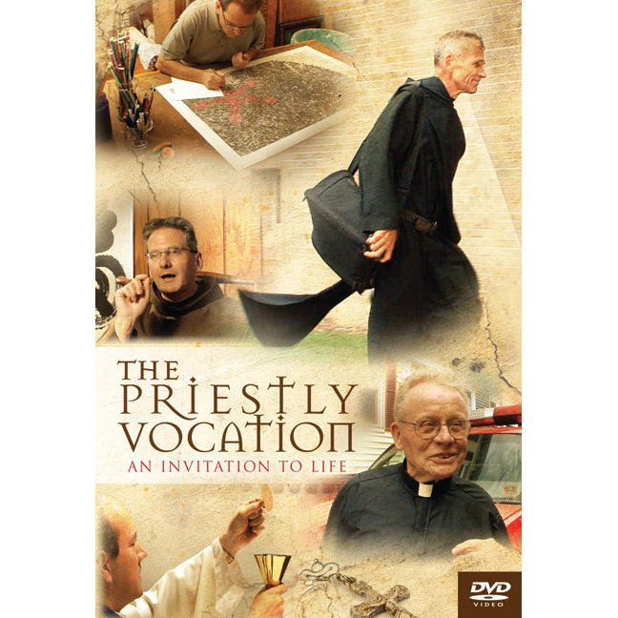
VOCATION TO PRIESTHOOD
St Agnes’ Parish, Belfast Music Ministry by DCF
Youth Gathering Novena to Our Lady of Lourdes
Sunday 8th Feb 7- 8:00pm
Fr Conor McGrath Vocation Director

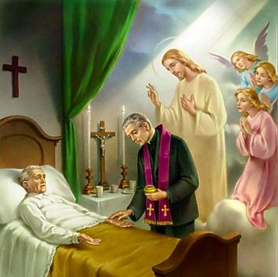
PASTORAL VISIT TO THE SICK AND HOUSEBOUND
“The Lord is close to the broken-hearted.” (Psalm 34:18)
Families are encouraged to let us know if a loved one is housebound and would welcome a visit from the priest or the sacraments.


SAFEGUARDING IN OUR PARISH “Let the little ones come to me.” (Mark 10:14)
We are pleased to share that diocesan safeguarding requirements for 2026 have now been completed, helping ensure our parish remains a safe, respectful, and caring community.
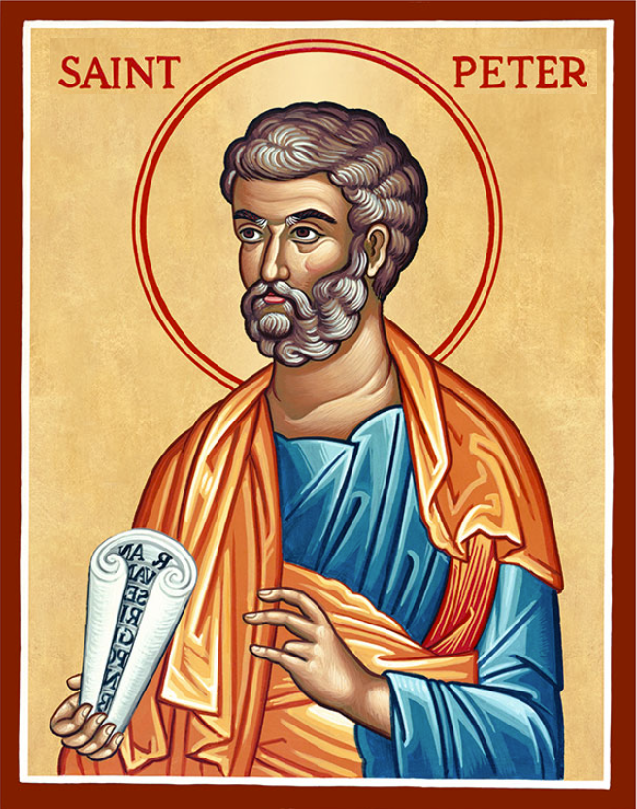
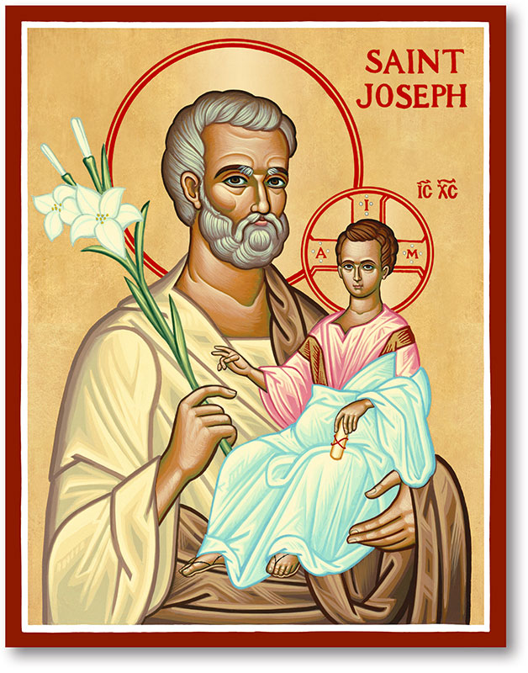
The Parish of Hannahstown
Saint Joseph’s and Saint Peter’s

8th February 2026

Family of Parishes Emergency Sick Calls: 07549209775
Monday | 9.15 am | Prayer for Vocations  Coffee morning. Hannahstown Community Hall afterwards. | St Joseph’s
Tuesday |  | Fr Patrick Away
Wednesday | 9.15 am | Parish Novena to Our Lady  Seniors group in Hannahstown Community Hall afterwards. | St Joseph’s
Thursday | 9.15 am | Parish Novena to Our Lady | St Peter’s
Friday | 9.15 am | Sacred Heart | St Joseph’s
Saturday | 6.00 pm | The Angelus | St Joseph’s
Sunday | 10.00 am | Prayer to St Peter | St Peter’s
Sunday | 11.30 am | Prayer to St Joseph | St Joseph’s
Very Reverend Patrick Devlin, Parish Priest.
Chaplain to the Deaf Community Down & Connor.
Chaplain to Antrim Hospital Thursday & Friday (Emergency Calls)
Please contact Fr. Patrick for Spiritual and Pastoral needs only, Tel: 07910 833699.
Parish Secretary Grainne McArevey 02890 614567
Email address: hannahstown@downandconnor.org Website: parishofhannahstown.com

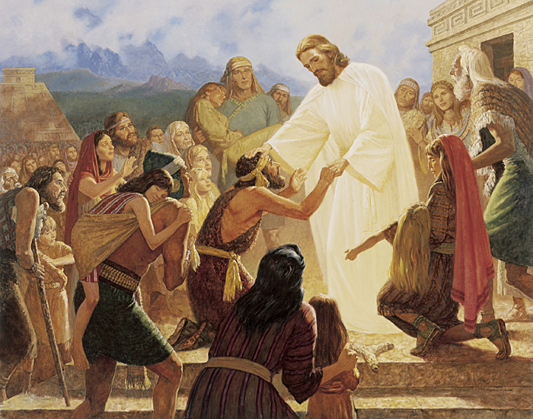
5th Sunday in Ordinary Time Year ‘A Life on Earth is Short’. The demands of our Christian life may not always be easy, but we know that if we live up to them, we are other Christs. We are continuing his great work by our own good example to our neighbour, and we are giving glory to God, and are earning for ourselves the eternal light of heaven.

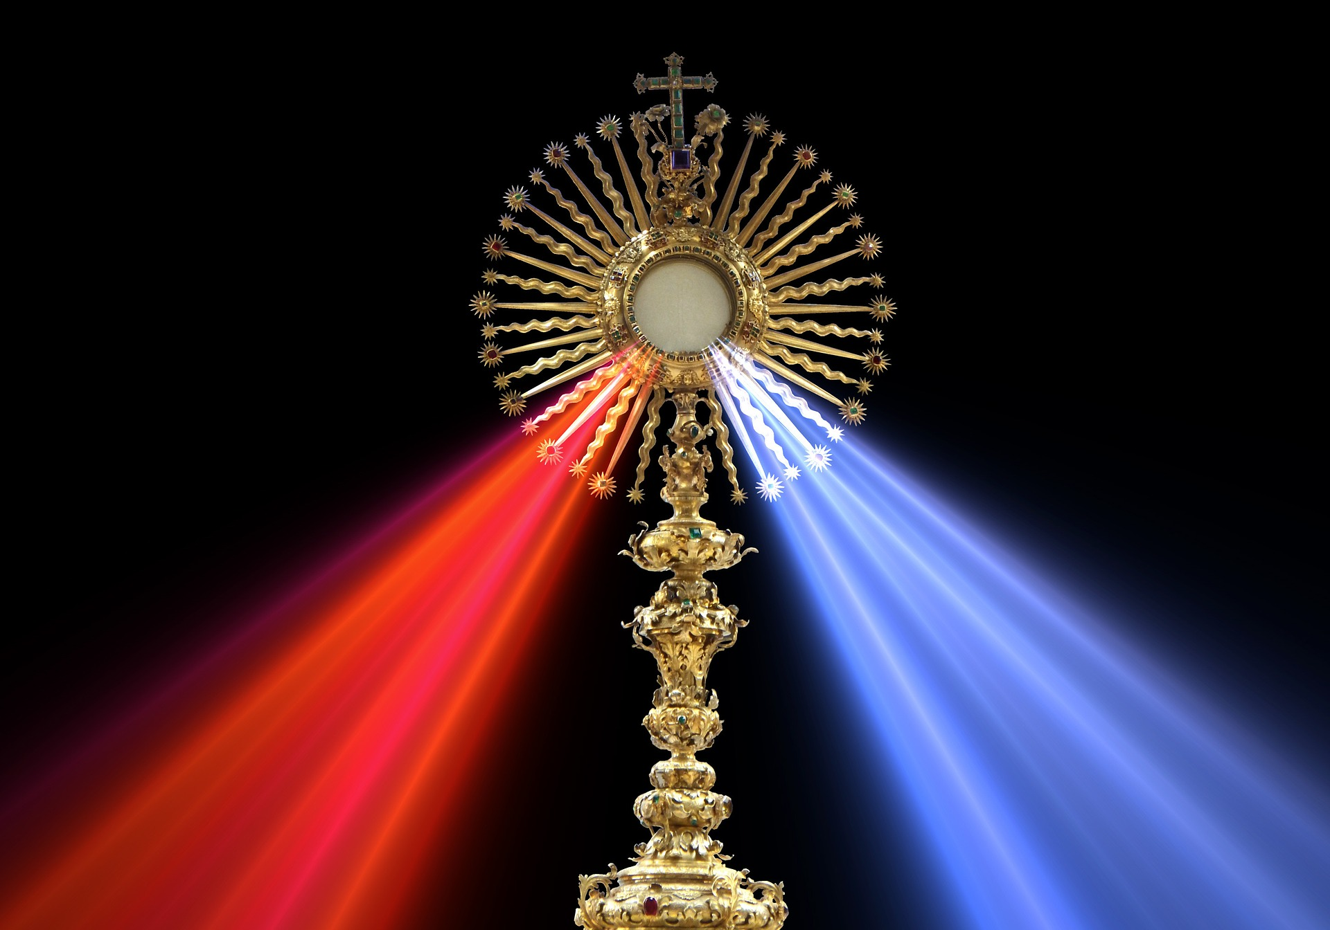
EUCHARISTIC ADORATION St Peter’s Church - Friday’s 2pm – 8.30 pm. Daily 6.30 pm – 7.30 pm with Adoration, Rosary & the Divine Mercy Chaplet. https://churchmedia.tv/st-peters-church-2
St Joseph’s Church – Friday’s 3 pm – 4 pm with Adoration & Divine Mercy Chaplet. Eucharistic Ministers Norms/ Application Form available on parish website
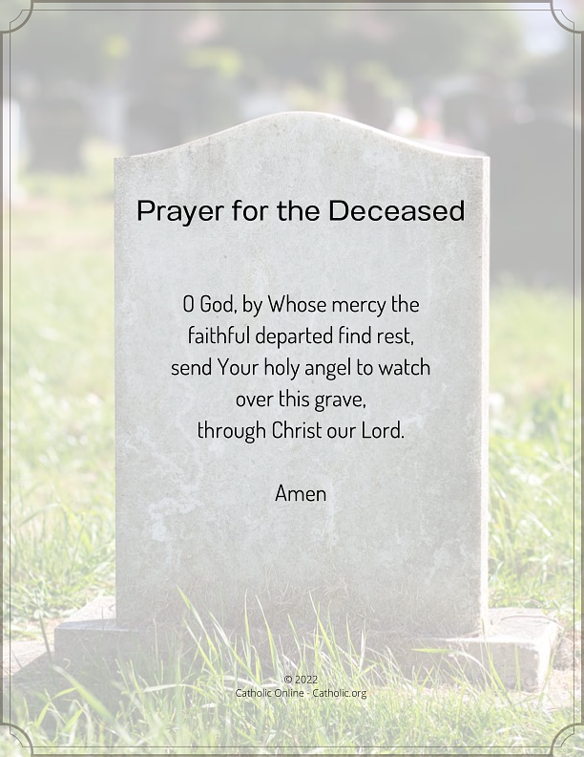
MONTH’S MIND – Marie McCann RIP ANNIVERSARIES – Tony Edwards, Jack Jordan, Margaret Hughes, Daniel & John Magill & Geraldine McGowan RIP Parish Funeral Norms –“A family guide to planning and celebrating a funeral in the Catholic Church” By Bishop Alan. Funeral Norms / Funeral Ministry Application Form available on parish website.
Hannahstown Parish – February 2026 St Joseph’s Church 200th Year Anniversary
HANNAHSTOWN PARISH PASTORAL COUNCIL (PCC)
Themes: Mercy, Healing and Unity

Ash Wednesday – 18th February

Lent begins with ashes which is a sign of our human frailty, but also of hope. This Ash Wednesday, we mark the start of Lent together as a parish family, standing before God in prayer, reflection, and renewal.

Masses: 9.15– St Peter’s Church 7.00pm – St Joseph’s Church

Special Outdoor Opportunity:
For those passing the church during the day, ashes and a short prayer will be offered in the car park near the entrance gate, 8.00am–8.00pm, served by Fr Devlin and Eucharistic Ministers. This is a quiet, dignified moment, not a replacement for Mass, inviting everyone to pause, reflect, and receive God’s blessing.
You are also welcome to receive a Lenten calendar, a Prayer to St Joseph, and an invitation to our Evenings of Mercy, Healing, and Unity later in the month. ASH WEDNESDAY Receive Ashes and Go in peace.

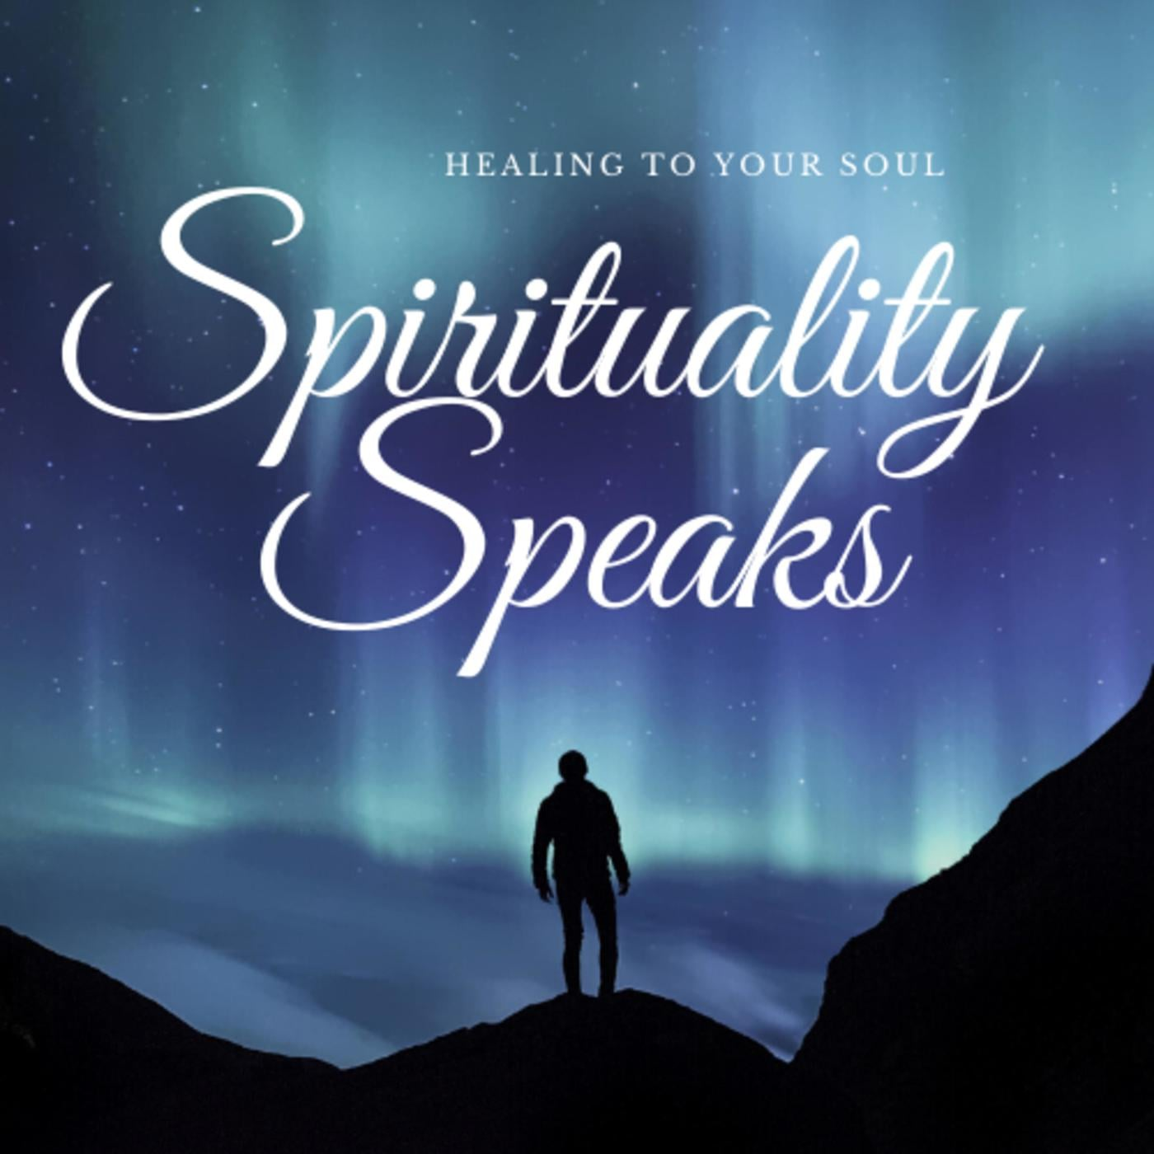
A Time of Prayer 1. Tuesday 24th February 2026 7pm St Joseph’s Church 200th Year Anniversary. Fr Needish St Lukes Parish
Theme: Mercy
Join us for a reflective prayer time on God’s mercy, prayer, and healing within families. Scripture, reflection, silence, and prayer will help us bring mercy into our homes and parish life. All generations welcome.

A Time of Prayer 2. Thursday 26th February 2026 7pm St Joseph’s Church 200th Year Anniversary.
Theme: Healing Fr Darren Brennan St Pauls Parish
Within the Family and Parish please join us for a reflective time of prayer, Scripture, and the Divine Mercy Chaplet, seeking healing from the Heart of Jesus for families, loved ones, and the parish community. All generations welcome.

A Time of Prayer 3. Tuesday 3rd of March 2026 7pm St Joseph’s Church 200th Year Anniversary.
Theme: Unity in the Heart of Jesus Fr. Brendan Mulholland from Holy Trinity Parish
Within the Family and Parish please join us for a reflective time of prayer, Scripture, and guided family prayer, seeking unity in the Heart of Jesus for families, loved ones, and the parish community. All generations welcome.

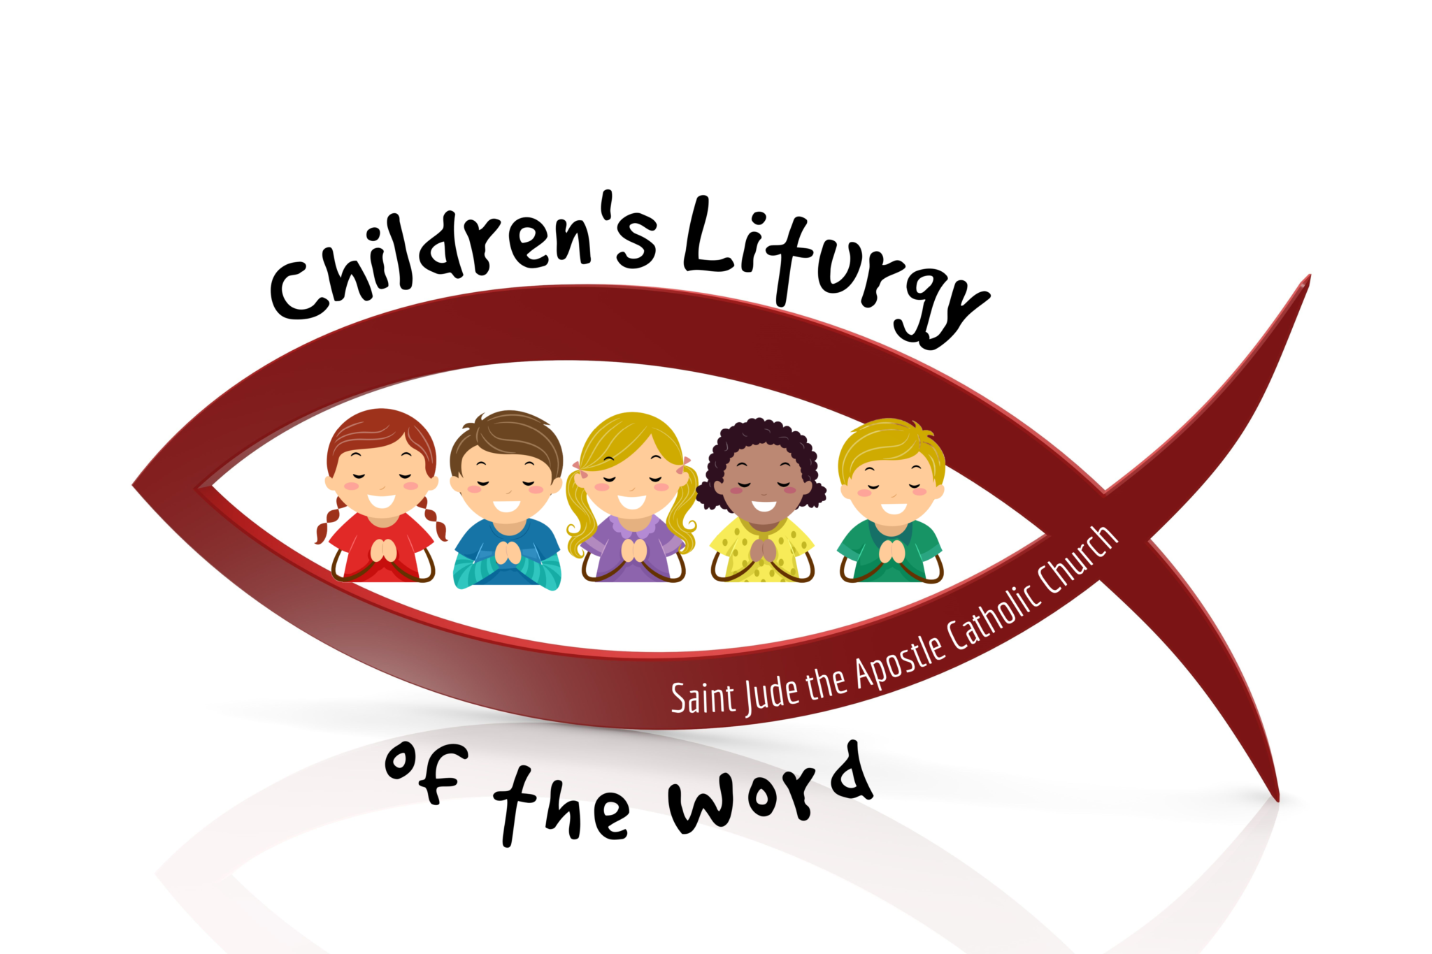
Hannahstown Parish – February 2026 St Joseph’s Church 200th Year Anniversary
Children’s Liturgy of the Word – Commissioning of Leaders Sunday 22nd February 2026 | 11:30am | St Joseph’s Church

As part of our Bicentenary Year, we are delighted to announce the training and commissioning of our Children’s Liturgy Leaders.

Key Points: Commissioning: Leaders will be officially commissioned at 1130 Mass on 22nd February, preparing to begin ministry on Sunday 1st March at the 1130 mass.

Purpose: Children’s Liturgy of the Word offers children a chance to hear and reflect on the Sunday Gospel at a level they can understand, in a safe and welcoming environment.

Leaders: All leaders have completed training, are confident in their roles, and are fully compliant with parish safeguarding requirements.
Parents: Please note participation is voluntary. Children will return to the main Mass for the Eucharist, and safeguarding measures are in place to ensure everyone’s safety.
We thank the leaders, families, and parish community for supporting this ministry and helping our children grow in faith.

THE WEST BELFAST HISTORICAL SOCIETY
HANNAHSTOWN PARISH / FAMILY OF PARISHES
The February meeting will take place on Friday the 13th of February at 7.30pm in St. Michael's Parish Centre, Finaghy Road North (Access via Church Gateway on Finaghy Road North, just past the garage opposite the Church at the junction with Andersonstown Road). The February talk is entitled: "THE CORRIDOR OF POWER.” The guest speaker will be PETER MCCABE. Refreshments will be provided.
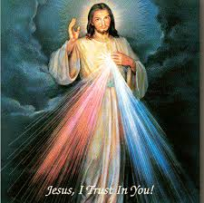
DIVINE MERCY CONFERENCE SATURDAY 28TH FEBRUARY 2026 - Bus will leave St Paul’s Church, Falls Road at 7.30am returning approx. 10.45/11.00pm. Travel cost is £25 (bus price only) which must be paid when booking your seat. Failure to get 30 people the bus would have to be cancelled. Travel confirmation, 1 week before departure. Unfortunately, no refund can be given in cases of sickness etc. Conference tickets to be bought individually at the venue £35. Bring enough food for lunch and dinner – there are tea and coffee stations where hot drinks and snacks can be purchased. Telephone Tina McCrory – 07523824350 to book a seat on the bus.
BLACK MOUNTAIN FAMILY OF PARISHES – WHAT DO YOU BELIEVE?
Informal courses about Christian faith and its relevance for life today. This LENT,
Black Mountain Family of Parishes are holding a 6 week series of presentations for those interested in learning more about the Catholic faith. All welcome! Wednesday 25th February at 7pm, in St Teresa’s Parish Centre, 135 Glen Road, Belfast. Call 02890 213122 leave your name and a contact number.
DAY OF PRAYER FOR SURVIVORS AND VICTIMS OF ABUSE - In Ireland, a Day of Prayer for Victims and Survivors of Abuse is marked each year on the Friday immediately following Ash Wednesday. This year it will be marked across Ireland on Friday 20th February 2026. This day is not only for victims and survivors who have been so severely injured inside our Church, but also for the families and communities affected by the pain and grief of their loved ones. Abuse happened within the Catholic Church in Ireland. Abuse happened in our Diocese of Down and Connor. Bishop Alan McGuckian SJ will celebrate Mass in St Peter’s Cathedral on Friday 20th February 2026 at 6:00pm.
Chairs and members of Parish - Family of Parishes Safeguarding Committees are invited to attend the Mass in St Peter’s Cathedral and join with Bishop Alan in praying for all those who have been affected by abuse.
HANNAHSTOWN PARISH / SCHOOL and Community School
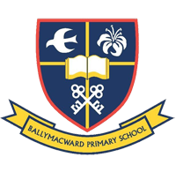
Ballymacward Primary School, Tel: (028) 92648130, Principal: Mr Hugh Kennedy Email: info@ballymacwardps.lisburn.ni.sch.uk
First Confession: Thursday 9th February 10:30am First Holy Communion: Sunday 26th April 10am, Confirmation: Sunday 1st March ALL at St Peter’s Church.
Ballymacward Community Pre-School Playgroup – Supervisor: Ms Sarah Scott. Tel: (028) 9264 8515

