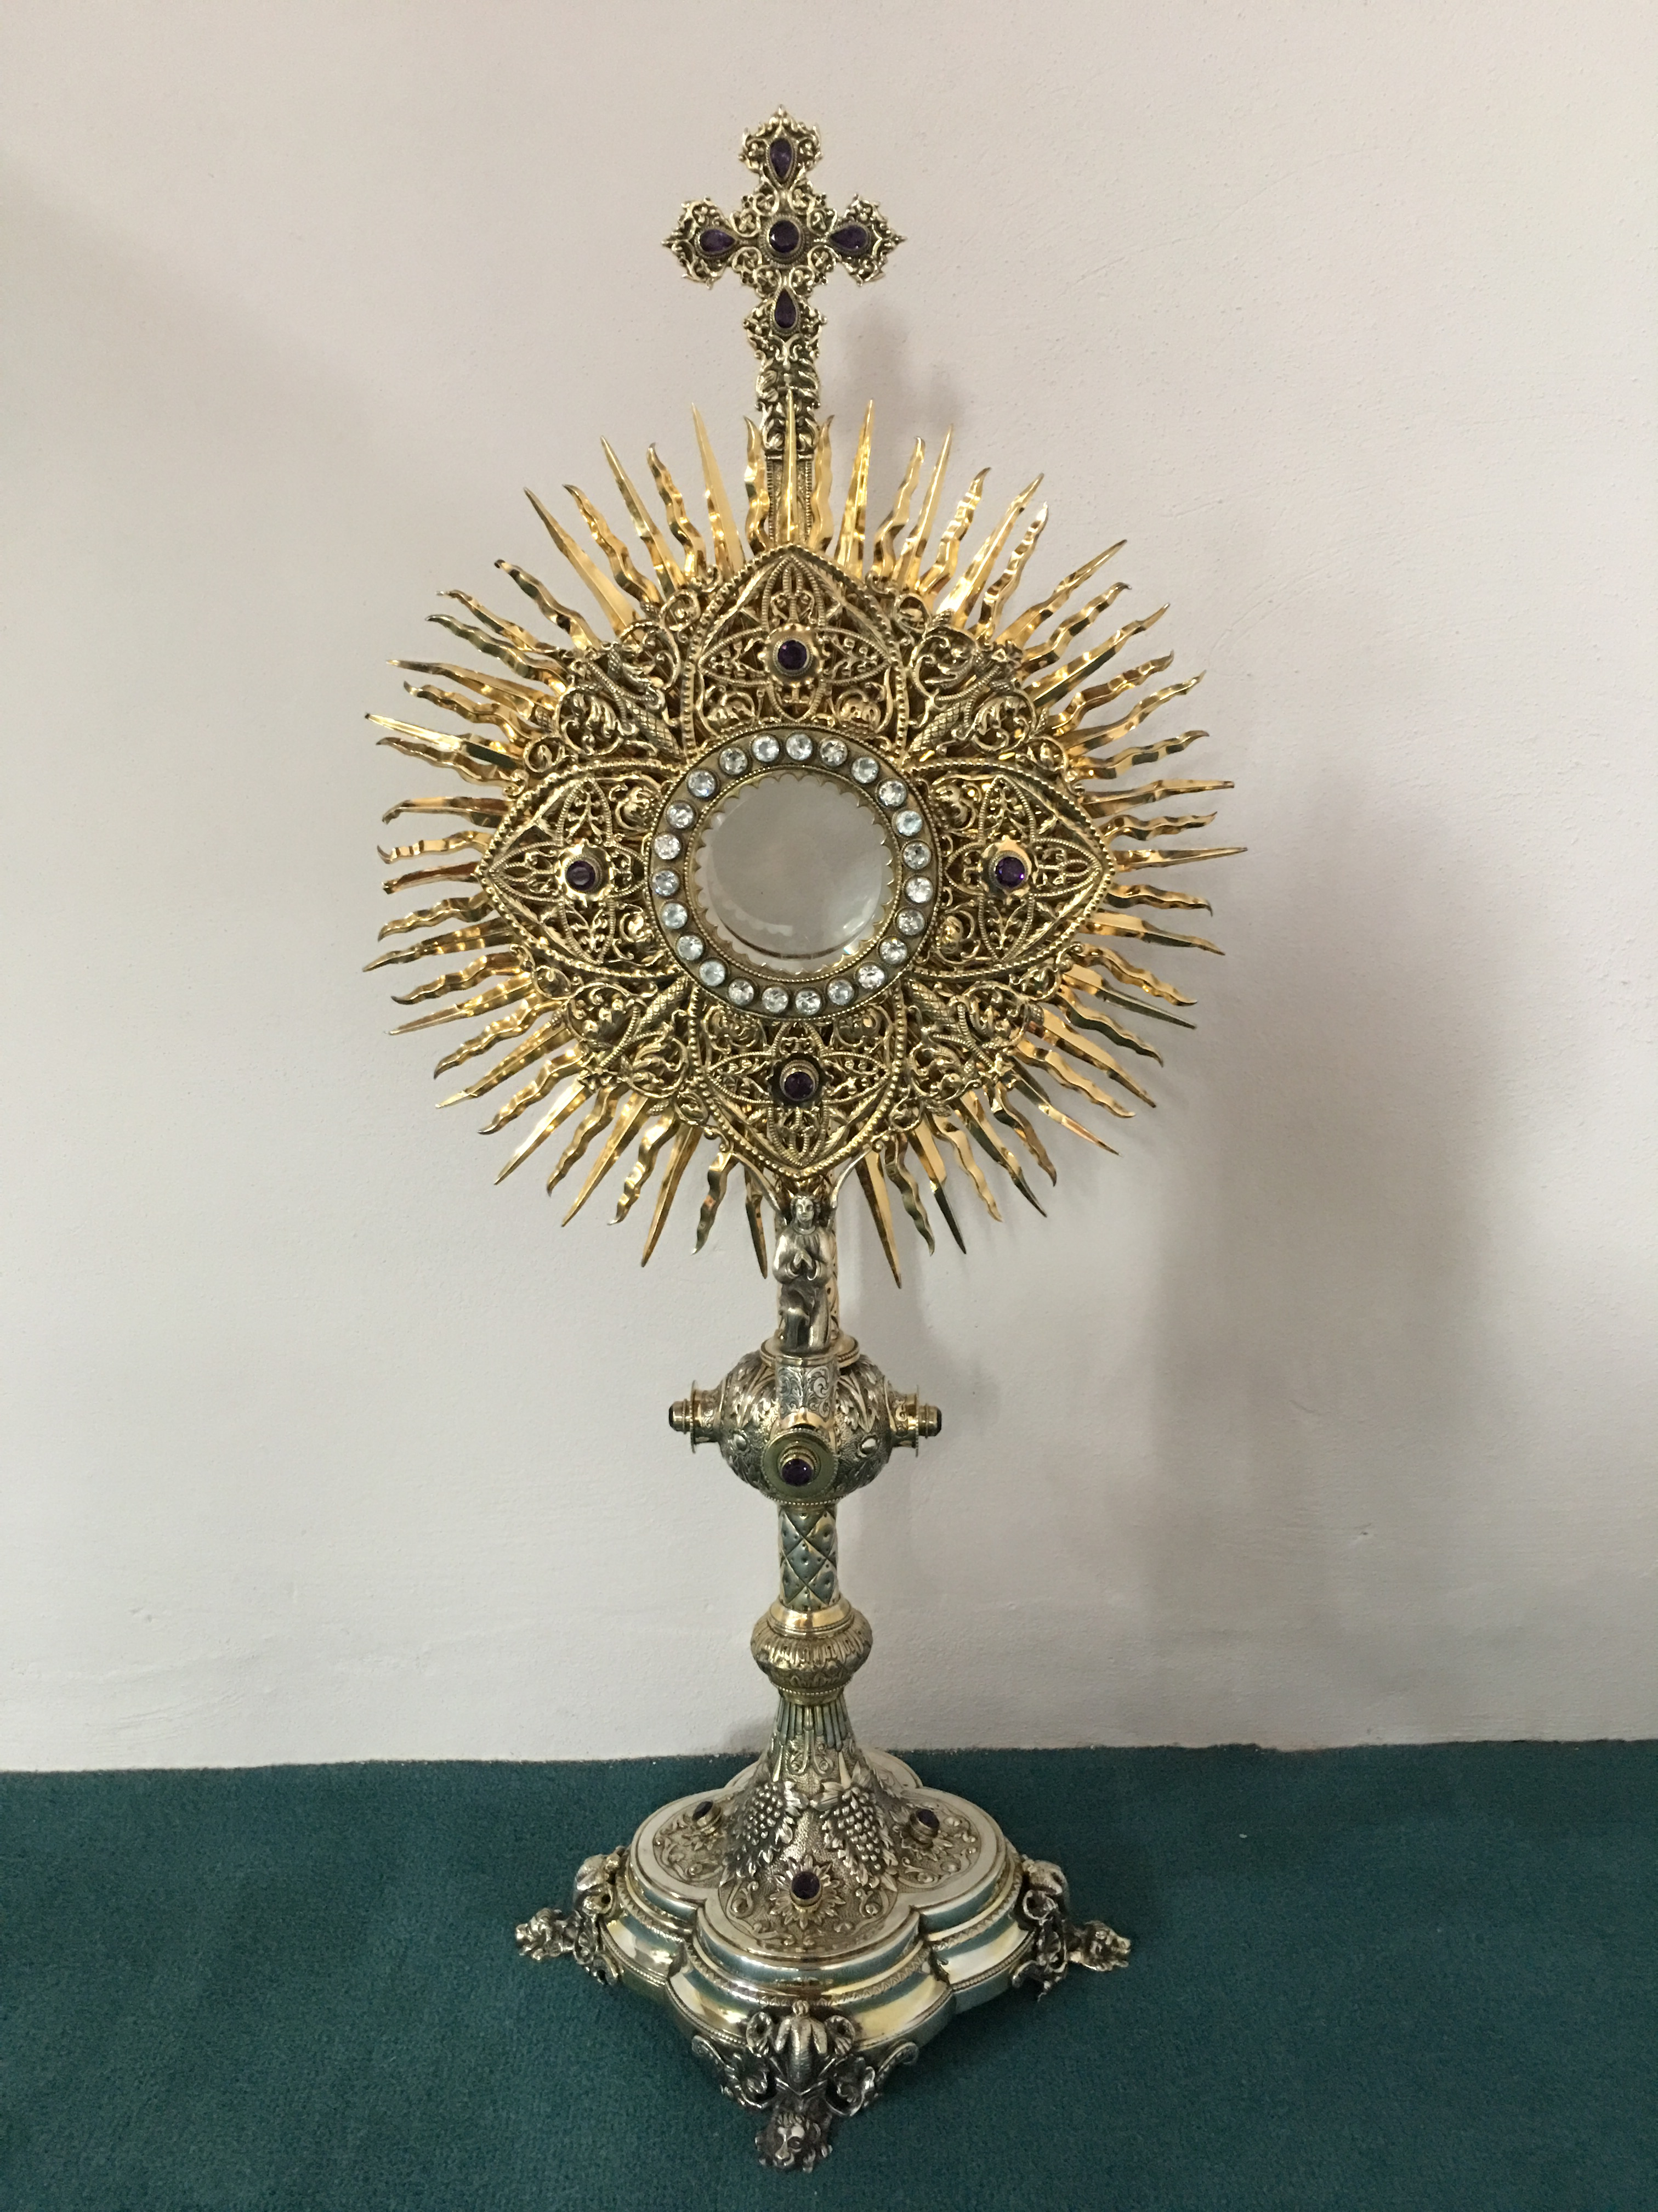
EUCHARISTIC ADORATION
The Parish of Hannahstown News
St Peter’s Church - Every Friday from 2 pm – 8.30 pm. Every evening Adoration & Prayer in St Peter’s Church 6.30 pm – 7.30 pm.
St Joseph’s Church Wednesdays during Lent from 9.45 am – 1.45 pm. You can join us in the Church or via the webcam. https://churchmedia.tv/st-josephs-church https://churchmedia.tv/st-peters-church-2
ANNIVERSARIES – Vera Brennan, Bob Connolly
& Tom Corr RIP.
MONTH’S MIND – Marian Ellis RIP
WEEKLY COLLECTIONS
18/03/2024 Weekly Collection £910.89
18/03/2024 Needy Parishes Collection £449.22
Thank you to everyone for their generosity to the Parish.

PRE-BAPTISM COURSES – Attendance at a Pre-Baptism course is required for all parents presenting a first baby for Baptism.
To book a Baptism, please visit the parish office with the new baby’s long birth certificate.

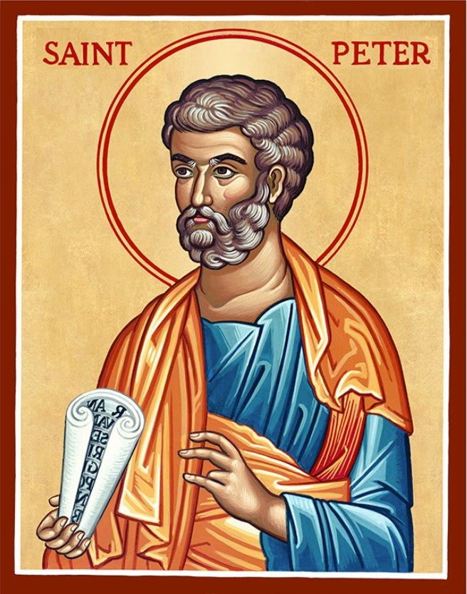
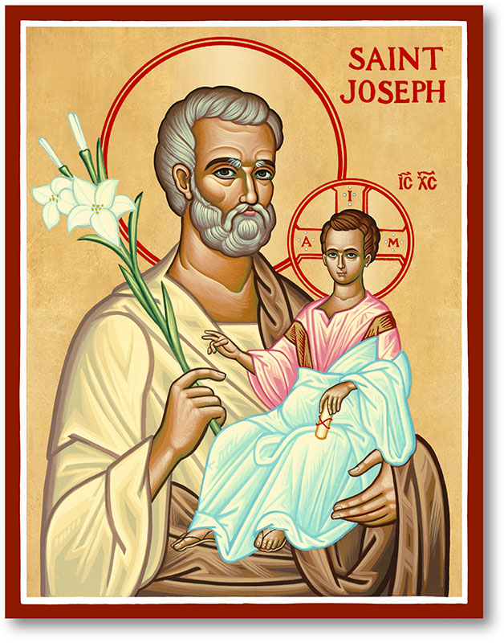
The Parish of Hannahstown
Saint Joseph’s and Saint Peter’s

24th March 2024
Palm Sunday

Vicariate / Family of Parishes Emergency Sick Calls: 07549209775
Readings: Sunday Cycle B Weekdays Psalter Week
Monday 09:15 am (Prayer for Vocations) Saint Joseph’s
Tuesday 09:15 am Saint Peter’s
Wednesday No Morning Mass
Chrism Mass noon St Peter’s Cathedral
Thursday No Morning Mass
Saturday 6:00 pm (Saint Michael the Archangel Prayer) Saint Joseph’s
Sunday 10:00 am (Prayer for Pope’s Intentions) Saint Peter’s
Sunday 11:30 am (Saint Joseph Prayer) BSL Signed Saint Joseph’s
Very Reverend Patrick Devlin Parish Priest,
Chaplain to the Deaf Community, Down and Connor Diocese
Chaplain to Antrim Area Hospital Thursday & Friday (Emergency calls)
(Fr. Patrick’s mobile…. For Spiritual and pastoral needs only, thank you) 07910 833699
Parish Secretary: Mrs Grainne McArevey Tel: 028 90614567
Parish Email: hannahstown@downandconnor.org
Parish Website: https://www.parishofhannahstown.com
CELEBRATING HOLY WEEK 2024

Palm Sunday Parish Confessions Saint Joseph’s 7pm

Chrism Mass Saint Peters’ Cathedral Wednesday - 27th 12 noon

HOLY THURSDAY – 28TH MARCH

7 pm Last Supper Washing of the feet St Joseph’s Church

GOOD FRIDAY – 29TH MARCH
Good Friday is a day of fast and abstinence
3 pm – Celebration of the Passion of Our Lord in St Joseph’s Church
7 pm – Stations of the Cross in St Peter’s Church

HOLY SATURDAY – 30TH MARCH
The Solemn Easter Vigil – St Joseph’s Church @ 6 pm

EASTER SUNDAY – 31ST MARCH

Easter Sunday morning Mass times as usual
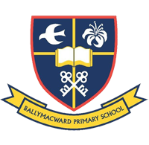
easters Sunday Mas times as usualOur Parish School Ballymacward Primary School,
THE PARISH OF HANNAHSTOWN SCHOOLS
22 Rock Road, Stoneyford, Lisburn, Co Antrim, BT28 3SUTel: (028) 92648130, Principal: Mr Hugh Kennedy
Email: info@ballmacwardps.lisburn.ni.sch.uk

Pre-School Playgroup - Supervisor: Ms Sarah Scott. Tel: (028) 9264 8515
18th April 2024 Service of Light St Peter’s at 9.15 am Mass

5th May 2024 First Holy communion St Peter’s at 10.00 am

19th May 2024 Confirmation St Peter’s at 10.00 am
HANNAHSTOWN COMMUNITY HALL
Monday – Coffee Morning after 9.15 am Mass, everyone welcome.
Please contact Anthony Adams for enquiries 02890 309795
Mon – Fri 10 am – 1 pm

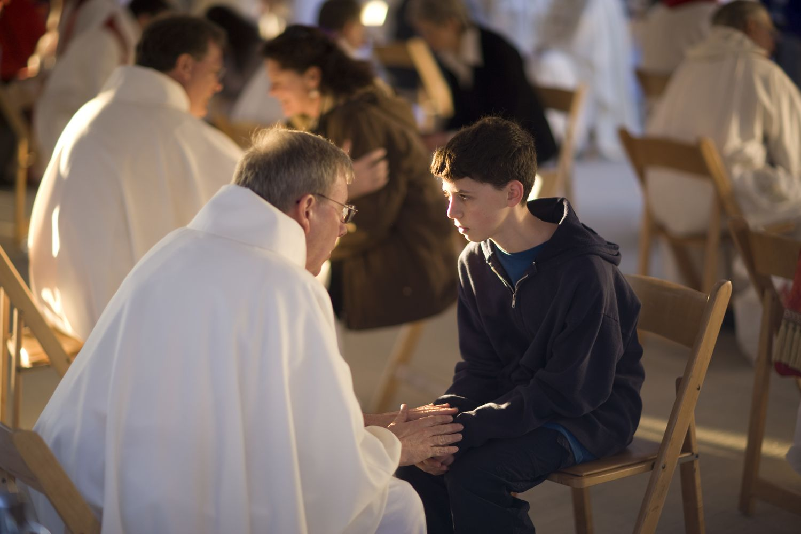
LIVING CHURCH / Family of Parishes
Reconciliation Services –
The following are dates for Lenten Parish Penitential Services, all starting @ 7 pm

St Joseph’s: Sunday 24th March

St Agnes': Monday 25th March
St Oliver Plunkett's: Tuesday 26th March
St Michael's: Wednesday 27th March
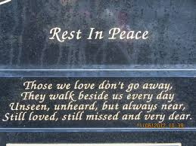
CEMETERY SUNDAY IN BELFAST CEMETERIES
LIVING CHURCH / WEST BELFAST PASTORAL COMMUNITY
Milltown (Service) Sunday 12th May @ 3 pm
City (Service) Sunday 19th May @ 3 pm
Hannahstown Parish
St Joseph’s (Mass) Sunday 26th May @ 3 pm
Tullyrusk (Mass) Sunday 16th June @ 1.30 pm
St Peter’s (Mass) Sunday 9th June @ 1.30 pm

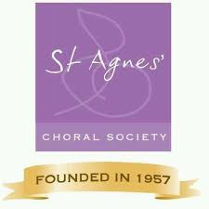
ST AGNES CHORAL SOCIETY - Have an electric night out at “Young Frankenstein” by St Agnes' Choral Society. One of Belfast’s biggest and best musical societies is back on stage with "Young Frankenstein" - the hilarious Mel Brooks Musical Comedy. St Agnes' Choral Society will be performing this monstrous hit at The MAC, Belfast from Tuesday 23rd to Saturday 27th April. "Walk this way" and get your tickets at themaclive.com

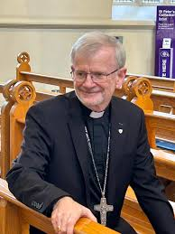
Chrism Mass Saint Peters’ Cathedral
Wednesday - 27th 12 noon
The Chrism Mass reminds us of our oneness in Christ through Baptism and its holy anointing, made possible by the ministry of the archbishop and his priests. The Chrism Mass is also a key moment in which the unity of the archbishop with his priests (together, they form the presbyterate) is manifested and renewed.

