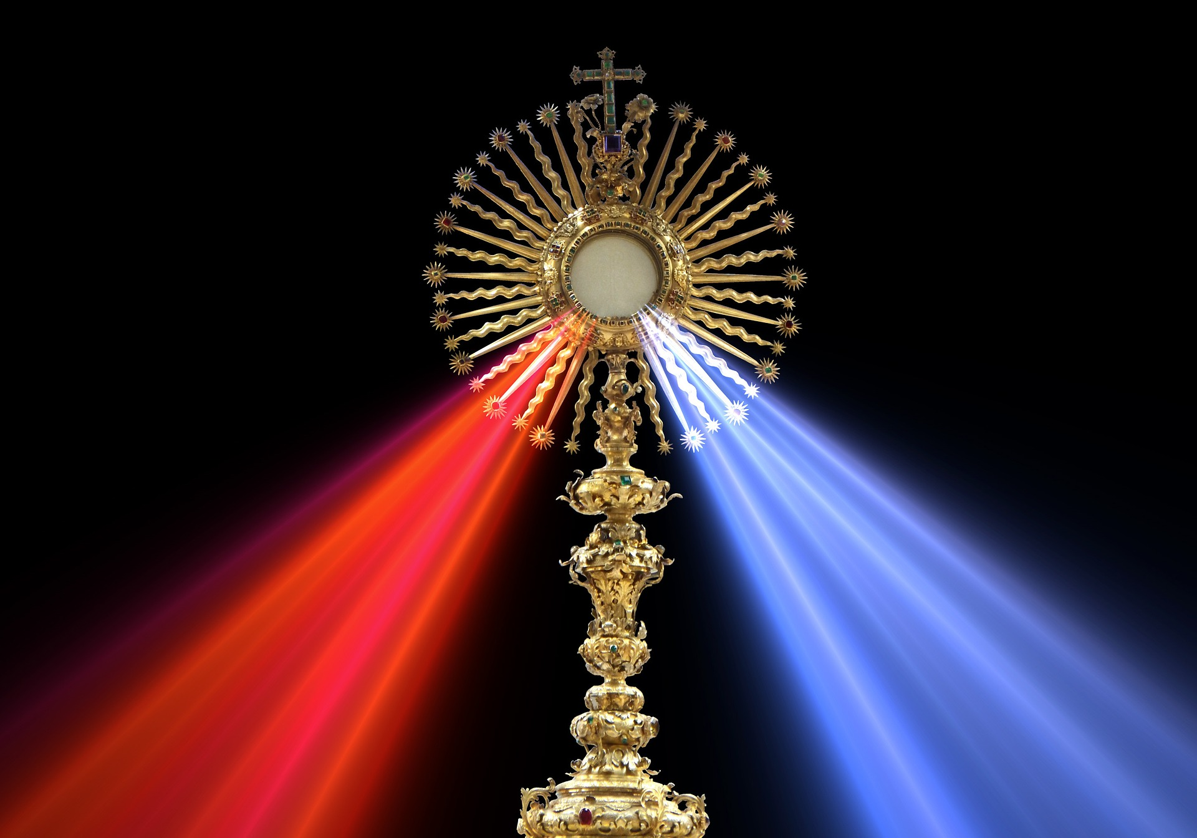
EUCHARISTIC ADORATION
THE PARISH OF HANNAHSTOWN
St Peter’s Church - Friday’s 2 pm – 8.30 pm.
Daily Adoration, Rosary & The Divine Mercy Chaplet St Peter’s Church 6.30 pm – 7.30 pm every evening. https://churchmedia.tv/st-peters-church-2
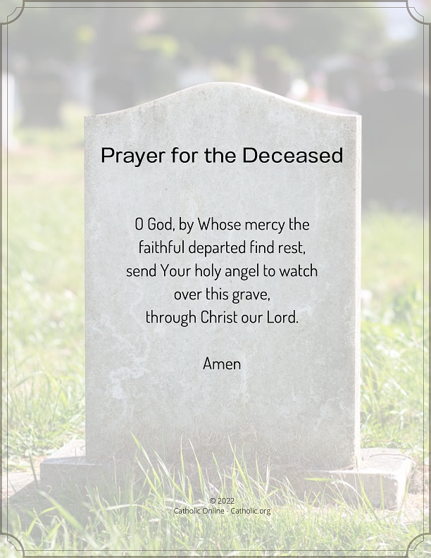
MONTH’S MIND – Tess McCullough RIP
ANNIVERSARIES – Celia Clarke, RIP
We pray especially during this month of the Dead for all our deceased family & friends.


WEEKLY COLLECTIONS
02/11/25 Weekly Collection £978.31
02/11/25 Monthly Collection £680.48
Thank you to everyone for their generosity to the Parish.

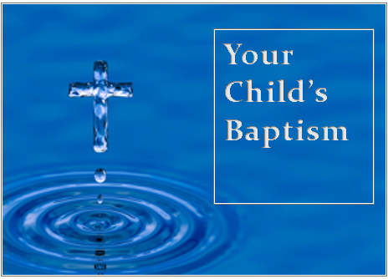
BAPTISMS
To arrange Baptisms, please present the long birth certificate to the parish office.
We welcome BabyJamie Buchanan into our parish family, who was recently baptised in St Peter’s Church.
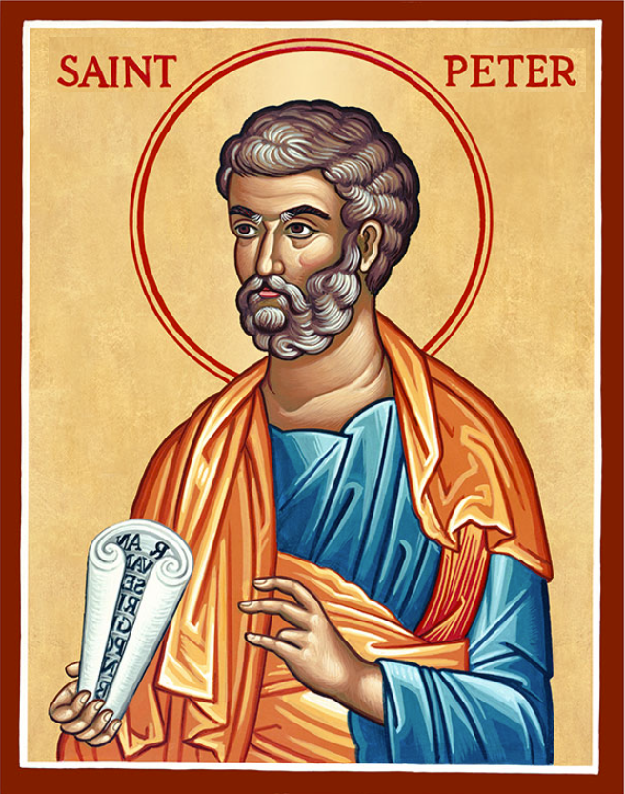
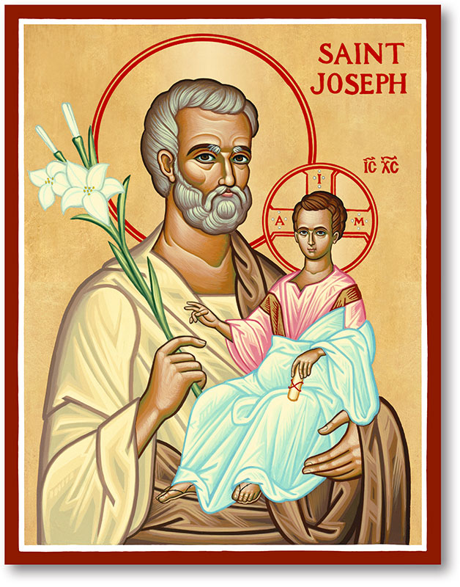
The Parish of Hannahstown
Saint Joseph’s and Saint Peter’s

9th November 2025
The Dedication of the Lateran Basilica
Family of Parishes Emergency Sick Calls: 07549209775
Monday 9.15 am Prayer for Vocations Saint Joseph’s
Tuesday Fr Patrick’s Day off.
Wednesday 9.15 am Parish Novena to Our Lady Saint Joseph’s
Thursday 9.15 am Parish novena to Our Lady Saint Peter’s
Friday 9.15 am Sacred Heart and St Michael’s Prayer Saint Joseph’s
Saturday 6:00 pm Prayer of Hope, Jubilee 2025, Saint Joseph’s
Sunday 10:00 am Prayer of Hope, Jubilee 2025 Saint Peter’s
Sunday 11:30 am Prayer of Hope, Jubilee 2025 Saint Joseph’s
Very Reverend Patrick Devlin, Parish Priest,
Chaplain to the Deaf Community, Down and Connor Diocese
Chaplain to Antrim Area Hospital Thursday & Friday (Emergency calls)
Fr. Patrick, for Spiritual and Pastoral needs only, thank you Tel: 07910 833699
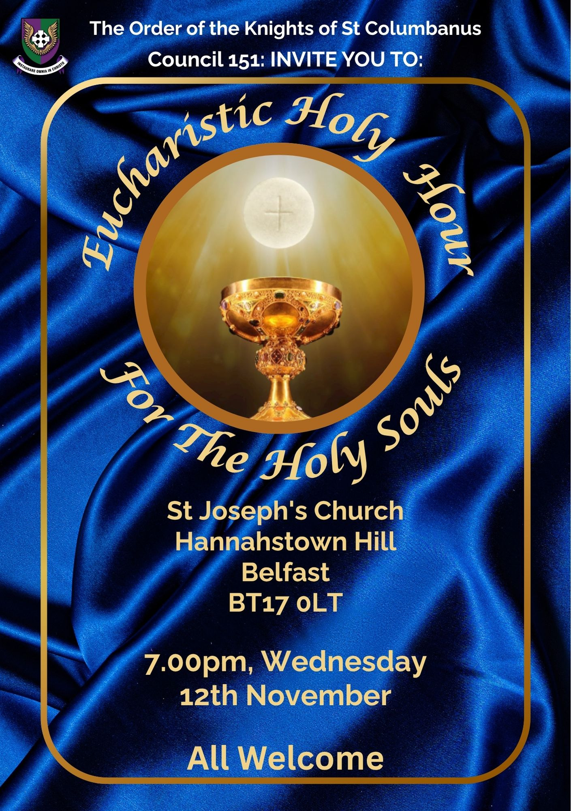
Parish Secretary: Mrs Grainne McArevey Tel: 028 90614567

KNOCK ALL NIGHT VIGIL – Departs from Clonard Monastery at 1.45 pm on Sunday 7th December, Returns Monday 8th December. Price is £75.00 and this includes dinner & breakfast. For further informtion call Brendan 02890 665211 or pay a £20 deposit to Shearers Butchers beside Andersonstown Leisure Centre.
HANNAHSTOWN PARISH / FAMILY OF PARISHES / PATHWAYS
The Annual Masses for the Deceased Teachers of Down and Connor will be celebrated on:
Tuesday 11th November 2025 at 7.30pm in Good Shepherd Church, Ormeau Road, Belfast
(Light refreshments will be served afterwards in Holy Rosary Parish Centre and All Saints’ Parish Centre)


Trócaire School Volunteers Notice - Are you a retired teacher or someone who has experience presenting to groups of school children? Do you have a passion for making this world a better place, especially for the most vulnerable? Trócaire is looking for volunteers to support our School Talks Programme for Lent 2026 in the Down and Connor Diocese. If you think you have the right skills and experience and will have time to volunteer during Lent, then we would love to hear from you! Full training and support will be provided. For more information call Fionnuala on 028 9080 8033 or email: fionnuala.mcguinness@trocaire.org

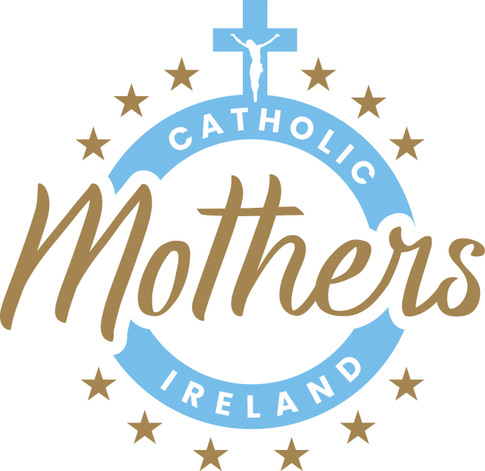
CATHOLIC MOTHERS OF IRELAND - Join us for a day of Spiritual Restoration, The Parish Hall @ St Joseph's, Antrim on SATRUDAY 29TH NOVEMBER 2025. This all day Retreat will run from 10am – 6pm. Email catholicmothers@outlook.ie for more information or to book your place.

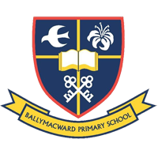
THE PARISH OF HANNAHSTOWN SCHOOL
COMMUNITY PRE-SCHOOL PLAYGROUP
Our Parish School Ballymacward Primary School,
22 Rock Road, Stoneyford, Lisburn, Co Antrim, BT28 3SUTel: (028) 92648130, Principal: Mr Hugh Kennedy
Email: info@ballmacwardps.lisburn.ni.sch.uk
Pre-School Community Playgroup – Supervisor: Ms Sarah Scott. 02892648515
HANNAHSTOWN COMMUNITY HALL

Please contact Anthony Adams for any enquiries on 90 309795.

Mon – Fri 10 am – 1 pm.

Mondays – Coffee Morning after 9.15 am Mass.



Wednesdays – Seniors Group after 9.15 am Mass.

HANNAHSTOWN ASSOCIATION AGM Our Annual General Meeting will be held on Monday 10th November at 6 pm in the Community Hall. We look forward to seeing you. (upstairs room).

