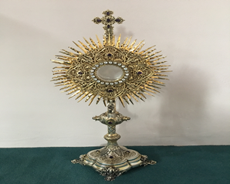
EUCHARISTIC ADORATIONSt Peter’s Church - Every Friday from 2 pm – 8.30 pm. Every evening Adoration & Prayer in St Peter’s Church 6.30 pm – 7.30 pm
THE PARISH OF HANNAHSTOWN
https://churchmedia.tv/st-josephs-church https://churchmedia.tv/st-peters-church-2

RECENTLY DECEASED Fionnuala Walsh RIP
FIRST ANNIVERSAIRES – Martin Fenton
& Ryan Stranney, RIP
ANNIVERSARIES – Sean Bannon, Kathleen Brankin, Michael Campbell & Margaret Toland RIP


WEEKLY COLLECTIONS
07/04/25 Weekly Collection £1101.83
07/04/25 Monthly Collection £639.18
Thank you to everyone for their generosity to the Parish.


BAPTISMS
We recently welcomed Baby Millie Ferguson into our parish family. We would like to ask the Ferguson family to kindly ring the parish office next week. Thank you.

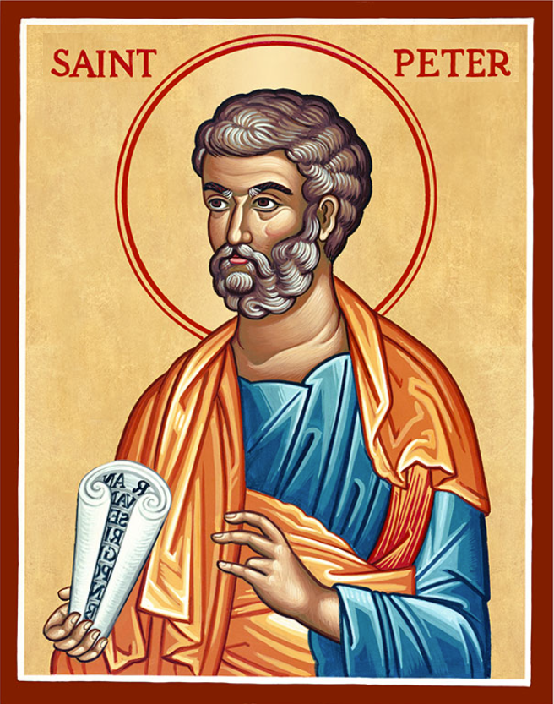
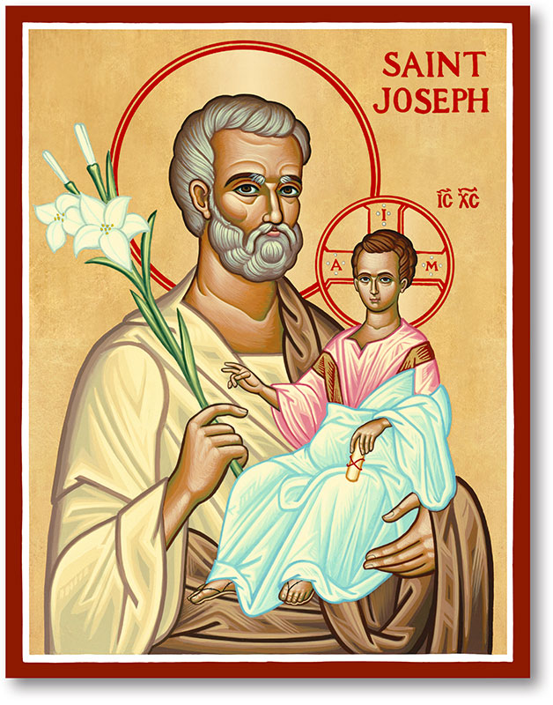
The Parish of Hannahstown
Saint Joseph’s and Saint Peter’s

13th April 2025
Palm Sunday

WEST BELFAST VICARIATE
Penitential Services All 7 pm
Sunday 13th March – St. Oliver Plunkett
Monday 14th March – St Agnes’
Tuesday 15th March – Hannahstown & St Teresa’s
Wednesday 16th March – St Michael’s.
Wednesday, 16th April
Noon Chrism Mass St Peter’s Cathedral

Holy Thursday 17th April
7 pm Mass of the Lord’s Supper St Joseph’s Church

Good Friday, 18th April
3 pm Celebration of the Passion of Our Lord in St Joseph’s Church
7 pm Stations of the Cross in St Peter’s Church

Holy Saturday, 19th April
6 pm Easter Vigil St Joseph’s Church

Easter Sunday, 20th April
10.00 am Mass in St Peter’s Church
11.30 am Mass in St Joseph’s Church


TRÓCAIRE- RTE Mass - Trócaire are delighted to lead the Holy Thursday Liturgy this year, live on RTE, on April 17th at 4.40pm. Please do join us by tuning in.
HANNAHSTOWN PARISH / FAMILY OF PARISHES / PATHWAYS
Fr Patrick encourages all parishioners to reflect on the good work of Trócaire in these final few weeks of Lent, and to remind you all at the end of Lent to please return your Trócaire boxes and any donations to the parish office or leave into the Sacristy. Many Thanks for all you help in this worthy appeal.

CHRISM MASS – ST PETER’S CATHEDRAL - The Mass of Chrism will be celebrated by Bishop Allan in the Cathedral on Spy Wednesday, 16 April, at 12 noon.
You can join us online Churchservices.tv

MESSAGE FROM FR. PATRICK /MEDJUGORJE PILGRIMAGE – Fr Patrick would like to remind all our Pilgrims travelling to Medjugorje on 1st of May to be aware of the date change from 2nd May to the 1st of May. Marian Pilgrimages should have made contact with the pilgrims but we have been made aware that a few have not bee notified. As we do not have the telephone numbers of all of the pilgrims we would appreciate if anyone travelling would ensure that their friends or family members are aware of the change in the dates. We will be returning on the 6th May. We will have an information evening before we travel. We apologise for any inconvenience this has caused.
HANNAHSTOWN PARISH
DIVINE MERCY SUNDAY - Divine Mercy Sunday: Would you like your soul to be as pure as on the day you were baptised? If the answer is yes, read on. St Pope John Paul II canonized a Polish mystic, Sister Faustina (1905 – 1938) on the Sunday after Easter in 2000 and declared that from then on, the second Sunday of Easter would be known as Divine Mercy Sunday. In a revelation to Sister Faustina (recorded in her Diary 1109) Jesus told her, ‘I want to grant a complete pardon to the souls that will go to confessions and receive Holy Communion on the Feast of My Mercy’ (Divine Mercy Sunday). The conditions for receiving this great grace, including going to confessions, can be fulfilled by attending any of the following Churches on Divine Mercy Sunday, 27 April this year. St Peter’s Cathedral at 2pm, St Paul’s, Falls Rd at 2pm, Sacred Heart, Oldpark Rd at 2.15pm, St Patrick’s, Lisburn at 3pm and All Saints Ballymena at 2pm, (huge crowds at Ballymena, come early!).
HANNAHSTOWN PARISH/FAMILY OF PARISHES


Our Parish School Ballymacward Primary School,
THE PARISH OF HANNAHSTOWN SCHOOLS
22 Rock Road, Stoneyford, Lisburn, Co Antrim, BT28 3SUTel: (028) 92648130, Principal: Mr Hugh Kennedy
Email: info@ballmacwardps.lisburn.ni.sch.uk
Pre-School Playgroup - Supervisor: Ms Sarah Scott. Tel: (028) 9264 8515

Please contact Anthony Adams for any enquiries on 90 309795.
HANNAHSTOWN COMMUNITY HALL
Mon – Fri 10 am – 1 pm.
Monday – Coffee Morning after 9.15 am Mass.
Wednesday Morning Seniors Group after 9.15 am Mass

