
WEEKLY COLLECTIONS:
THE PARISH OF HANNAHSTOWN
11/5/26 Weekly Collection £899.02
11/5/26 Building Collection £331.32

Collectors/ Volunteers Application Forms available on parish website, or in the Church Sacristy. Thank you.


HANNAHSTOWNTOWN COMMUNITY: SPRING/SUMMER FESTIVAL FRIDAY-12TH JUNE-SUNDAY JUNE 14TH Fri-Seniors Tea-Dance 12-3.30 pm -Live music/Bingo/Ballots Sat-Historical Society Coach Trip (more information to follow) Sun- Outdoor Mass at 11.30am-followed by Tea in the community Centre Please provide any Bric-a-Brac such as good clothing, toys, games, books, etc. by contacting Anto at Hannahstown Community Centre on 02890-309795 More info to follow

DOWN AND CONNOR DIOCESAN NEWS
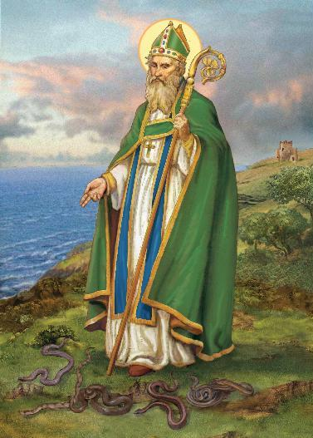
ST.PATRICK’S WAY: Walk in the footsteps of our Patron Saint on Saint Patrick’s Way Pilgrim. Walk in Downpatrick with guides Martina Purdy and Elaine Kelly on Sat 6 June and 8 August, and Mairead Sweeney on Sat 4 July, begin at Saint Patricks Centre with the fabulous 180° IMAX film of St Patrick, price includes entrance fees, internal bus transfers, pilgrimage lunch at the famous Saul Barn, plus a stamped Camino passport and a 6 mile pilgrimage walk finishing at Saint Patrick’s grave. Come and Be Amazed! (Duration 9am-approx 3pm, all for just £55) To book ring 02844 619000 or go to website www.saintpatrickcentre.com
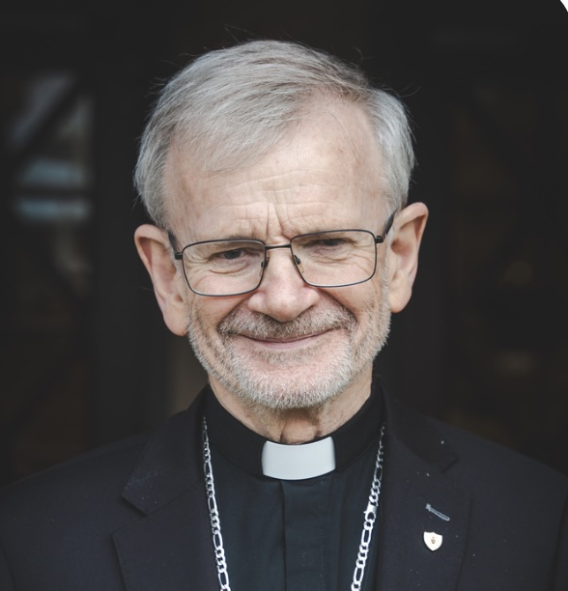
UNDERSTANDING THE SACRAMENTS:
My dear brothers and sisters, the seven sacraments are precious gifts from God, through which He walks with us and shares His life with us. In the sacraments, we encounter God in a real and powerful way through signs, words, and prayer. This booklet, generously supported by the Order of the Knights of St Columbanus, will help you understand the meaning and beauty of each sacrament and how they draw us closer to God’s love. I pray that you open your heart to the Holy Spirit and grow in faith, charity, and love of the Lord throughout your life. May God bless you. Alan McGuckian SJ Download a copy from Pathways Down and Connor Website

THREE DAY PILGRIMAGE TO LOUGH DERG: Bishop Alan McGuckian SJ and Jim Deeds will lead the Three-Day Pilgrimage to Lough Derg. Date: 19th – 21st June 2026. The bus will depart from St Patrick’s Church Donegall Street. Cost £100. Places are limited early booking advised. To book contact

Claire on 028 90690920 or email: pathwaystothefuture@downandconnor.org
ENCOUNTER WEEKEND DONEGAL, Radisson Blu Hotel, Letterkenny. 6.00pm - 10.30pm Friday 5th June. 9.00am - 10.30pm. Saturday 6th June. Expect to experience the presence of God through the celebration of the Sacraments, Spirit-led worship, inspiring talks, healing service, and fellowship. Come and be refreshed and empowered by the Holy Spirit and learn from the Saints how to live the lifestyle God intended you to live. Keynote Speakers: Patrick Reis: co-founder and Executive Director of Encounter Ministries USA & Fr. Patrick Gonyeau who serves with the U.S. Province of the Missionaries of the Precious Blood in Ohio. Bookings at https://encounterschoolofministrydoneg.regfox.com/encounter-conference-donegal

AN IGNITE LRELAND DAY ONFERENCE: with special guest speaker from the US, Scott Hahn, will take place on Saturday 23rd of May in the Convention centre, Dublin. Scott Hahn is a well-known writer and broadcaster and much sought after speaker. It is an event not to be missed. For more information and to book your ticket go to: www.dominicans.ie
mail donegal@encounterschool.org

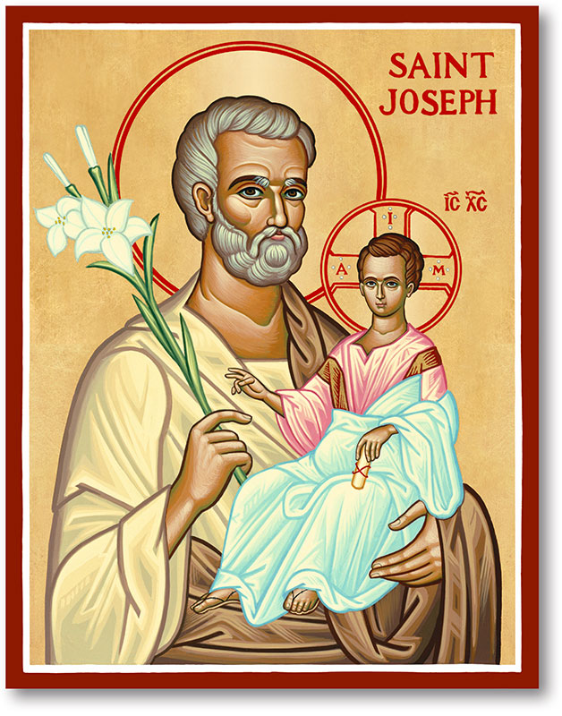
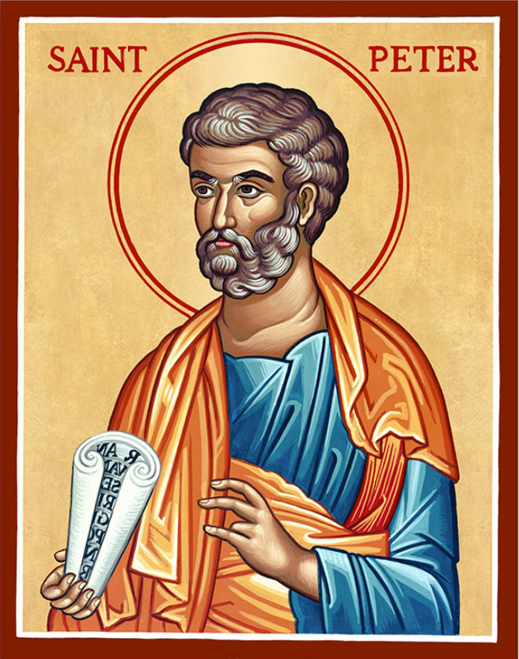
The Parish of Hannahstown
Saint Joseph’s and Saint Peter’s

17th May 2026
Family of Parishes Emergency Sick Calls: 07549209775
Very Reverend Patrick Devlin, Parish Priest.
Chaplain to the Deaf Community Down & Connor. Chaplain Antrim Hospital Thurs / Frid (Emergency Calls)
Contact Fr. Patrick for Spiritual and Pastoral needs only, Tel: 07910 833699. Parish Secretary Grainne McArevey 02890 614567 Email address: hannahstown@downandconnor.org Website: parishofhannahstown.com

Monday | 9.15 am  6.30-7.30 pm | Morning Mass Prayer for Vocations  Adoration, Rosary and Divine Chaplet  https://churchmedia.tv/st-peters-church-2 | St Joseph’s  St Peter’s
Tuesday | 6.30-7.30 pm | Fr Patrick Away  Adoration, Rosary and Divine Chaplet | St Peter’s
Wednesday | 9.15 am  6.30-7.30 pm | Morning Mass Novena to Our Lady  Adoration, Rosary and Divine Chaplet | St Joseph’s  St Peter’s
Thursday | 9.15 am  6.30-7.30 pm | Morning Mass Novena to Our Lady  Adoration, Rosary and Divine Chaplet | St Peter’s  St Peter’s
Friday | 9.15 am  2.pm-8.30 pm  3.pm | Morning Mass Prayer to the Sacred Heart  Adoration, Rosary & Divine Mercy Chaplet  Adoration and Divine Mercy Chaplet | St Joseph’s  St Peter’s  St Joseph’s
Saturday | 6.00 pm  6.30-7.30 pm | Vigil Mass The Angelus Prayer  Adoration, Rosary and Divine Chaplet | St Joseph’s  St Peter’s
Sunday | 10.00 am  6.30-7.30 pm | Morning Mass Prayer to St Peter  Adoration, Rosary and Divine Chaplet | St Peter’s  St Peter’s
Sunday | 11.30 am  6.30-7.30 pm | Morning Mass Prayer to St Joseph  Adoration, Rosary and Divine Chaplet | St Joseph’s  St Peter’s
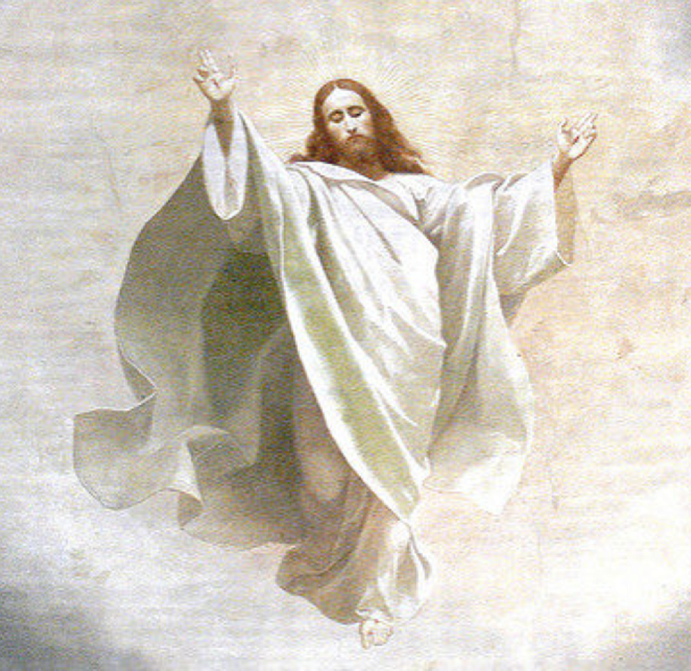
THE ASCENSION OF THE LORD
The Ascension of the Lord is not a farewell, but a glorification.
Christ, who had risen from the dead, now enters definitively into the glory of the Father.
He does not leave the earth, but inaugurates a new form of presence:
Jesus is with us invisibly, but real, through the Holy Spirit.


MONTH’S MIND – Kathleen Wilson RIP

ANNIVERSARIES: – K & J Harwood, Stephen Maguire,

Thomas McKeever, Charles O’Neill & P J O’Neill RIP.


CEMETERY SUNDAYS: – You are warmly invited to our Cemetery Sunday Masses, as we remember and pray for our loved ones.
Sunday 31st May – St Joseph’s Sunday,
7th June – St Peter’s, & Sunday 14th June – Tullyrusk.
Milltown Cemetery Sunday 10th May @ 3 pm. “I am the resurrection and the life, says the Lord; whoever believes in me will live, even though they die.”

HANNAHSTOWN PARISH PASTORAL COUNCIL (PPC)
Themes: Mercy, Healing and Unity May
HANNAHSTOWN PARISH MAY 2026 ST. JOSEPH’S CHURCH 200TH ANNIVERSARY

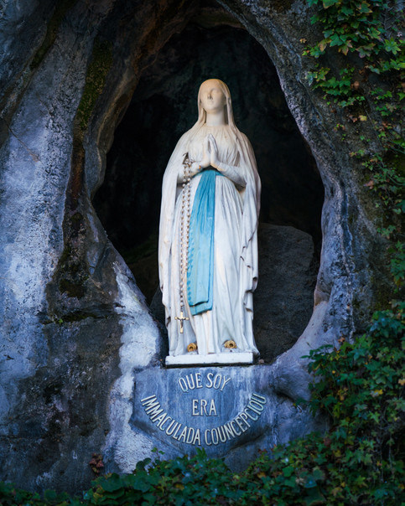
THEME: WITH MARY AT ST JOSEPH’ AND ST PETER’S:
Throughout the month of May, we invite parishioners and families to honour Our Lady by contributing to the May Altar in St Joseph’s Church AND St Peter’s.
Flowers, especially from your own gardens, are most welcome as a simple and beautiful sign of love for Mary. Children are especially encouraged to take part.
Let us come together to create a prayerful space, placing our intentions before Our Lady and asking her to lead us ever closer to her Son.
TODAY SUNDAY 17TH MAY- CROWNING OF OUR LADY AN ROSARY PROCESSION:
All parishioners, families, and especially children are warmly invited to join us. Today we honour Our Lady of Lourdes with a crown of flowers, not to add to her glory, but to express our gratitude for her maternal care for over two hundred years of parish life. Children are especially welcome to take part in the crowning. A joyful and prayerful gathering for all generations.
“My soul glorifies the Lord, and my spirit rejoices in God my Saviour.


ACKNOWLEDGEMENT OF MARY PEYTON: The Parish Council invites parishioners to join in giving thanks for the devoted service of Mary Peyton to our parish community. Mary has given over 60 years’ service to St Peter’s The Rock and St Joseph’s. This will take place on Sunday, 24th May 2026 at the 10.00 am Mass in St Peter’s Church. During the Mass, Mary will be presented with a gift from the parish, along with the Knights of Columbanus (Council 151) presentation trophy, “Honour of Faith”. And the afterwards to Ballymacward School for refreshments. Please find Gift/Donation envelopes for Mary in the Church porches. Please return your envelope in the basket collections over the next couple of weeks. Thank you.
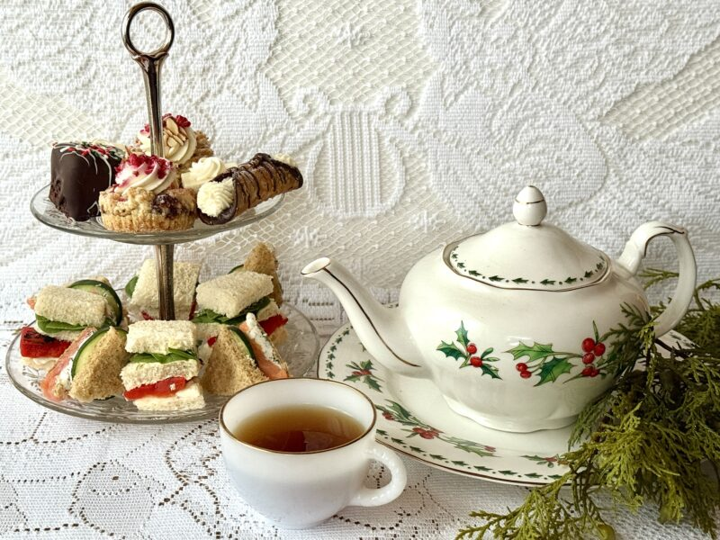
200th ANNIVERSARY: Tea Party for seniors: We warmly invite all seniors to join us for a special tea party celebrating our 200th year. Date: Wednesday 27th May in Hannahstown Community Hall. Everyone is very welcome! Please add your name to the sign-up sheet available in the church porches. If you require transport, kindly indicate this when signing up or contact us in advance. We look forward to celebrating together!

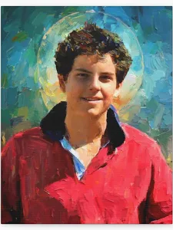
HANNAHSTOWN PARISH JUNE 2026
ST. JOSEPH’S CHURCH 200TH ANNIVERSARY

ST JOSEPH’S & ST PETER’S CHURCHS

As we celebrate the 200th anniversary of the building of St Joseph’s Church, the parish is delighted to mark this blessed and historic milestone in a meaningful and prayerful way. Time & date to be confirmed.
To commemorate this sacred occasion, we will gather on the Feast of the Most Holy Body and Blood of Christ (Corpus Christi) for a joyful celebration of faith, thanksgiving, and Eucharistic devotion.
As part of our observance, there will be a display of images and reflections on Blessed Carlo Acutis, whose deep love for the Real Presence of Christ in the Eucharist continues to inspire and guide people around the world, especially the young, toward holiness. All parishioners are warmly invited to join us as we honour this grace-filled anniversary in a spirit of reverence and unity. Let us come together in gratitude, prayer, and joyful celebration of God’s enduring presence among us.
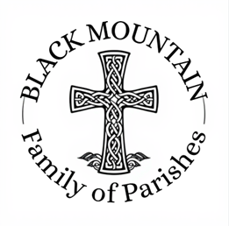
BLACK MOUNTAIN FAMILY OF PARISHES: Or emergency phone 07549209775. Only for those needing the last rites, or in the case of a death. Thank you.
BLACK MOUNTAIN FAMILY OF PARISHES NEWS

Fr McCullagh ` St Agnes 028 90615 702, Fr Gabriel Lyons St Teresa’s 028 9061 2855, Fr Ciaran Feeney St Michaels 028 9508 8030
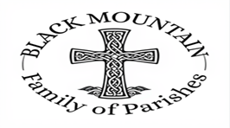
Fr Brendan Mulhall Holy Trinity 028 9059 0985.

BLACK MOUNTAIN FAMILY OF PARISHES PRAYER BEFORE AN EXAM: Loving God be with me now, as I prepare for my exams. Thank you for the many talents and gifts you have given me and for the opportunity of education. Calm my nerves and anxiety. Help me to remember all that I have studied, to express it clearly and to answer the questions the very best I can. Holy Spirit, sit with me in my exam and always. AMEN
DIVINE INSPIRATION: You are invited to share their memories of St Michael's parish which is turning 50 this year. We hope to publish the best of them in our parish commemorative magazine. Also if anyone has any memories of the pilgrimage to the Holy Land - and photographs. Parishioners are also invited to say in 100 words or less what their faith means to them. We will endeavour to publish them! Please email or write to martinapurdy1@gmail.com or leave a hand written note with personal details for Martina's attention in the parish office.
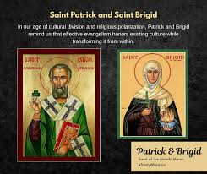
BLACK MOUNTAIN FAMILY OF PARISHES: invites you to a three-day pilgrimage to the Shrines of St Brigid and St Oliver Plunkett on 10th, 11th and 13th June. Ballymascanlon Hotel, single Room £380 Double Room £450 Twin £530 B&B and 2 evening meals 3 course transport included.
A time of Mass, prayer and fellowship as we journey together in faith and step away from the busyness of life.
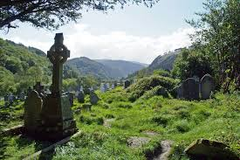
All are most welcome. Booking: Contact your local parish office (cash only).
BLACK MOUNTAIN FAMILY OF PARISHES: Warmly invites you to a three-day pilgrimage to Glendalough from Monday 7th to Wednesday 9th September. Join us for a prayerful journey in the beautiful setting of St Kevin’s Glendalough, with opportunities for Mass, prayer, reflection, and fellowship. Tulfarris Hotel, prices include B&B, two 3-course evening meals, and transport: Single Room – £340, Double Room – £410, Twin Room – £410. All are welcome. Booking: Please contact your local parish office (cash payments only)
KINGHTS OF COLUMBANUS 151 FAMILY OF PARISHES NEWS
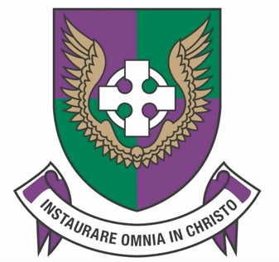
KNIGHTS OF COLUMBANUS COUNCIL 151- INVITATION TO A HOLY HOUR: The Knights of Columbanus (Council 151) warmly invite all parishioners to a Holy Hour in honour of Eucharistic Adoration. This will take place on Sunday 17th May in St Peter’s Church at 3pm. Come and spend time in quiet prayer before the Blessed Sacrament, deepening your love for Christ truly present in the Eucharist. All are most welcome.
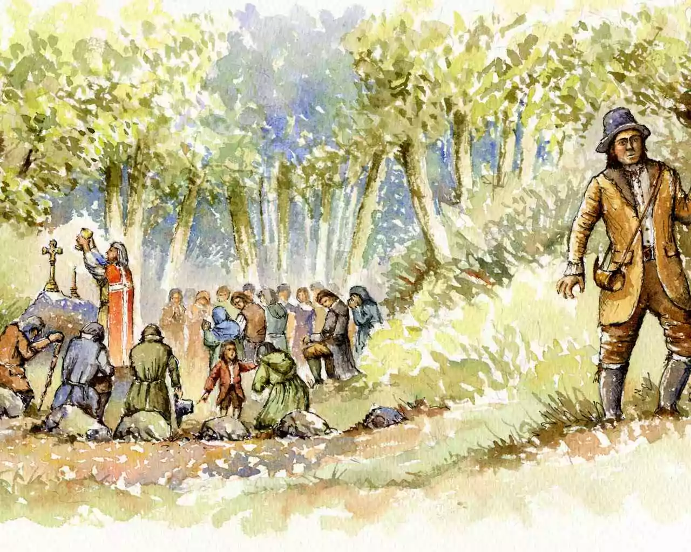
HOLY MASS CELRBRATED: The Mass Rock in Colin Glen is one of several authentic historical Mass Rocks (secret open-air altars used during the Penal Laws) located in the hills and glens surrounding Hannahstown: Colin Glen Mass Rock: A secluded site at the base of a ravine, marked by a wooden cross and a stone altar with inscribed crosses. It is accessible via a trail from the Colin Glen Visitor Centre. Mass at the Mass Rock – Colin Glen. The parish warmly invites you to a special celebration of Holy Mass at the historic Mass Rock in Colin Glen on Saturday 20th June, at 11.30am rosary walk time 10am Eucharistic Adoration. This sacred site, is one of several places where Mass was celebrated in secret during the time of the Penal Laws. In those difficult days, the faithful gathered quietly in the hills keeping alive the gift of the Eucharist. As we gather once again in this holy place, we honour their courage and deepen our own faith. Come and join us for this meaningful and prayerful celebration, reconnecting with the faith of our forebears. All are most welcome.

