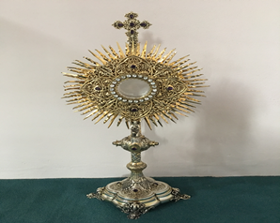
EUCHARISTIC ADORATION
THE PARISH OF HANNAHSTOWN
St Peter’s Church - Every Friday from 2 pm – 8.30 pm. Every evening Adoration & Prayer in St Peter’s Church 6.30 pm – 7.30 pm
https://churchmedia.tv/st-josephs-church https://churchmedia.tv/st-peters-church-2

ANNIVERSARIES –Declan Connolly, Maureen Gough 1st A, Jack Jordan, Jim McGarrity, Sally O’Neill & Alice Wilson.
RECENTLY DECEASED – Arthur McKenna RIP
Brendan Mulholland RIP Aidan MurrayRIP
Aidan Murray RIP
MONTHS MIND - James O’Connor RIP

WEEKLY COLLECTIONS
19/01/25 Weekly £1,116.58
Thank you to everyone for their generosity to the Parish.


BAPTISMS

For first-time parents there is a Baptsim course within the Family of Parishes that must be attended prior to the Baptism. Further information upon booking. Long birth certificate needed to book a Baptism.

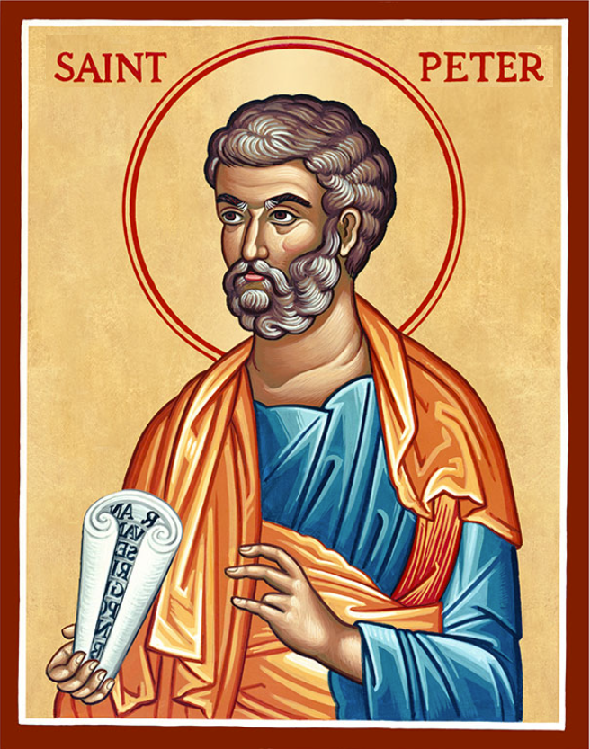
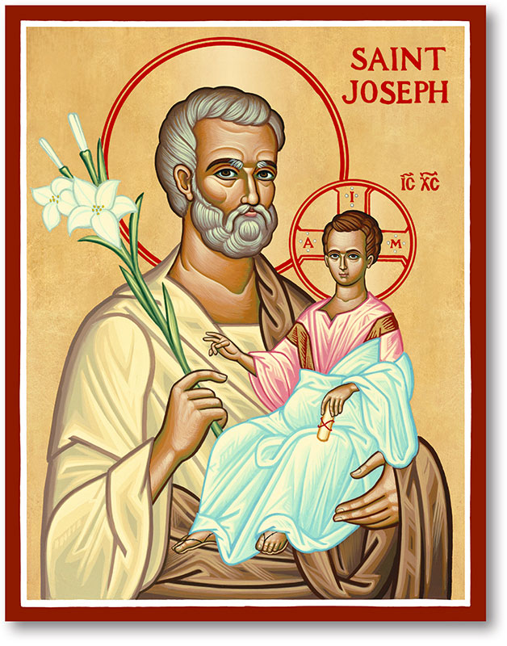
The Parish of Hannahstown
Saint Joseph’s and Saint Peter’s

2nd February 2025
Third Sunday in Ordinary Time

Family of Parishes Emergency Sick Calls: 07549209775
Monday 09.15 am (Prayer for Vocations) Saint Joseph’s
Tuesday Fr. Patrick’s day off.
Wednesday 9.15 am (Parish novena to Our Lady) St Joseph’s
Thursday 9.15 am (Parish novena to Our Lady) St Peter’s
Friday 9.15 am (Sacred Heart Prayer) Saint Joseph’s
Saturday 6:00 pm (St Michael the Archangel Prayer) Saint Joseph’s
Sunday 10:00 am (Prayer for Pope’s intentions) Saint Peter’s
Sunday 11:30 am (Saint Joseph Prayer) ( BSL Signed ) Saint Joseph’s

Very Reverend Patrick Devlin Parish Priest,
Chaplain to the Deaf Community, Down and Connor Diocese
Chaplain to Antrim Area Hospital Thursday & Friday (Emergency calls)
Fr. Patrick, for Spiritual and Pastoral needs only, thank you Tel: 07910 833699
Parish Secretary: Mrs Grainne McArevey Tel: 028 90614567
Parish Email: hannahstown@downandconnor.org Parish Website: https://www.parishofhannahstown.com

The Presentation of the Lord
World Day for Consecrated Life

Almighty and everliving God, we humbly pray that, as your Only-begotten Son was this day presented in the temple, so we may be presented to you with pure and clean hearts by Jesus Christ our Lord; who lives and reigns with you and the Holy Spirit, one God, now and for ever Amen.
Please contact: Anthony Adams for any enquiries on 90 309795.

HANNAHSTOWN COMMUNITY HALL
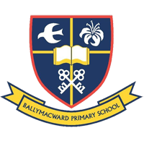
Mon – Fri 10 am – 1 pm. Monday – Coffee Morning after 9.15 am Mass. Wednesday Morning Womens Group after 9.15 am Mass
Our Parish School Ballymacward Primary School,
THE PARISH OF HANNAHSTOWN SCHOOLS
22 Rock Road, Stoneyford, Lisburn, Co Antrim, BT28 3SUTel: (028) 92648130, Principal: Mr Hugh Kennedy
Email: info@ballmacwardps.lisburn.ni.sch.uk
Pre-School Playgroup – Supervisor: Ms Sarah Scott. 02892648515


Message from Fr. Patrick. Dear all, Thank you to everyone who participated in the session on Parish Pastoral Councils (PPC) in St Teresa's.
People who wish to put their names forward as potential members, can I advise you to give your name to the Parish Secretary by 7th of February, 12 O' Clock, noon. May God bless your prayerfulness, reflection and discernment.
HANNAHSTOWN PARISH / FAMILY OF PARISHES / PATHWAYS

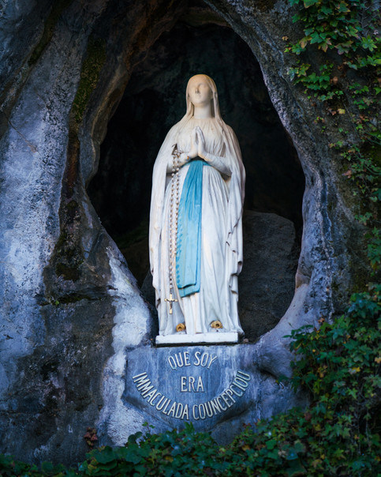
Our Lady of Lourdes Novena – St Agnes Church 3rd to 11th February Monday – Friday 10 am & 7 pm. Saturday 8th Feb @ 1 pm. The Sacrament of Reconciliation 1 pm & 6.30 pm.Mass for the sick Saturday will be available during the Novena.
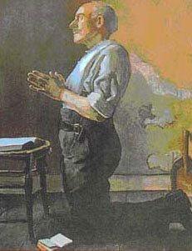
MATT TALBOT RELICS - Venerable Matt Talbot: ‘A Saint for our Times’ Arrival of the Relics of Venerable Matt Talbot at St Peter's Cathedral, Belfast, 3rd February 2025. The Relics will be received into St Peter’s Cathedral, Belfast at 5pm on Monday 3rd February 2025. Mass will be celebrated at 7.30pm with Veneration of the relics ongoing before, and after Mass, concluding with Night Prayer at 10pm.
JUBILEE PRAYER 2025
Matt Talbot Prayer Society at St Peter's—Mass is celebrated on the first Monday of every month at 10 a.m. in Saint Peter's Cathedral and offered for those struggling with addiction, their families, and all those affected by addiction. All are welcome.
Hannahstown Parish Draw January 2025

Prize  Place | Prize  Money | Name | Number | Collector
1st | £250 | Brian White | 88 | Parish Office
2nd | £150 | Eilish McGowan | 31 | Angela McGowan
3rd | £100 | Lawrence Mulholland | 402 | Mary Peyton
4th | £100 | Daniel O’Hare | 252 | Jim McCormick
5th | £50 | John D McQuillan | 147 | Johnny McQuillan
6th | £50 | K. Lennon | 296 | Irene Phillips
7th | £50 | Lawrence Finnegan | 161 | Robert Finnegan
8th | £50 | Jeanette McKnight | 73 | Jim Mc Cormick
9th | £50 | Lisa & Aishling Mulholland | 116 | Mark Mulholland
10th | £50 | Marie McClenaghan | 102 | Johnny McQuillan

