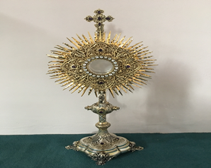
EUCHARISTIC ADORATION in St Peter’s Church - Every Friday from 2 pm – 8.30 pm.
THE PARISH OF HANNAHSTOWN
Every evening within St Peter’s Church, Adoration & Prayer from 6.30 pm – 7.30 pm
https://churchmedia.tv/st-josephs-church https://churchmedia.tv/st-peters-church-2


RECENTLY DECEASED – Winnifred Crean RIP
MONTH’S MIND – Maureen Beattie RIP
1st ANNIVERSARIES – Jim O’Neill RIP
ANNIVERSARIES – Mary Alice Murray RIP


WEEKLY COLLECTIONS
30/6/25 Weekly Collection £ 1,138.26
30/3/25 Migrant Collection £ 461.33

Thank you to everyone for their generosity to the Parish.


BAPTISMS
To arrange Baptisms, please present the long birth certificate to the parish office.
Baptisms will be arranged upon request.

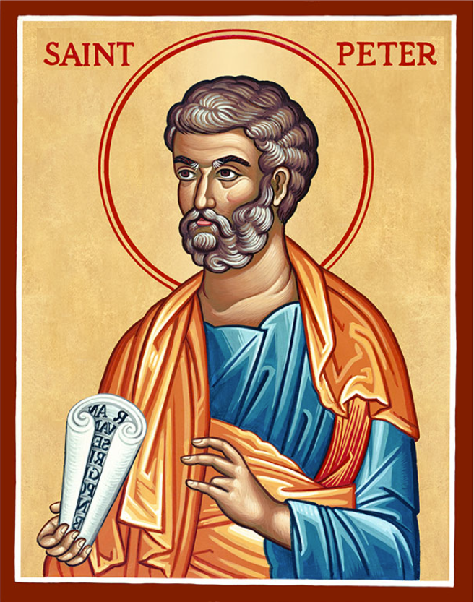
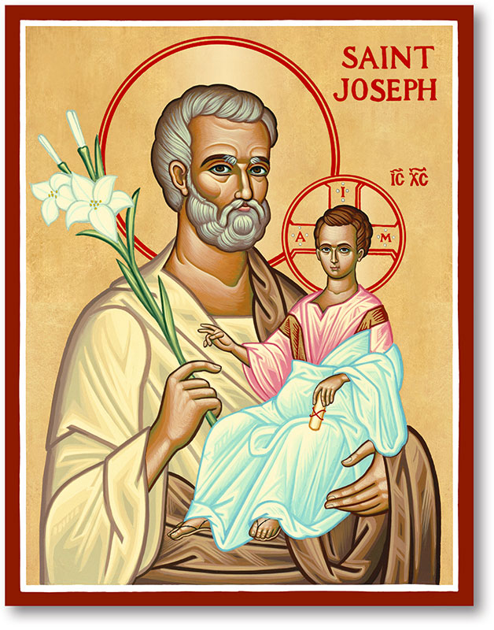
The Parish of Hannahstown
Saint Joseph’s and Saint Peter’s

6th July 2025
Fourteenth Sunday In Ordinary Time
Family of Parishes Emergency Sick Calls: 07549209775
Monday 09.15 am (Prayer for Vocations) Saint Joseph’s
Tuesday Fr. Patrick’s day off.
Wednesday 9.15 am (Parish novena to Our Lady) St Joseph’s
Thursday 9.15 am (Parish novena to Our Lady) St Peter’s
Friday 9.15 am (Sacred Heart Prayer) Saint Joseph’s
Saturday 6:00 pm (St Michael the Archangel Prayer) Saint Joseph’s
Sunday 10:00 am (Prayer for Pope’s intentions) Saint Peter’s
Sunday 11:30 am NO MASS Saint Joseph’s
Fr. Patrick covering in Family of Parishes on 13th July ( next cover AUGUST TIME)
Very Reverend Patrick Devlin, Parish Priest,
Chaplain to the Deaf Community, Down and Connor Diocese
Chaplain to Antrim Area Hospital, Thursday & Friday (Emergency calls)
Fr. Patrick, for Spiritual and Pastoral needs only, thank you Tel: 07910 833699
Parish Secretary: Mrs Grainne McArevey Tel: 028 90614567
Parish Email: hannahstown@downandconnor.org Parish Website:
https://www.parishofhannahstown.com
Please note that the parish office will be closed Monday 14th, Tuesday 15th and Wednesday 16th of July. There will be cover in the office from Thursday 17th until Tuesday 22nd. The parish secretary will be back into the office on Thursday 24th July 2025.

PRAYER FOR GOING ON HOLIDAY
Heavenly Father,
Please bless our holiday time. Help our family to have patience and understanding. Guide us to be mindful of this gift of time together.
Help us to make compromises when necessary and handle any
Chaos that comes our way with Your love and grace.
Open our eyes to truly see the beauty of the memories we are creating.
Through Christ our Lord. Amen.
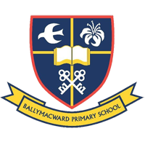
Ballymacward Primary School,
HANNAHSTOWN PARISH SCHOOL / COMMUNITY PLAYGROUP
22 Rock Road, Stoneyford, Lisburn, Co Antrim, BT28 3SUTel: (028) 92648130, Principal: Mr Hugh Kennedy
Email: info@ballmacwardps.lisburn.ni.sch.uk
Ballymacward Community Pre-School Playgroup - Supervisor: Ms Sarah Scott. Tel: (028) 9264 8515

We would like to wish all the staff and children of Ballymacward a happy summer break.
HANNAHSTOWN PARISH/FAMILY OF PARISHES

Remembering Srebrenica Genocide 30th Anniversary Interfaith Walk - - Sunday 6th July, gathering at 1.45 pm at the NI Muslim Family Association (7 Rugby Rd, BT7 1PS) leaving there at 2 pm, stopping midway at St Malachy’s Parish (24 Alfred St), and finishing around 3.15 pm at the Belfast Islamic Centre (13-19 University Rd, BT7 1NA). All welcome.

ATU St Angelas Is inviting applications for the following programme beginning Autumn 2025. Part-Time Certificate in Religious Education for Primary School with Online Delivery

The programme is open to: Qualified primary school teachers; Qualified post-primary school teachers who wish to transfer to primary school teaching. Parents, sacramental preparation teams and parish catechists who have a specific interest in the area of primary religious education may also apply.

Closing date for Applications is Friday, 15th August 2025.
For further information, contact Mary Kearns, Senior Administrator, School of Education, ATU St Angela's, Lough Gill, Sligo. E. mary.kearns@atu.ie or visit Website: www.atu.ie

Pilgrims of Hope at Lough Derg & Knock this July
Pioneers and friends of the PTAA are invited to mark the Jubilee of Hope on pilgrimage at Lough Derg from Friday, 11 July - Sunday, 13 July. The three days of prayer, keeping Vigil and fasting, will allow us to connect in prayer with all who live under the shadow of addiction. Details from www.pioneers.ie.

The annual Pioneer pilgrimage to Knock Shrine will take place on Sunday, 20 July.
Prayers will be offered at Our Lady’s Shrine for all who work in alcohol and drug treatment centres around Ireland. Contact Fr. Robert McCabe via prayer@pioneers.ie for further details.
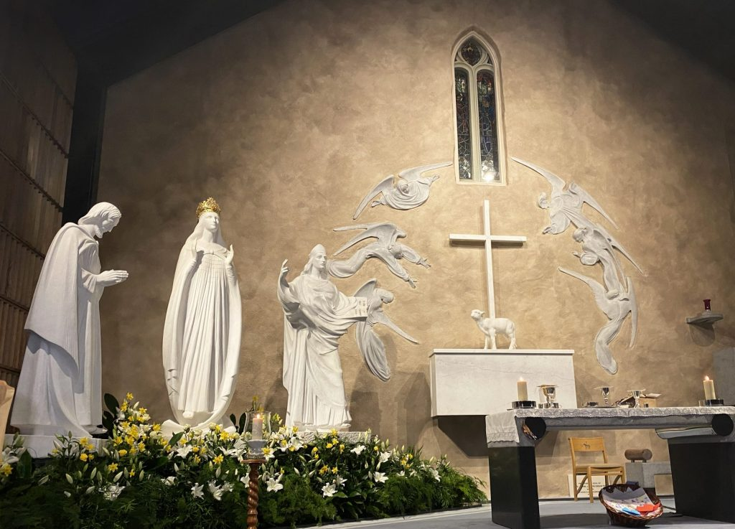
PARISH PILGRIMAGE TO KNOCK SHRINE – We are pleased to announce that the trip is filled. We welcome all pilgrims to be at the Parochial House for 10 am as the bus will depart at 10 am. Prayers for all our parishioners personal intentions will be offered during this Pilgrimage.
HANNAHSTOWN PARISH/FAMILY OF PARISHES

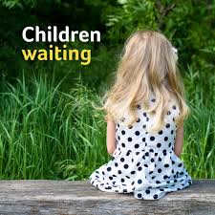
BELFAST TRUST FOSTERING RECRUITMENT CAMPAIGN 25/26 - The Belfast Trust are seeking to make positive connections and build its Fostering Community. Currently, there are 3,154 children in the North of Ireland being looked after by a total of 2,562 foster carers. The reality is that there are local children who need local foster carers to care for and support them. Community input is essential. If you are interested, please contact Aisling McLaughlin, Senior Practitioner, on 07385422706.

MARY’S MEALS RECENT PARISH COLLECTION
A heartfelt thank you from Mary’s Meals for the £1809.23 that was raised during the recent parish collection. These precious donations will enable more than 94 children, in some of the world’s poorest communities, to receive a daily meal at school for a full year and gain hope of a better future through education. Thank you for your generosity, and please continue to keep our work in your prayers. Also, we welcome anyone interested in volunteering (totally flexible, as and when you can, and full support given). A wide variety of activities available to choose from, including helping us to give talks, to fundraise, to plan events, to distribute collection cans and leaflets, to take part in bucket collections, and even to share any crafting skills/items at events and fairs. Further details about our work and how to get involved can be found at www.marysmeals.org.uk or contact Caoimhe McCann on 07394564065.

